Experiment No.: 06

- Title: Use String functions and regex for email validation,data extraction and text analysis.

- Software/Tools Required: HTML, VS Code.

- Theory: JavaScript string functions and Regular Expressions (Regex) are used for text processing, pattern matching, and data validation. String methods such as length, toUpperCase(), toLowerCase(), substring(), replace(), and split() help manipulate and analyze text data. Regex provides a powerful way to search, match, and validate patterns in strings.
In this practical, regex is used to validate email addresses by checking their format, while string functions are used for data extraction and text analysis, such as counting words, finding specific text, and replacing or extracting information from a string.

Output:

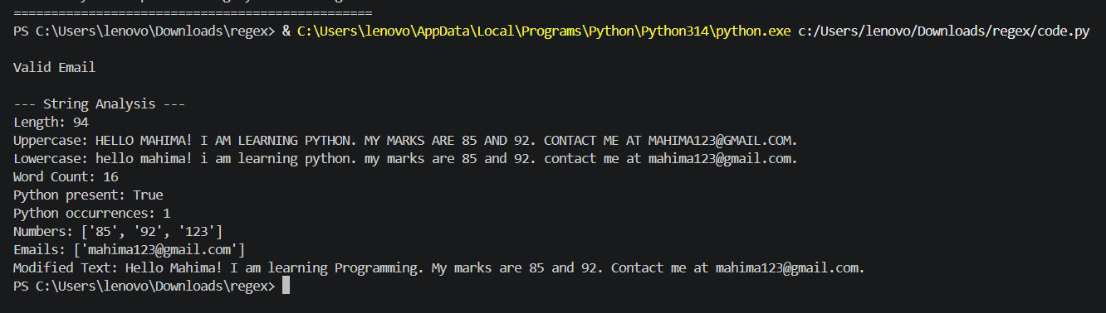

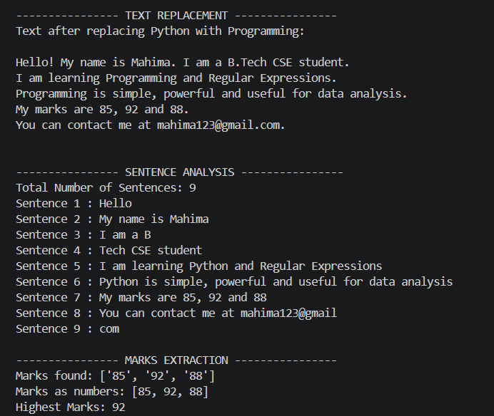

5.Result: Successfully implemented email validation, data extraction, and text analysis using JavaScript string functions and Regular Expressions (Regex). The program correctly validates email formats, extracts required data, and performs text processing operations efficiently.

CASE STUDY
AIM: To perform various String operations using Java Script.
a) To perform Basics of string.
b) Work with strings: substring(), indexOf(), split(), replace().
Case Study :-
- Write a program to reverse a string.
- WAP to count the number of vowels in a paragraph.

Code:
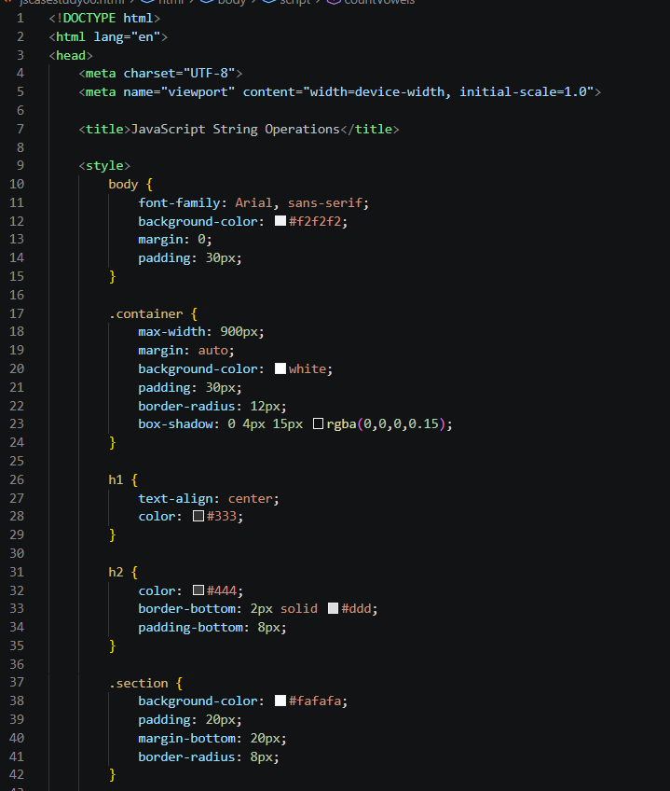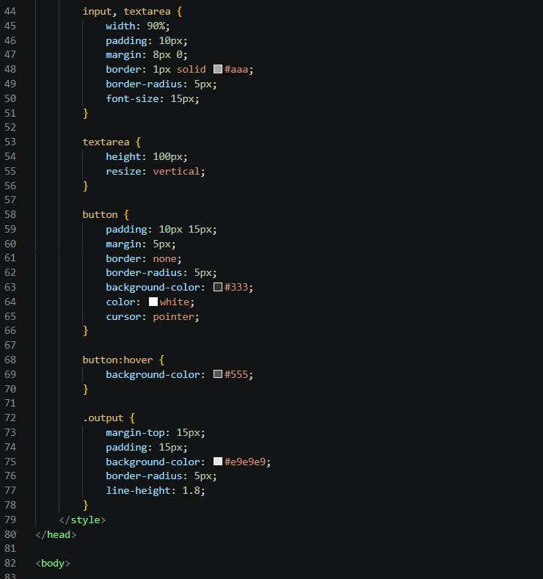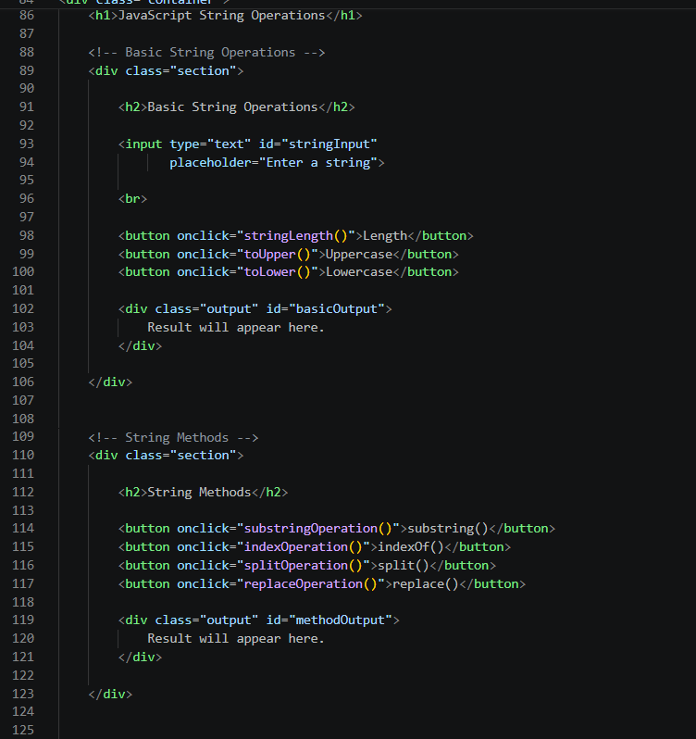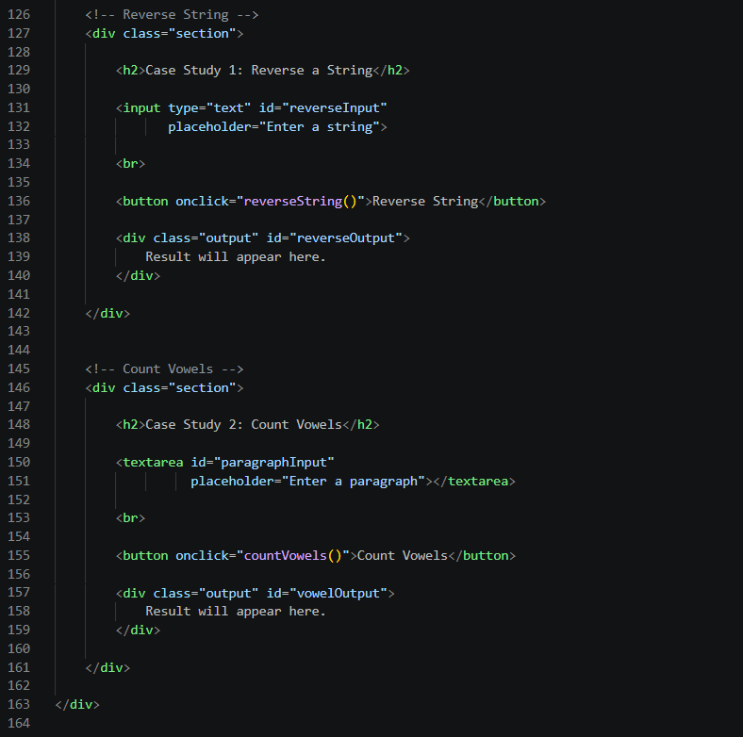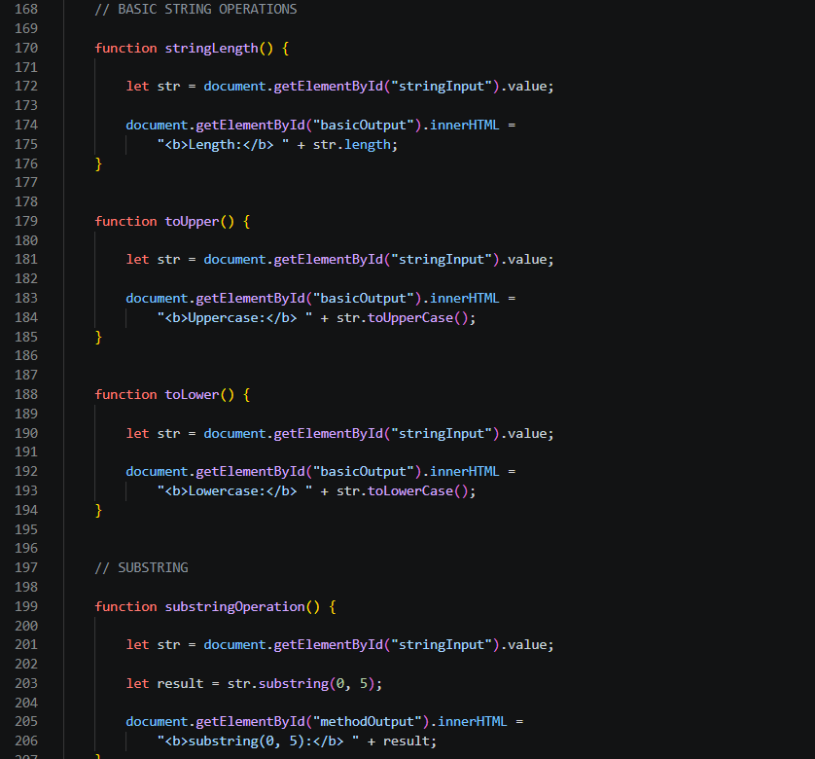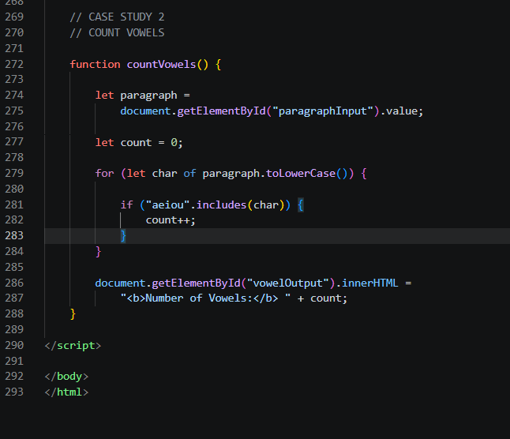

Output:
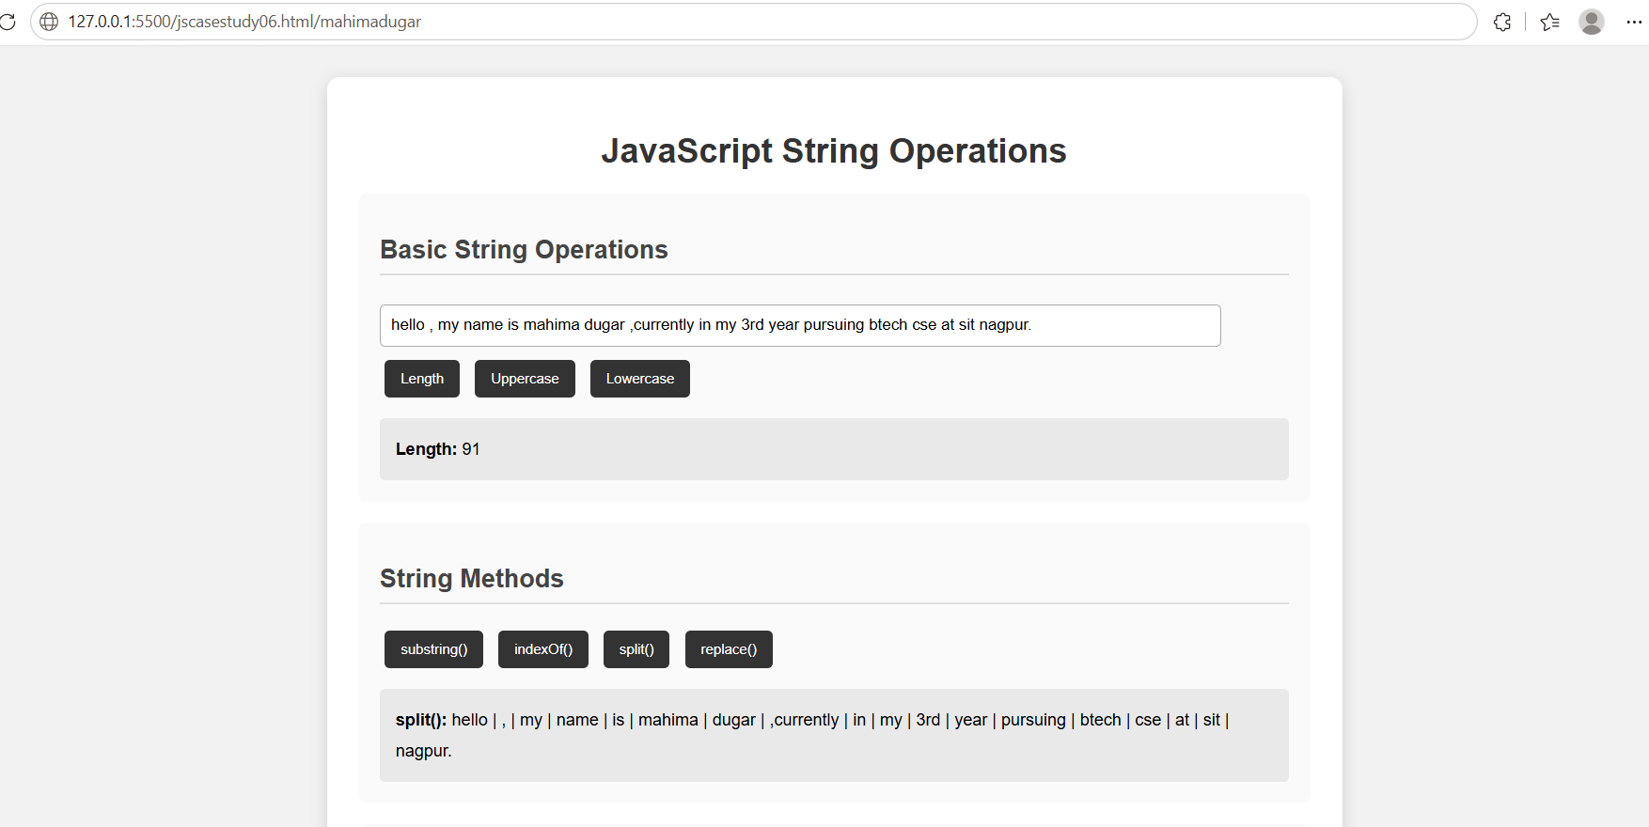

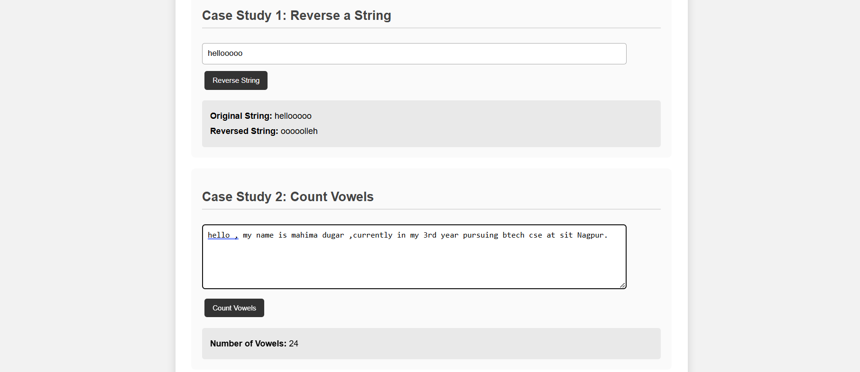

Conclusion: Thus, we successfully performed various String operations in JavaScript such as substring(), indexOf(), split(), and replace(). We also implemented programs to reverse a string and count the number of vowels in a paragraph, gaining a better understanding of JavaScript string manipulation and loops.

