Experiment No.: 03

- Title: Implement control structures and form validation; create a grading system based on user-entered marks.

- Software/Tools Required: HTML, VS Code.

- Theory: This experiment demonstrates the use of control structures (if-else statements) and form validation in JavaScript. The user enters marks through an HTML form, and the program checks whether the input is valid (between 0 and 100). Based on the entered marks, the program determines the student's grade using conditional statements and displays the result dynamically on the webpage. This experiment helps in understanding decision-making, input validation, and user interaction in web development.

Output:
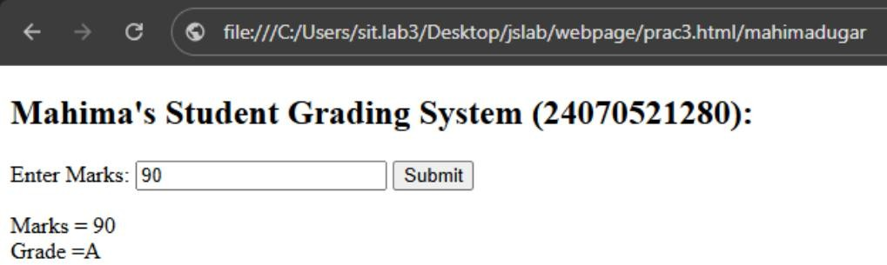

Case Study Title:
# Task 1: Scholarship Eligibility
Case Study:
A college awards scholarships based on marks.

Below 50 - Not Eligible 50–69 - Bronze
70–84 - Silver
85–94 - Gold
95–100 - Platinum

Task:
Write a JavaScript program that accepts student marks and displays the scholarship category.

Case Study Program Code:
<!DOCTYPE html>
<html lang="en">
<head>
<meta charset="UTF-8">
<meta name="viewport" content="width=device-width, initial-scale=1.0">
<title>Scholarship Eligibility</title>
<style>
body {
font-family: Arial, sans-serif; background: #f2f2f2; display: flex;
justify-content: center; align-items: center; height: 100vh;
}
.container { background: white; padding: 25px; border-radius: 10px;
box-shadow: 0 0 10px rgba(0,0,0,0.2); width: 350px;
text-align: center;
}
h2 {
color: #2c3e50;
}

input {

}

width: 90%; padding: 10px; margin: 10px 0; font-size: 16px;

button {
padding: 10px 20px; background: green; color: white; border: none; cursor: pointer; font-size: 16px; border-radius: 5px;
}

button:hover { background: darkgreen;
}

#result {
margin-top: 20px; font-size: 18px; font-weight: bold; color: blue;
}
</style>
</head>
<body>

<div class="container">
<h2>Scholarship Eligibility</h2>

<label>Enter Student Marks:</label><br>
<input type="number" id="marks" placeholder="Enter marks (0-100)">

<br>
<button onclick="checkScholarship()">Check</button>

<p id="result"></p>
</div>

<script>
function checkScholarship() {

let marks = Number(document.getElementById("marks").value);

let scholarship = "";

if (marks < 0 || marks > 100) {

scholarship = "Please enter valid marks (0-100).";

}
else if (marks < 50) { scholarship = "Not Eligible";
}
else if (marks <= 69) {
scholarship = "Bronze Scholarship";
}
else if (marks <= 84) {
scholarship = "Silver Scholarship";
}
else if (marks <= 94) {
scholarship = "Gold Scholarship";
}
else {
scholarship = "Platinum Scholarship";
}

document.getElementById("result").innerHTML = "Scholarship Category: " + scholarship;
}
</script>
</body>
</html>

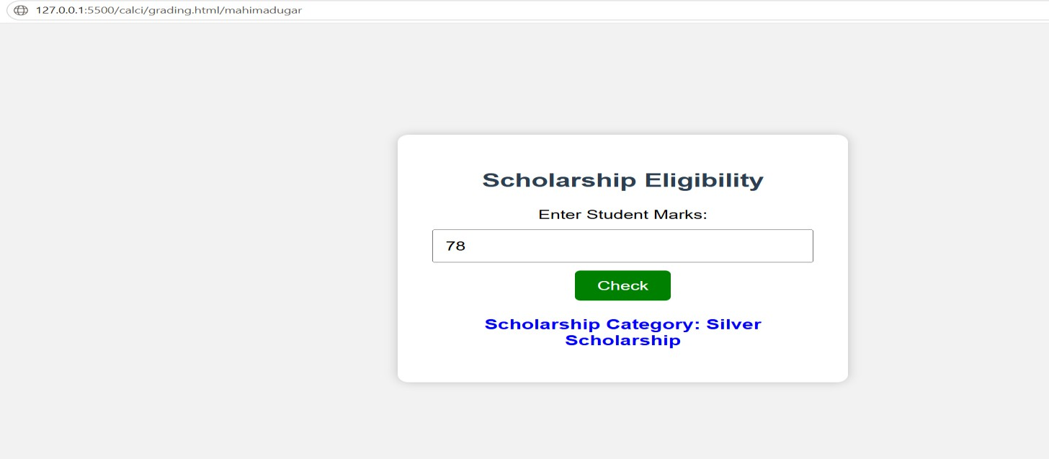
Output:

- Result/Conclusion: The grading system successfully accepted the user's marks, validated the input, and displayed the correct grade according to the predefined grading criteria. This experiment helped in understanding how form validation ensures valid user input and how control structures (if-else statements) are used to make decisions and generate appropriate output in a web application.

