Experiment No.: 04

- Title: Implement control structures and form validation; create a grading system based on user-entered marks.
- Software/Tools Required: HTML, VS Code.

- Theory: JavaScript provides different types of functions, such as function declarations, function expressions, and arrow functions, to perform reusable tasks efficiently. Variable scope controls where variables can be accessed and includes global, function, and block scope. A closure is a feature in which an inner function remembers and accesses variables from its outer function even after the outer function has finished execution. JavaScript also supports exception handling through the try-catch statement, which helps detect and manage runtime errors without stopping the program. In this practical, these concepts are applied to develop a palindrome checker, which verifies whether a given string or number reads the same forwards and backwards, demonstrating the practical use of functions, scope, closures, and error handling.

Output:
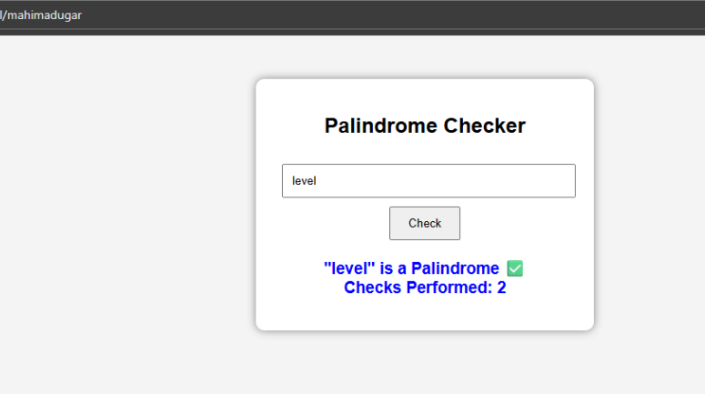

CASE STUDY-04

Practical 4: ATM Card PIN Verification Using JavaScript Functions
- Aim:
To verify whether an ATM PIN is a palindrome using JavaScript functions and demonstrate function declaration, function expression, arrow function, and scope.

Case Study Program Code:
<!DOCTYPE html>
<html lang="en">
<head>
<meta charset="UTF-8">
<meta name="viewport" content="width=device-width, initial-scale=1.0">
<title>ATM PIN Verification</title>

<style>
*{
margin:0; padding:0;
box-sizing:border-box;
font-family:Arial, Helvetica, sans-serif;
}

body{
height:100vh; display:flex;
justify-content:center; align-items:center;
background:linear-gradient(135deg,#0f2027,#203a43,#2c5364);
}

.container{ width:400px; background:white; padding:30px; border-radius:20px; text-align:center;
box-shadow:0 10px 30px rgba(0,0,0,0.4);
}

.icon{
font-size:60px;
}

h2{
color:#0d47a1; margin:10px 0;
}

p{
color:gray;
margin-bottom:20px;
}

input{
width:100%; padding:12px;
border:2px solid #2196F3; border-radius:10px;
font-size:18px; text-align:center; outline:none;
}

input:focus{
border-color:#4CAF50;
}

button{ width:100%; margin-top:20px; padding:12px; border:none;
border-radius:10px; background:#1565c0; color:white;
font-size:18px; cursor:pointer; transition:.3s;

}
button:hover{ background:#0d47a1; transform:scale(1.05);
}

#output{
margin-top:25px; padding:15px; border-radius:10px; display:none;
}
.success{ background:#d4edda; color:#155724; border:2px solid #28a745;
}

.error{
background:#f8d7da; color:#721c24; border:2px solid #dc3545;
}
.footer{
margin-top:20px; color:#666;
font-size:14px;
}
</style>
</head>

<body>

<div class="container">

<div class="icon">⬛tna</div>

<h2>ATM PIN Verification</h2>

<p>Enter your 4-digit ATM PIN</p>

<input type="password" id="pin" placeholder="Enter PIN">

<button onclick="checkPIN()">Verify PIN</button>
<div id="output"></div>

<div class="footer">
ABC Bank Security System
</div>

</div>

<script>

// Global Variable
let bankName="ABC Bank";

// Function Declaration function reversePIN(pin){
return pin.split("").reverse().join("");
}

// Function Expression
const isPalindrome=function(pin){ return pin===reversePIN(pin);
}

// Arrow Function
const displayResult=(pin)=>{

let output=document.getElementById("output");

if(isPalindrome(pin)){ output.className="success"; output.innerHTML=

"<h3> ⬛ PIN Verified</h3>"+ "<p><b>Bank:</b> "+bankName+"</p>"+ "<p><b>PIN:</b> "+pin+"</p>"+
"<p>·3 ˛.‘~˙.ª~˙˙ Your PIN is a <b>Palindrome</b>.</p>";
}
else{ output.className="error"; output.innerHTML=
"<h3>+ Invalid Pattern</h3>"+ "<p><b>Bank:</b> "+bankName+"</p>"+ "<p><b>PIN:</b> "+pin+"</p>"+
"<p>Your PIN is <b>Not a Palindrome.</b></p>";
}

output.style.display="block";

}

function checkPIN(){
let pin=document.getElementById("pin").value; if(pin==""){
alert("Please enter your PIN.");
return;
}

displayResult(pin);

}

</script>

</body>
</html>

Output:
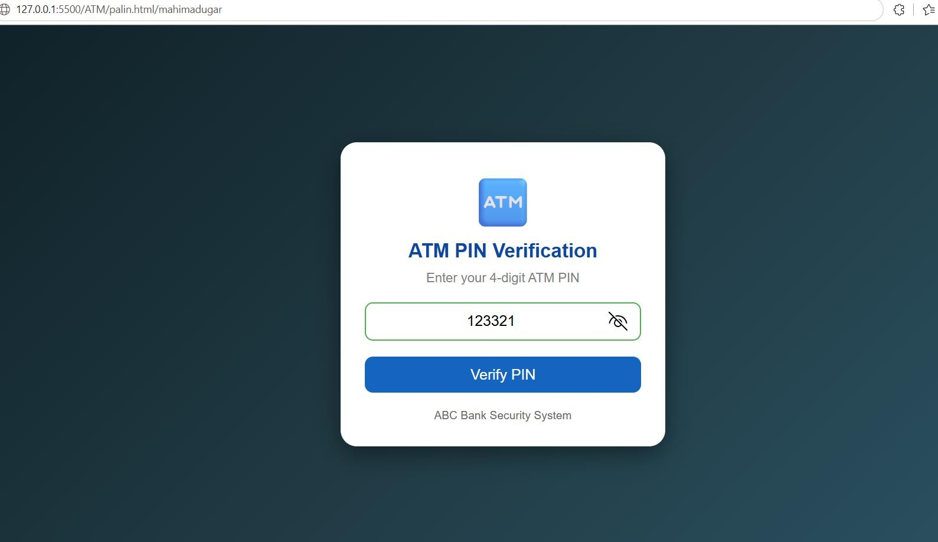
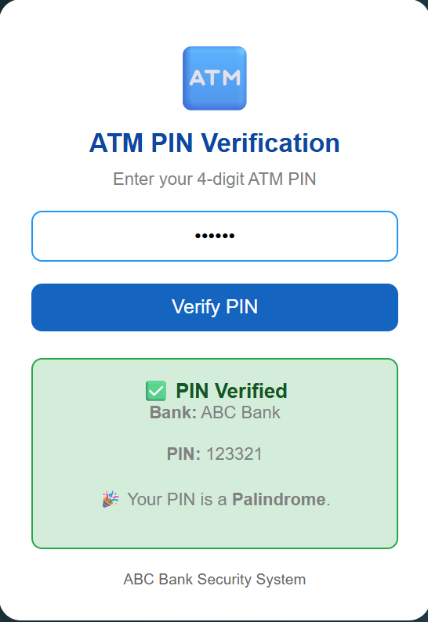

5.Result: The program was executed successfully. It demonstrated different types of JavaScript functions, variable scope, closures, and exception handling using try-catch. The palindrome checker correctly identified whether the given input was a palindrome or not.

