Experiment No.: 02

- Title: Use var, let, const, and demonstrate basic features like template literals and destructuring, build a billing calculator with user input.

- Software/Tools Required: HTML, VS Code.

- Theory: JavaScript is a scripting language used to make web pages interactive and dynamic. It allows developers to perform calculations, validate user input, display messages, and manipulate webpage content. In this experiment, a Billing Calculator is developed using JavaScript. The program accepts user inputs such as customer name, product name, quantity, and price per item through dialog boxes (prompt()). It then calculates the total bill and displays a formatted billing receipt on the webpage. The program demonstrates the following JavaScript features:
  - var – Used to declare function-scoped variables. It can be redeclared and updated.
  - let – Used to declare block-scoped variables. It can be updated but not redeclared within the same scope.
  - const – Used to declare constants whose values cannot be reassigned.
  - Template Literals – Enclosed within backticks (`), they allow embedding variables directly into strings using ${} for easier string formatting.
  - Destructuring – A feature that extracts values from arrays or objects into separate variables, making the code cleaner and more readable.

Output:
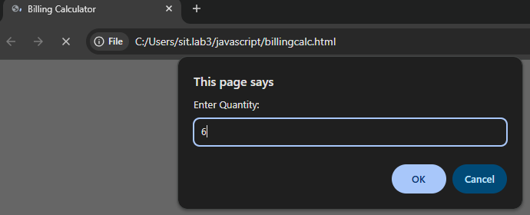

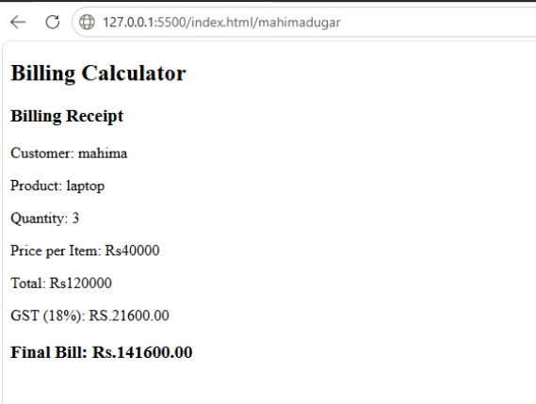

- Case Study Title: Develop a webpage for an online shopping website using HTML, CSS, and HTML5 tags, and calculate the bill.

Case Study Program Code:
<!DOCTYPE html>
<html lang="en">
<head>
<meta charset="UTF-8">
<meta name="viewport" content="width=device-width, initial-scale=1.0">
<title>Online Shopping Bill Calculator</title>

<style> body{
font-family: Arial, sans-serif; background:#f2f2f2;
}

.container{ width:500px; margin:30px auto; background:white; padding:20px; border-radius:10px;
box-shadow:0 0 10px gray;
}

h2{
text-align:center; color:darkblue;
}

label{
display:block; margin-top:10px; font-weight:bold;
}

input,select{ width:100%; padding:8px; margin-top:5px;
}

button{ width:100%; padding:10px; margin-top:20px;
background:green; color:white; border:none;
font-size:16px; cursor:pointer;
}
button:hover{ background:darkgreen;
}

#result{
margin-top:20px; padding:15px; background:#e8f5e9; border-radius:5px;
}
</style>
</head>

<body>

<div class="container">

<h2>Online Shopping Bill Calculator</h2>
<label>Customer Name</label>
<input type="text" id="name">

<label>Mobile Number</label>
<input type="text" id="mobile">

<label>Invoice Number</label>
<input type="text" id="invoice">

<label>Product Name</label>
<input type="text" id="product">

<label>Quantity (Kg)</label>
<input type="number" id="qty">

<label>Rate per Kg (₹)</label>
<input type="number" id="rate">

<label>Discount (%)</label>
<input type="number" id="discount">

<label>GST (%)</label>
<input type="number" id="gst">

<label>Packing Charges (₹)</label>
<input type="number" id="packing">

<label>Payment Mode</label>
<select id="payment">
<option>Cash</option>
<option>Card</option>
<option>UPI</option>
</select>

<label>Membership</label>
<select id="member">
<option>Yes</option>
<option>No</option>
</select>

<button onclick="calculateBill()">Generate Bill</button>

<div id="result"></div>

</div>

<script>
function calculateBill(){

// String Data Types
var customerName = document.getElementById("name").value; var mobile = document.getElementById("mobile").value;
var invoice = document.getElementById("invoice").value; var product = document.getElementById("product").value;

// Number Data Types
let qty = Number(document.getElementById("qty").value); let rate = Number(document.getElementById("rate").value);
let discount = Number(document.getElementById("discount").value); let gst = Number(document.getElementById("gst").value);
let packing = Number(document.getElementById("packing").value);

// Constant
const payment = document.getElementById("payment").value;

// Boolean Data Type
let membership = document.getElementById("member").value==="Yes";

// Undefined and Null let remarks;
let coupon = null;

let amount = qty * rate;

let discountAmount = amount * discount / 100; let afterDiscount = amount - discountAmount; let gstAmount = afterDiscount * gst / 100;
let total = afterDiscount + gstAmount + packing;

if(membership){
total = total - (total * 5 / 100);
}
document.getElementById("result").innerHTML = `
<h3>Invoice</h3>

Customer Name : ${customerName}<br> Mobile Number : ${mobile}<br>
Invoice Number : ${invoice}<br> Product Name : ${product}<br><br>

Quantity : ${qty} Kg<br> Rate : ₹${rate}<br>
Amount : ₹${amount.toFixed(2)}<br>
Discount : ₹${discountAmount.toFixed(2)}<br> GST : ₹${gstAmount.toFixed(2)}<br>
Packing Charges : ₹${packing}<br> Membership : ${membership}<br> Payment Mode : ${payment}<br><br>

<h3>Total Bill : ₹${total.toFixed(2)}</h3>
<hr>

<b>Primitive Data Types Used</b><br> String : ${typeof customerName}<br> Number : ${typeof qty}<br>
Boolean : ${typeof membership}<br> Undefined : ${typeof remarks}<br> Null : ${coupon}

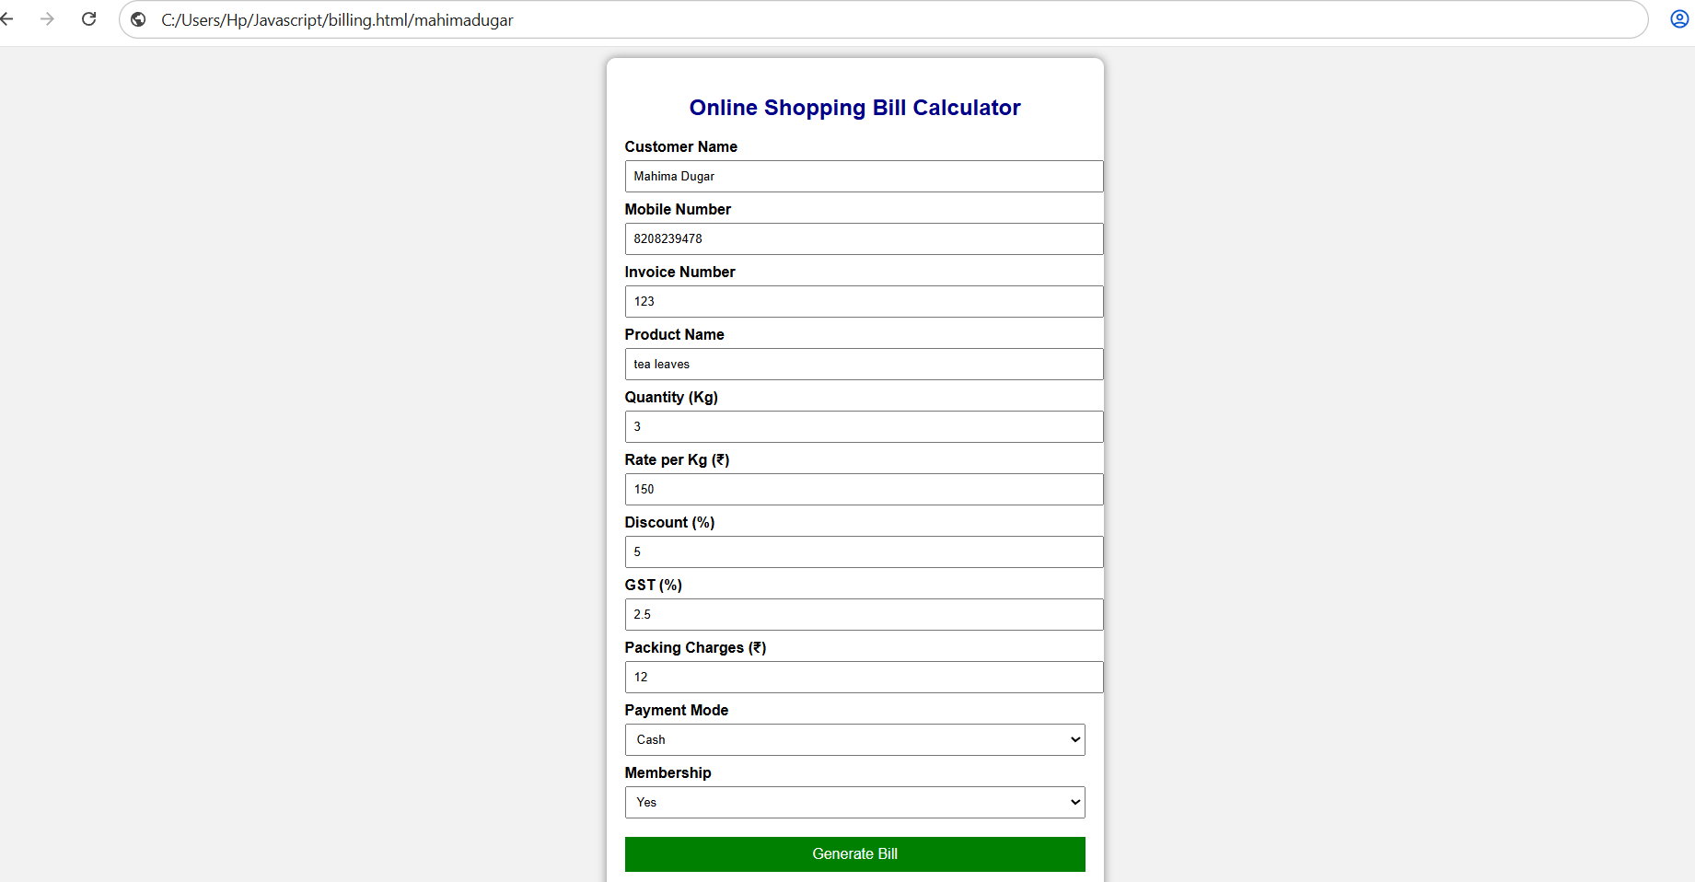
`;
}

</script>

</body>
</html>

Output:

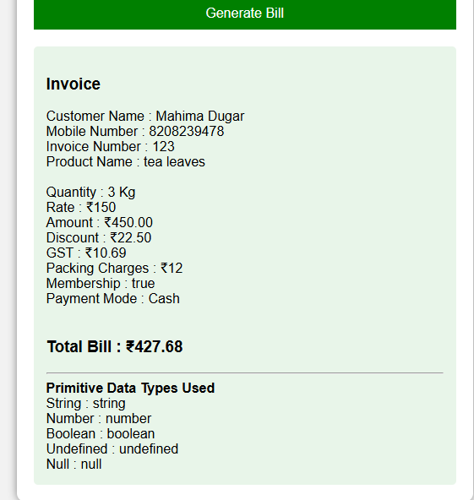

5. Result/Conclusion: The Billing Calculator was successfully implemented using JavaScript. The program accepts user input, performs the billing calculation, and displays the receipt correctly. It successfully demonstrates the use of var, let, const, template literals, and destructuring while providing a simple and interactive billing application.

