Experiment No.: 07

- Title: Perform DOM traversal and updates; develop a to-do list app with add, edit, and delete features.

- Software/Tools Required: HTML, VS Code.

- Theory: DOM (Document Object Model) represents an HTML page as a tree of elements. JavaScript uses the DOM to access, traverse, create, update, and delete HTML elements dynamically.
In this experiment, DOM methods and event handling are used to develop a To-Do List application. The user can enter a task and add it to the list. Each task contains Edit and Delete options. The Edit option modifies the task, while Delete removes it from the DOM.
Key methods used: getElementById(), querySelector(), createElement(), appendChild(), textContent, and remove().

To-Do List Application
A to-do list is a simple application that demonstrates DOM manipulation and event handling. The user enters a task and clicks Add to create a new list item. Each task can have Edit and Delete buttons.
Working Logic:
- Take the task entered by the user from the input field.
- Create a new <li> element using JavaScript.
- Add the task text and Edit/Delete buttons to the list.
- The Edit button allows the user to modify the existing task.
- The Delete button removes the task from the DOM.
- DOM methods are used to dynamically update the to-do list.

- Output:

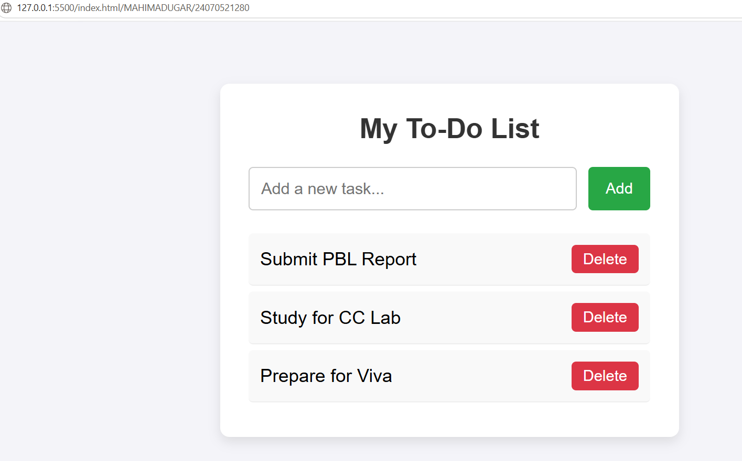

5.Conclusion: Thus, the experiment successfully demonstrates DOM traversal and dynamic DOM updates using JavaScript. A functional to-do list application was developed with Add, Edit, and Delete operations. This experiment helps in understanding how JavaScript interacts with HTML elements and dynamically changes webpage content based on user actions.

CASE STUDY
AIM: To Demonstrate the Events Handling in JavaScript
a) Access and manipulate form elements using JavaScript.
b) Validate user input (e.g. email, empty fields).
c) Use various form events (submit, change, focus).
Case Study:-
Create the following HTML form and use required JavaScript and events in a given form.

Code: 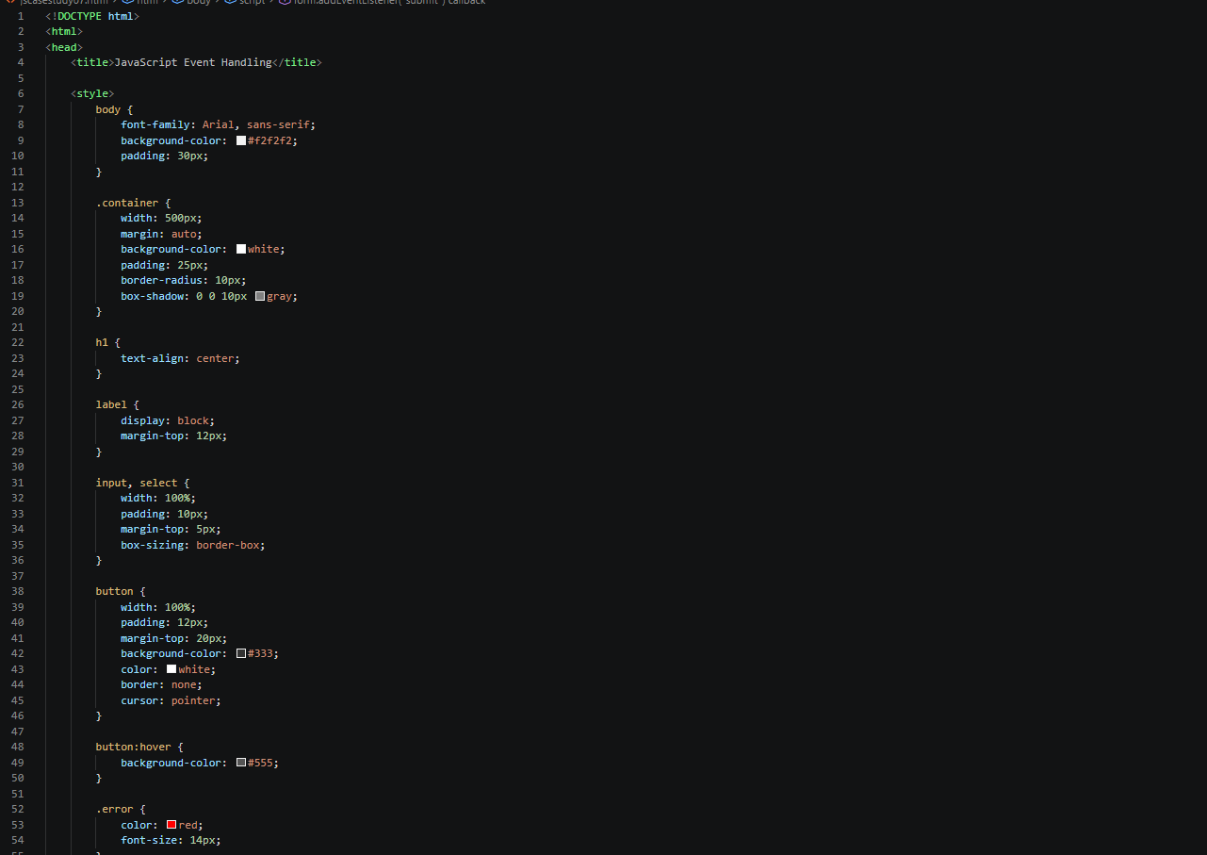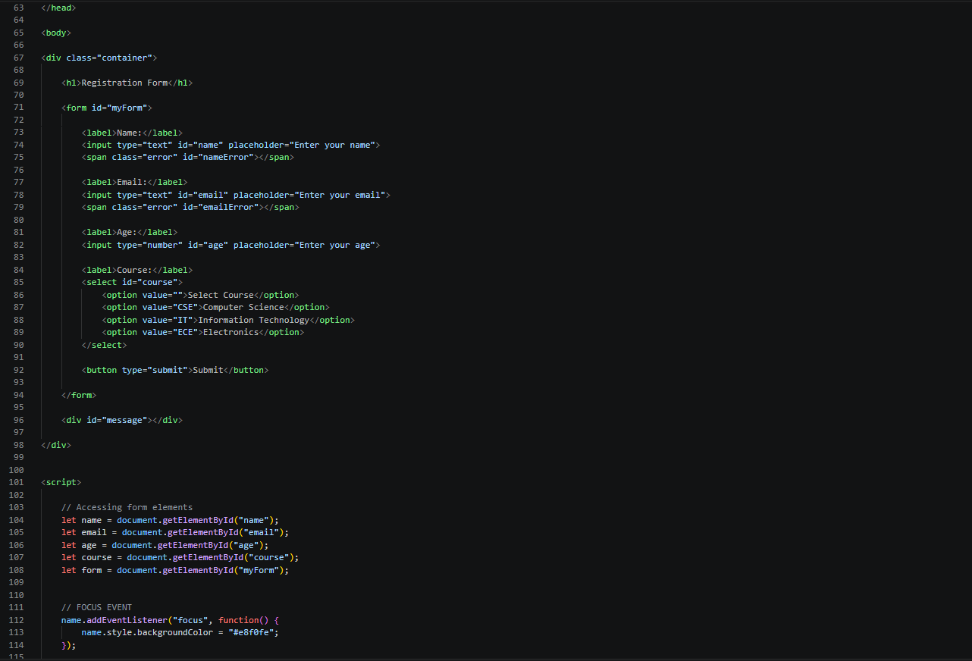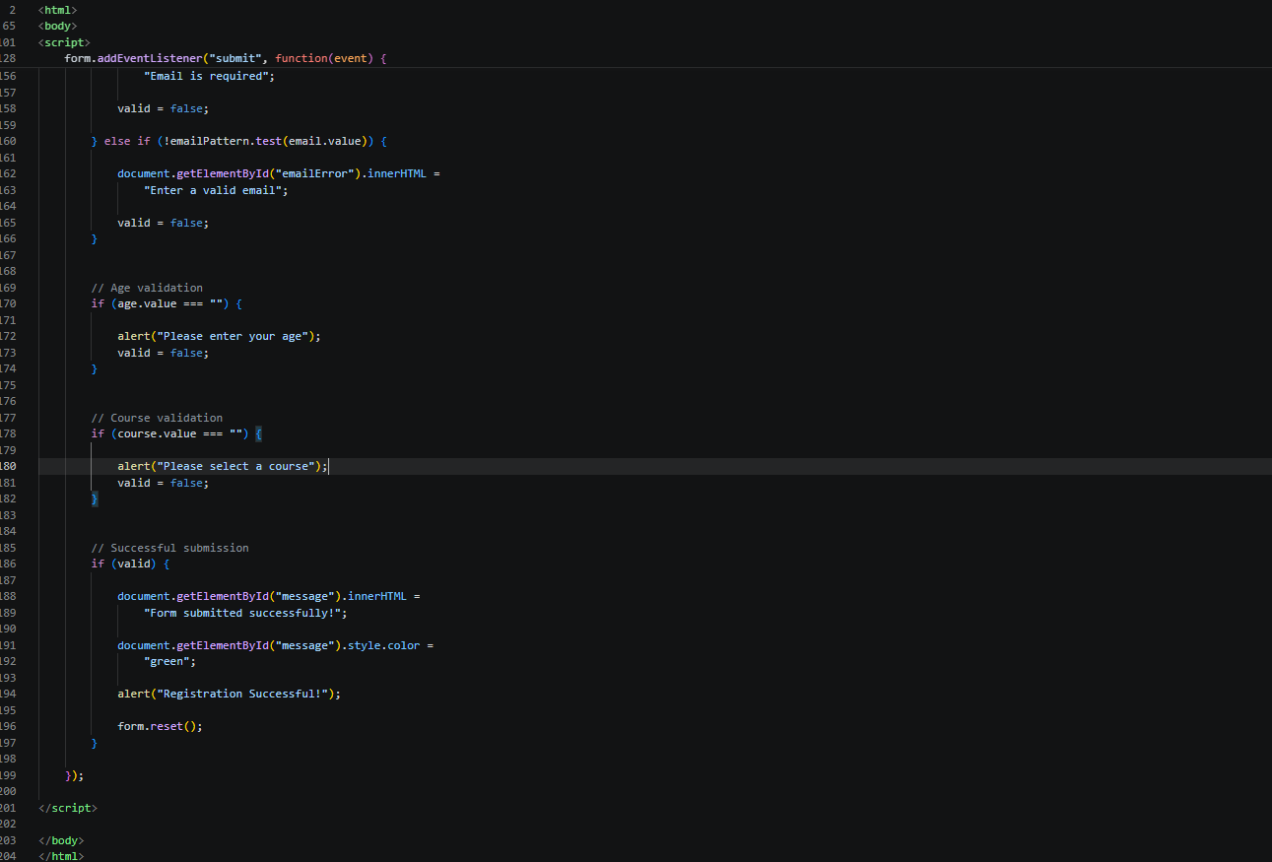

Output:
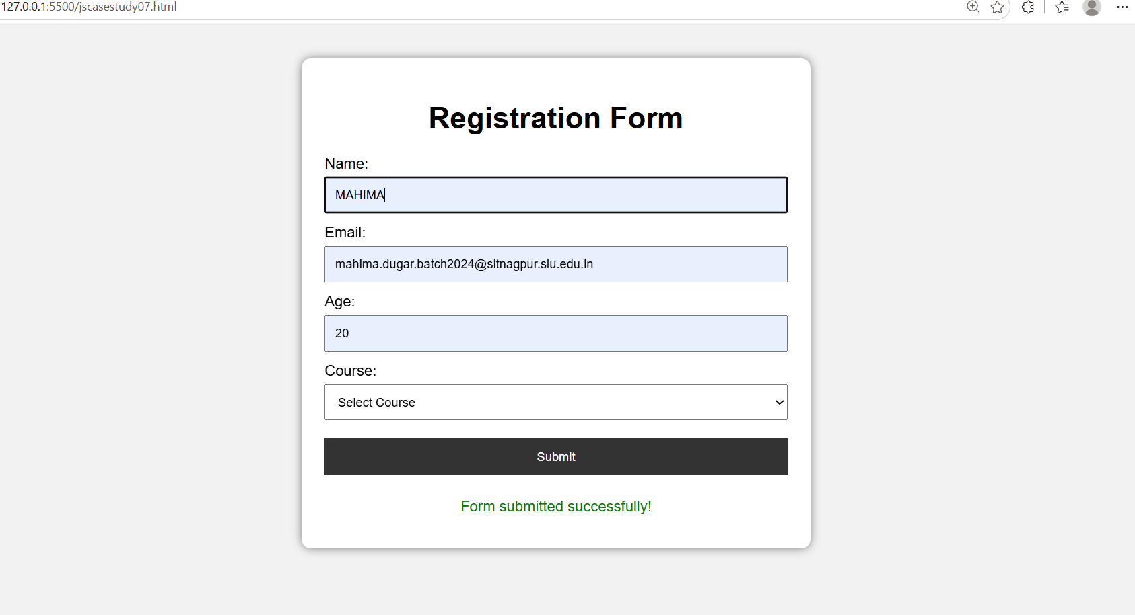

Result: Thus, the experiment successfully demonstrates DOM traversal and dynamic DOM updates using JavaScript. A functional to-do list application was developed with Add, Edit, and Delete operations. This experiment helps in understanding how JavaScript interacts with HTML elements and dynamically changes webpage content based on user actions.

