Title: Load and display JSON data using fetch() and jQuery $.getJSON(); render results dynamically in a table.

Software/Tools Required: Vscode

Theory: JSON (JavaScript Object Notation) is a lightweight data-interchange format used to store and transfer data between a client and a server. JSON represents data in the form of key-value pairs and arrays, making it easy for JavaScript to process.

In JavaScript, the fetch() API is used to request data from a JSON file or server asynchronously. It returns a Promise, which can be used with .then() to process the response. The JSON data can be converted into a JavaScript object using the response.json() method.
jQuery $.getJSON() is another simple method for loading JSON data asynchronously. It directly retrieves a JSON file or resource and provides the parsed data through a callback function.
After retrieving the JSON data, JavaScript or jQuery can dynamically create HTML table rows and cells using DOM manipulation. This allows the webpage to display data without manually writing each table row in HTML.

Key Features
- JSON: Provides a simple format for representing structured data.
- fetch() API: Loads data asynchronously without refreshing the webpage.
- response.json(): Converts the JSON response into a JavaScript object.
- $.getJSON(): Provides a convenient jQuery method for retrieving JSON data.
- DOM Manipulation: Dynamically creates and updates HTML elements.
- Dynamic Table: Displays the retrieved JSON records in rows and columns.
Output:
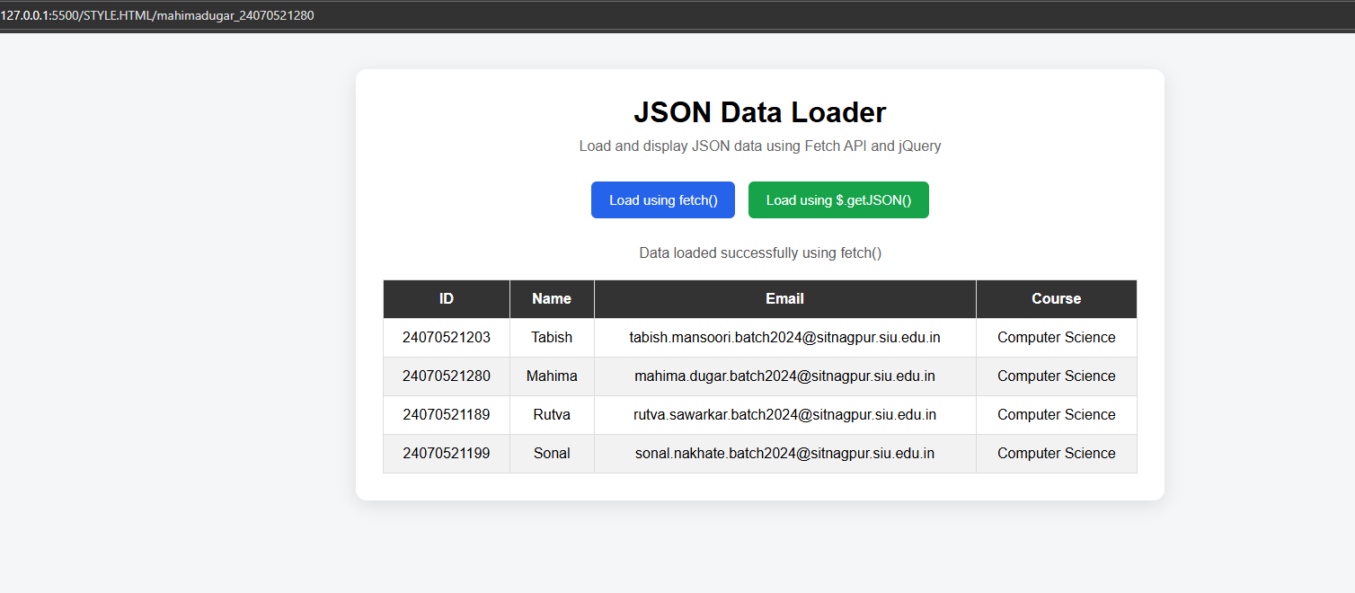

Result/Conclusion: The practical successfully demonstrates how JSON data can be loaded using both the JavaScript fetch() API and jQuery $.getJSON() method. The retrieved data is processed and dynamically displayed in an HTML table using DOM manipulation. This helps in understanding asynchronous data fetching, JSON processing, jQuery, and dynamic webpage content generation.

