Experiment No.: 08

- Title: Access and validate form fields using events; design a gym admission form with live input checks.

- Software/Tools Required: HTML, VS Code.

- Theory: JavaScript is used to access and validate form fields and make web forms interactive. Form elements can be accessed using methods like getElementById() and querySelector().
JavaScript events such as input, blur, change, and submit help detect user actions. Live validation checks the entered information immediately and displays an error message if the data is incorrect or incomplete.
In the Gym Admission Form, fields such as Name, Age, Email, Phone Number, Gender, and Membership Plan can be validated. JavaScript displays suitable error messages when the entered data is invalid and provides feedback immediately. This improves user experience and prevents incorrect or incomplete data from being submitted.

Key features:
- Access form elements using JavaScript DOM methods.
- Handle user actions using events.
- Perform live input validation.
- Display error messages dynamically.
- Prevent form submission when invalid data is entered.
- Ensure that required fields are properly filled.

- Output:

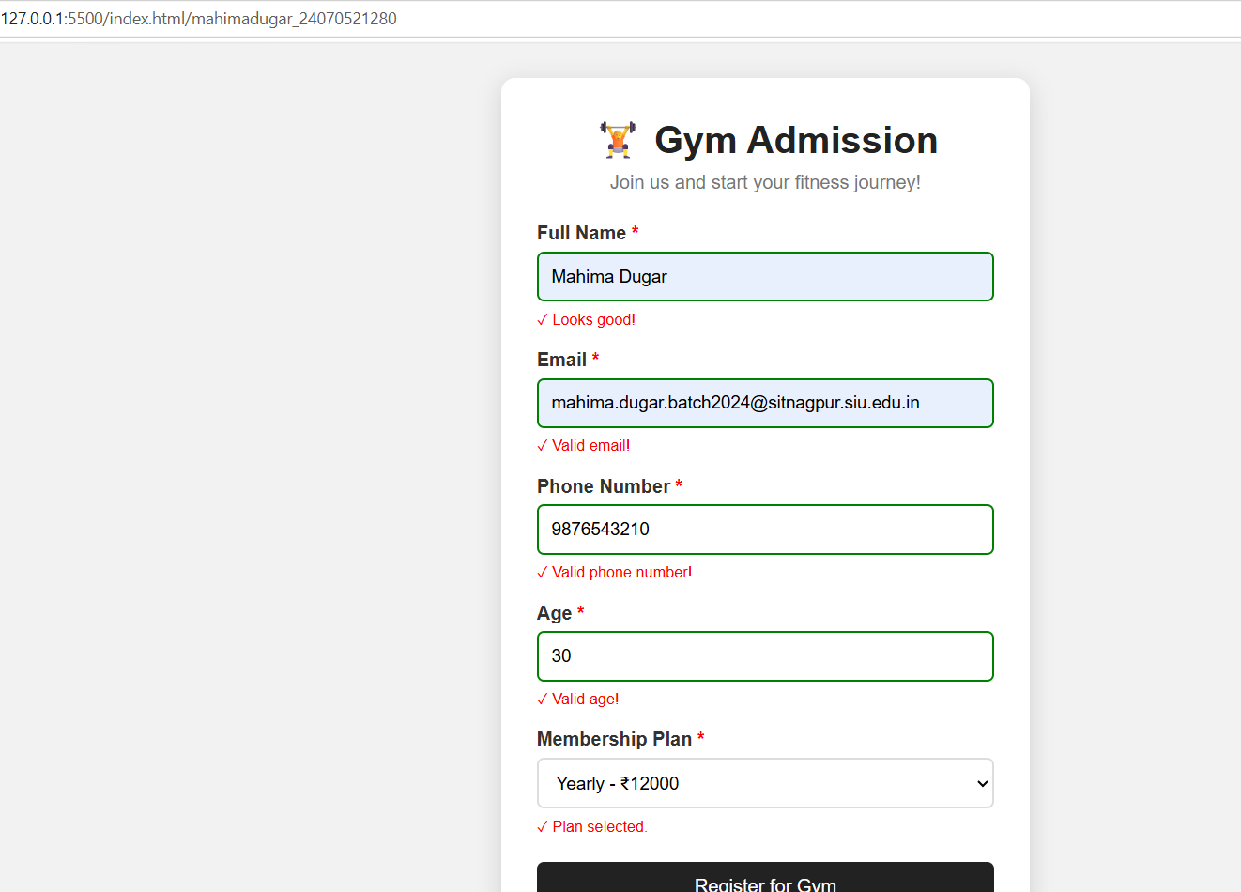



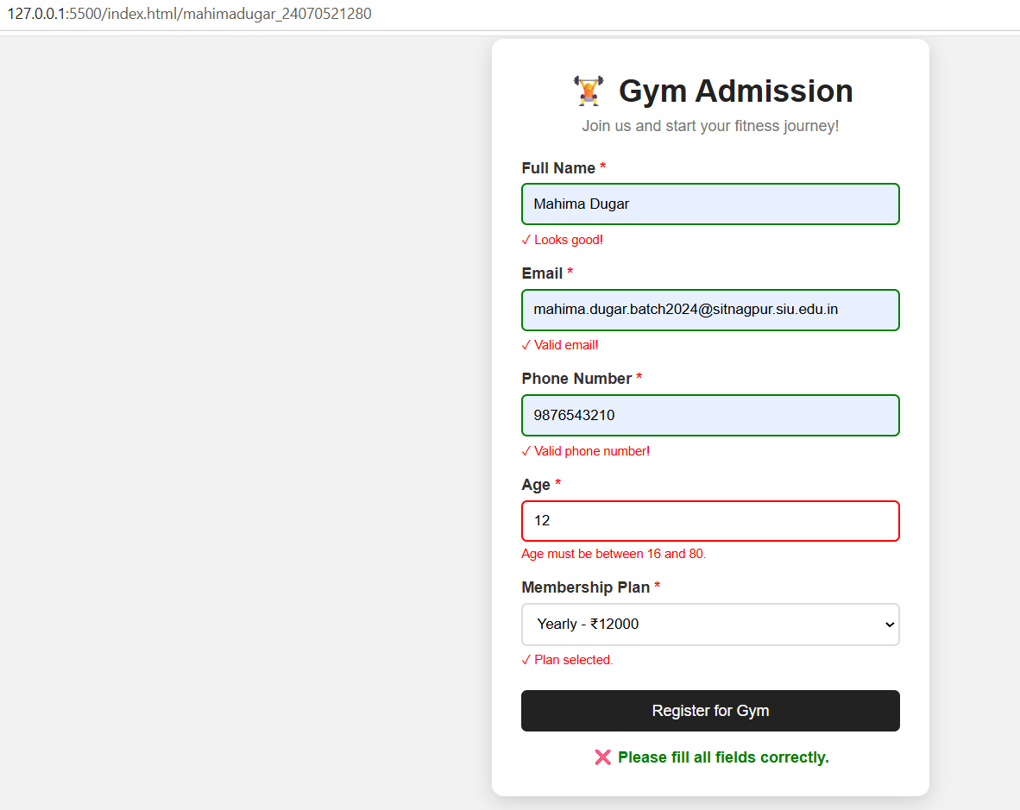
CASE STUDY

AIM: To design an Online Job Application Form using HTML, CSS, and JavaScript with real-time form validation, ensuring that the entered details are valid before submission.
Code: 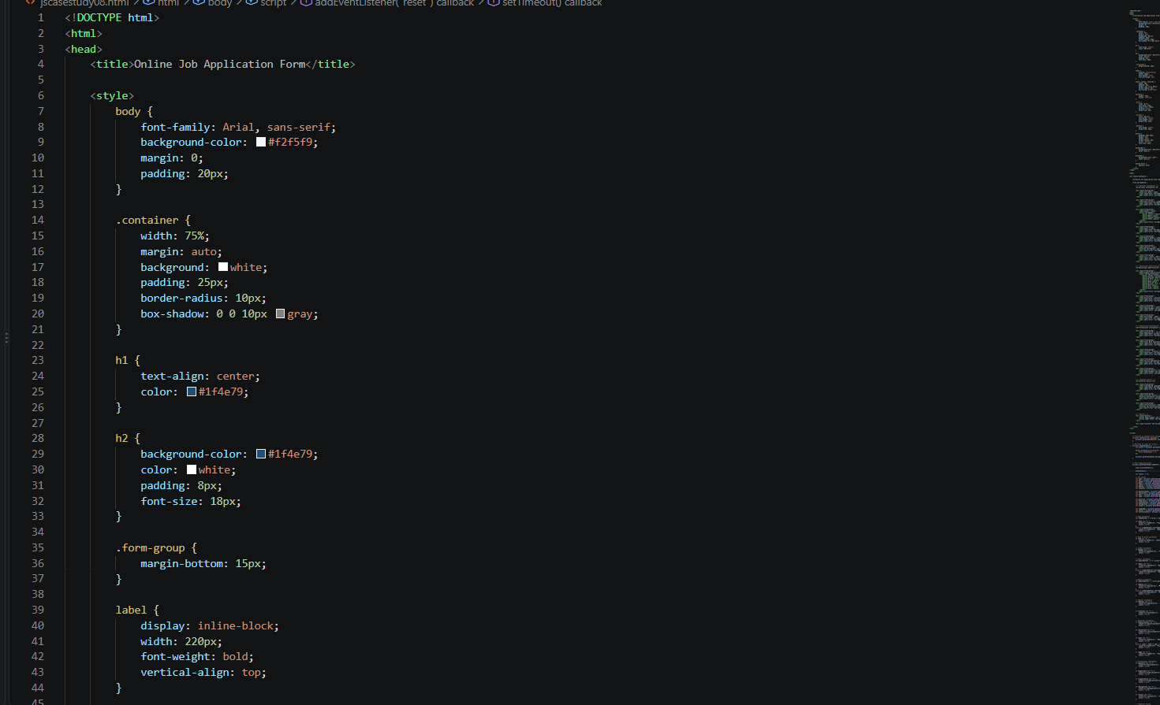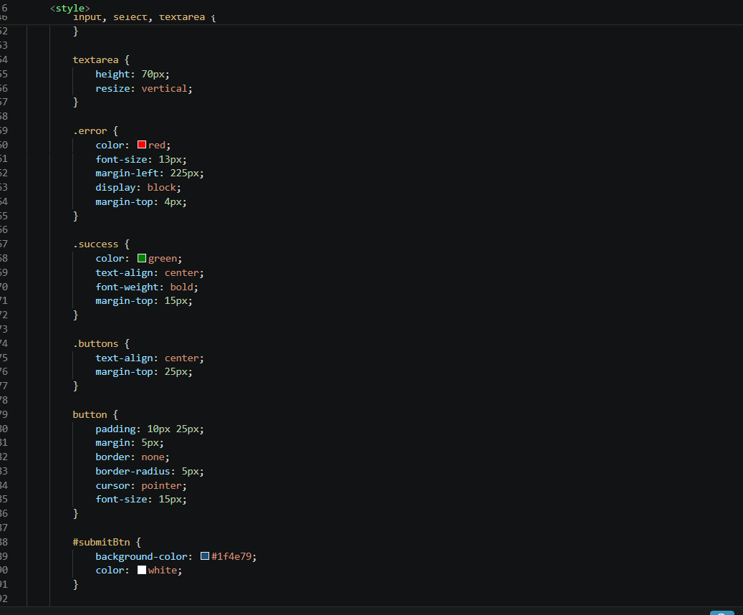

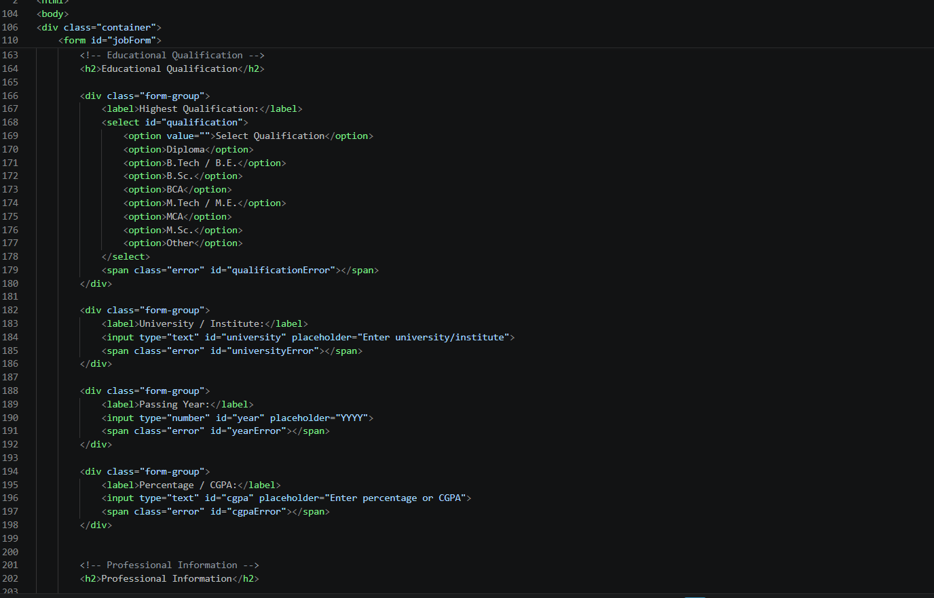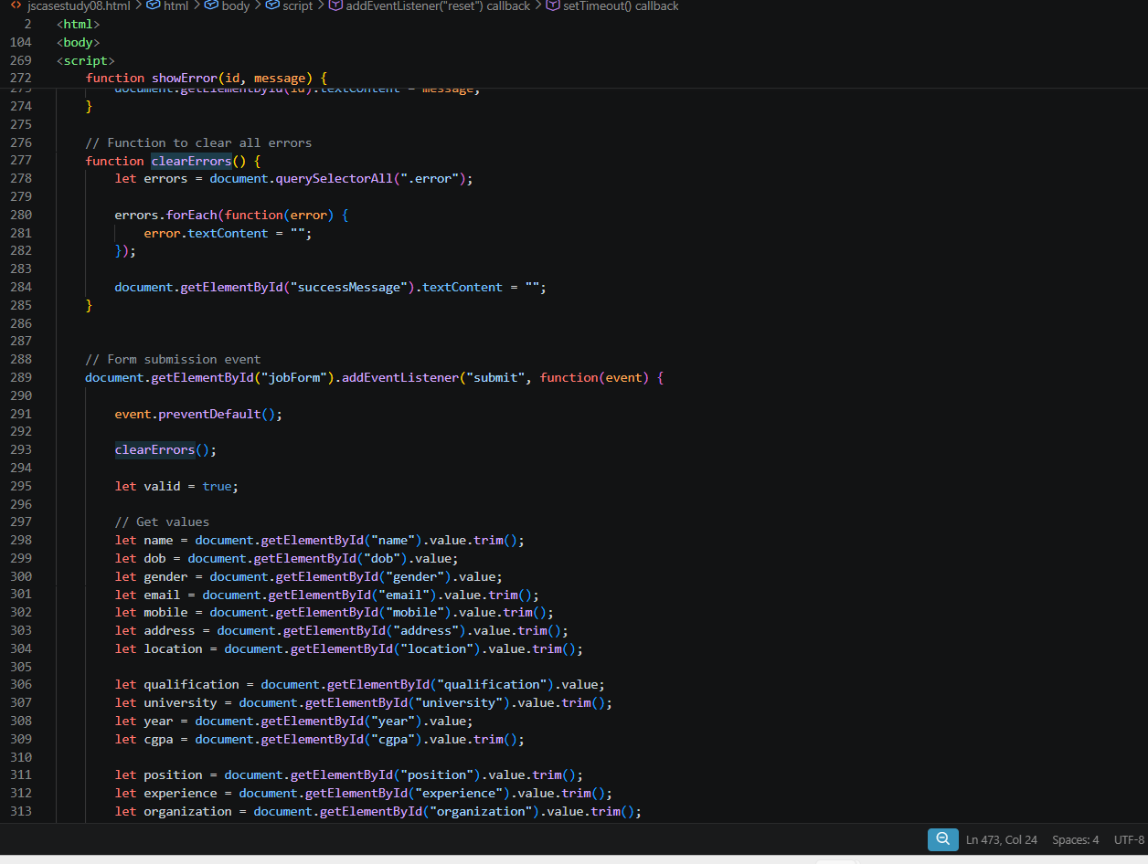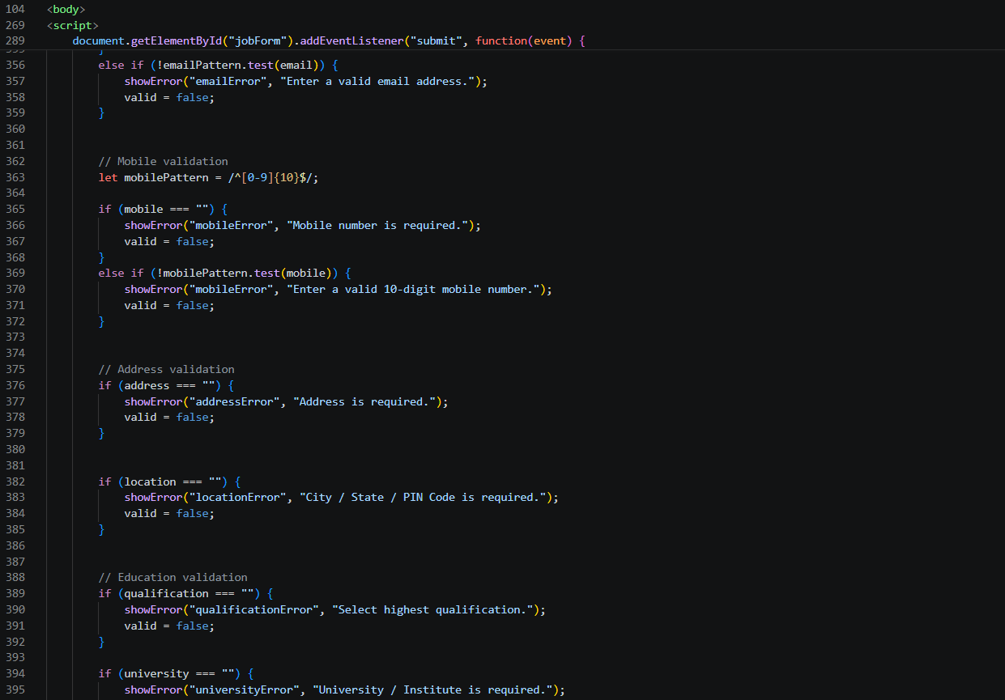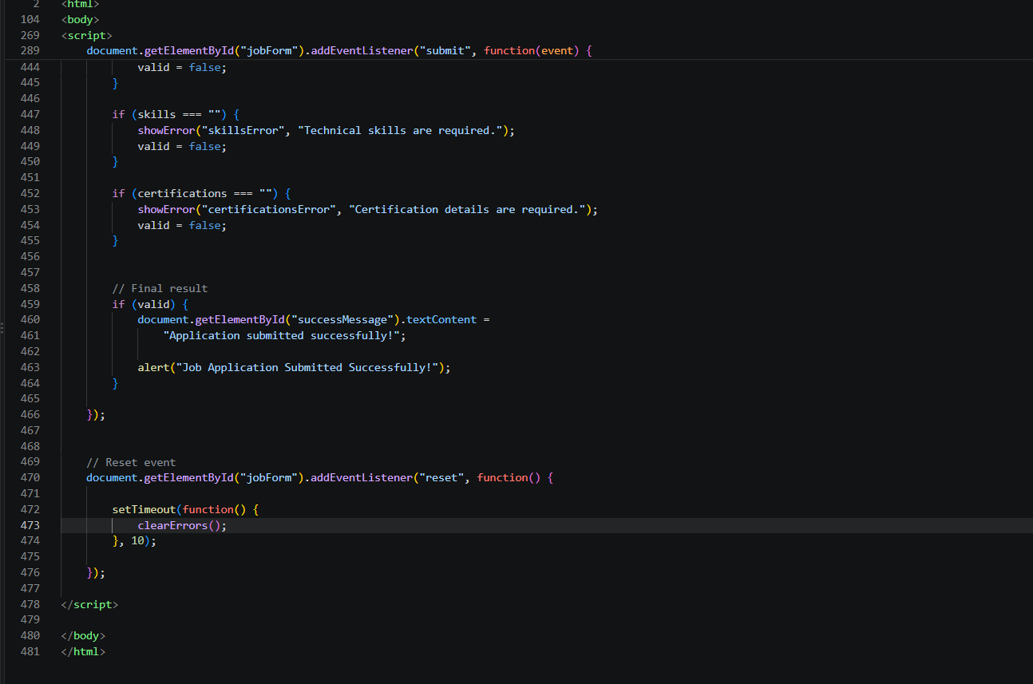

Output:
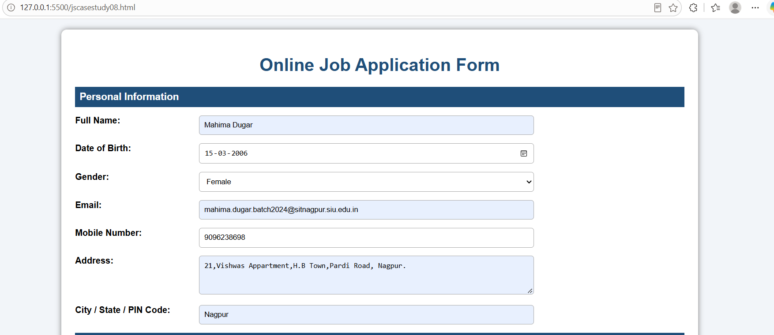

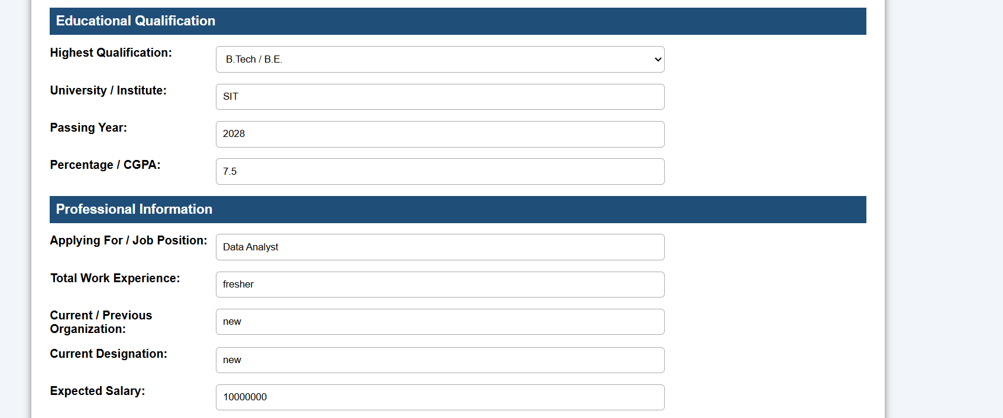

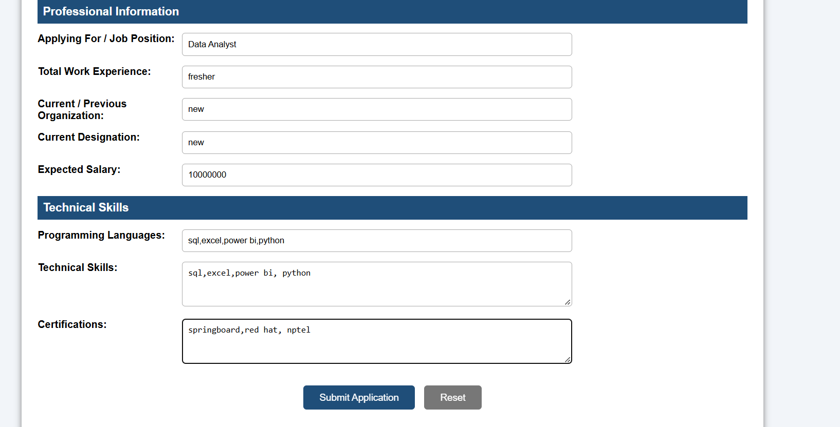

Result: Thus, an Online Job Application Form was successfully developed using HTML, CSS, and JavaScript. JavaScript validation ensures that incorrect or incomplete information is detected before submission, making the form more reliable, user-friendly, and interactive.

