Experiment No.: 05

- Title: Apply array methods and object handling; create a cart total calculator with discount logic.

- Software/Tools Required: HTML, VS Code.

- Theory: JavaScript arrays are used to store multiple values, while objects store data in key-value pairs. Array methods like map (), filter (), and reduce () are useful for processing and calculating data. In a shopping cart, each product is represented as an object containing its name, price, and quantity. The reduce () method is used to calculate the total cart value. Based on the total amount, discount conditions are applied using conditional statements, and the final payable amount is calculated.

- Output:

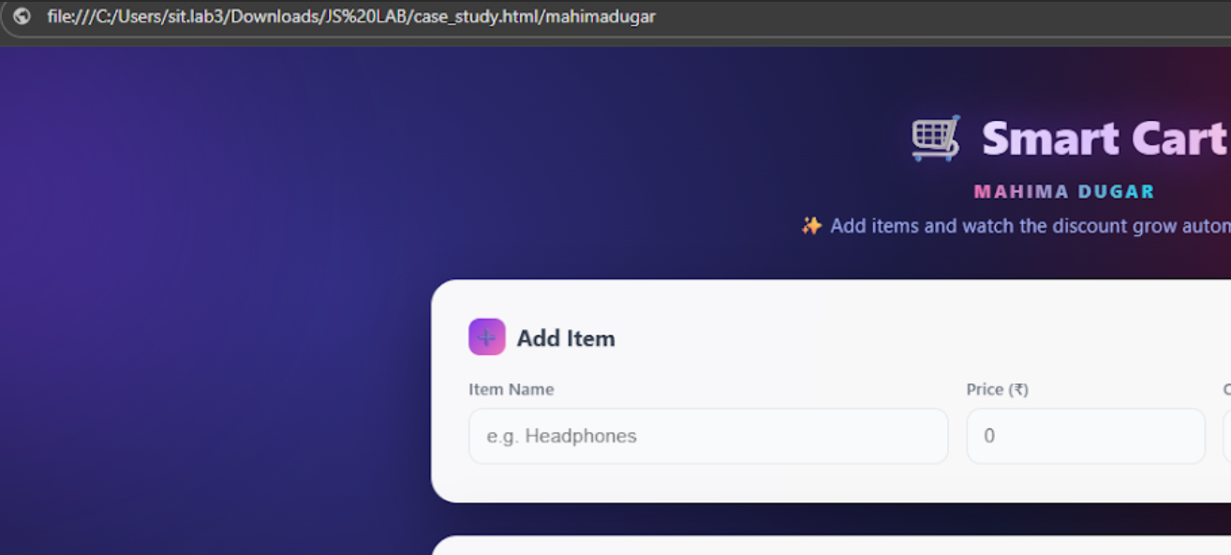

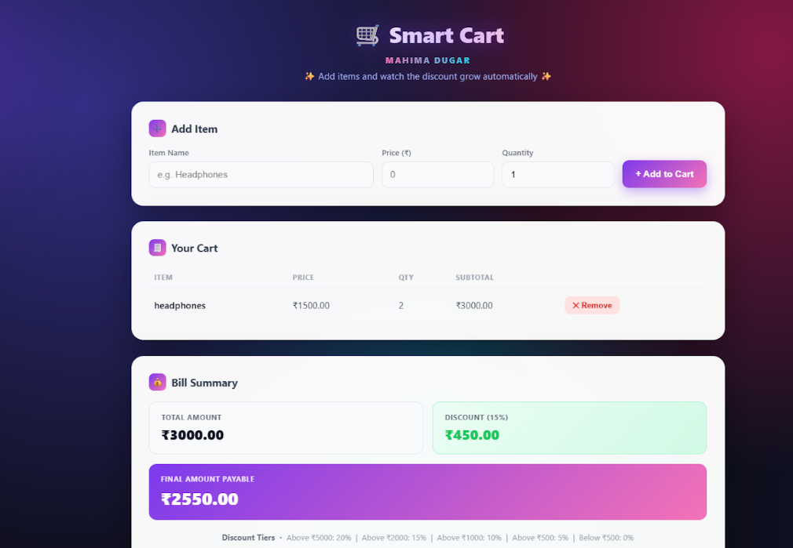

5.Result/Conclusion: The cart total calculator was successfully implemented using JavaScript arrays, objects, array methods, and conditional discount logic. The program calculates the total price, applies the appropriate discount, and displays the final amount to be paid.

CASE STUDY

To study the functioning of Arrays and Loops in Java Script
a) Create and manipulate arrays: push, pop, shift, unshift, splice, slice.
b) Use array methods: map(), filter(), reduce(), forEach().
CaseStudy:-
Create an array of numbers and find the maximum and minimum value.

Code:

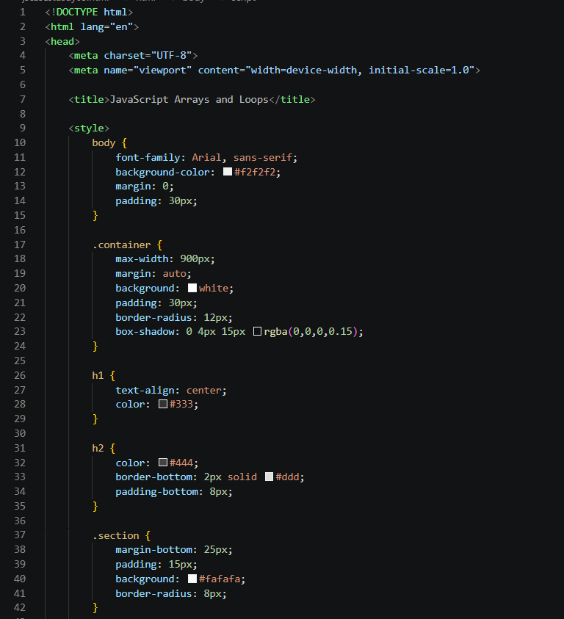

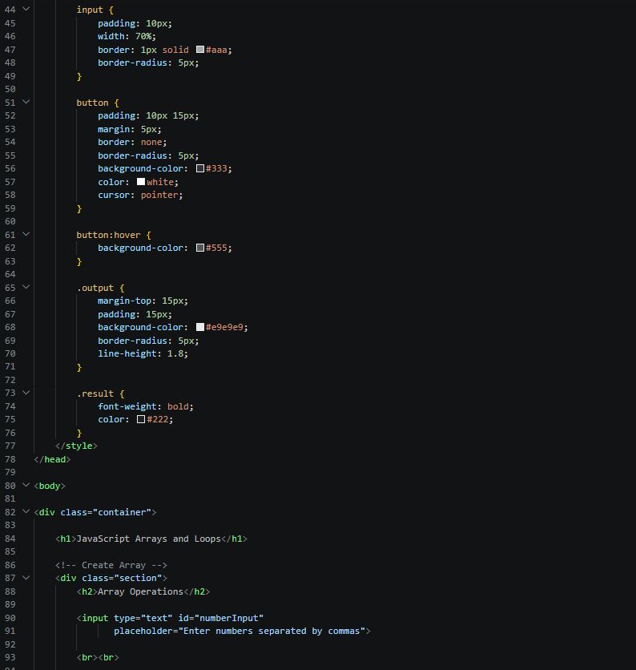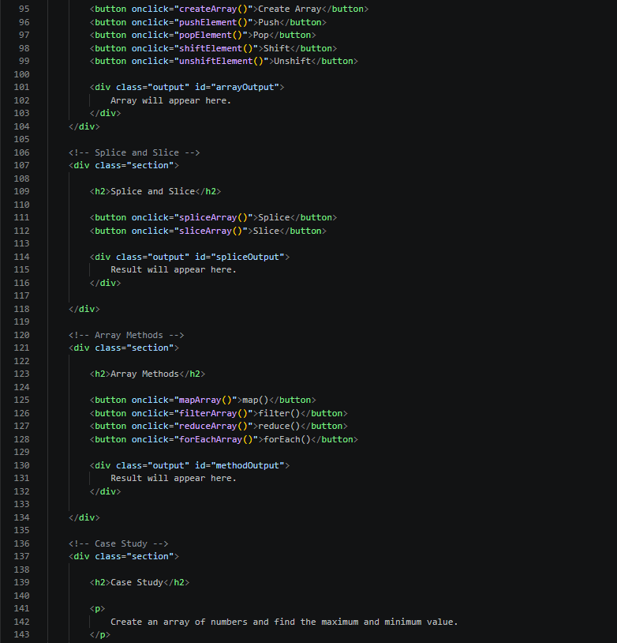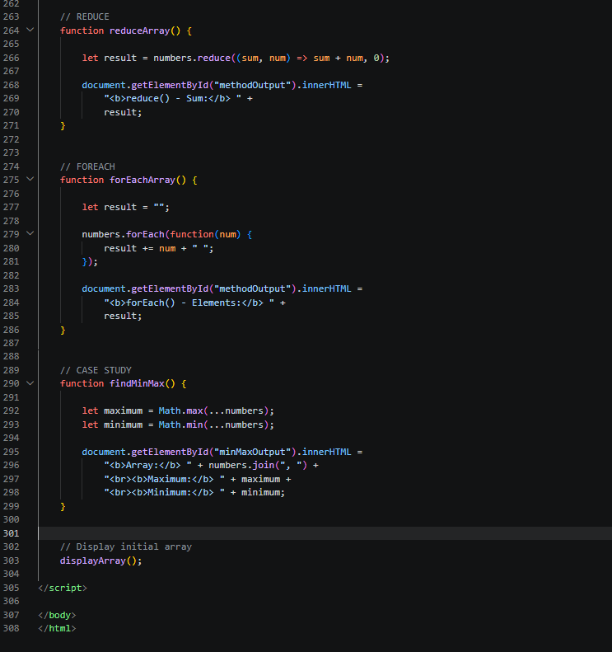
OUTPUT: 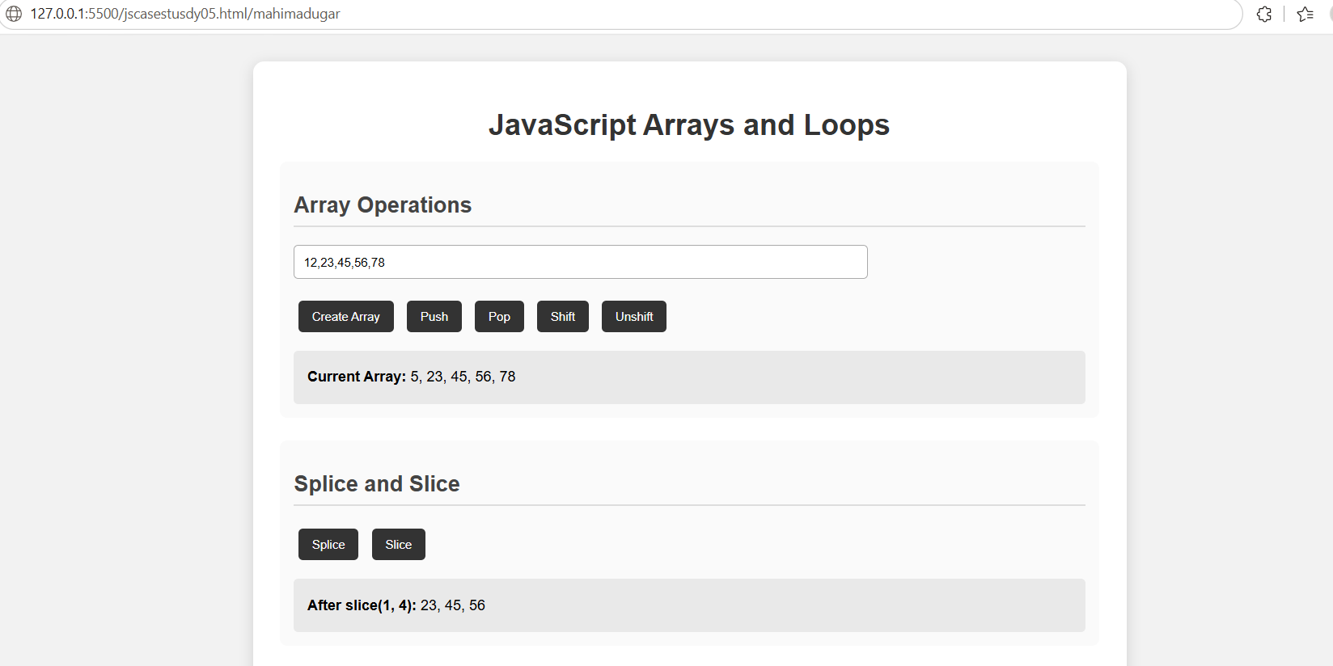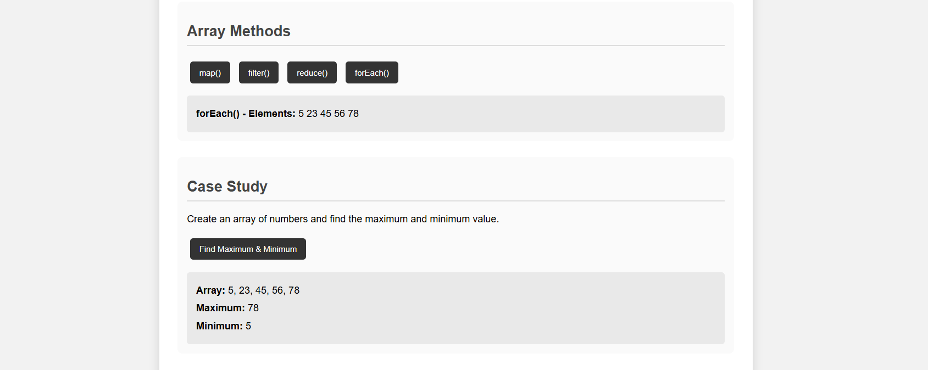

Result/Conclusion: The cart total calculator was successfully implemented using JavaScript arrays, objects, array methods, and conditional discount logic. The program calculates the total price, applies the appropriate discount, and displays the final amount to be paid.

