Title: Implement localStorage and sessionStorage to save user preferences like theme settings.
Software/Tools Required: Vscode
Theory: LocalStorage and SessionStorage are Web Storage APIs used to store data in the browser. localStorage keeps data even after the browser is closed, while sessionStorage stores data only for the current browser session. They store information in key-value pairs and can be used to save user preferences such as theme settings.
Key Features
• Stores data as key-value pairs.
• localStorage persists data until manually cleared.
• sessionStorage stores data only for the current session.
• Supports setItem(), getItem(), removeItem(), and clear().
• Useful for saving theme and user preferences.
Output:
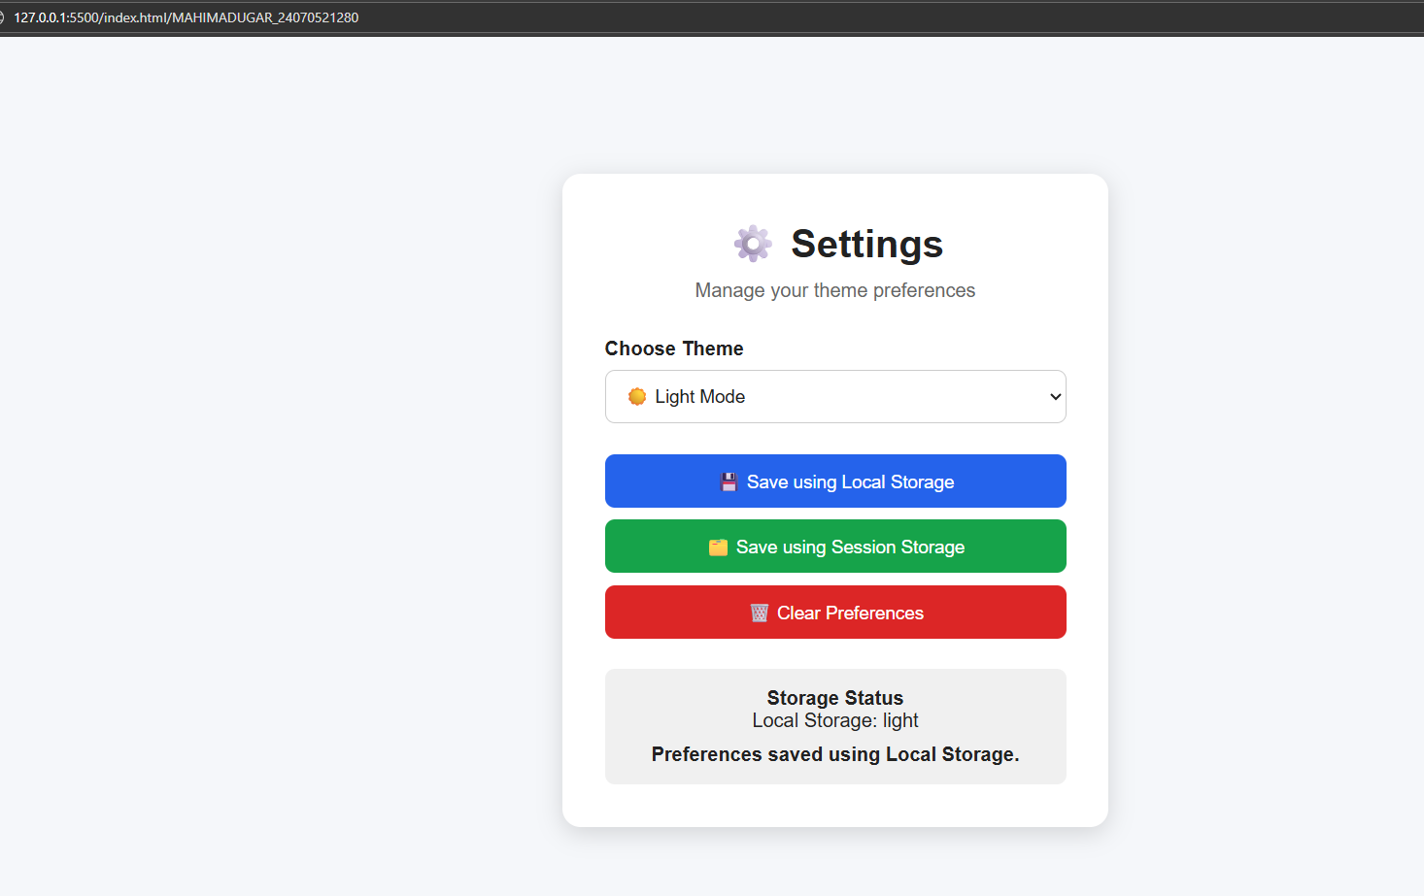
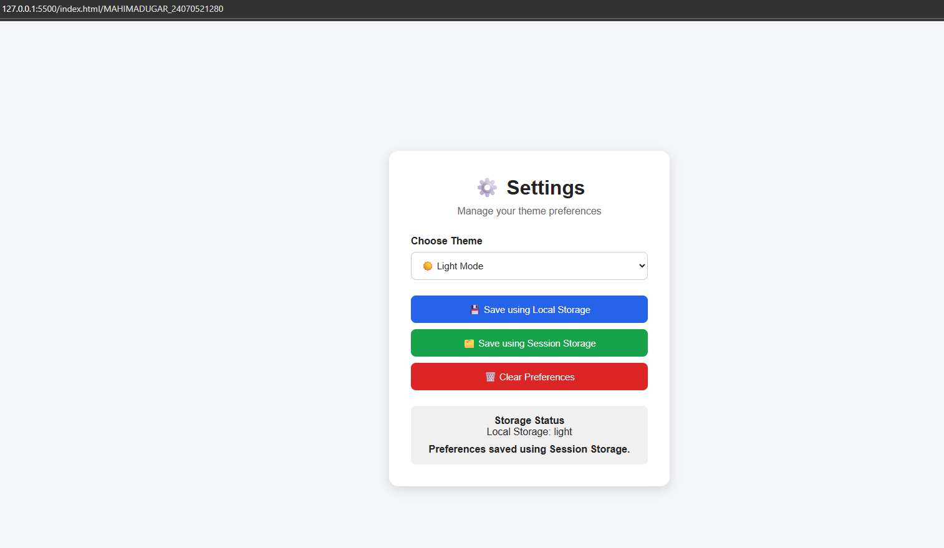
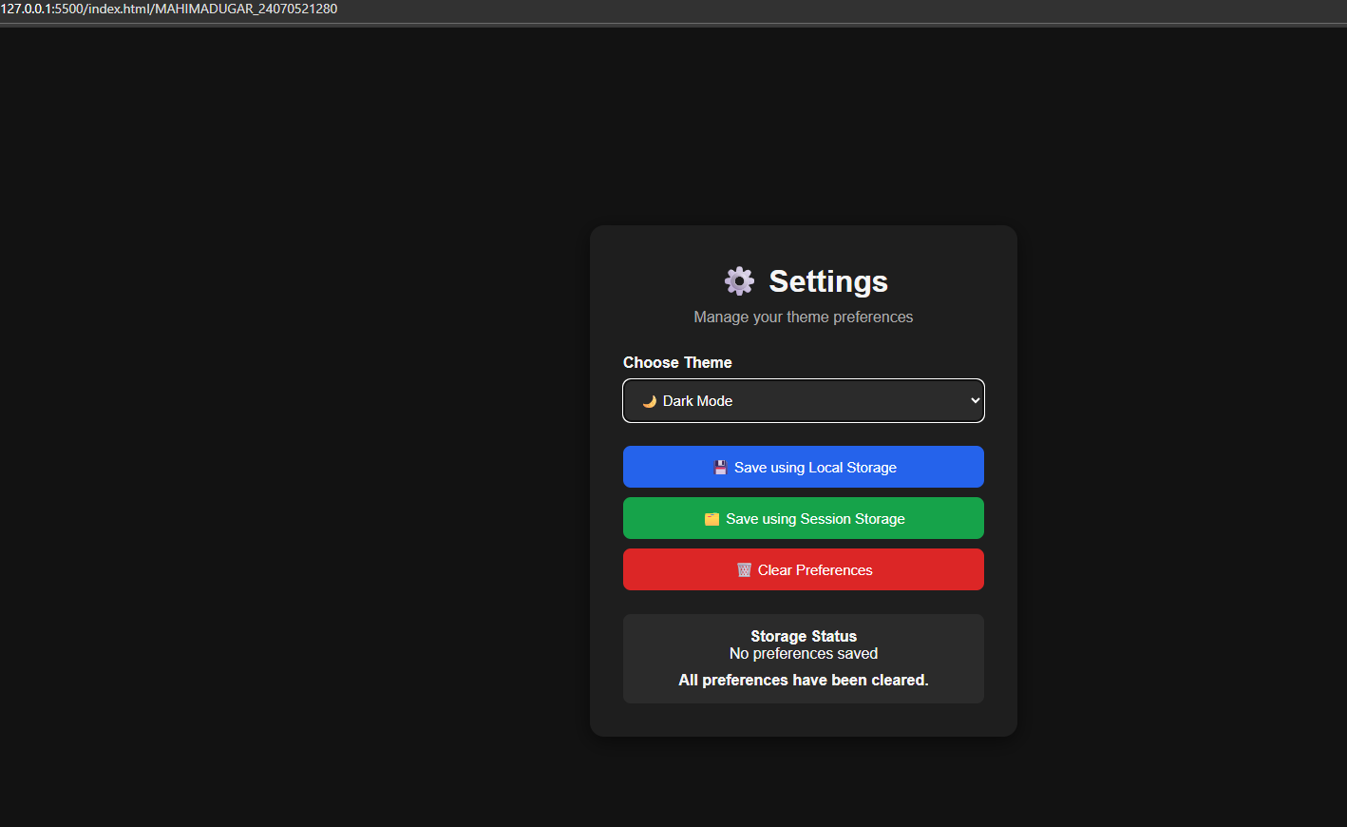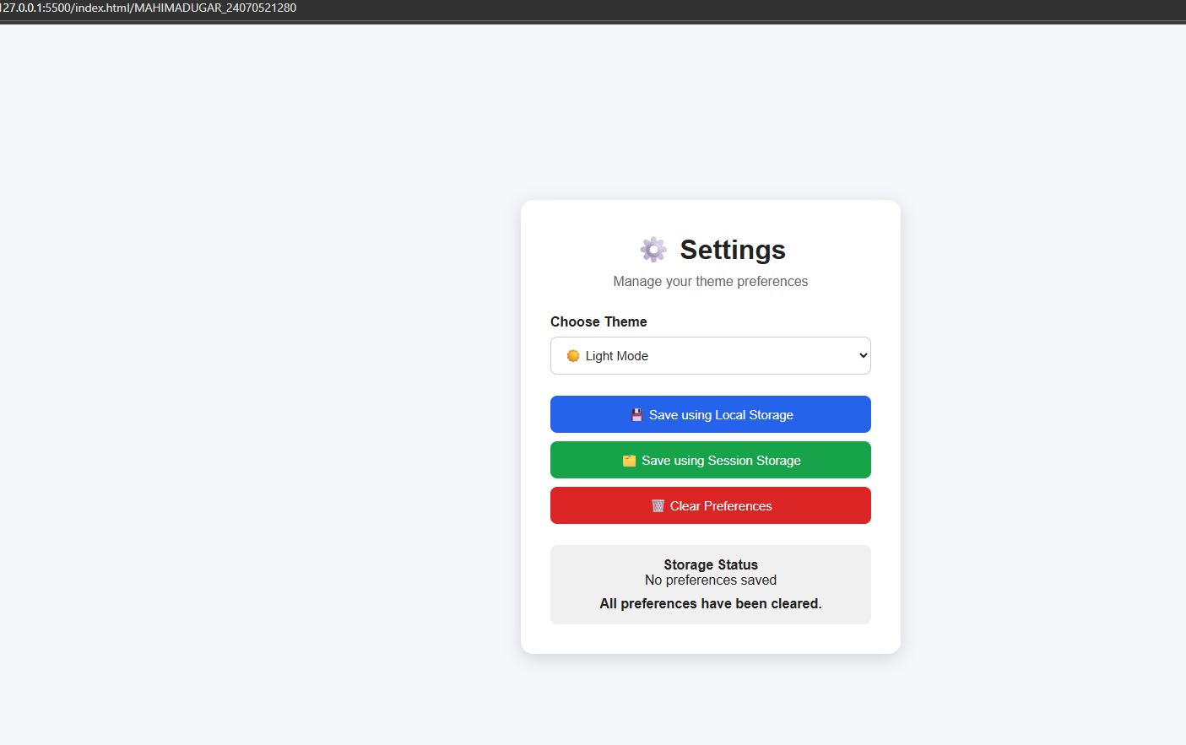

Result/Conclusion: The implementation successfully demonstrated the use of localStorage and sessionStorage for storing user preferences. The selected theme setting was saved and retrieved using browser storage. localStorage preserved the preference after reopening the browser, while sessionStorage maintained it only during the current session.

