PROJECT SYNOPSIS
StorySpill
Interactive Digital Bookshelf Library

1. Project Title
StorySpill — Interactive Digital Bookshelf Library

2. Introduction
StorySpill is a full-stack web application that presents a personal and community library as a visual, neon-colored virtual bookshelf. Users can register, upload books (cover image, intro video, and PDF), browse an interactive shelf, filter by genre with a fall-off animation, save books to a wishlist, and manage their profile. Administrators have separate authentication and full control over users and books.

3. Objectives
- To design an engaging bookshelf-style UI inspired by curated digital libraries.
- To support multi-user book upload with media (image, video, PDF).
- To implement real-time client-side genre filtering with visual animation.
- To provide secure authentication with strong password policy and role separation.
- To give administrators complete oversight (view profiles, edit/delete books and users).

4. Problem Statement
Traditional online reading lists are presented as flat grids or tables. Static “bookshelf” demos often lack real multi-user uploads, persistence, and administration. There is a need for a lightweight academic system that combines an attractive shelf metaphor with practical features: upload, search, filter, wishlist, and admin control.

5. Proposed System
StorySpill is a LAMP-style application (PHP, MySQL, Apache) with Bootstrap and vanilla JavaScript. All books are stored in MySQL; media files are stored on the server. The home page renders every book as a colored spine. Selecting a genre hides non-matching books with a CSS fall animation. Logged-in users can wishlist books; admins can open any user profile and manage content.

6. Features

6.1 User Module
- Sign up / Login / Logout with bcrypt password hashing
- Strong password policy (8+ chars, upper, lower, digit, special character)
- Upload book: title, author, genre, cover, intro video, PDF
- Edit / delete own books; change password
- Wishlist (Shelve It)

6.2 Shelf & Discovery
- Neon spines with abstract patterns
- Genre filter with fall-off animation
- Search by title, author, genre
- Surprise Me random picker
- Modal preview; hover cover to play intro video with sound

6.3 Admin Module
- Admin login / signup (company code: Mahi052005)
- Dashboard: total users, online users, total books
- Click user → full profile (books + wishlist)
- Edit / delete any book; delete any user (cascade)

7. Technology Stack
Layer | Technology
Front-end | HTML5, CSS3, Bootstrap 5, JavaScript
Back-end | PHP 8 (PDO, Sessions)
Database | MySQL / MariaDB (utf8mb4)
Server | Apache (XAMPP)

8. Database Design (ERD)
Four tables: users, admins, books, wishlist. Foreign keys use ON DELETE CASCADE. Admins are stored separately from users.
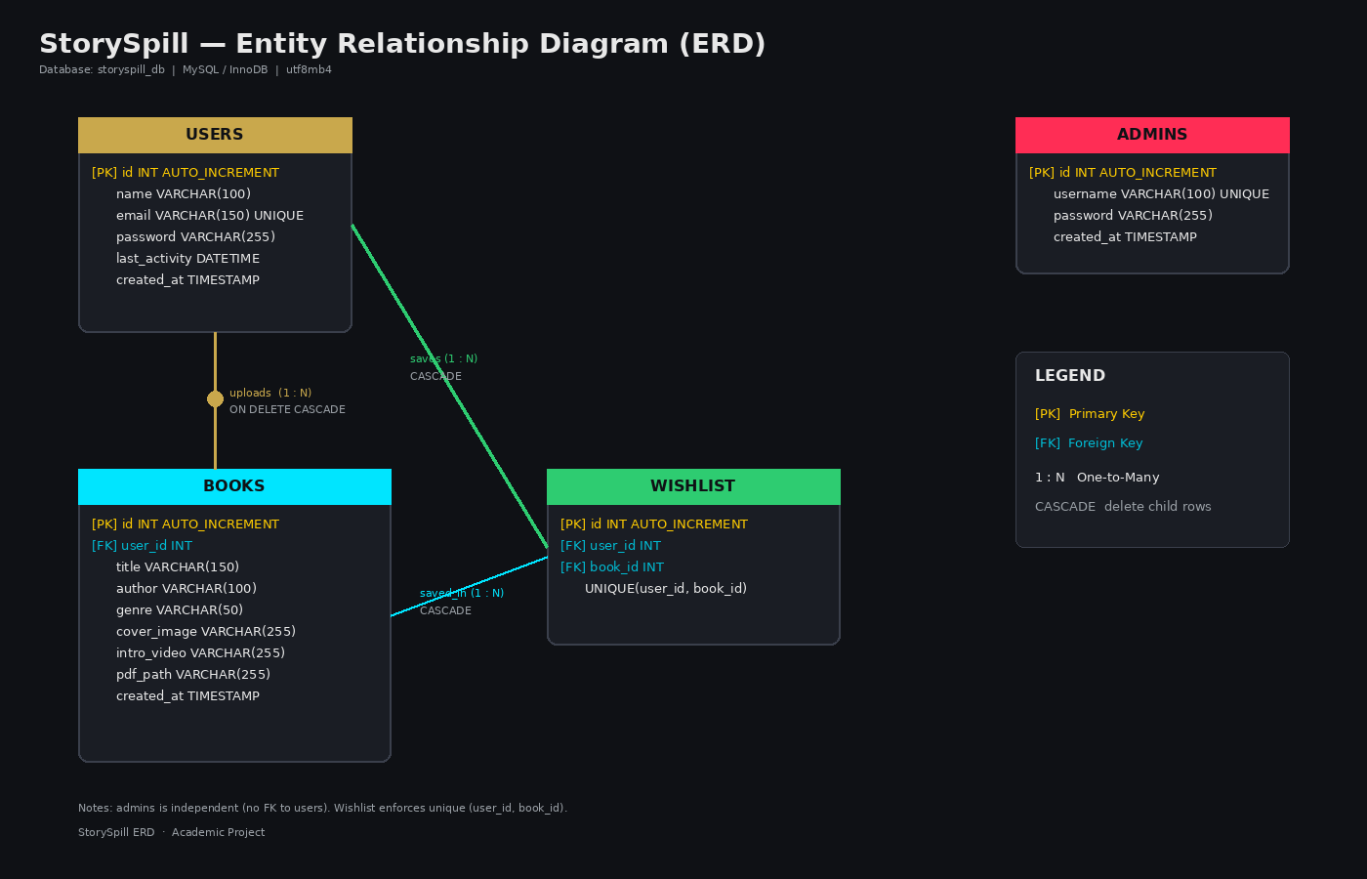
Figure: Entity Relationship Diagram of StorySpill

9. Software Requirements
- XAMPP / WAMP (Apache, MySQL, PHP 8+)
- Web browser (Chrome, Edge, Firefox)
- Optional: phpMyAdmin or MySQL Workbench

10. Scope & Limitations
The system is designed for local academic demonstration. Media is stored on the local filesystem. Future enhancements may include cloud storage, recommendations, and social features (comments, shared lists).

11. Conclusion
StorySpill successfully merges a visually distinctive bookshelf interface with a complete multi-user backend and admin control panel. It demonstrates skills in UI design, client-side interaction, secure PHP development, and relational database design.

12. Project Team / Details
Project Name: StorySpill
Type: Full-Stack Web Application
Database: storyspill_db (or storyspill_db1 as configured)
Default Admin: mahima / mahi | Company Code: Mahi052005

