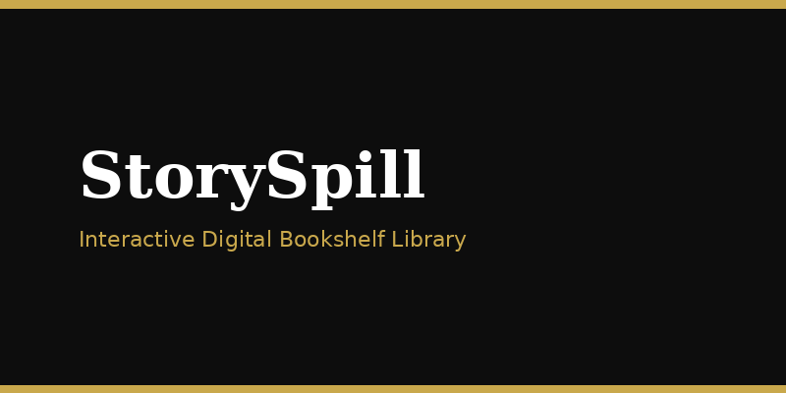
PROJECT REPORT
StorySpill — Interactive Digital Bookshelf

1. Abstract
StorySpill is a PHP/MySQL bookshelf web application with neon spine UI, multi-user uploads, wishlist, star reviews, content reports, and an admin moderation panel. The data model uses seven tables. Review and Report actions are available on the book modal and persist through dedicated API endpoints.

2. Introduction
Digital libraries are often plain lists. StorySpill uses a spatial bookshelf metaphor and adds practical features: media upload, genre filtering with animation, wishlist, reviews, and reports.

3. System Design

3.1 Architecture
Browser (HTML/CSS/JS) → PHP application (sessions, PDO, file uploads) → MySQL + uploads filesystem.

3.2 Database (7 tables)
Table | Role
users / admins | Authentication roles
genres | Master list for dropdowns
books | Content + media paths
wishlist | User saved books
reviews | Ratings and text
reports | Moderation workflow
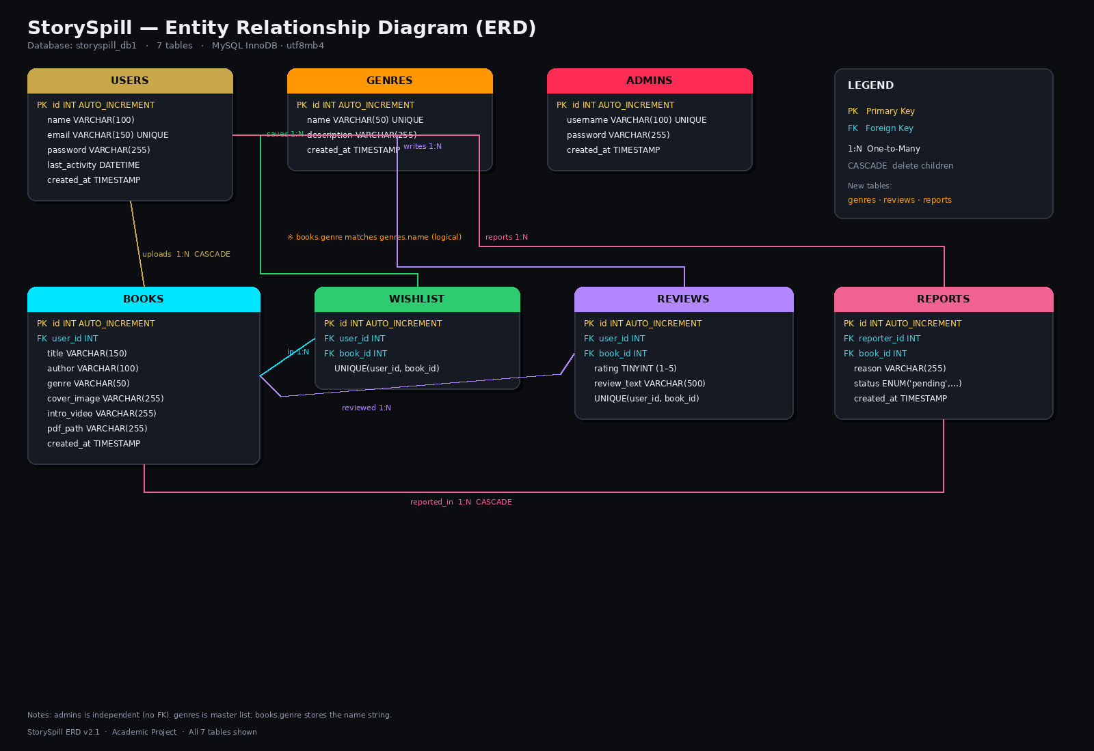

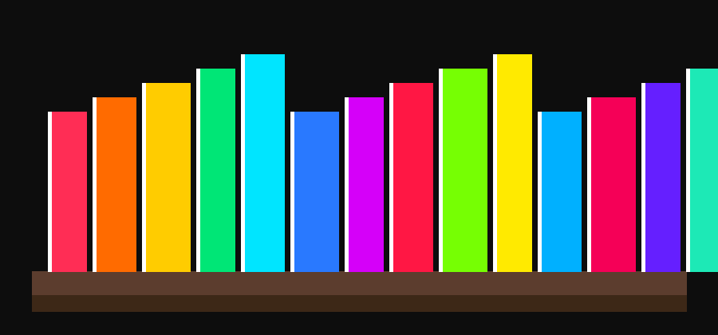
Figure 1: Bookshelf UI concept with neon spines

7. Testing

7.1 Test Cases (Summary)
ID | Scenario | Expected
T1 | User signup + login | Session created; profile accessible
T2 | Upload book with media | Appears on shelf; modal shows cover
T3 | Select genre filter | Others fall off; count updates
T4 | Hover cover in modal | Video plays with sound
T5 | Admin wrong company code | Signup rejected
T6 | Admin delete user | User + books removed

7.2 Results
Core flows were verified on local XAMPP with seeded data (12 users, sample books, admin mahima). UI animations and media hover behaved as designed in Chromium-based browsers.

8. Screenshots / Visuals
index.page
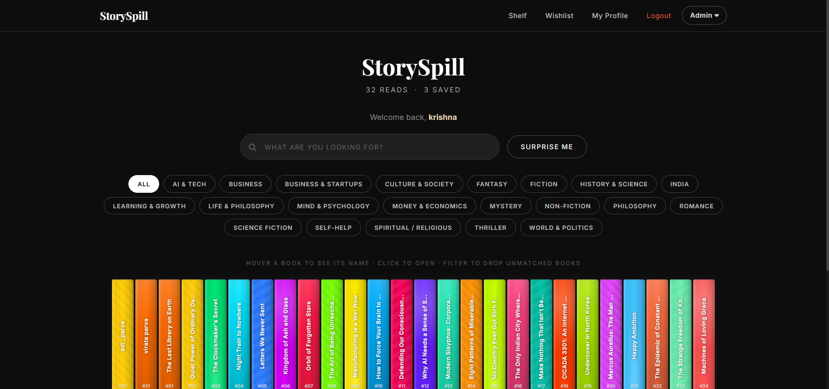
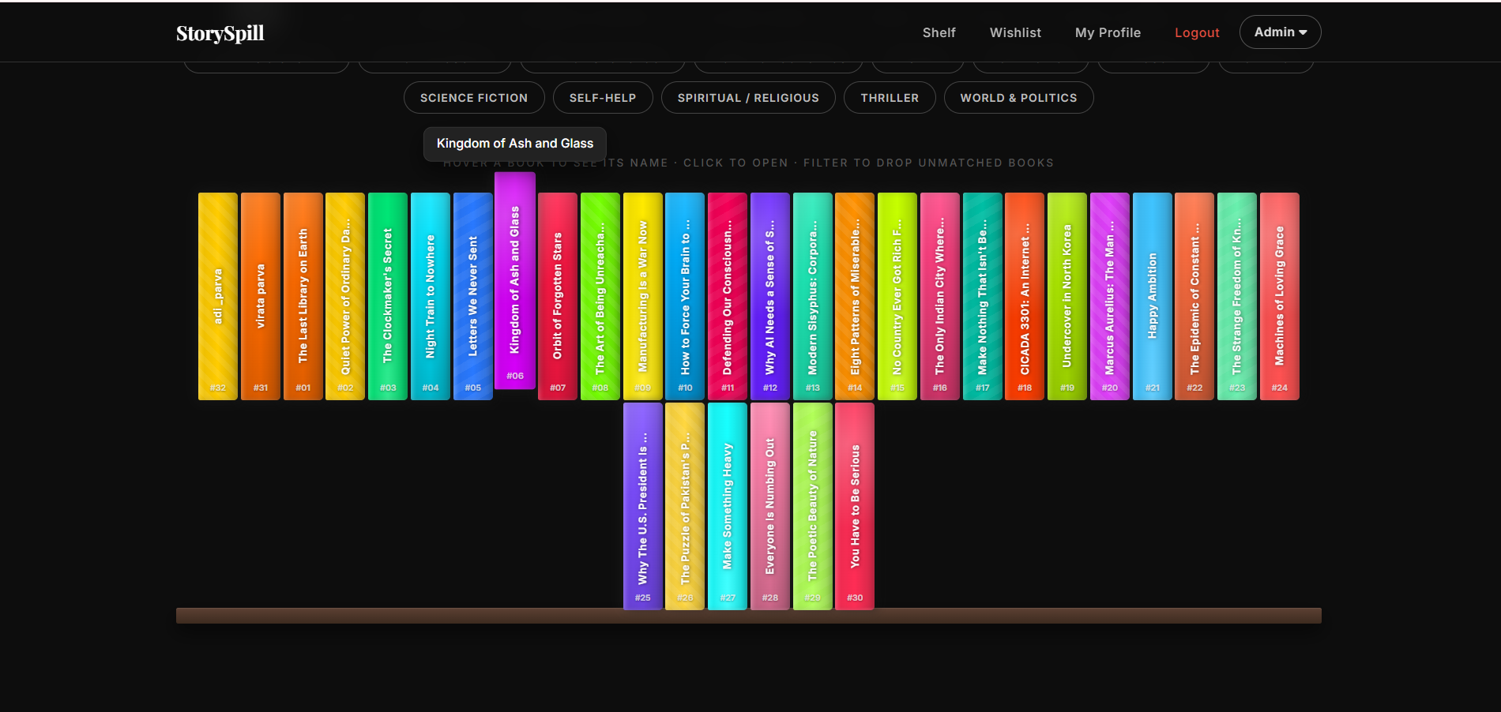
signup page

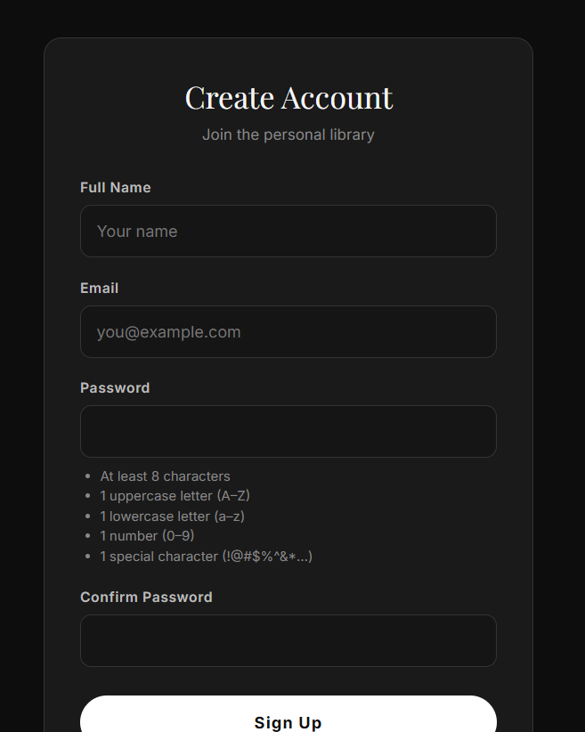
myprofile page
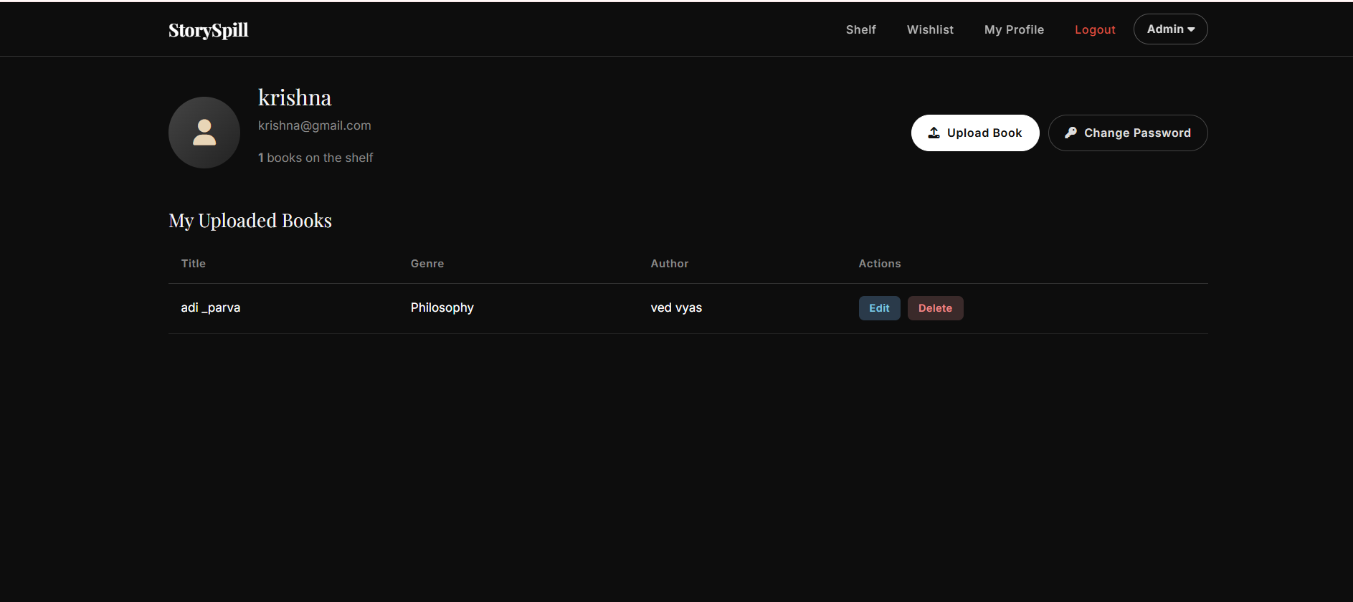
wishlist page
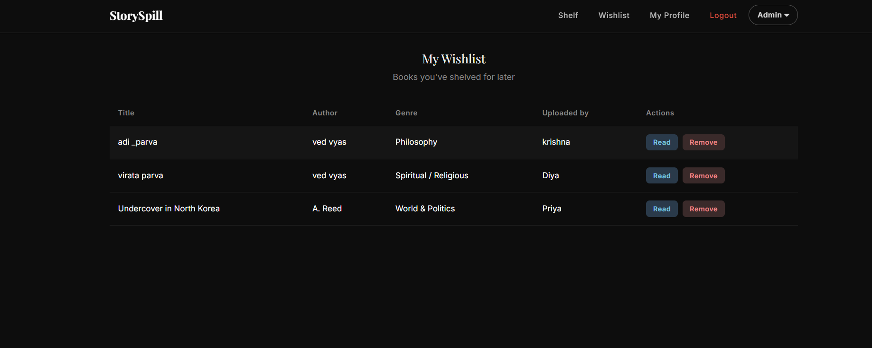
edit book
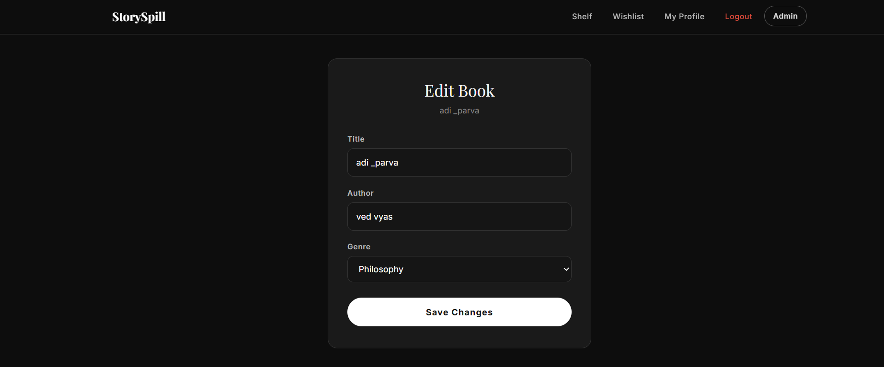
password change page
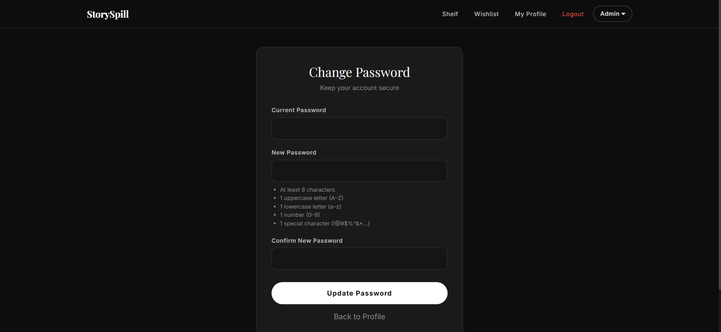
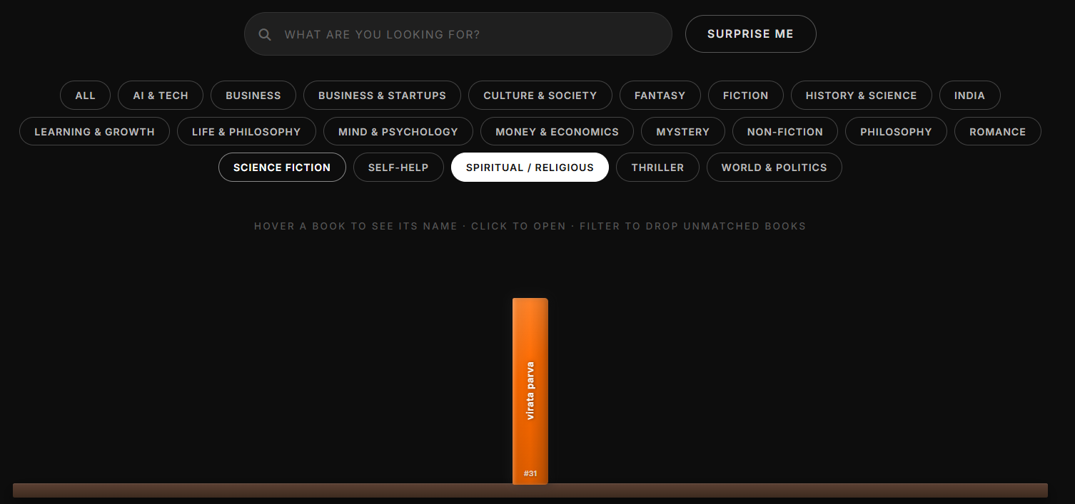
login page
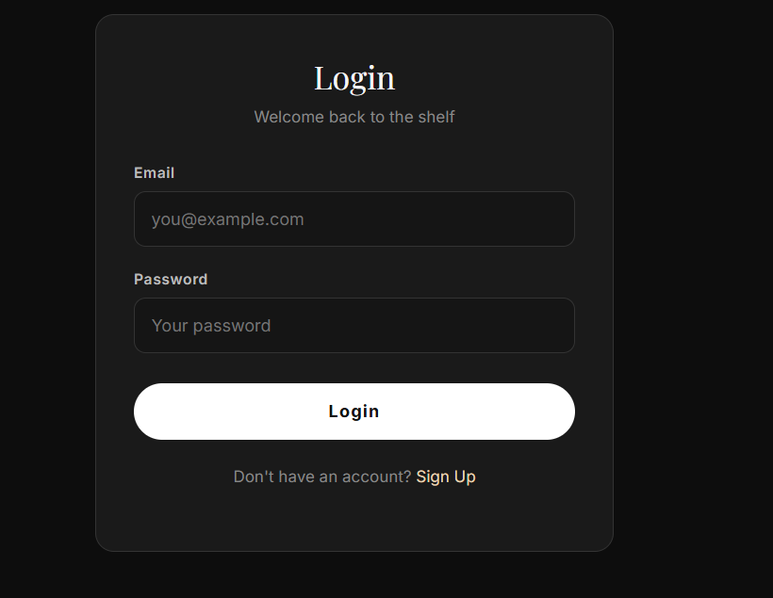
book description:
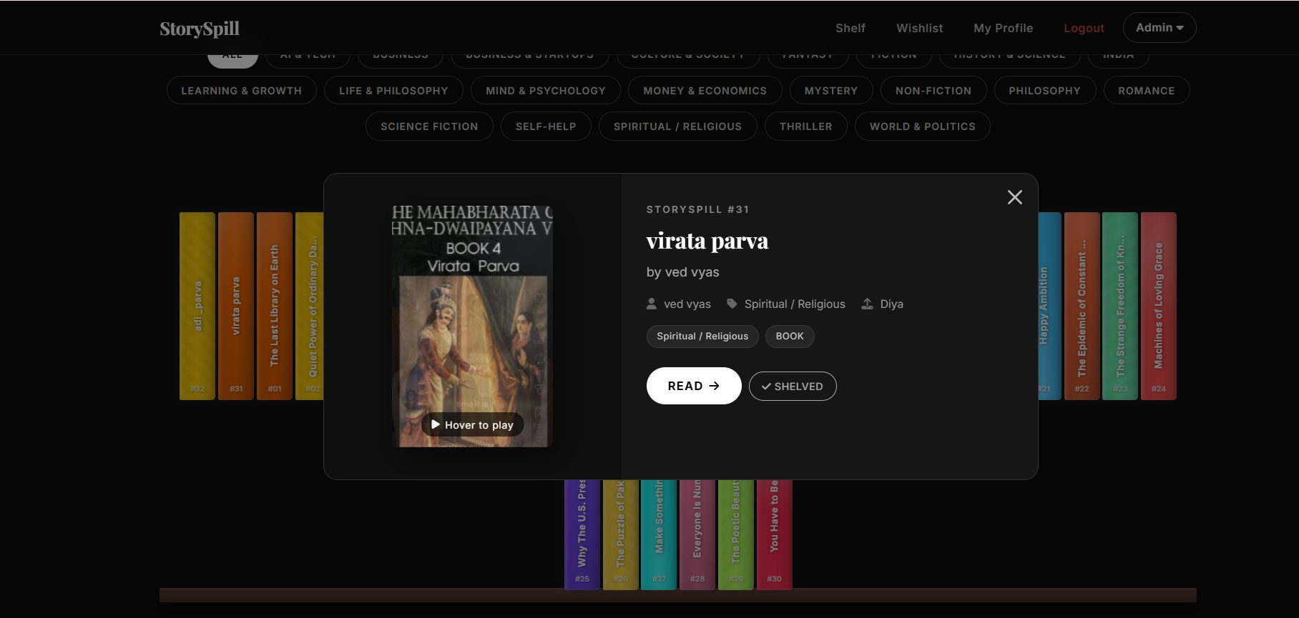
admin page
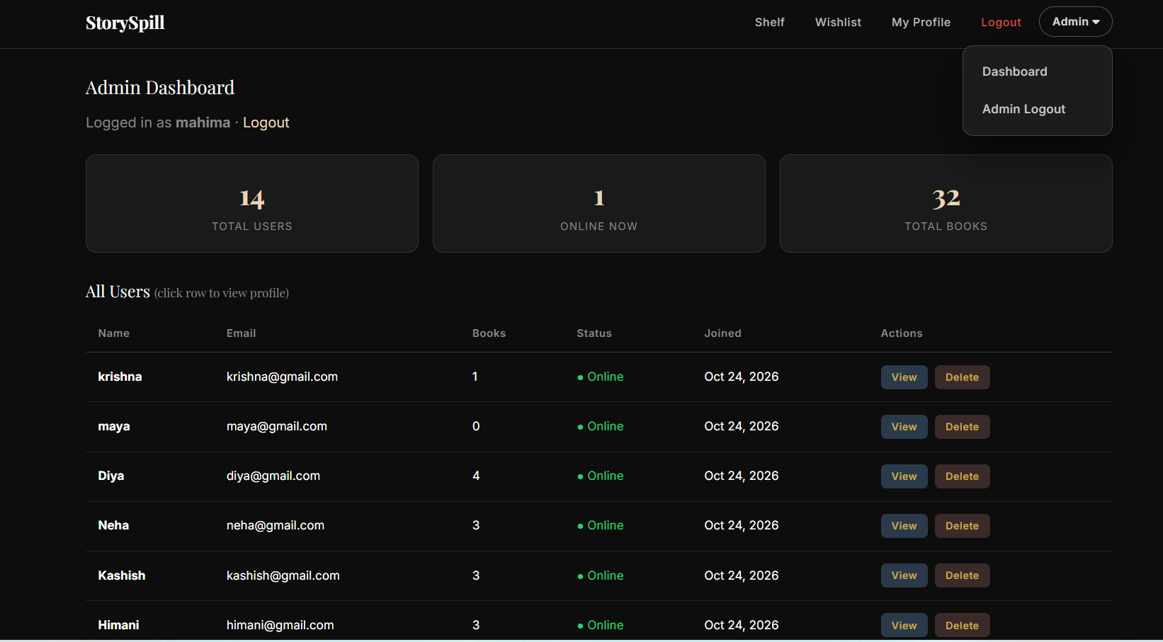
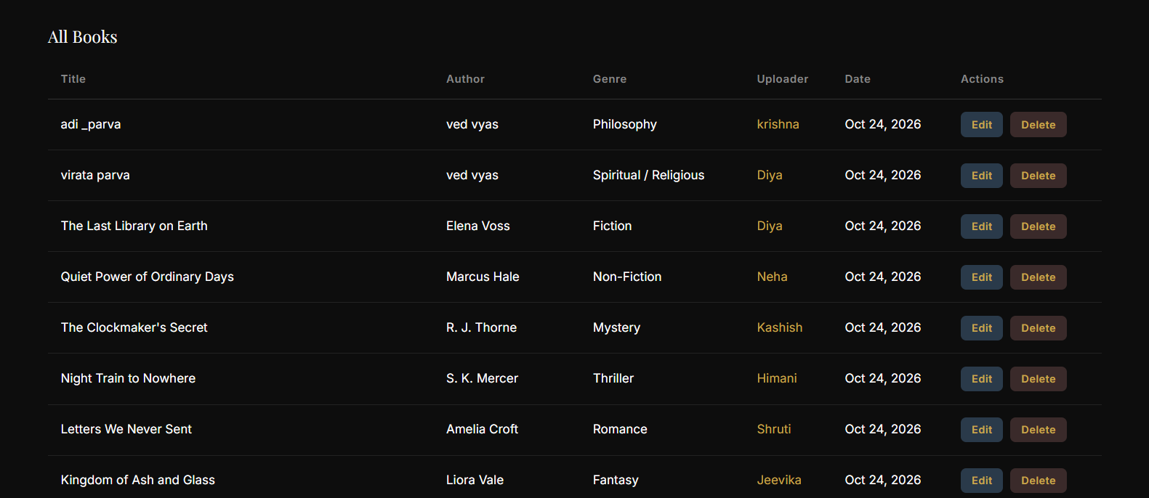
admin login page:
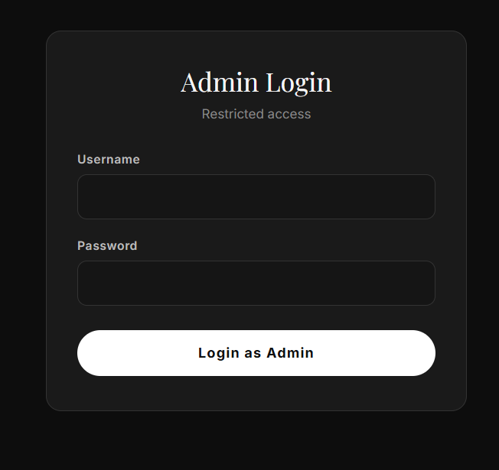
admin signup page:
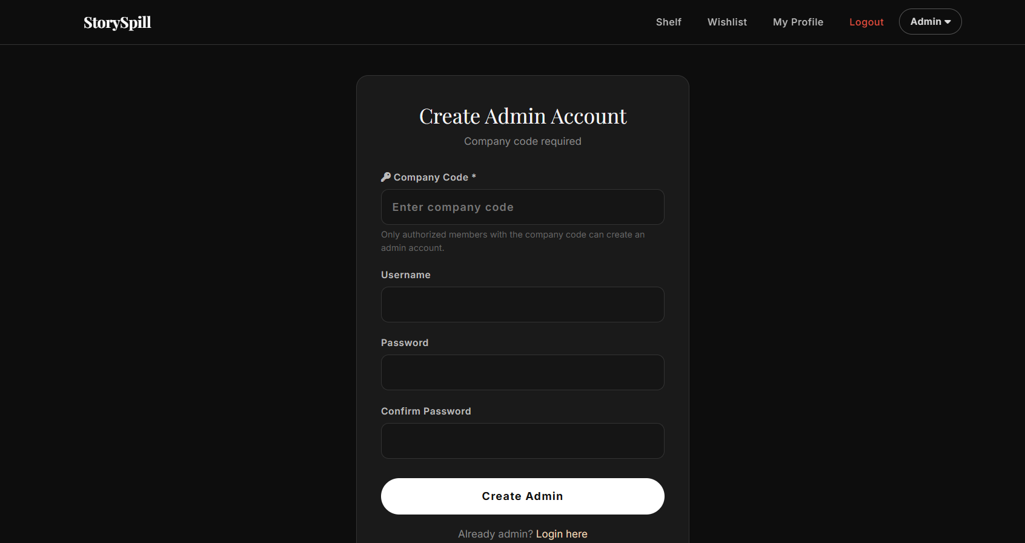
database
tables:
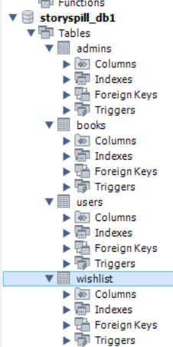
admin table:
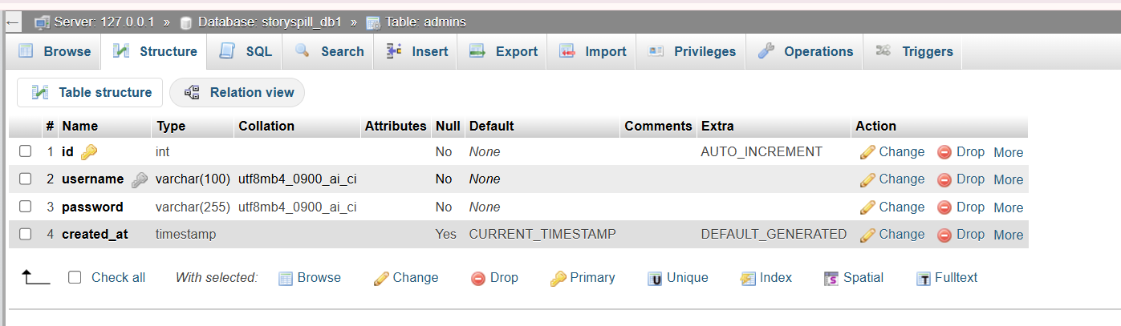
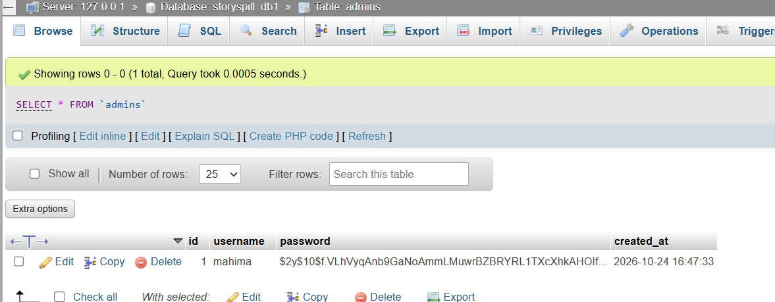
book table:
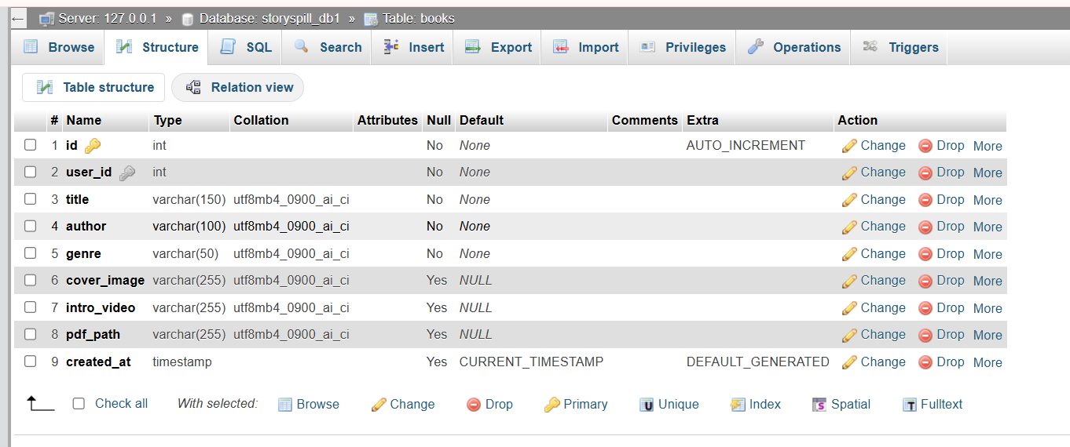
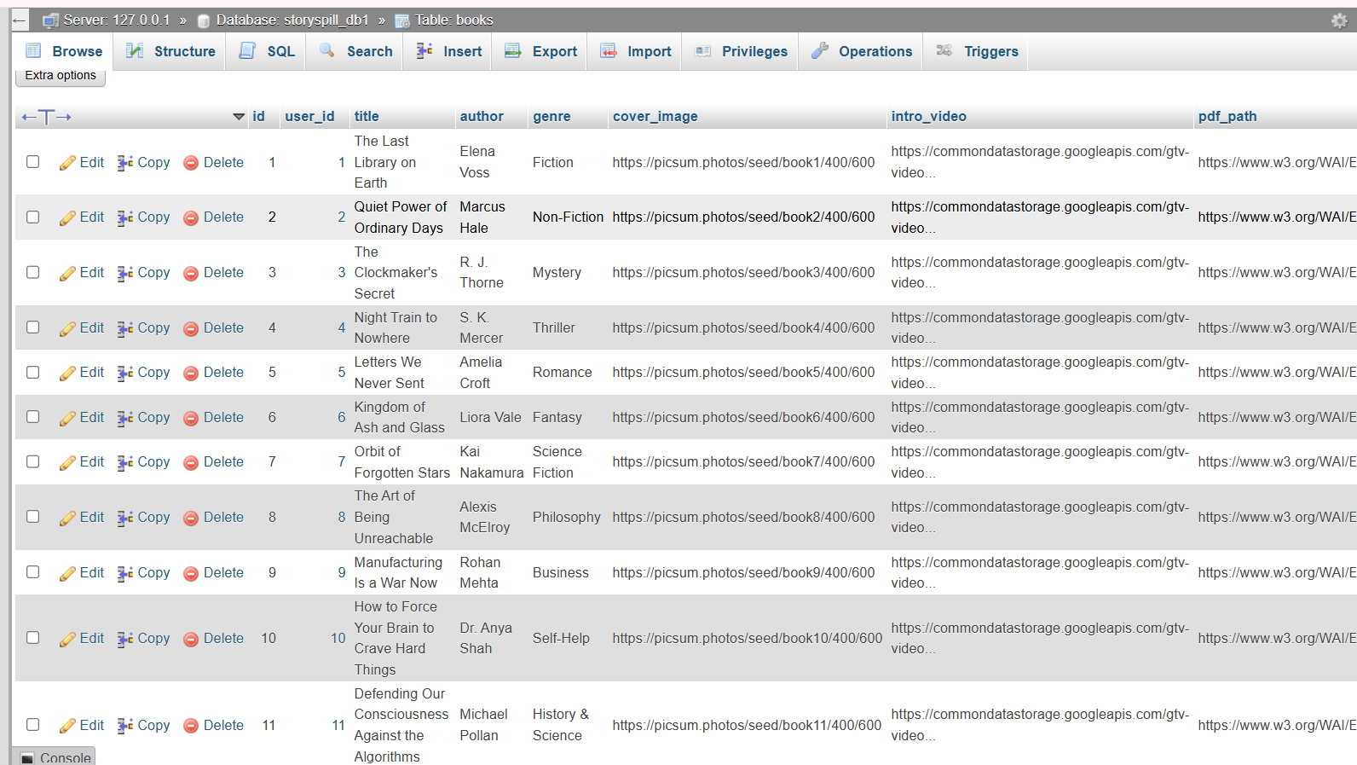
user table:
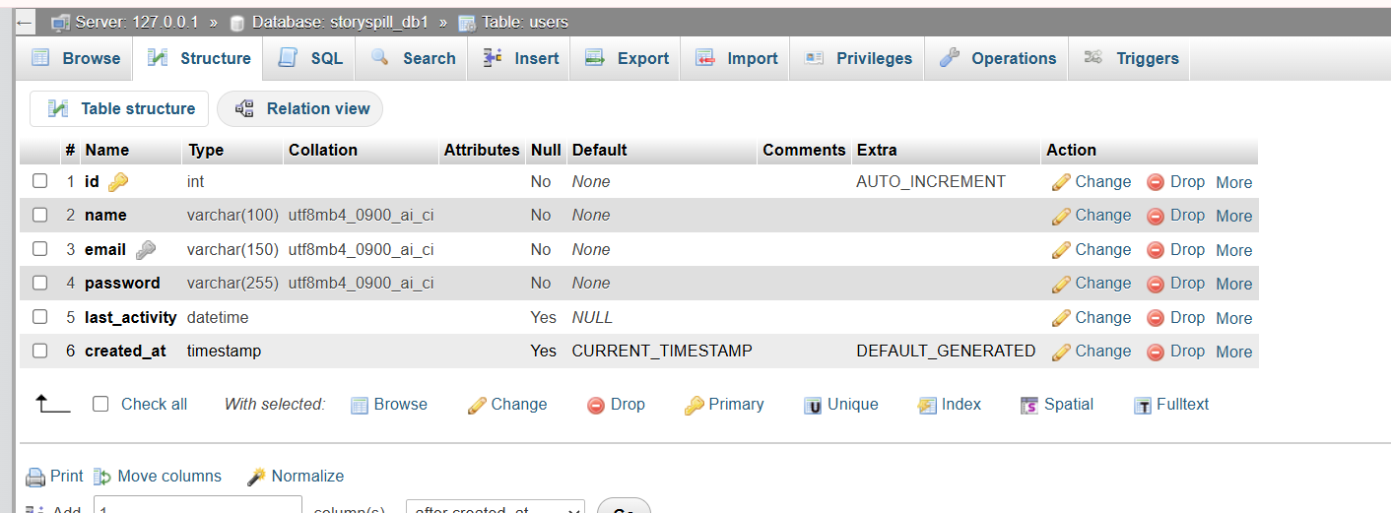
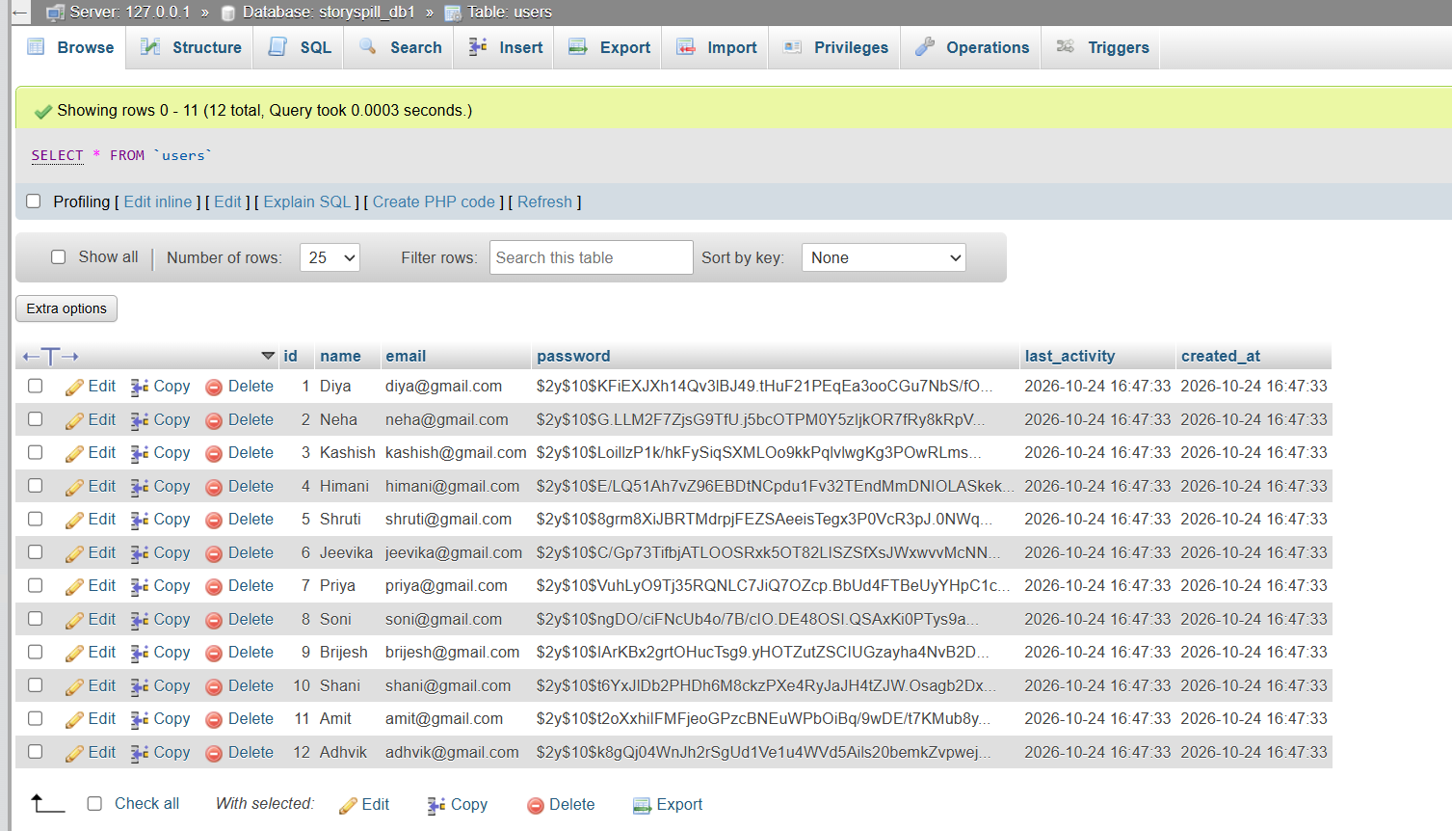
wishlist:
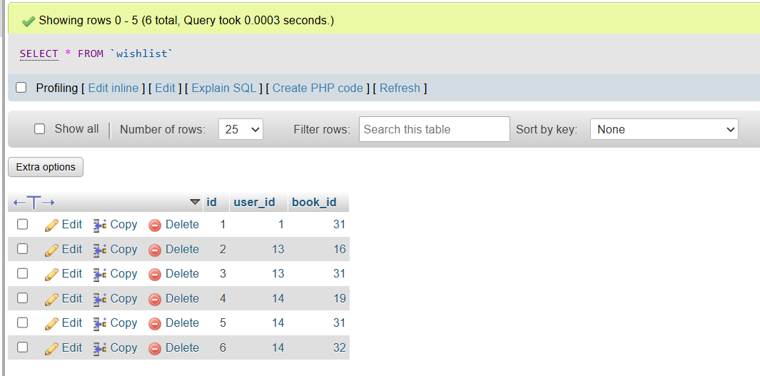
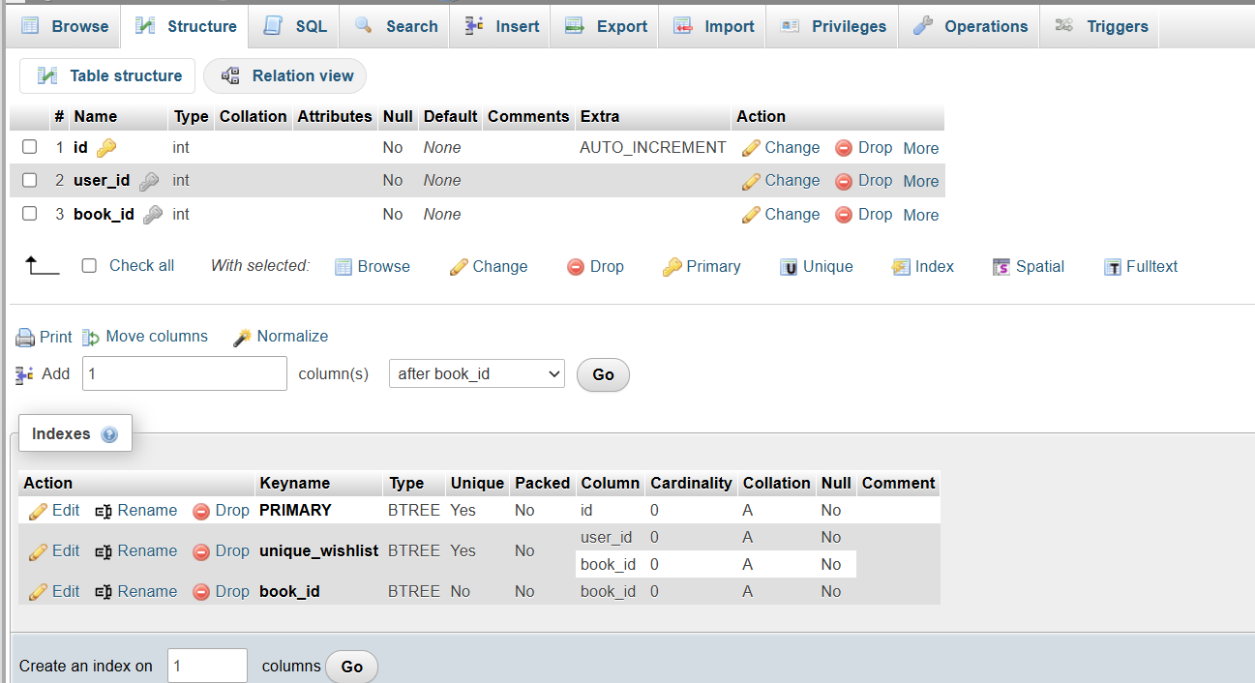

Figure 2: Example book cover uploaded by a user
Additional screens include the home shelf, login/signup forms, upload form, My Profile, wishlist, admin dashboard, and admin user profile. These can be captured from the running application at http://localhost/storyspill03/.

9. Conclusion
StorySpill successfully combines an engaging bookshelf metaphor with a practical multi-user backend. The project demonstrates full-stack skills: UI/UX design, client-side interaction design, secure PHP development, relational modeling, and role-based administration. Future work could include cloud media storage, recommendations, and social features such as comments or reading lists shared between users.

10. References
1. PHP Manual — password_hash, PDO.
2. Bootstrap 5 Documentation.
3. MySQL 8 Reference Manual — Foreign Keys & Cascades.
4. MDN Web Docs — HTMLMediaElement (video play/pause).

