REQUIREMENTS SPECIFICATION
StorySpill v1.2 — Bookshelf, Reviews & Reports

1. Purpose
Specify functional and non-functional requirements for StorySpill, including genres master data, user reviews, content reports, and the UI that writes to those tables.

2. User Classes
- Guest — browse shelf, open modals (no review/report/upload)
- Registered User — upload, wishlist, review, report, change password
- Admin — dashboard stats, user profiles, book CRUD, reports moderation

3. Functional Requirements

3.1 Authentication
- Strong password on signup / admin signup / change password
- Admin signup requires company code Mahi052005

3.2 Bookshelf
- Neon spines, genre filter fall animation, search, Surprise Me, video hover with audio

3.3 Reviews
- Book modal shall show average rating and existing reviews
- Logged-in users shall submit rating 1–5 and optional text via Review button
- System shall store one review per user per book (upsert)

3.4 Reports
- Logged-in users shall report a book with a free-text reason
- Reports shall start as pending; admin can set reviewed or resolved

3.5 Genres
- System shall maintain genres table; upload dropdown shall load from it

3.6 Admin
- Dashboard shall show counts including reviews and pending reports
- admin_reports.php shall list reports with moderation actions

4. Non-Functional
Security: bcrypt, PDO prepared statements, session auth. Performance: client-side genre filter. Compatibility: PHP 8, MySQL, modern browsers.

5. Data Requirements
Table | Purpose
genres | Master genre names (20 seeded)
reviews | user_id, book_id, rating, review_text
reports | reporter_id, book_id, reason, status
users/admins/books/wishlist | Core membership and content tables
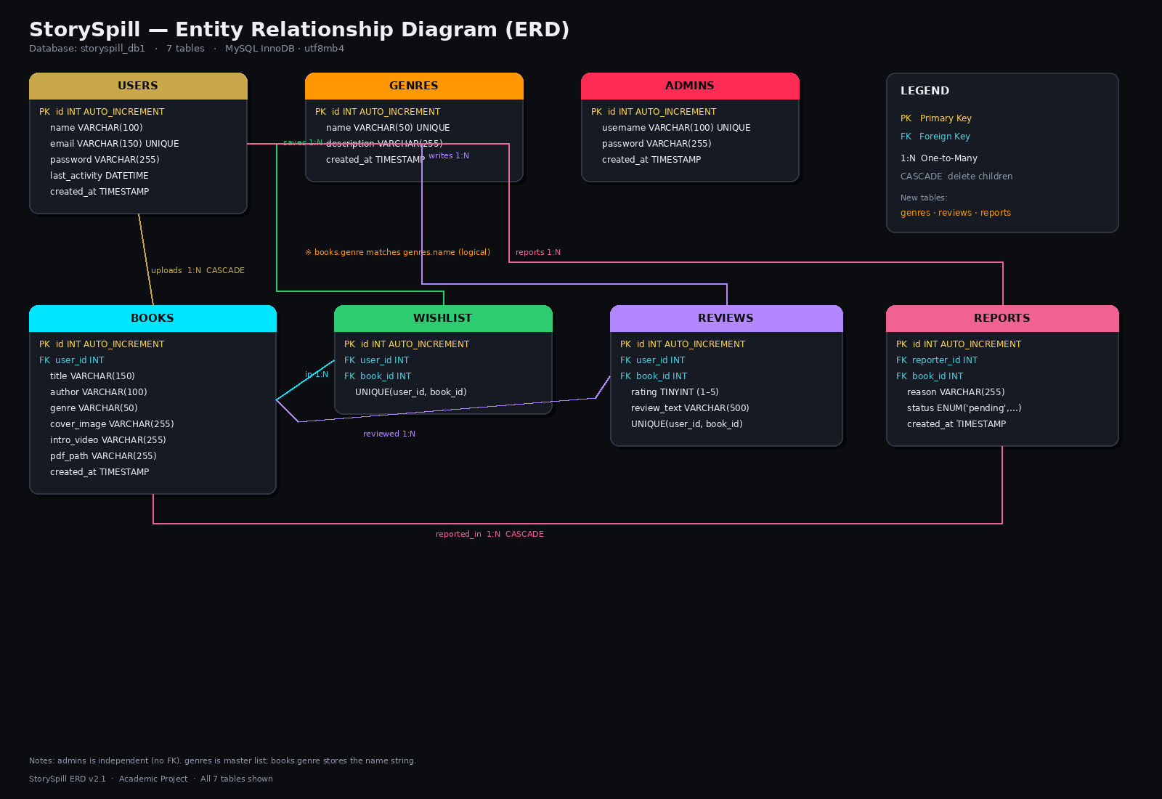

6. Acceptance Criteria
- After seed: 20 genres, sample reviews, sample reports visible in phpMyAdmin
- Logged-in user can Review and Report from book modal; rows appear in DB
- Admin can open admin_reports.php and change report status
- Upload folders covers/videos/pdfs exist or upload fails gracefully

