FULL STACK DEVELOPMENT WITH MERN PROJECT DOCUMENTATION

**1. Introduction**

Project Title : Flight finder -Navigating your Air Travel Option

Team id : LTVIP2025TMID59024

Team Members:

1. **Team Leader:**

Akkisetty Mahima Jyothi– Full Stack Developer & Project Coordinator  
Responsible for overall planning, coordination, GitHub management, and integration of frontend and backend.

1. **Team Member**:

Maavuri Santhosh Kumar – Frontend Developer  
Works on the React-based UI, handles component design, page routing, and user interactions.

1. **Team Member**:

M.Gowtham Durga Pravin – Backend Developer  
Builds RESTful APIs using Node.js and Express.js, manages authentication and server logic.

1. **Team Member:**

M.Durga Charan– Database Administrator  
Designs and manages MongoDB schemas, handles CRUD operations and ensures data consistency.

**2. Project Overview**

* **Purpose:**  
  To simplify flight booking and management by providing users with real-time availability, secure bookings, and user-friendly search features.
* **Features:**
  + Search and filter flights
  + Book tickets with user login
  + Admin panel for managing flights
  + Email confirmation and booking history

**3. Architecture**

* **Frontend:**  
  Built with React.js using components, hooks, and React Router for navigation. UI powered by Material-UI.
* **Backend:**  
  Developed using Node.js and Express.js. RESTful API handles all CRUD operations related to users, flights, and bookings.
* **Database:**  
  MongoDB stores user data, flight details, and booking records. Mongoose is used for schema design and data validation.
* **Frontend (React.js)**

**Components**:

* + SearchForm.js: Handles user inputs (source, destination, dates).
  + FlightList.js: Displays ranked results from ML model.

**State Management**: Redux for shared state (user sessions, bookings).

* **Backend (Node.js/Express.js)**

**API Routes**:

javascript

app .get ('/api/flights', flightController .search);

app.post('/api/bookings', authMiddleware , bookingController.create);

* **Middleware**: JWT validation, rate limiting.

**Database (MongoDB)**

**Schemas**:

javascript

const User = new Schema({

email: { type: String, unique: true },

bookings: [{ type: Schema.Types.ObjectId, ref: 'Booking' }]

});

**4. Setup Instructions**

**Prerequisites:**

* Node.js >= 18
* MongoDB installed and running
* npm or yarn

**Installation:**

* + git clone https://github.com/your-username/FlightFinder.git
  + cd FlightFinder
  + cd server
  + npm install
  + cd ../client
  + npm install

**Environment Variables:**  
Create a .env file in the /server folder with:

PORT=3000

MONGODB URI-mongodb+srv://nehapriya:<db_password>@cluster0.zghkpqk.mongodb.net/?retryWrites=true&w=majority&appName=Cluster0

**5. Folder Structure**

* **Client:**

/client

├── /src

│ ├── /components

│ ├── /pages

│ ├── /api

│ ├── App.js

│ └── index.js

* Server:

/server

├── /controllers

├── /routes

├── /models

├── server.js

└── .env

**5.Running the Application**

**Frontend:**

* cd client
* npm start

**Backend:**

* cd server
* npm start

**7. API Documentation**

* **POST /api/auth/register**  
  Registers a new user.  
  Request Body: { name, email, password }  
  Response: { success, token }
* **POST /api/auth/login**  
  Logs in an existing user.
* **GET /api/flights**  
  Retrieves list of available flights.
* **POST /api/bookings**  
  Books a flight for the logged-in user.

**8. Authentication**

* Implemented using JWT (JSON Web Token).
* Tokens are stored in HTTP-only cookies.
* Protected routes validate tokens before granting access.

**9. User Interface**

Home Page with flight search

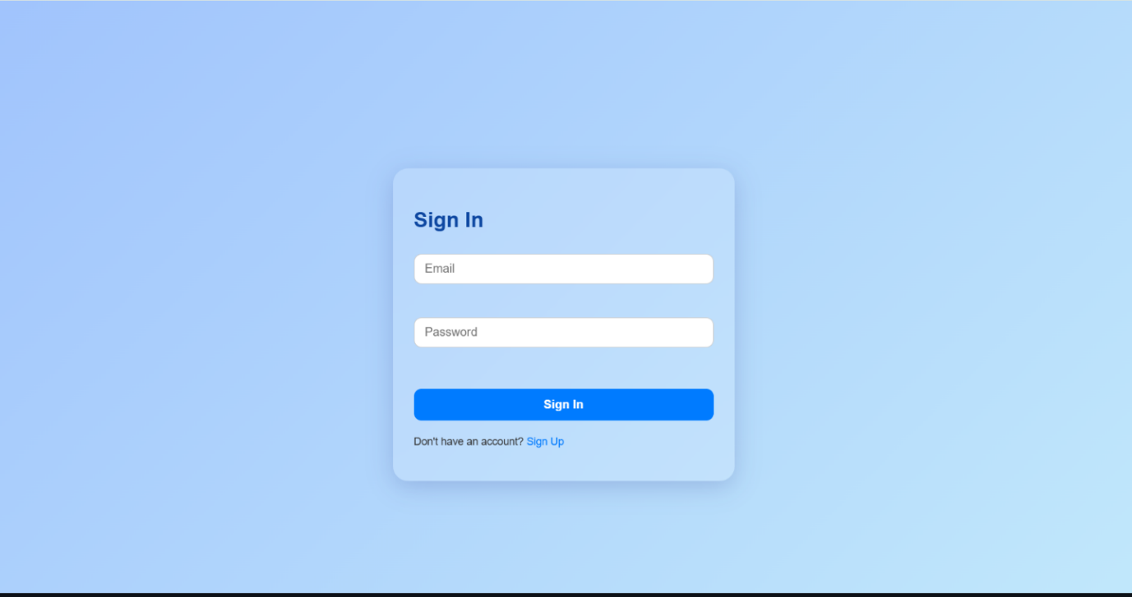

Login form

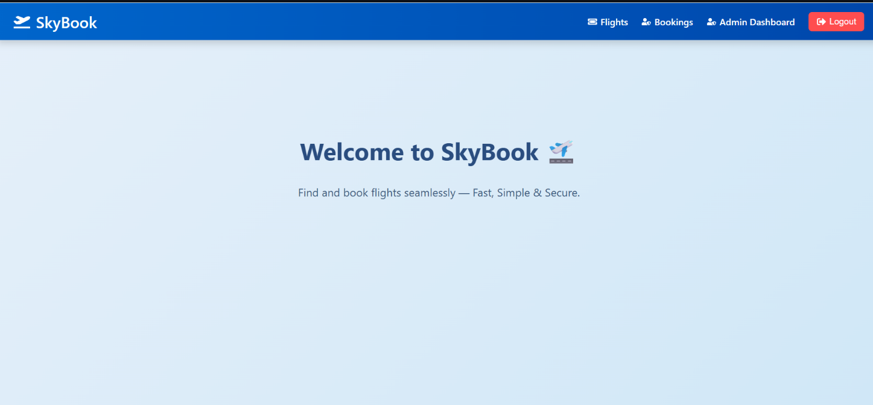

Register form

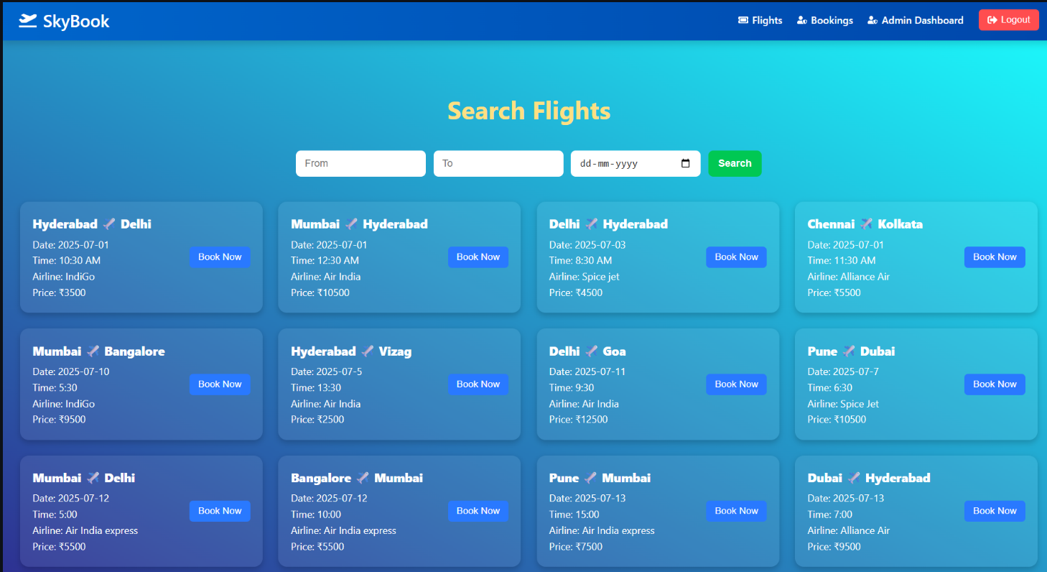

Admin dashboard

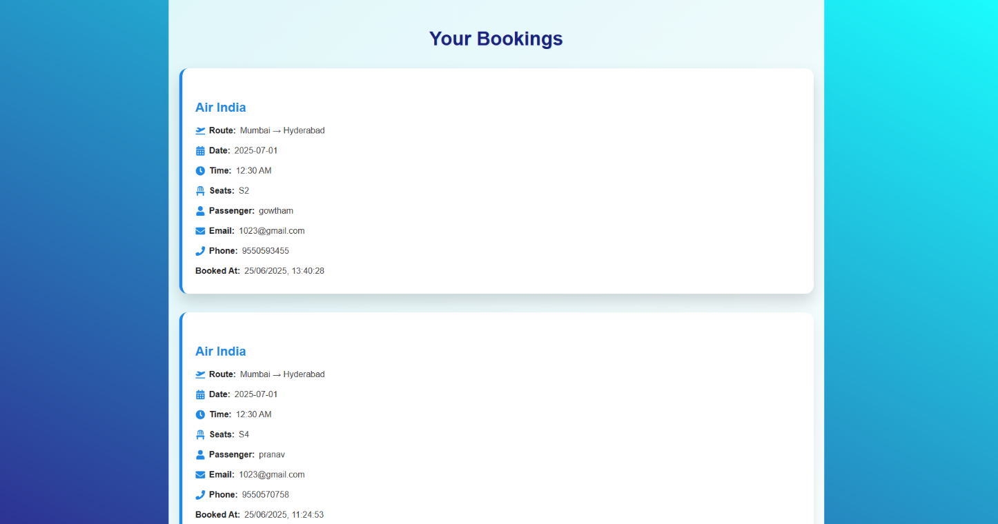

Booking confirmation page

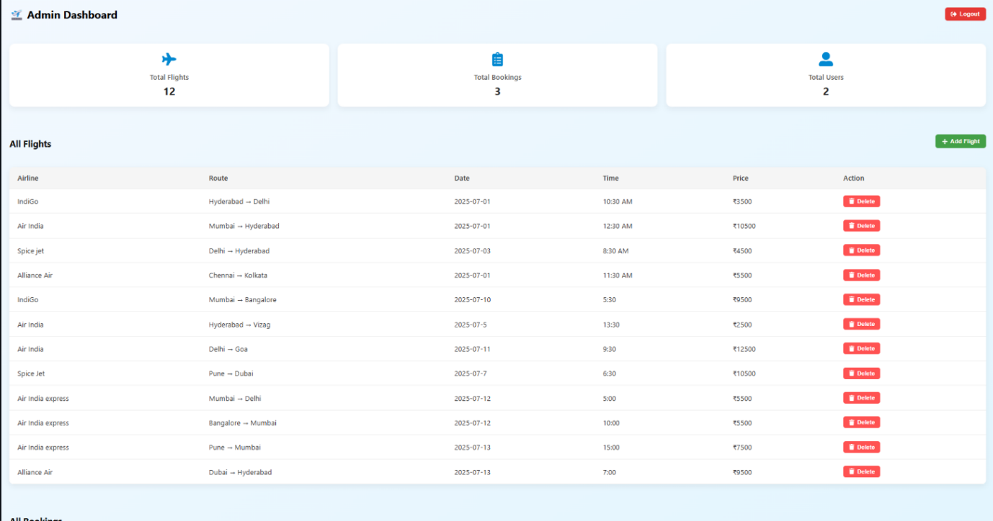

**10. Testing**

* Manual testing on Postman for backend APIs
* Basic component tests in React using Jest and React Testing Library

**11.Demo**

**Link:**

<https://drive.google.com/drive/folders/1tDHDBNsxkE-i61M5vhmxxlKQHX_q9JKW?usp=drive_link>

**12. Known Issues**

* No password recovery implemented yet
* UI responsiveness needs improvement on tablets

**13. Future Enhancements**

* Payment integration with Razorpay/Stripe
* Role-based admin access
* Real-time flight tracking integration