Project Development Phase
Model Performance Test

Date | 21 February 2025
Team ID | LTVIP2025TMID21049
Project Name | Project -Flight finder-navigating your air travel options
Maximum Marks

Model Performance Testing:
Project team shall fill the following information in model performance testing template.
S.No. | Parameter | Values |  | Screenshot
1. | Model Summary | Salesforce automation setup for Data management using Object, Fields and Reports.  Note : Import Records if data  Match Correctly then Records will  Created or Else it will Show Error |  | 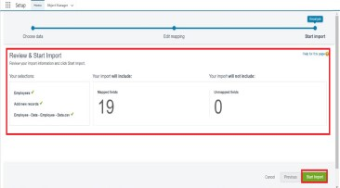
2. | Accuracy | Training Accuracy - 98%  Validation Accuracy - 98% | . | 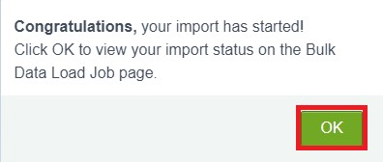
3. | Confidence Score (Only Yolo Projects) | Class Detected - If detecting Object and fields name if wrong and other activity  Confidence Score - If the model is 92% sure the object is correctly detected |  | 