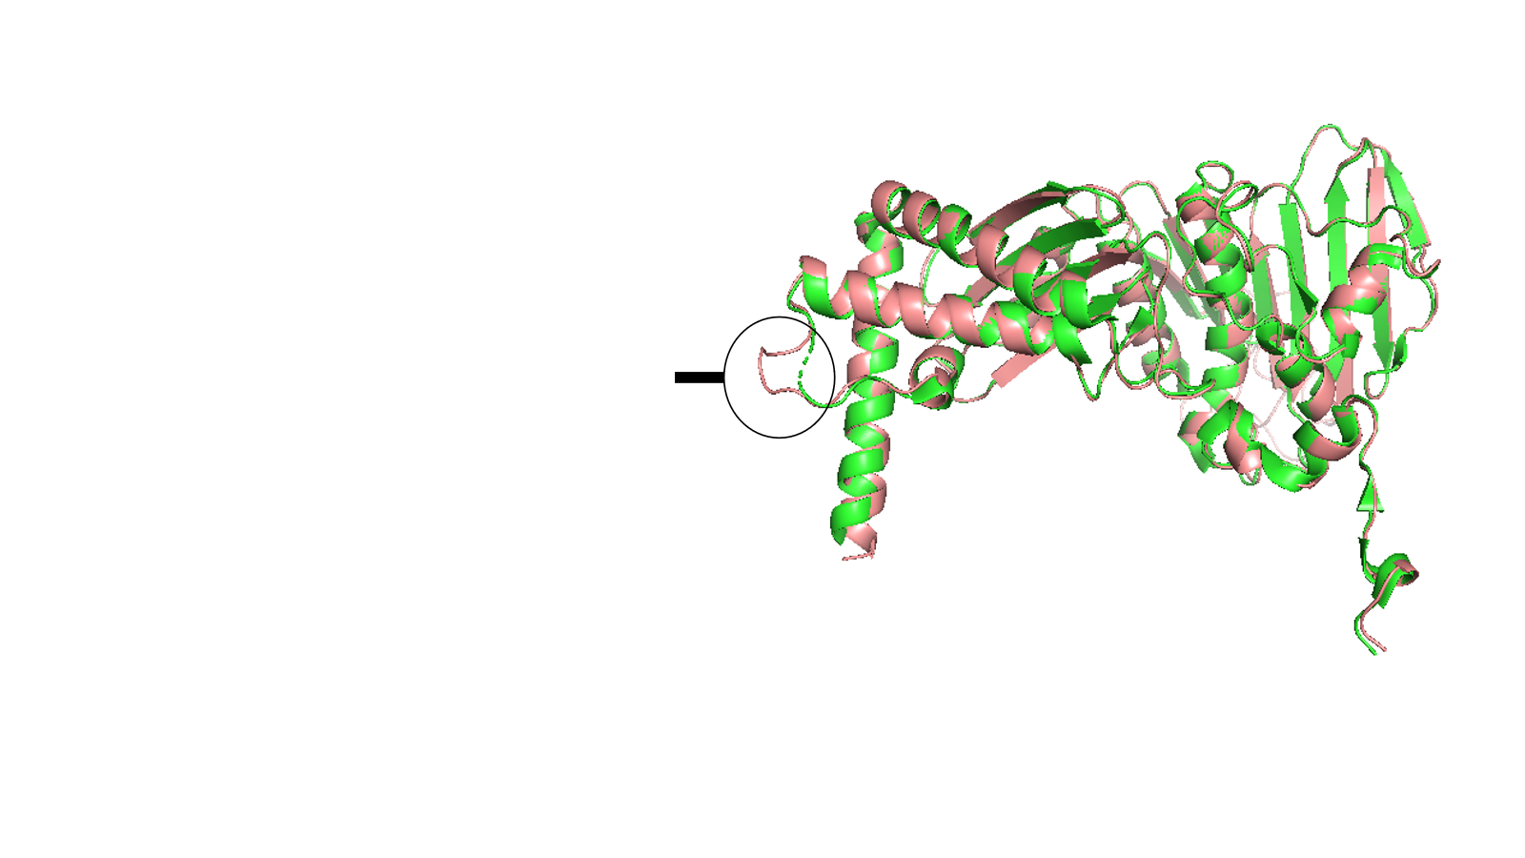
Figure S1. Superimposed structure of the ATPase domain of DNA Gyrase B (PDB ID: 3ZKB). The green regions represent the unmodeled protein segments, while the pink regions correspond to the modeled protein segments reconstructed through homology modeling, highlighting the repaired missing regions.

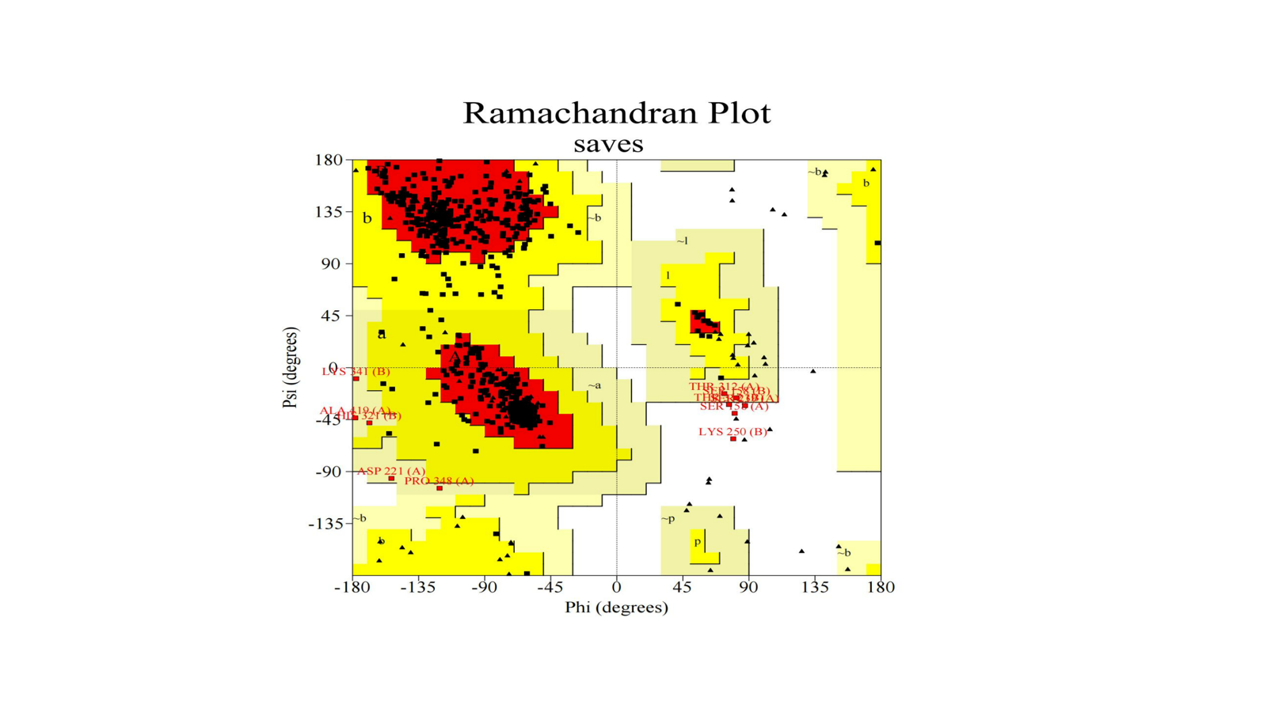
Figure S2: Ramachandran plot of the modelled protein.

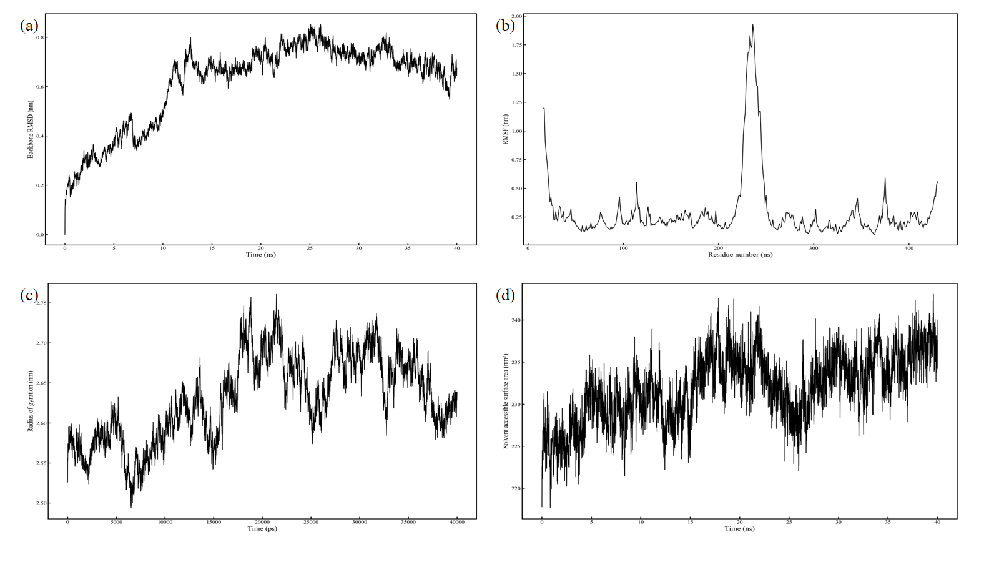
Figure S3. Molecular dynamics simulation analysis of the modelled protein. (a) RMSD shows structural stability. (b) RMSF highlights flexible regions. (c) Rg indicates consistent protein compactness. (d) SASA reflects solvent exposure and conformational changes.

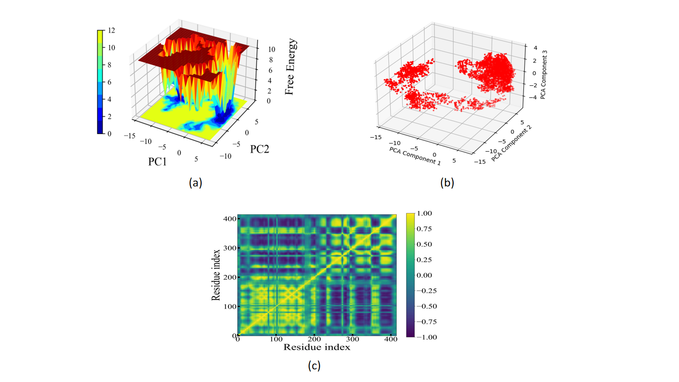
Figure S4: (a) Free energy landscape (FEL) derived from principal components (PC1 and PC2), showing conformational stability. (b) Principal component analysis (PCA) scatter plot illustrating conformational clusters of the protein. (c) Dynamic cross-correlation matrix (DCCM) depicting correlated and anti-correlated motions between residues.

Table S1. Post homology modeling values of model quality of DNA Gyrase B protein.

Parameters | Values
GMQE | 0.91
QMean | 0.84
MolProbity Score | 1.67
Ramachandran Favored | 92.80 %
Ramachandran Outliers | 0.85%

Table S2. Different statistical data obtained from the Post MD simulation analysis.
Parameters |  | RI_1 | RI_2 | RI_3 | RI_4 | ANP
Backbone RMSD (nm) | Average | 0.39 | 0.42 | 0.57 | 0.54 | 0.53
 | Maximum | 0.67 | 0.85 | 0.86 | 0.81 | 0.87
 | Minimum | 0.00 | 0.00 | 0.00 | 0.00 | 0.00
Ligand RMSD (nm) | Average | 0.09 | 0.18 | 0.18 | 0.19 | 0.12
 | Maximum | 0.21 | 0.22 | 0.33 | 0.29 | 0.24
 | Minimum | 0.00 | 0.00 | 0.00 | 0.00 | 0.00
RMSF (nm) | Average | 0.24 | 0.26 | 0.28 | 0.27 | 0.28
 | Maximum | 1.60 | 1.66 | 2.13 | 2.09 | 1.63
 | Minimum | 0.09 | 0.09 | 0.11 | 0.09 | 0.09
RoG (nm) | Average | 2.62 | 2.62 | 2.67 | 2.66 | 2.71
 | Maximum | 2.76 | 2.73 | 2.80 | 2.79 | 2.58
 | Minimum | 2.51 | 2.52 | 2.55 | 2.53 | 2.53
SASA (nm²) | Average | 236.25 | 234.39 | 236.92 | 234.35 | 243.53
 | Maximum | 251.57 | 252.63 | 250.61 | 252.13 | 259.84
 | Minimum | 219.56 | 218.33 | 222.45 | 220.50 | 228.57

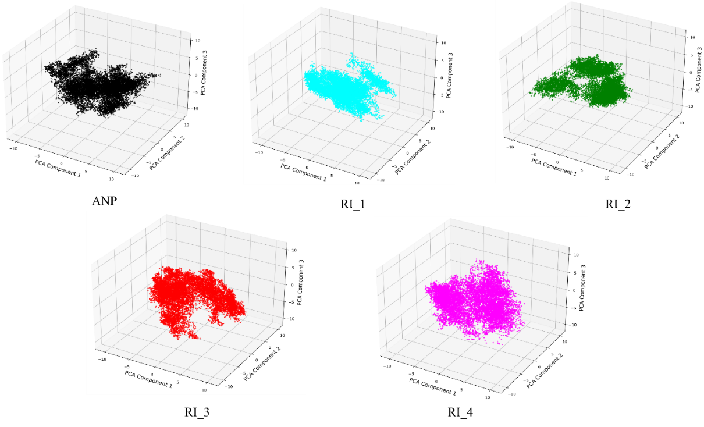
Figure S5. PCA plots showing the conformational space of DNA Gyrase B-ligand complexes during MD simulations, including ANP, RI_1, RI_2, RI_3, and RI_4

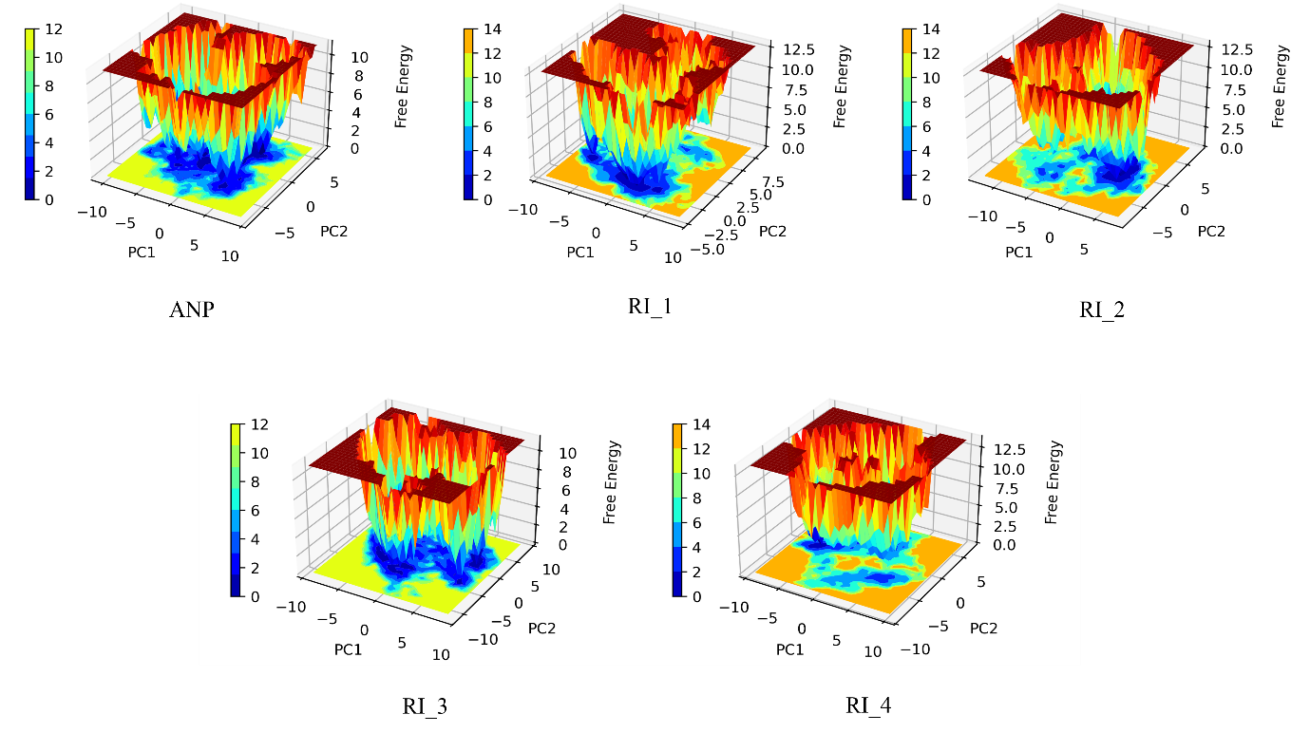
Figure S6. Free energy landscape FEL plots of DNA Gyrase B-ligand complexes based on MD simulations, including ANP, RI_1, RI_2, RI_3, and RI_4.

