Contents

Credentials 1

Instruction for adding master menu and café menu 1

Board of Director 1

Add master menu 1

Café Manager 2

# Credentials

|  |  |  |  |
| --- | --- | --- | --- |
| **Email** | **User Id** | **Password** | **Role** |
| [mahima@example.com](mailto:mahima@example.com) | DB1100 | Mahima123# | Board of Director (Admin) |
| karan@example.com | CS7070 | Karan123# | cafe manager (The Ref) |
| krita@example.com | CS2020 | Krita123# | cafe staff (The Ref) |
| aditi@example.com | CS5427 | Aditi123# | cafe manager (Trade Table) |
| amrita@example.com | CS8090 | Amrita123# | cafe staff (Trade Table) |
| sabina@example.com | US2424 | Sabina123# | Student |
| soni@example.com | UE4581 | Soni123# | Employee |

# Instruction for adding master menu and café menu

## Board of Director

### Add master menu

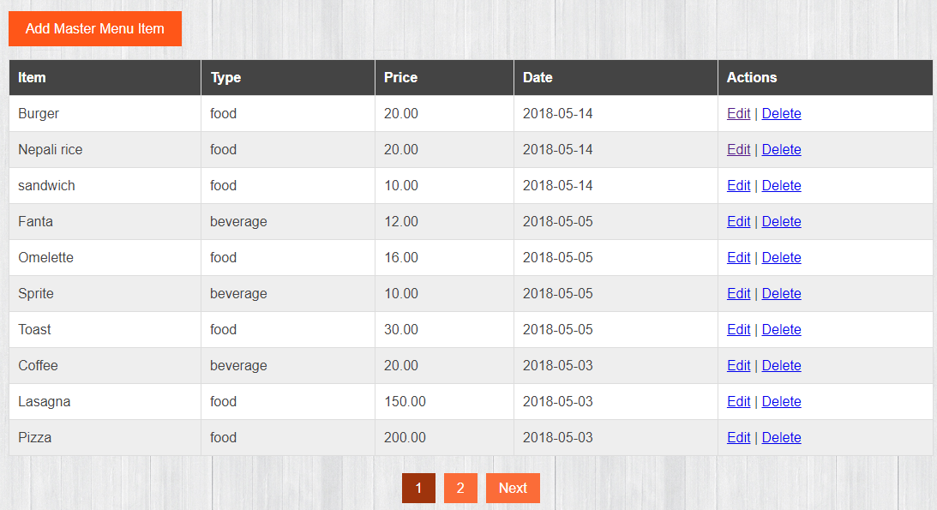

1. Only menu item edited or added **today** can be viewed by the student or Employee. The menu items added to other days except today cannot be viewed by the user. Therefore, if the menu items have to be displayed on the menu page, the date should be edited to today’s date.

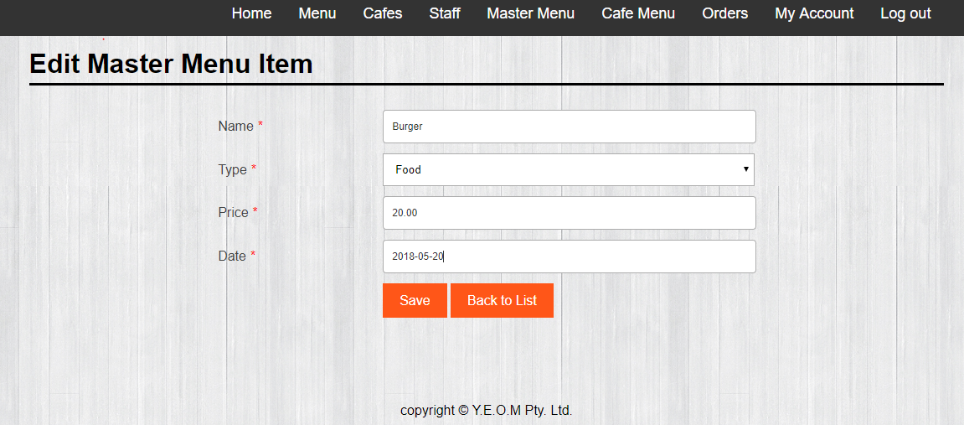

Todays date

## Café Manager

To add and view the menu item of the café, Manager can input the date on which the master menu item was created. For example: 2018-05-20



Café manager will be able to view all the menu items added to his/her café on that date only.

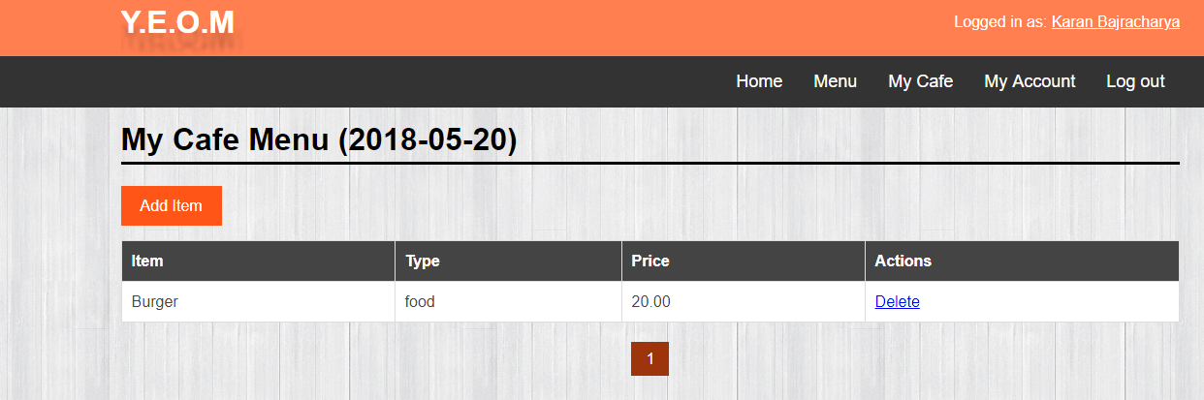

* In the above image, Burger was added on 2018-05-20. Therefore, only this item is visible.
* By clicking the add item button, café manager can add menu item from the master menu list which was added/edited on 2018-05-20 only.

# Users

Students and employees can view and order menu items from only today’s date.