**Introduction:**

* This is POM (Page Object Model) based automated test framework for web application testing.
* For the given browser and URL, it can create automated tests for various functionalities of an application.
* Test data is provide from Excel.

**Software Prerequisites:**

1. Eclipse
2. Java 1.8
3. Selenium 3.0.1
4. Drivers
5. Junit 4.12
6. Web Browser

**Framework Structure: -**

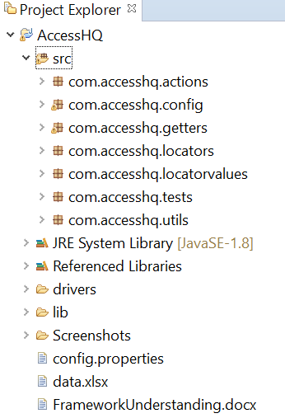

* **Configuration details:** -

Inputs like browser for execution, URL to be launched can be specified here.

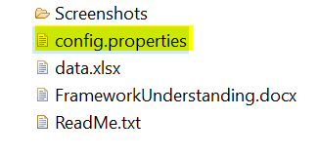

* A**ctions to be performed on web elements (page wise) are listed in this package**

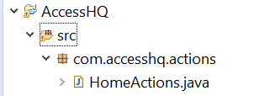

* **Object Repository:**

Locators of elements under actions are organised in these packages. Page wise classes are created, and elements are listed respectively.



* Commonly used methods / **Utilities** are placed in this package-

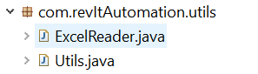

* Junit **tests** are placed in this package. One separate class needs to be created for each functionality.



**Set Up**

1. Checkout the project from GIT
2. Check the classpath including JDK
3. Clean and build the project
4. There should be no errors
5. Project should look like below:

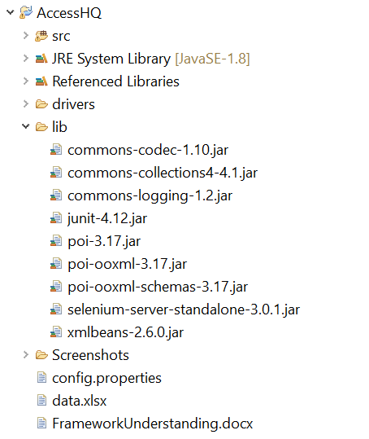

* **Running tests**

1. Open ‘TripPlanner.java’ From the package ‘com.accesshq.tests’
2. Go to ‘Run’ 🡪 ‘Run As’
3. Click ‘JUnit Test’

**Result of sample run: -**

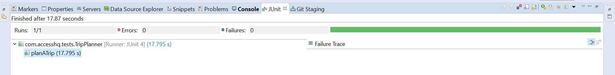

**In case of any errors, refer the screenshots generated in folder:**

