Introduction:

This is POM based automated test framework for web application testing.

For the given browser and URL , it can create automated tests for various functionalities of an application.

Software Prerequisites:

1. Eclipse
2. Java 1.8
3. Selenium 3.0.1
4. Drivers
5. Junit 4.12

Framework Structure: -

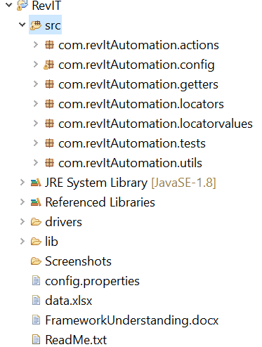

* Configuration details: -

Inputs like browser for execution, URL to be launched can be specified here.

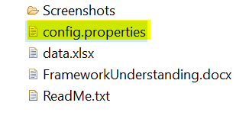

* Actions to be performed on web elements (page wise) are listed in this package

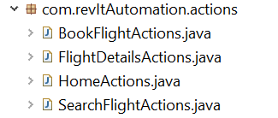

* Locators of elements under actions are organised in these packages. Page wise classes are created, and elements are listed respectively.

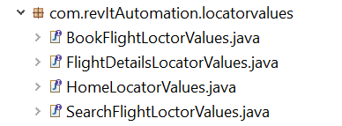

* Commonly used methods are placed in this package-

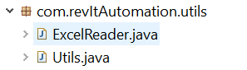

* Junit tests are placed in this package. One separate class needs to be created for each functionality.



Set Up

1. Checkout the project from GIT
2. Check the classpath including JDK
3. Clean and build the project
4. There should be no errors
5. Project should look like below:

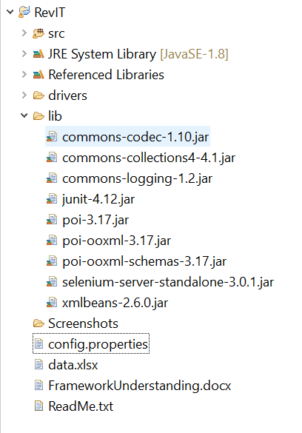

Running tests

1. Open ‘BookAFlight.java’ From the package ‘com.revItAutomation.tests’
2. Go to ‘Run’ 🡪 ‘Run As’
3. Click ‘JUnit Test’

Result of sample run: -

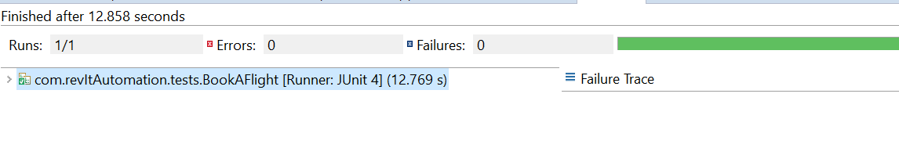

In case of any errors, refer the screenshots generated in folder:

