**Introduction**:

* For the given requirement, I have designed a Page Object Model (POM) to automate given two scenarios.
* The framework can be easily extended to multiple scenarios, cross browser testing etc.
* I have created a self-explanatory design which need not have any comments.
* I have modularized the code to make it reusable and maintainable.

Following are some details of the framework:

**Framework Structure: -**

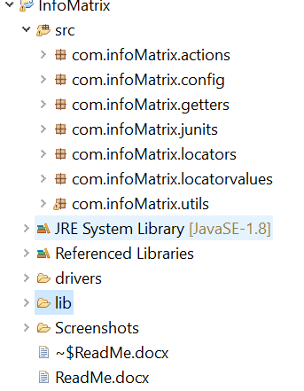

**Framework packages:**

* Configuration details: -

Inputs like browser for execution, URL to be launched can be specified in this package.

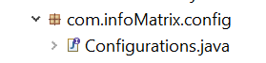

* Actions to be performed on web elements (page wise) are listed in this package

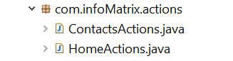

* Locators of elements under actions are organised in these packages. Page wise classes are created and elements are listed respectively.

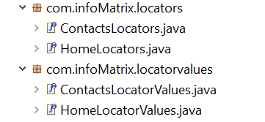

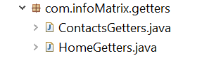

* Commonly used methods are placed in this package-



* Junit tests are placed in this package. One separate class needs to be created for each functionality.

