Module Name: Login, Cart, Checkout, Logout
Test Case ID: ST_10
Webpage URL: https://www.saucedemo.com/

Test 1A
Scenario: Verify that multiple selected products appear correctly in the shopping cart.
Test Steps:
- Open Swag Labs and log in as standard_user.
- Add Sauce Labs Backpack to the cart.
- Add Sauce Labs Bike Light to the cart.
- Open the shopping cart.
- Verify the product names and quantities.
Screenshots: 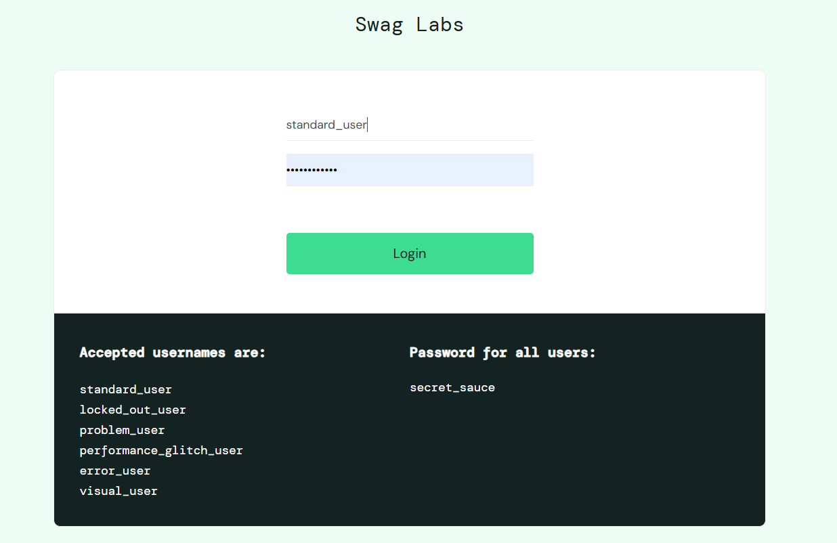
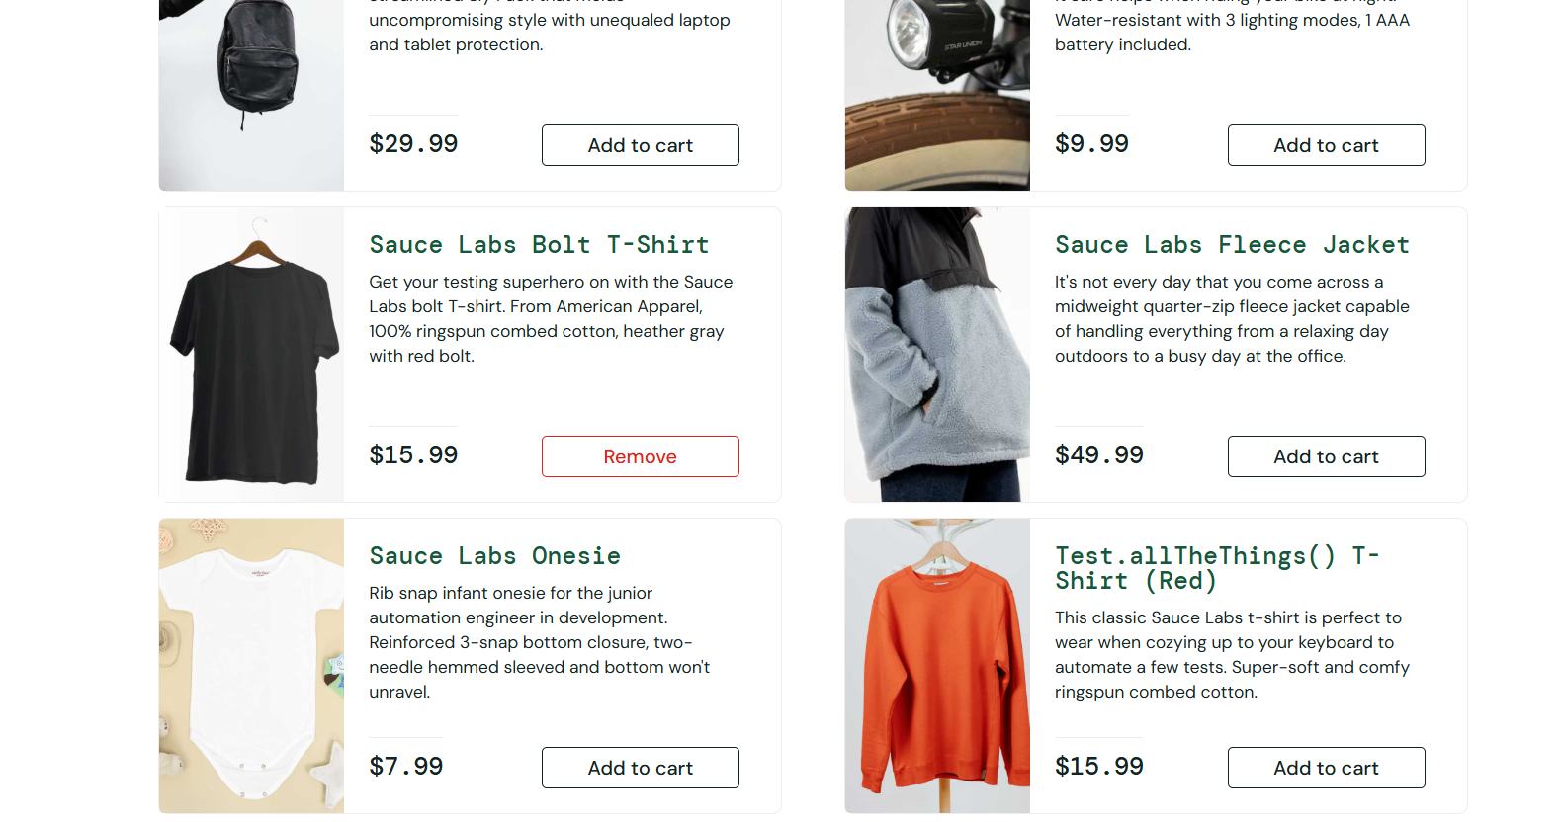
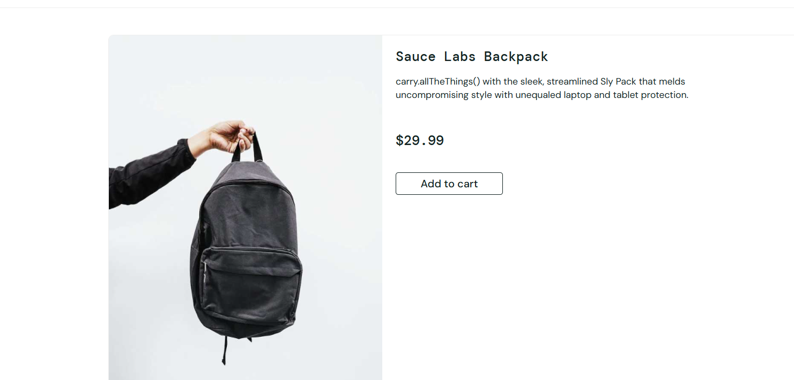
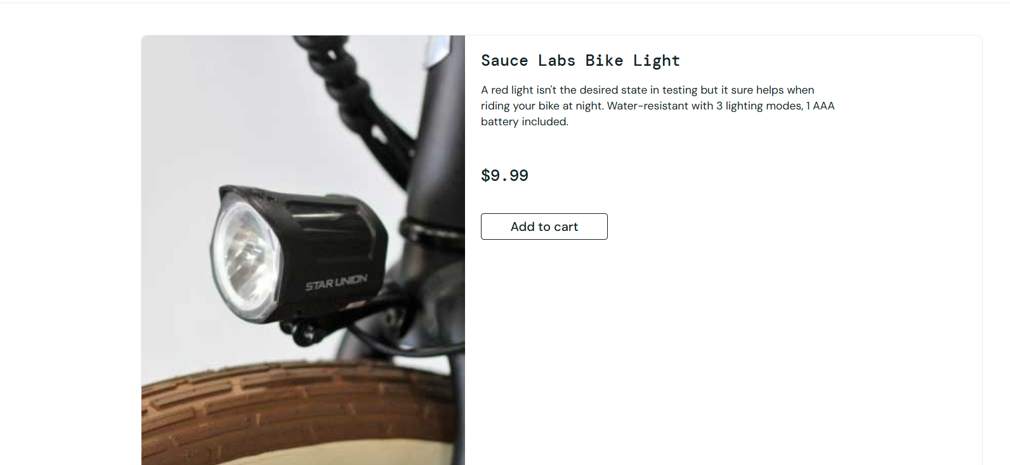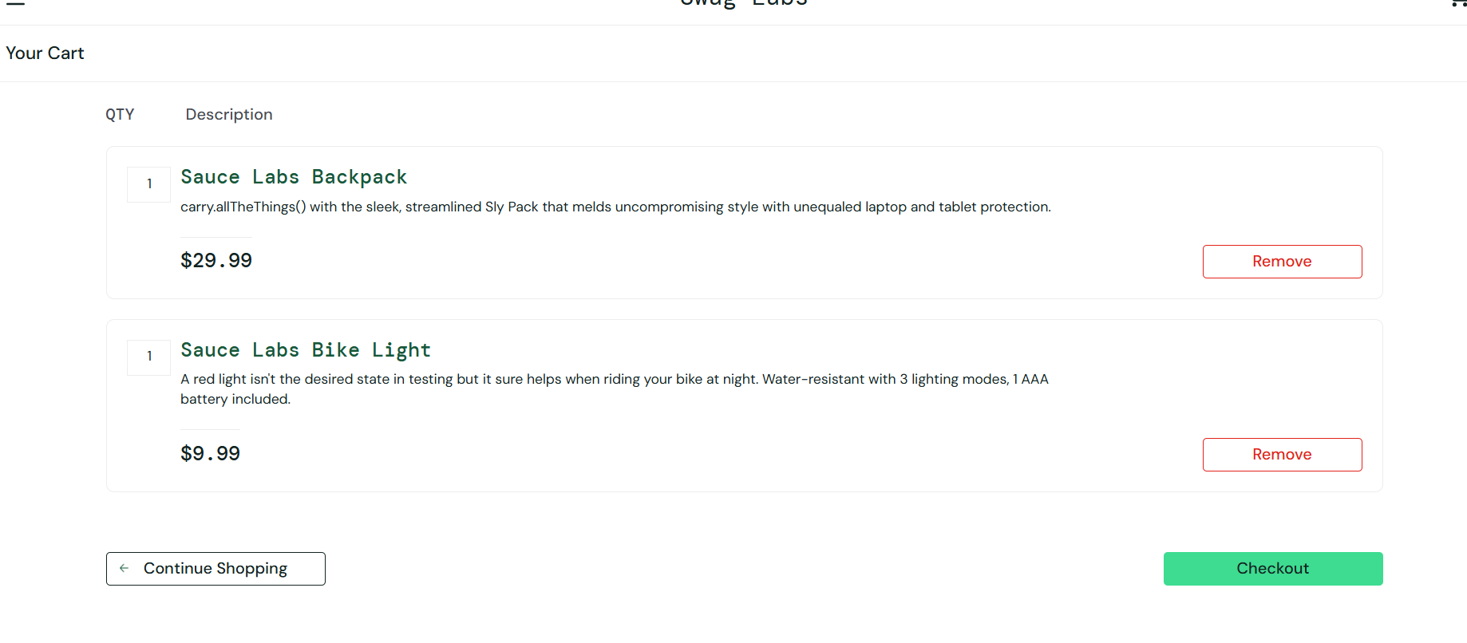

Test 2B
Scenario: Verify login rejection when both credential fields are empty.
Test Steps:
- Navigate to the login page.
- Keep the username field empty.
- Keep the password field empty.
- Click Login.
- Observe the validation message.
Screenshots: 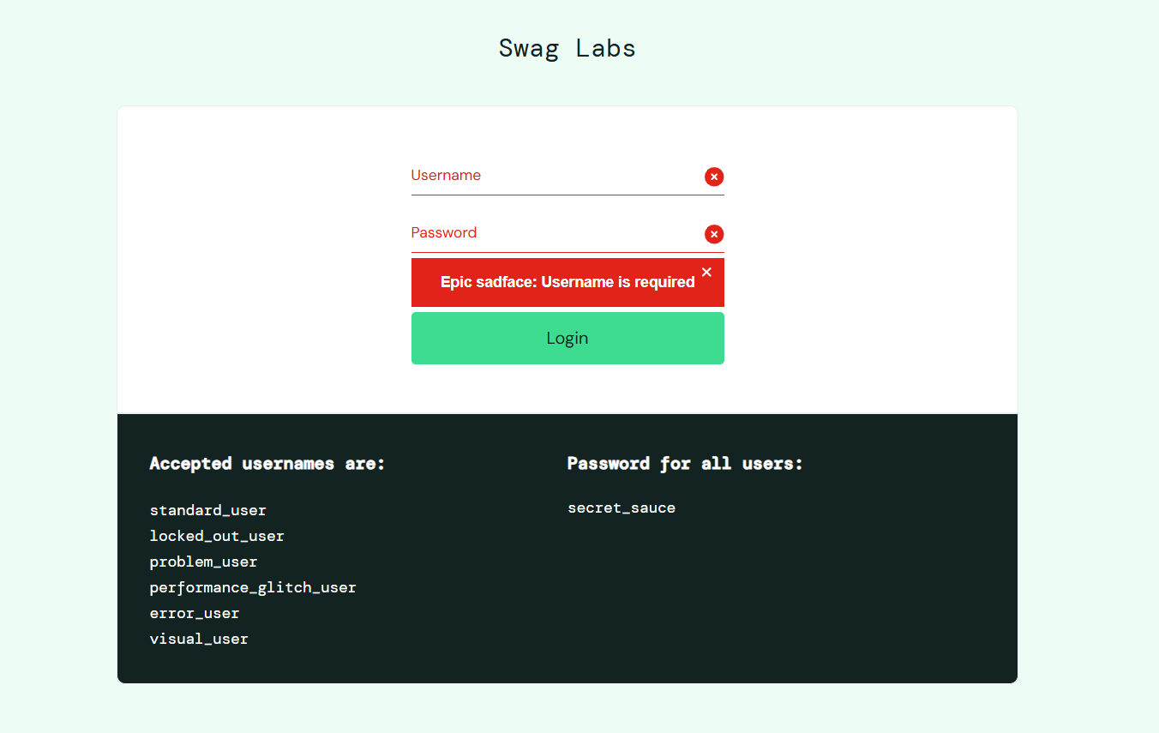
Test 3C
Scenario: Verify that product information is displayed correctly.
Test Steps:
- Log in using standard_user.
- Open the Products page.
- Locate Sauce Labs Backpack.
- Check its title, price, image, and description.
Screenshots:
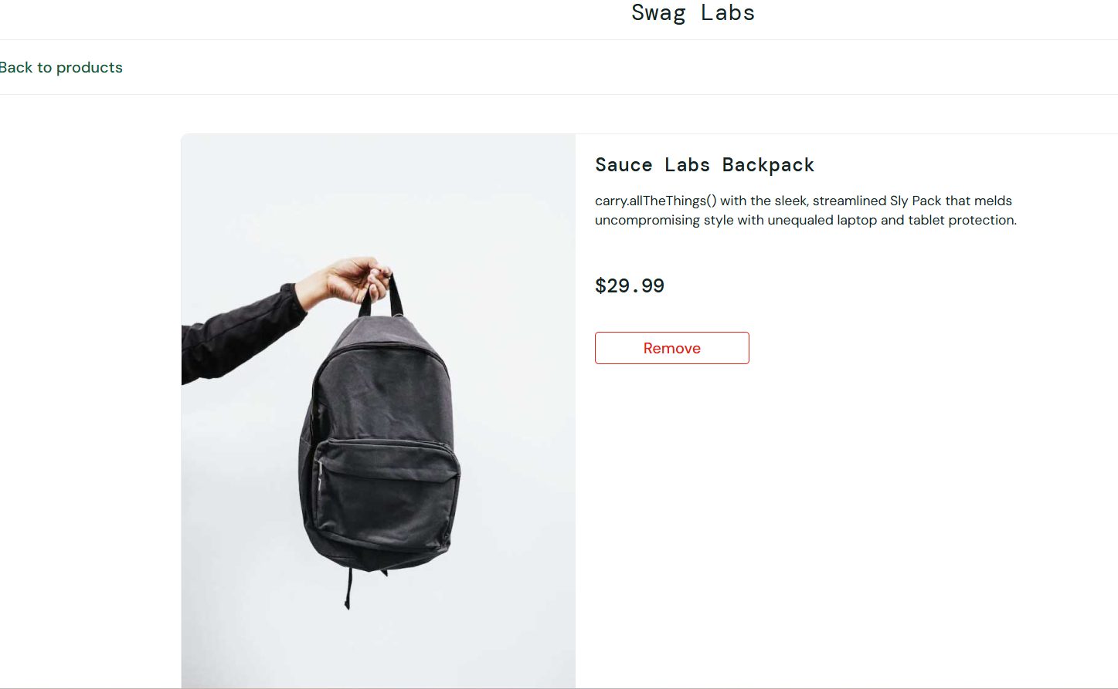Test 4D
Scenario: Verify checkout validation when customer details are missing.
Test Steps:
- Add a product to the cart.
- Open the cart and click Checkout.
- Leave First Name, Last Name, and Zip/Postal Code blank.
- Click Continue.
- Check the validation message.
Screenshots: 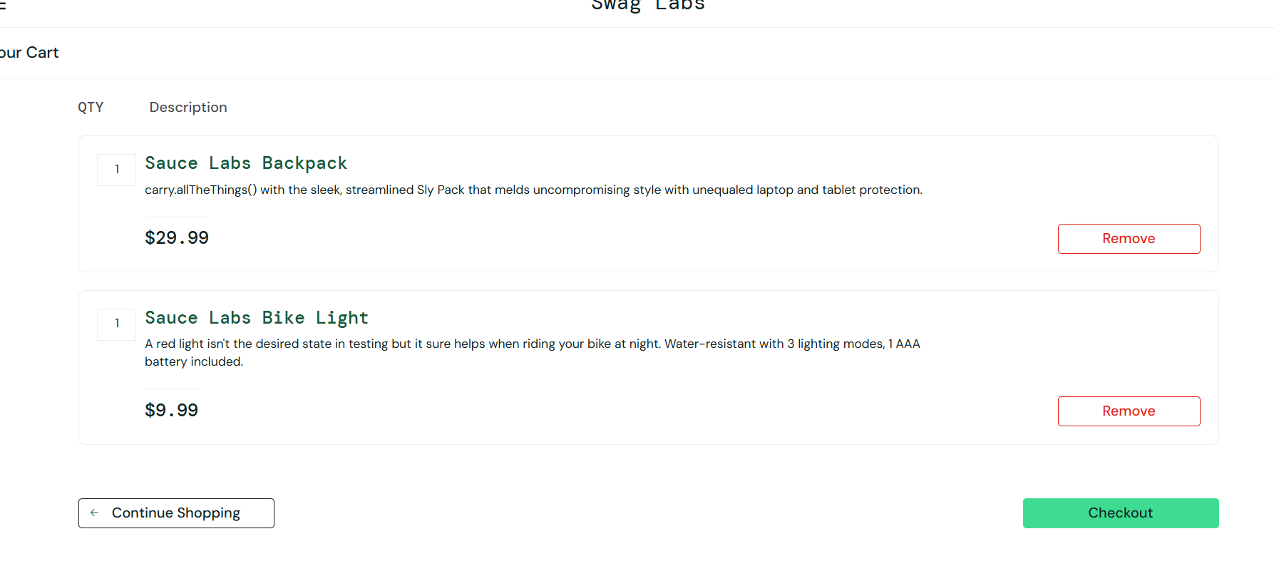
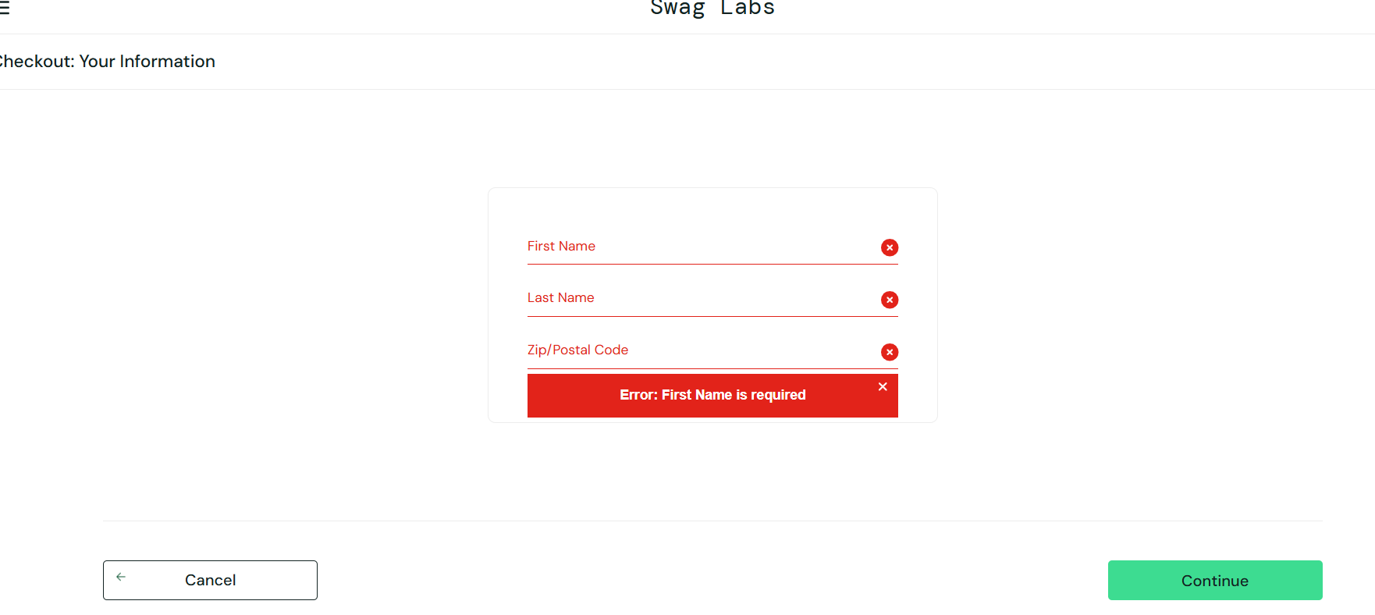
Test 5E
Scenario: Verify successful authentication using valid credentials.
Test Steps:
- Open the Swag Labs login page.
- Enter username standard_user.
- Enter password secret_sauce.
- Click Login.
- Confirm that the Products page appears.
Screenshots:
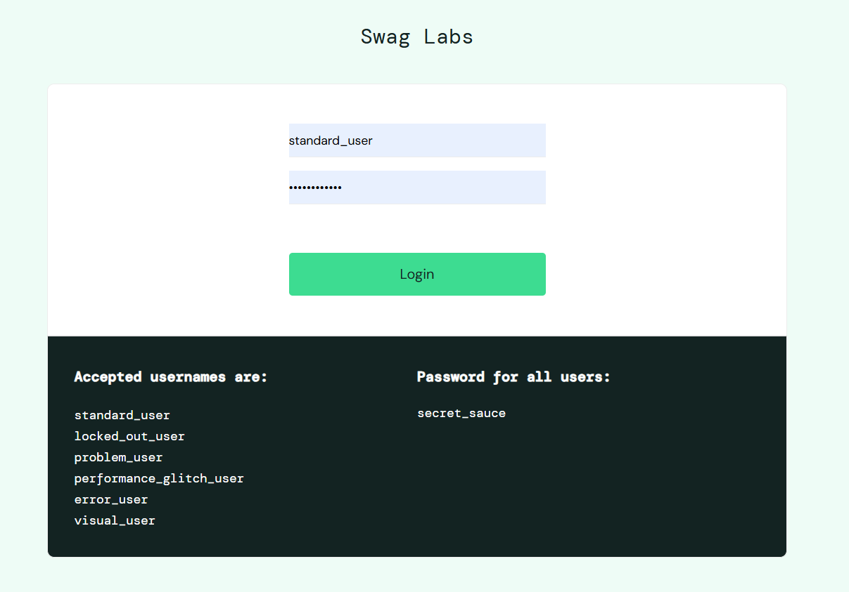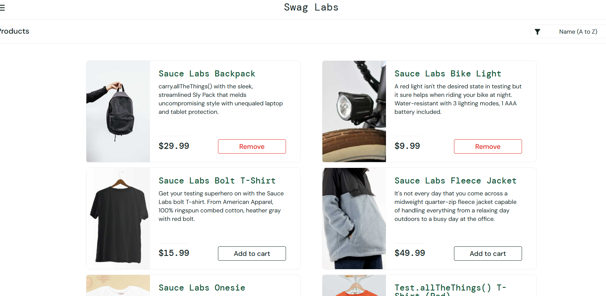Test 6F
Scenario: Check whether the cart badge reflects the number of selected products.
Test Steps:
- Log in as standard_user.
- Add Sauce Labs Backpack to the cart.
- Add Sauce Labs Bike Light.
- Add Sauce Labs Fleece Jacket.
- Check the cart badge.
Screenshots:
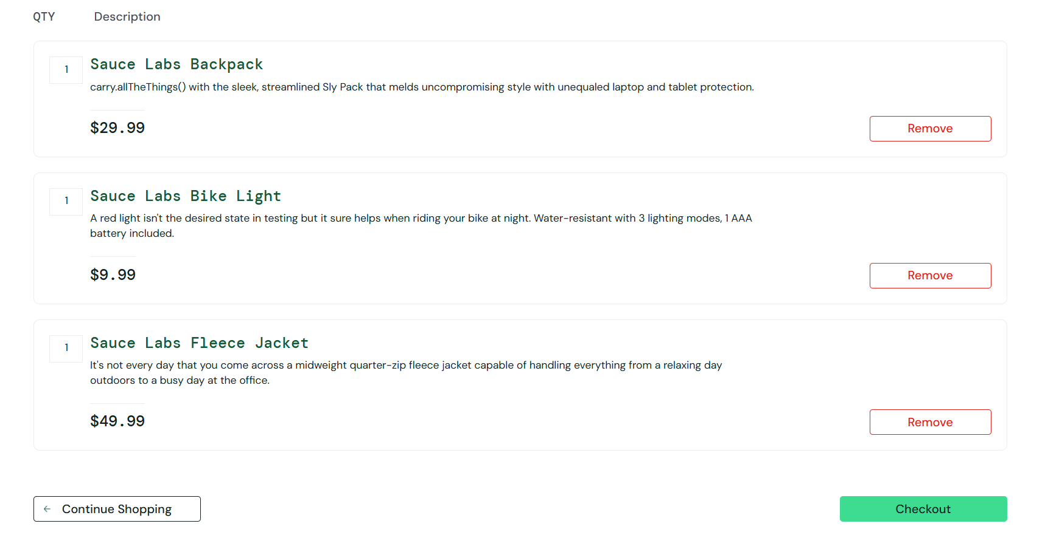Test 7G
Scenario: Verify that a locked account cannot access the application.
Test Steps:
- Open the login page.
- Enter username locked_out_user.
- Enter password secret_sauce.
- Click Login.
- Observe the error displayed.
Screenshots: 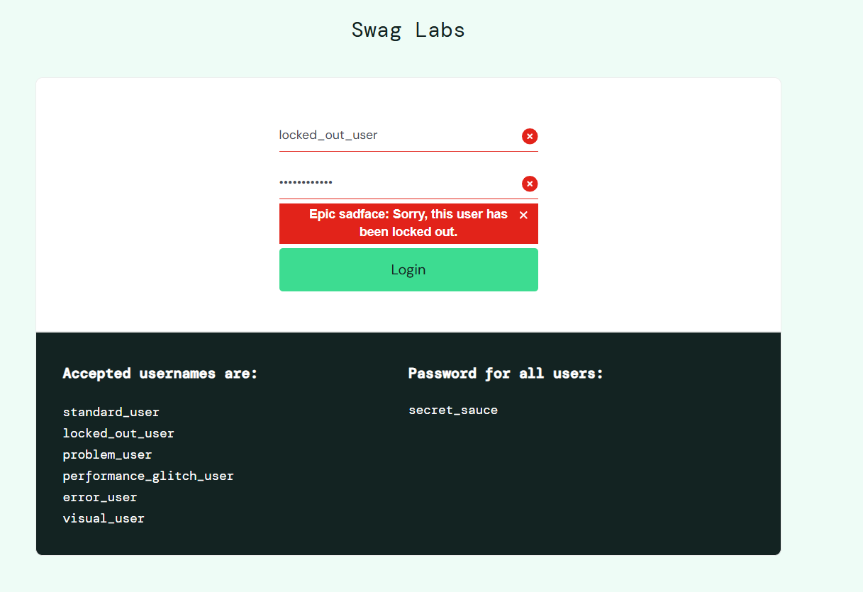Test 8H
Scenario: Verify that selecting a product title opens its individual details page.
Test Steps:
- Log in as standard_user.
- Locate Sauce Labs Bolt T-Shirt.
- Click its product title.
- Inspect the product details page.
- Verify the product name, price, and description.
Screenshots:
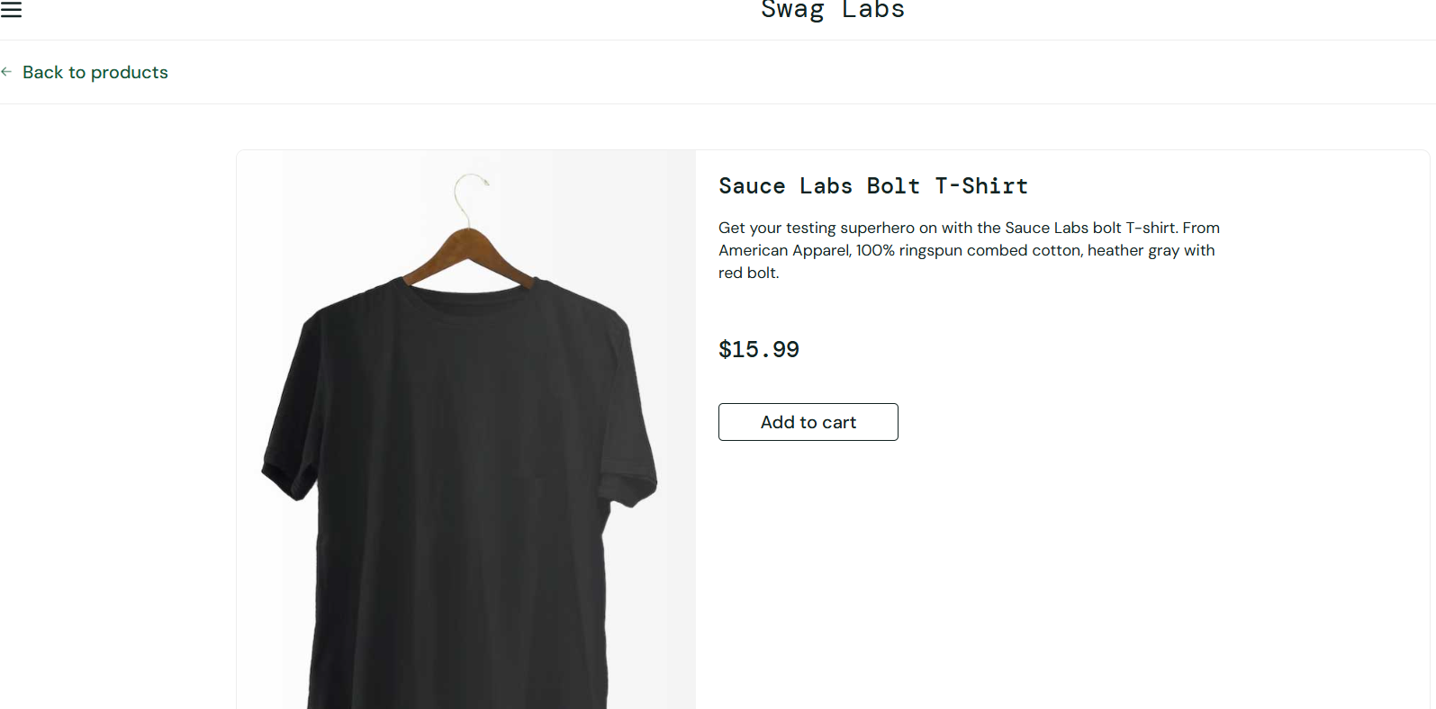Test 9I
Scenario: Verify that an item can be removed directly from the inventory page.
Test Steps:
- Log in as standard_user.
- Add Sauce Labs Backpack to the cart.
- Confirm the cart badge shows 1.
- Click Remove on the Backpack product card.
- Check the cart badge again.
Screenshots:
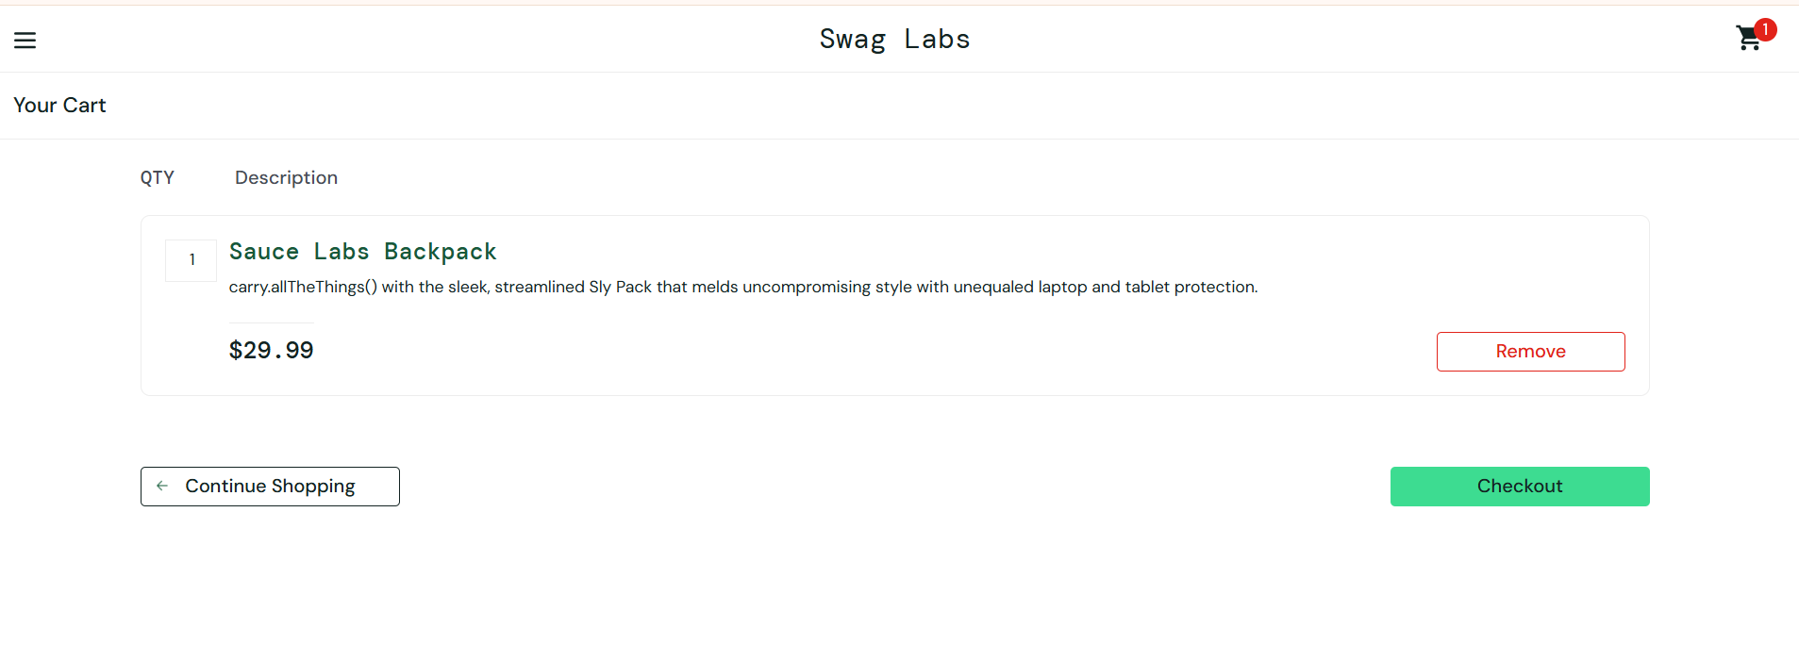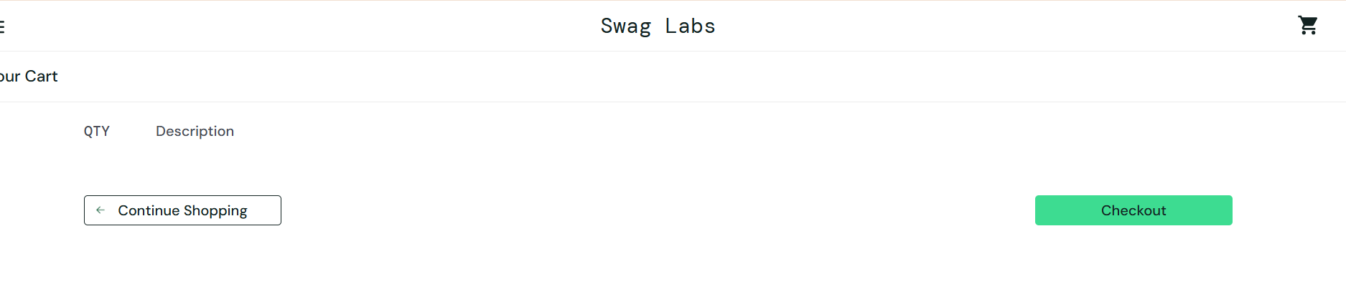Test 10J
Scenario: Verify the item total, tax, and final amount in the checkout summary.
Test Steps:
- Add Sauce Labs Backpack to the cart.
- Add Sauce Labs Fleece Jacket.
- Open the cart and proceed to Checkout.
- Enter the required customer details.
- Click Continue.
- Compare the item total, tax, and grand total.
Screenshots:
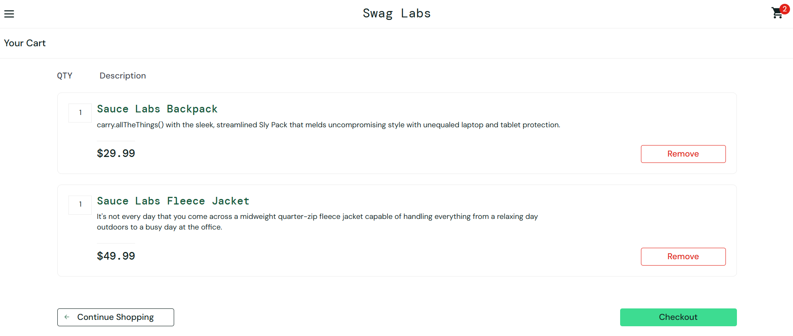
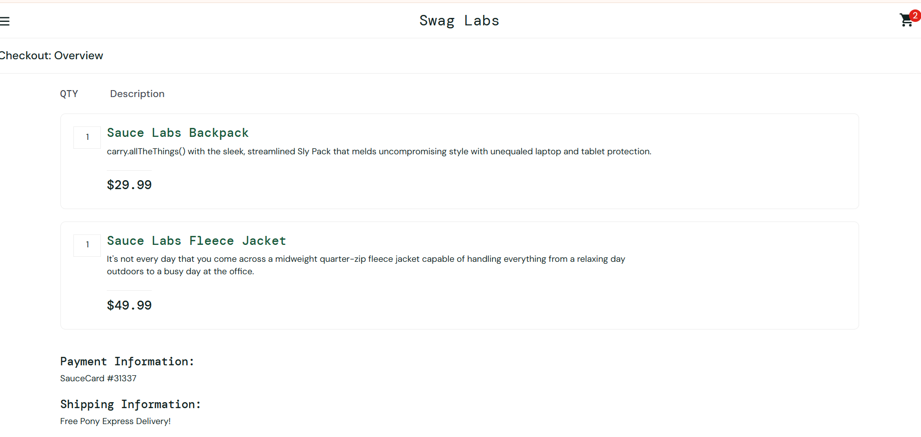
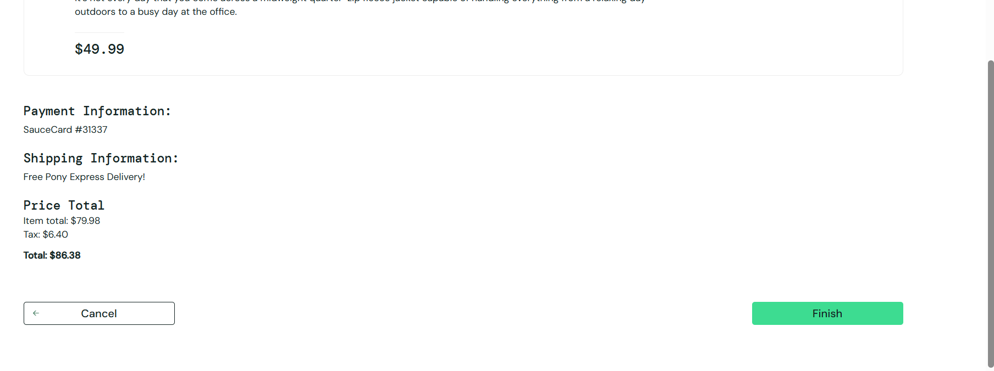
Test 11K
Scenario: Verify that products are sorted in ascending order of price.
Test Steps:
- Log in as standard_user.
- Locate the sorting dropdown on the Products page.
- Select Price (low to high).
- Review the order of the displayed products.
Screenshots: 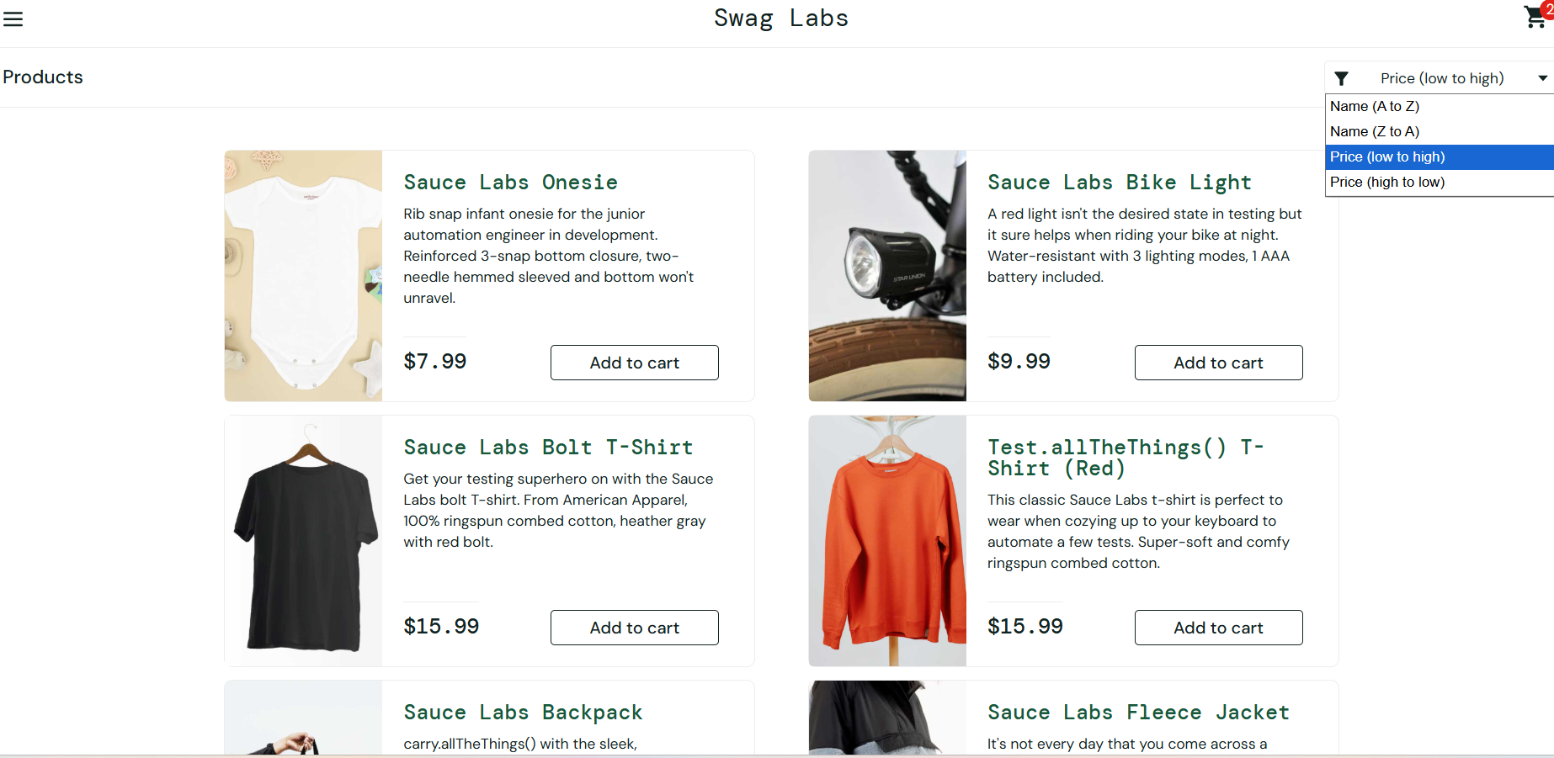
Test 12L
Scenario: Verify that the user can exit the application using the navigation menu.
Test Steps:
- Log in using standard_user.
- Click the menu icon in the top-left corner.
- Select Logout.
- Verify that the login page is displayed.
Screenshots: 