Module Name: Static Testing (Requirement Review & Inspection)
Test Case ID: st_03
Webpage URL: https://storedemo.testdino.com/

- Review ID : R001
Scenario: Review Login Page Requirements
Test Steps:
1. Open Demo website.
2. Review the sign in page.
3. Verify Email Address and Password fields.
4. Check sign in button availability.

Screenshots: 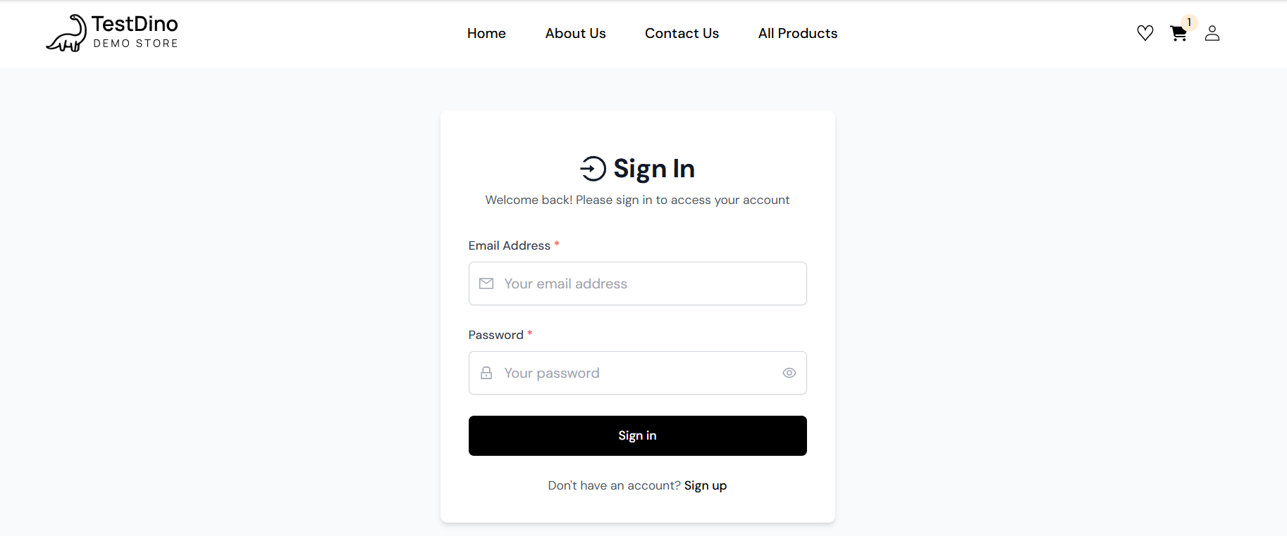

- Review ID : R002
Scenario: Review E-mail Field Requirement
Test Steps:
1. Verify E-mail field visibility.
2. Check placeholder text.
3. Verify field alignment

Screenshots:
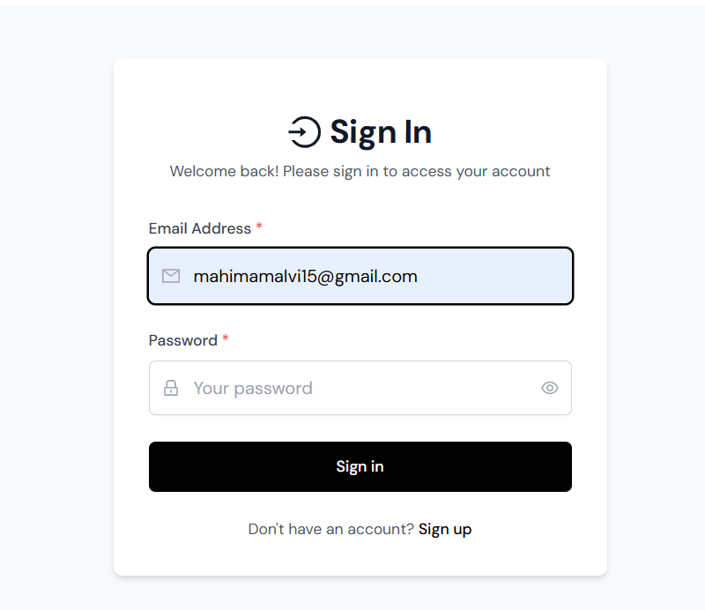

- Review ID : R003
Scenario: Review Password Field Requirement
Test Steps: 1. Verify Password field.
2. Check password masking.
3. Verify placeholder text.
Screenshots: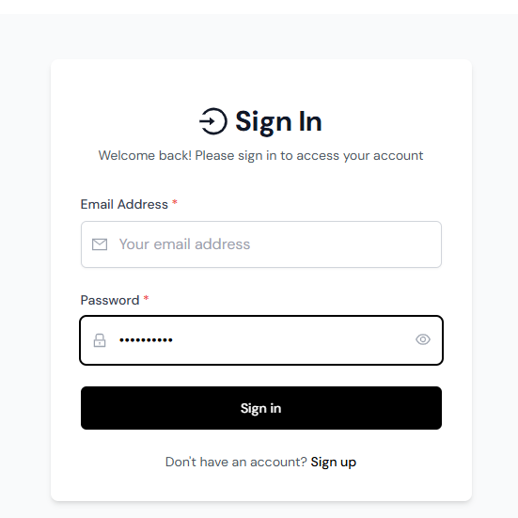

- Review ID : R004
Scenario: Review Login Button
Test Steps: 1. Verify sign in button visibility.
2. Check button label.
3. Verify button alignment.
Screenshots: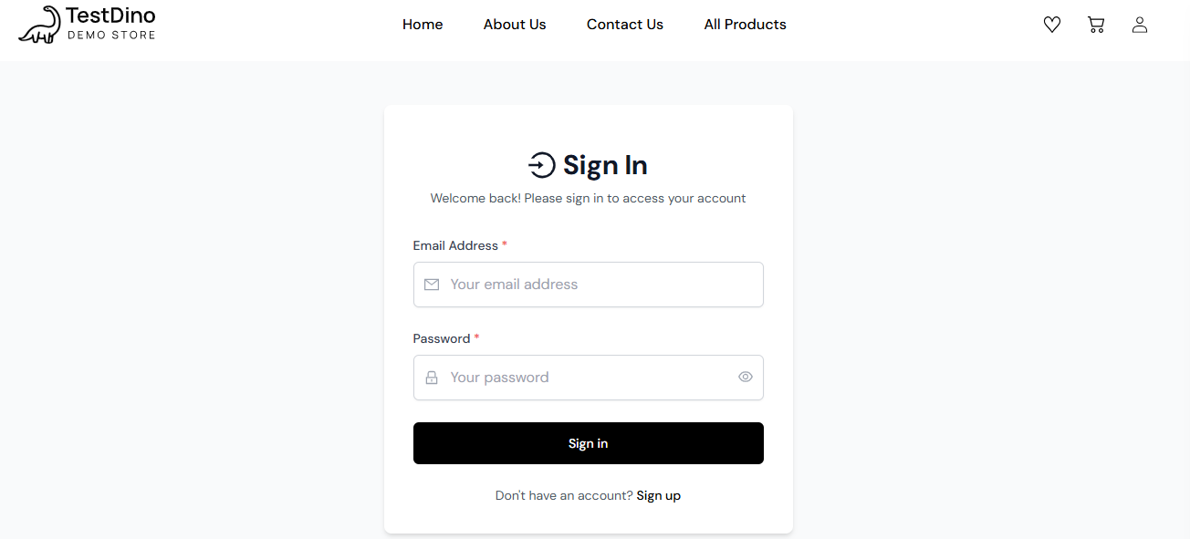

- Review ID : R005
Scenario: Review Required Field Validation
Test Steps: 1.Leave Email Address blank.
2. Leave Password blank.
3. Click Sign in.
4.Review validation messages.
Screenshots: 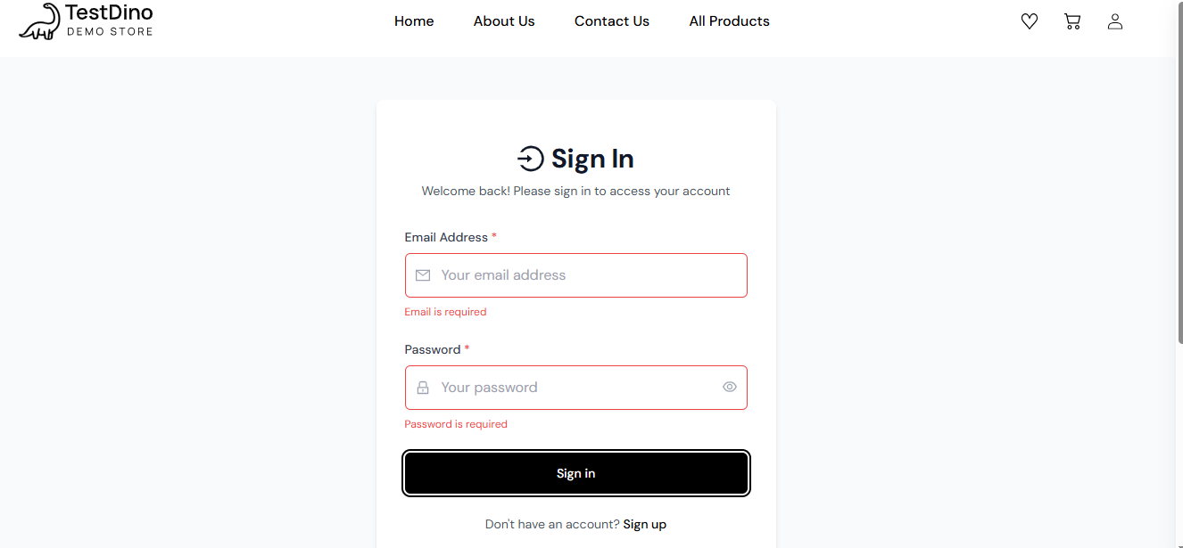

Review ID : R006

Scenario: Review Invalid Login Requirement
Test Steps: 1. Enter invalid E-mail.
2. Enter invalid Password.
3.Click Sign in.
4. Review displayed invalid credential

Screenshot: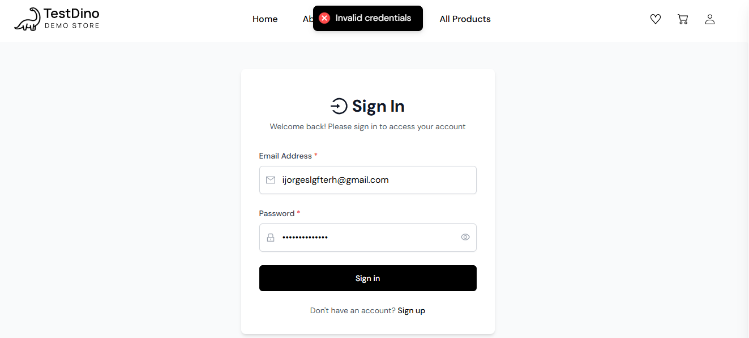

Review ID : R007

Scenario: Code Walkthrough of Login Process
Test Steps: 1. Review Sign in process.
2. Verify input flow.
3. Review authentication logic.
4. Note observations.

Screenshot: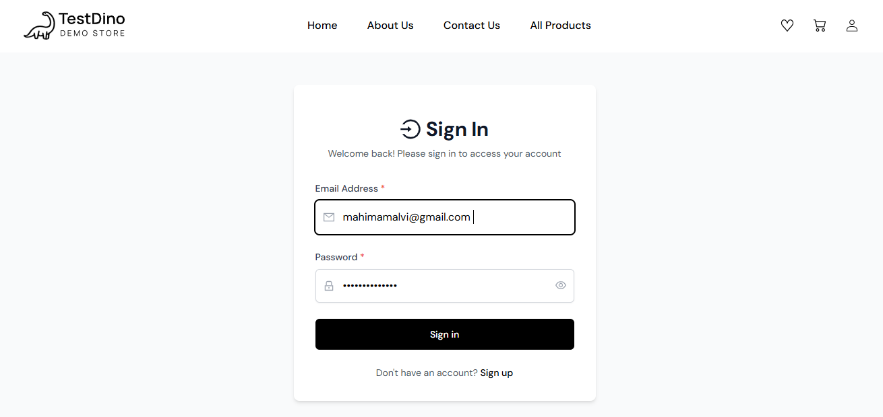

Review ID : R008

Scenario: Inspection of Login Page UI
Test Steps: 1. Inspect page layout.
2. Verify logo.
3. Verify alignment of UI elements.
4. Review consistency.
Screenshot:

Review ID : R009

Scenario: Review Inventory Page Navigation
Test Steps: 1. Login using valid credentials.
2. Verify Inventory page opens.
3. Review page navigation.

Screenshot: 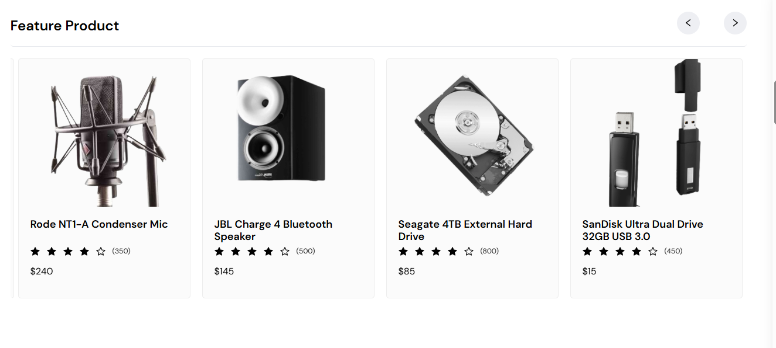

Review ID : R010

Scenario: Review Product Information
Test Steps: 1. Open Inventory page.
2. Verify product names.
3. Verify product prices.
Screenshot: 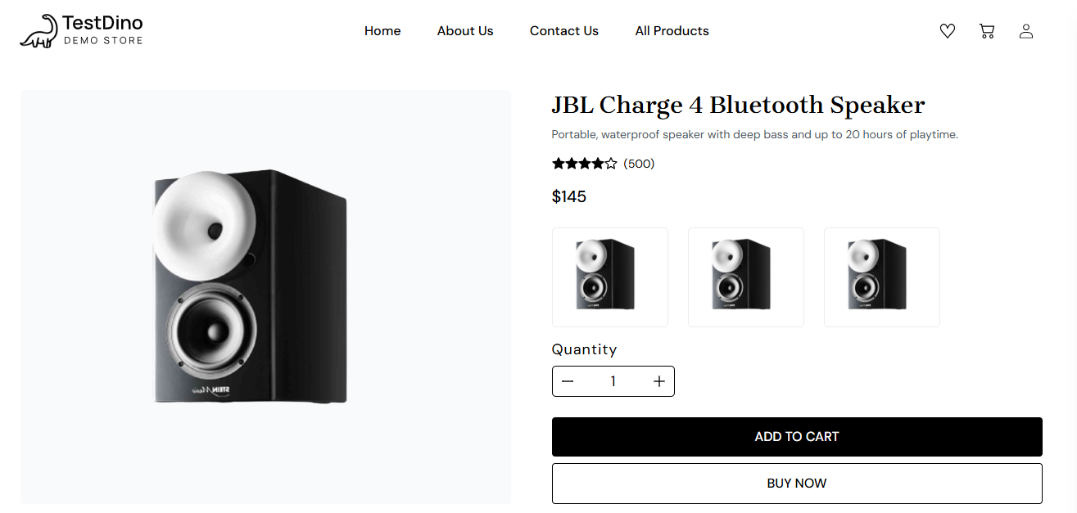
Review ID : R011

Scenario: Review Add to Cart Button
Test Steps: 1. Open Inventory page.
2. Review Add to Cart button.
3. Verify button placement.

Screenshot: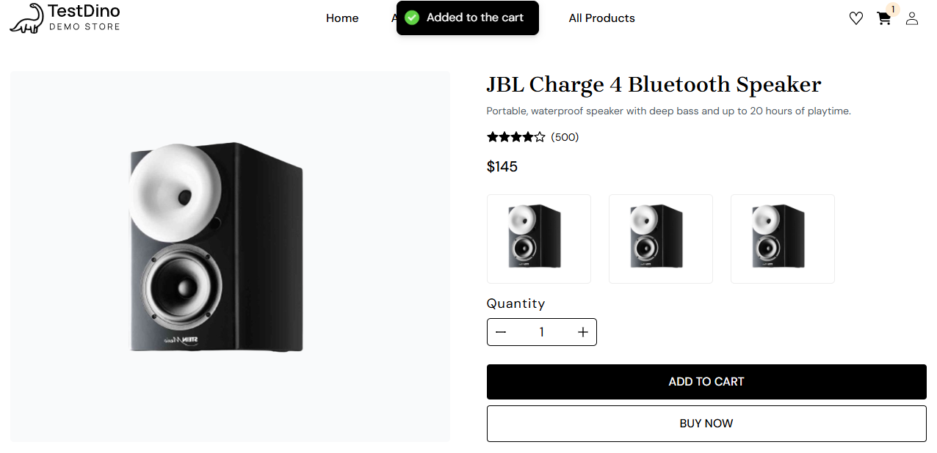

Review ID : R012

Scenario: Review Shopping Cart Functionality
Test Steps: 1.Login with valid credentials.
2. Click Add to Cart for any one product.
3. Verify the cart icon updates with 1.

Screenshot:
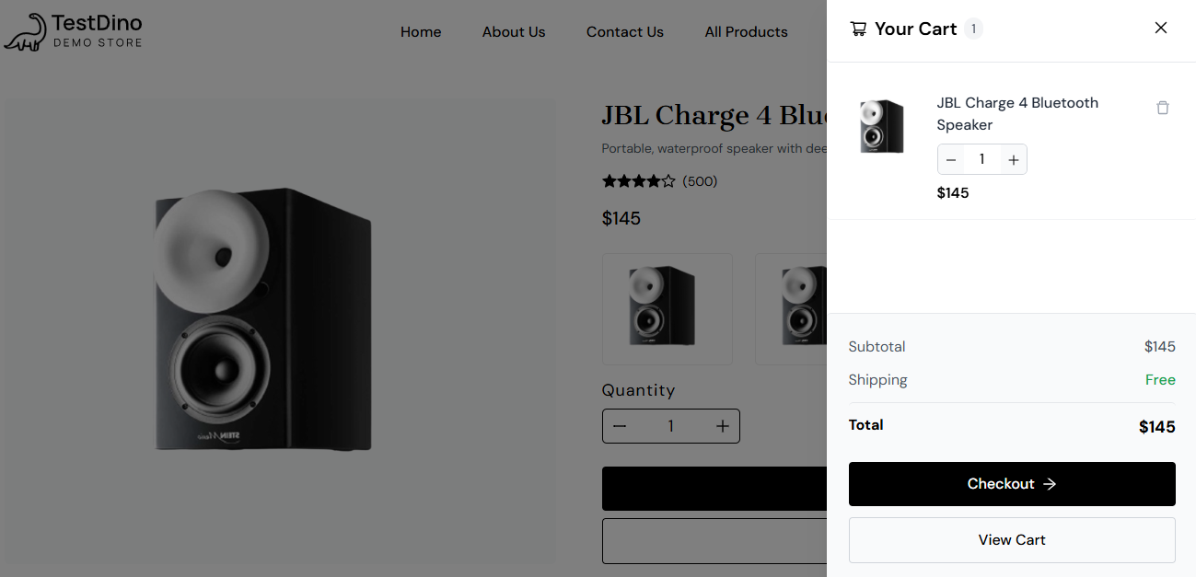

Review ID : R013

Scenario: Final Review (Logout)
Test Steps: 1. Open the side menu.
2. Click Logout.
3. Verify the Login page is displayed again.

Screenshot: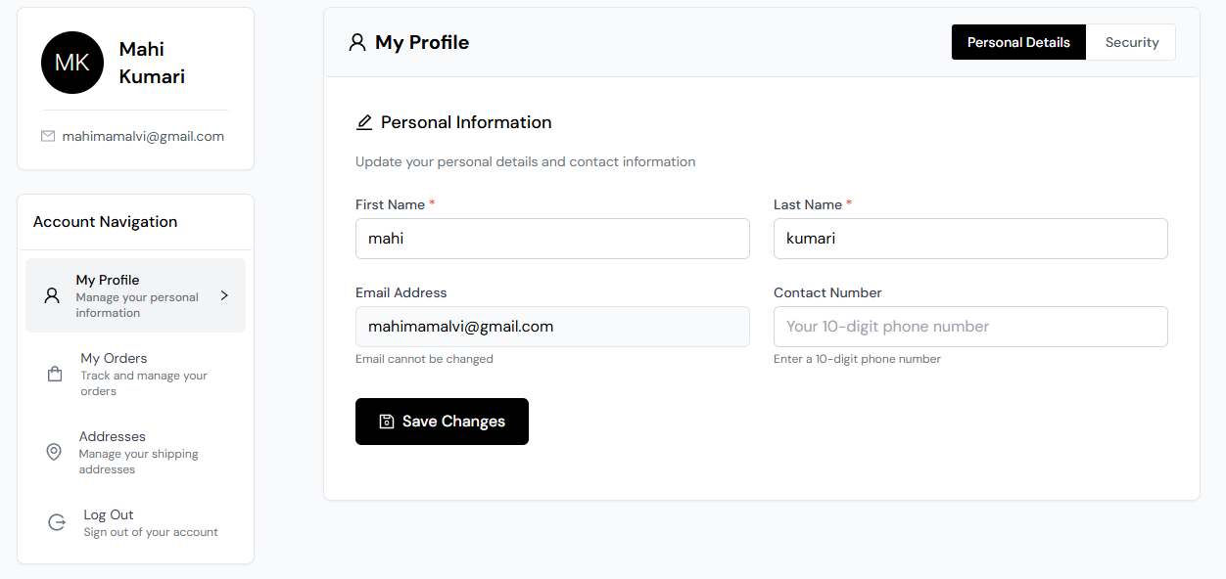
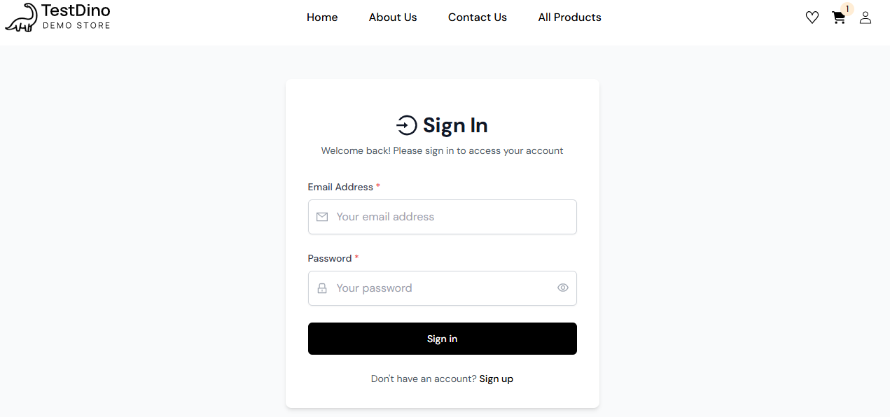

Summary Of Test Results
Total Review Scenarios | Passed | Review Observations | Pass %
13 | 13 | 0 | 100.0%

Conclusion and Recommendations

Pass Rate:
100.0% – Requirement Review Completed Successfully

Recommendations
- Add clear password policy information in the requirement document or login guidelines.
- Include detailed validation requirements for username and password fields.
- Document all possible login error messages in the Software Requirement Specification (SRS).
- Perform regular requirement reviews before the testing phase to reduce defects.

