Module Name: Functional & Non-Functional Testing
Test Case ID: ST_04
Webpage URL: https://storedemo.testdino.com/

Test : 1A
Scenario : Verify successful user registration with valid details

Test Steps
1. Navigate to Registration page
2. Fill in all required fields with valid data
3. Click 'Create Account' button

Screenshots:
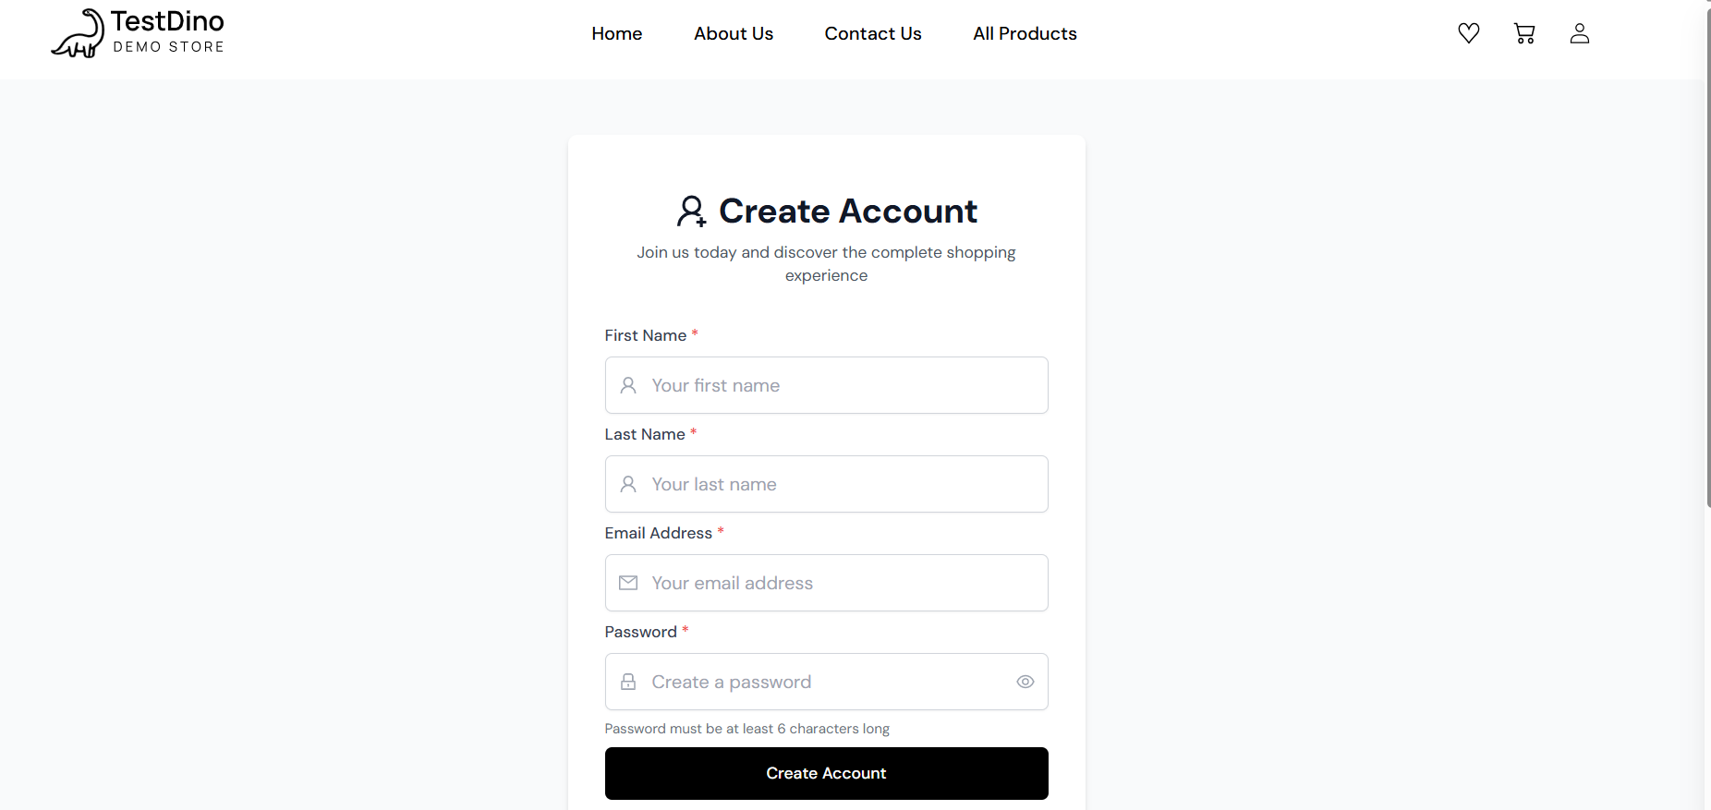

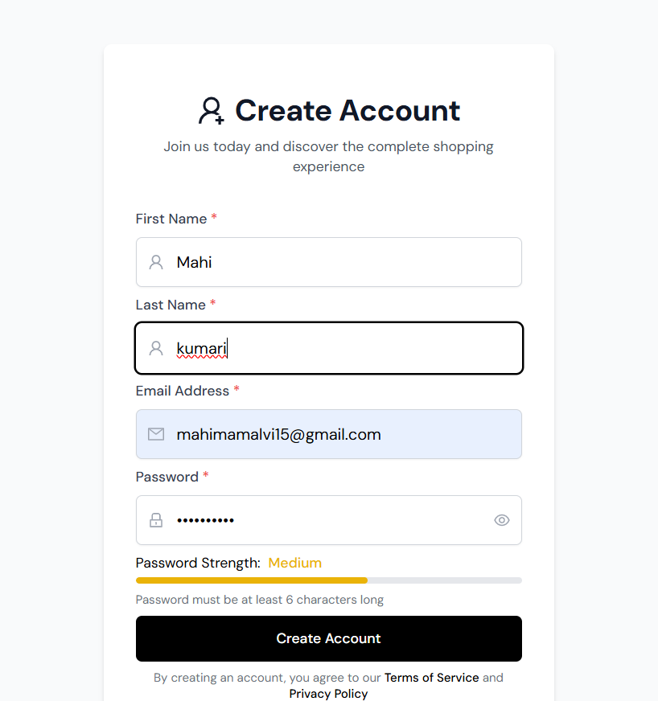
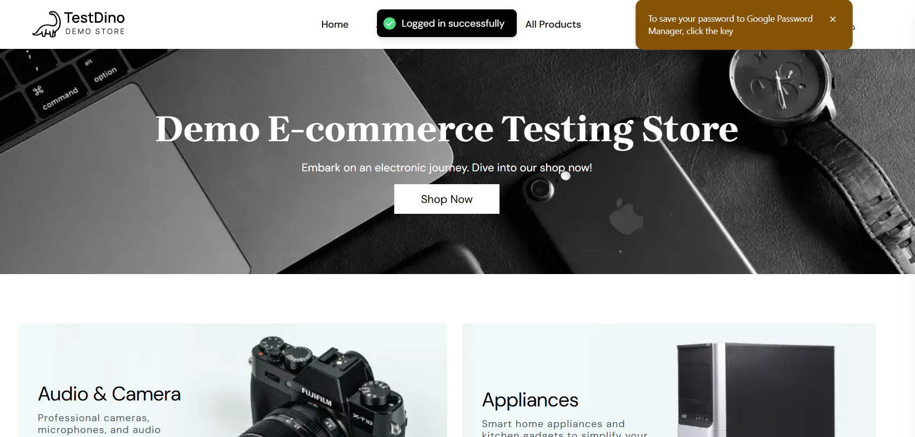

Test:2B
Scenario : Register with an already registered email ID

Test Steps:
1. Go to Registration page
2. Enter an existing email address
3. Fill other valid fields
4. Click 'Sign in'

Screenshots
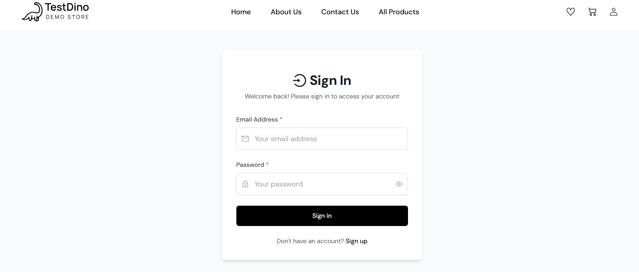
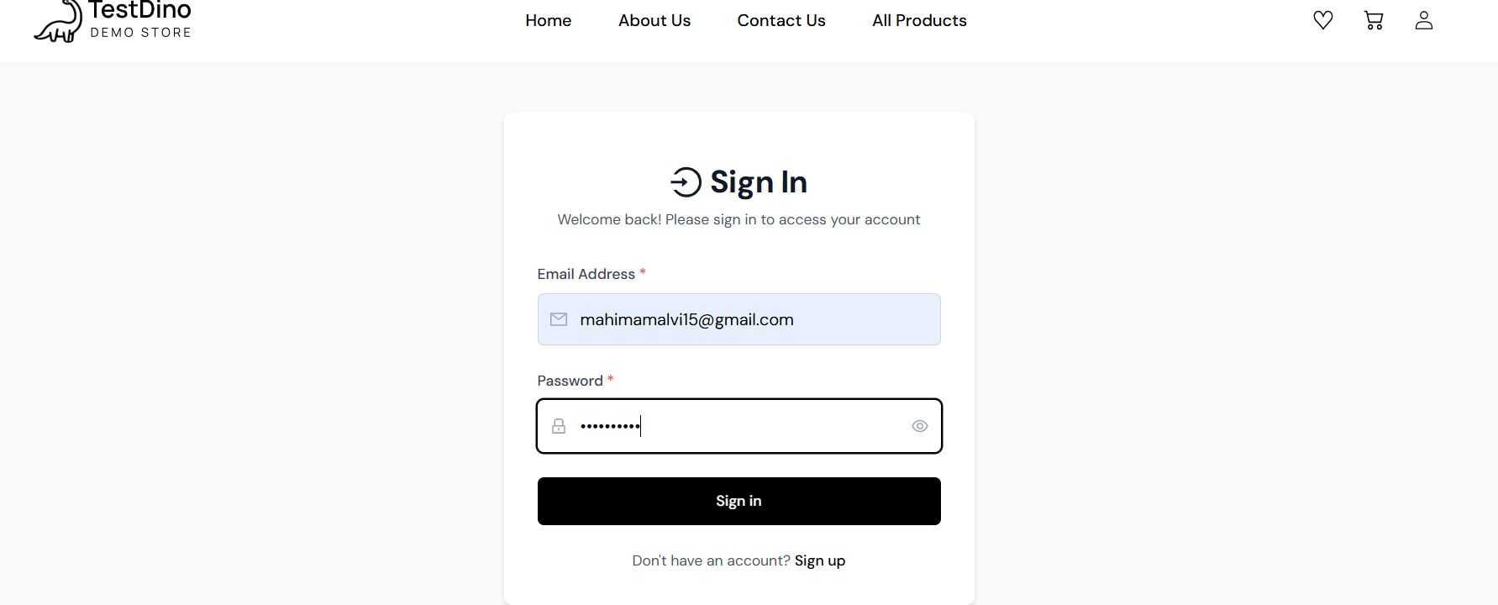
Test:3C
Scenario : Verify registration with weak password

Test Steps:
1. Go to Registration page
2. Fill name and email
3. Enter weak password
4. Submit form

Screenshots: 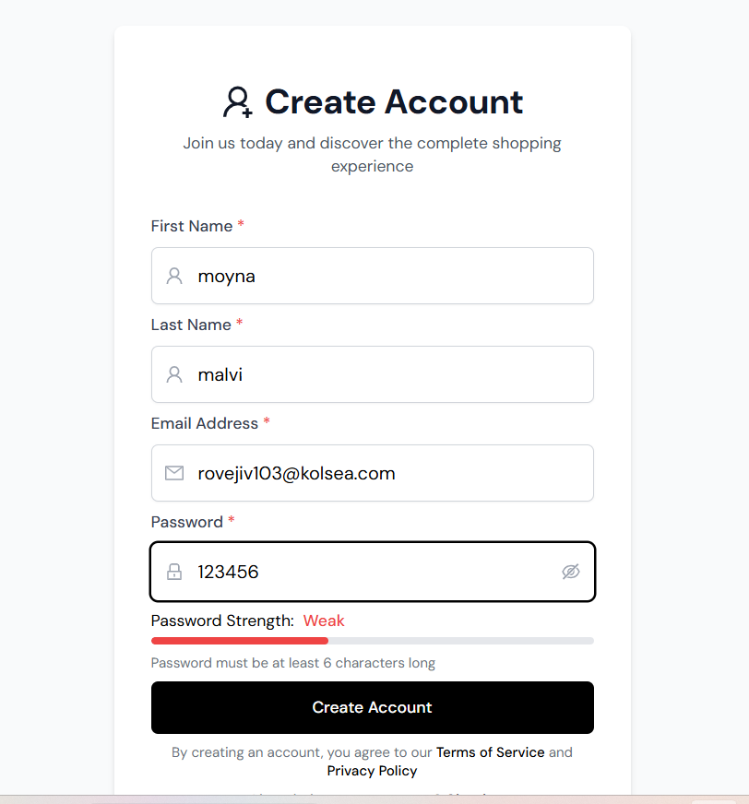
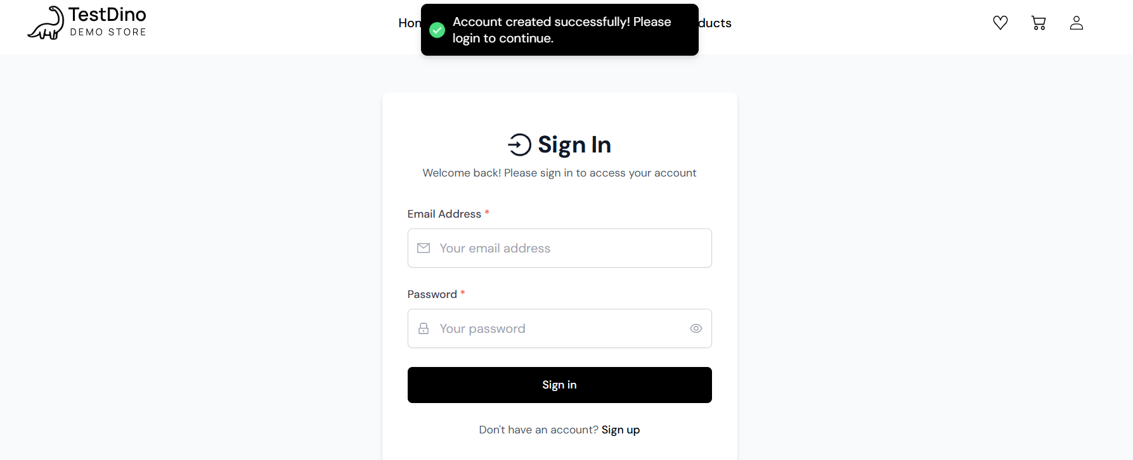
Test:4D
Scenario : Verify registration with empty fields

Test Steps:
1. Go to Registration page
2. Leave mandatory fields blank
3. Click 'Create Account' button

Screenshots:
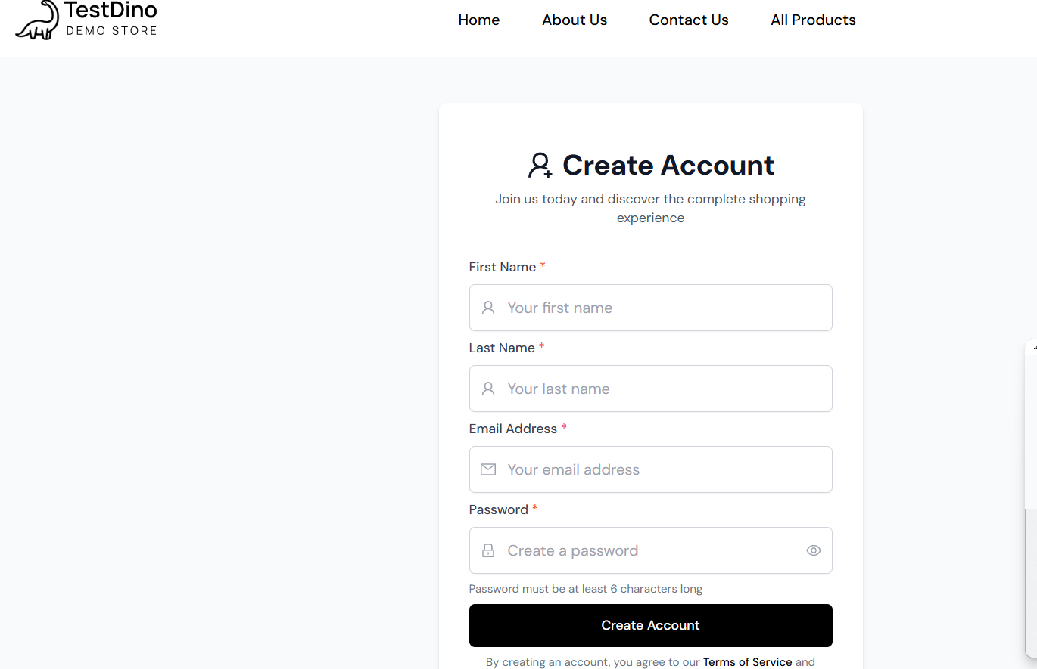
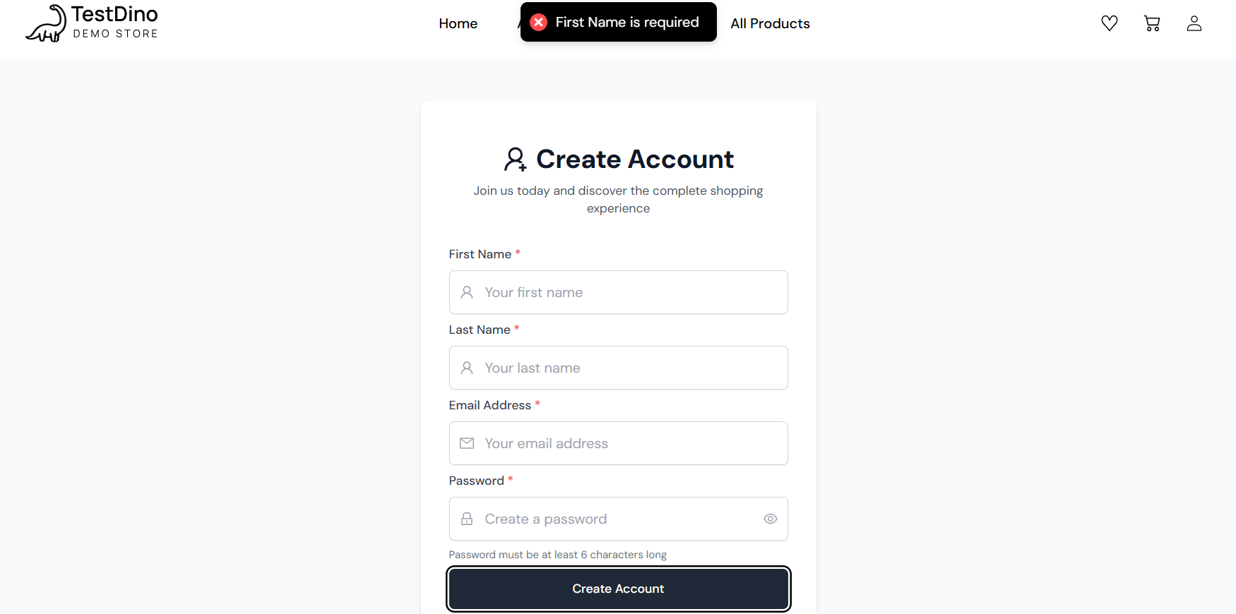
Test: 5E
Scenario : Verify registration page load performance & responsiveness

Test Steps:
1. Open Browser
2. Measure load time of register
3. Check responsive layout

Screenshots:
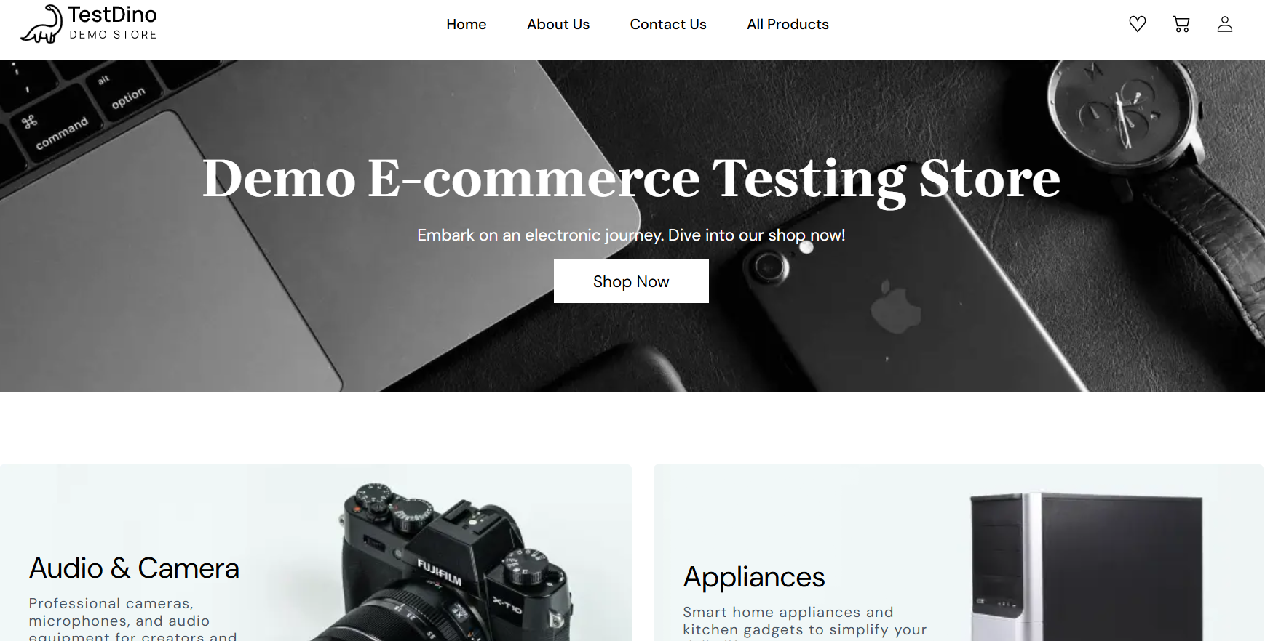
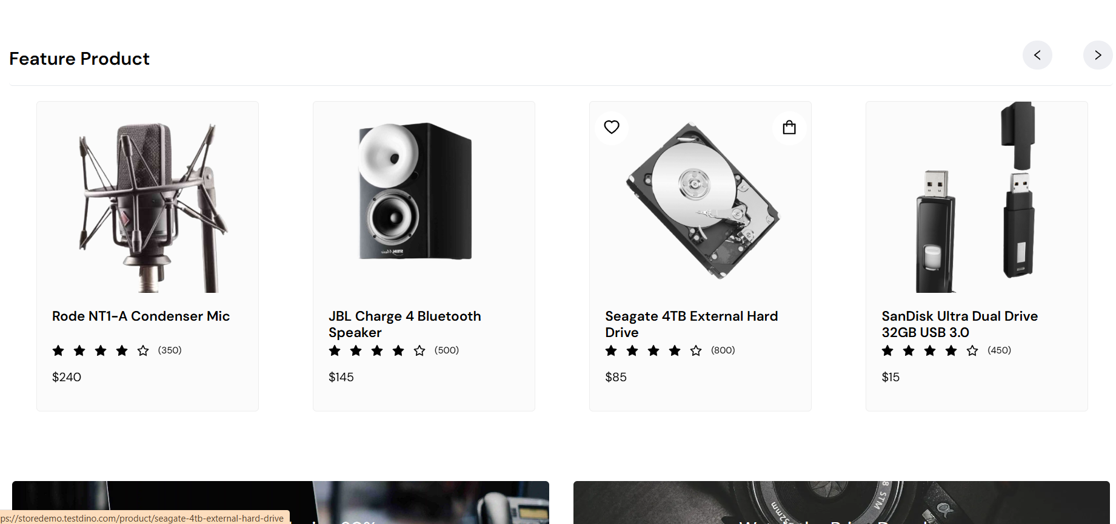

Test: 6F
Scenario : Verify login with valid registered credentials

Test Steps:
1. Go to Login page
2. Enter valid registered email & password
3. Click 'Sign In'

Screenshots:
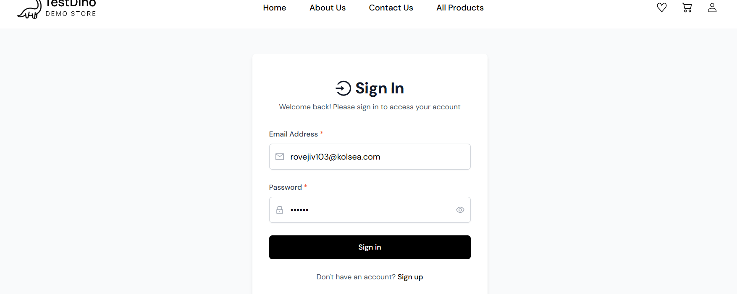
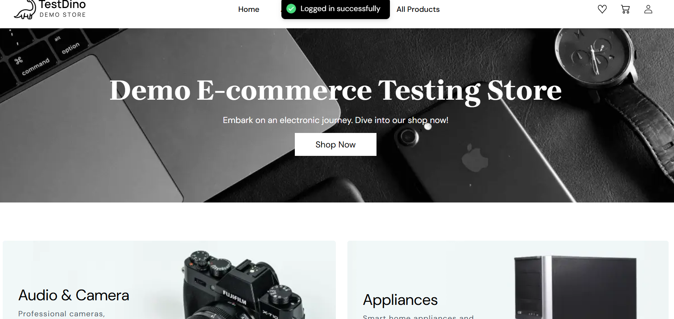
Test:7G
Scenario : Verify login with invalid password

Test Steps:
1. Go to Login page
2. Enter valid email & incorrect password
3. Click 'Sign In'

Screenshots:
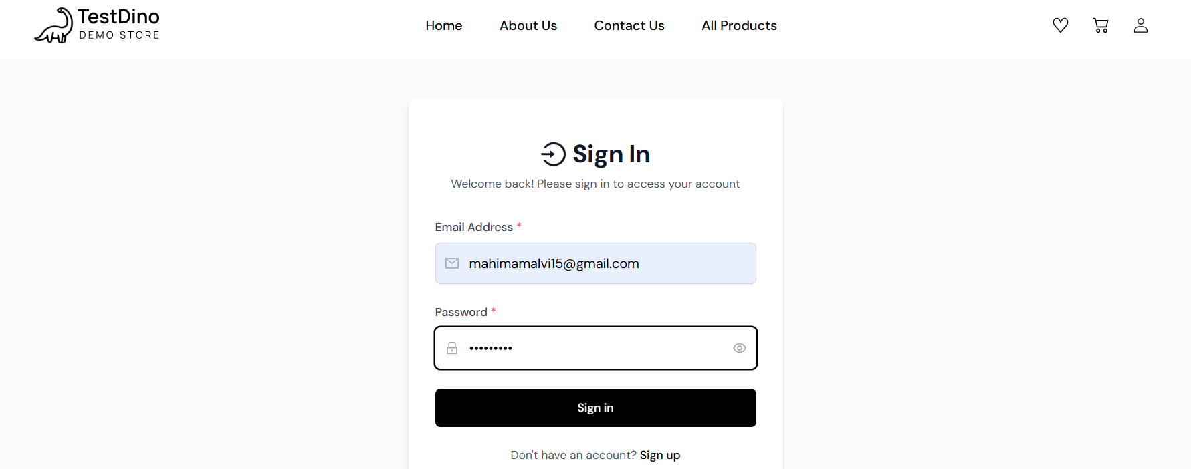
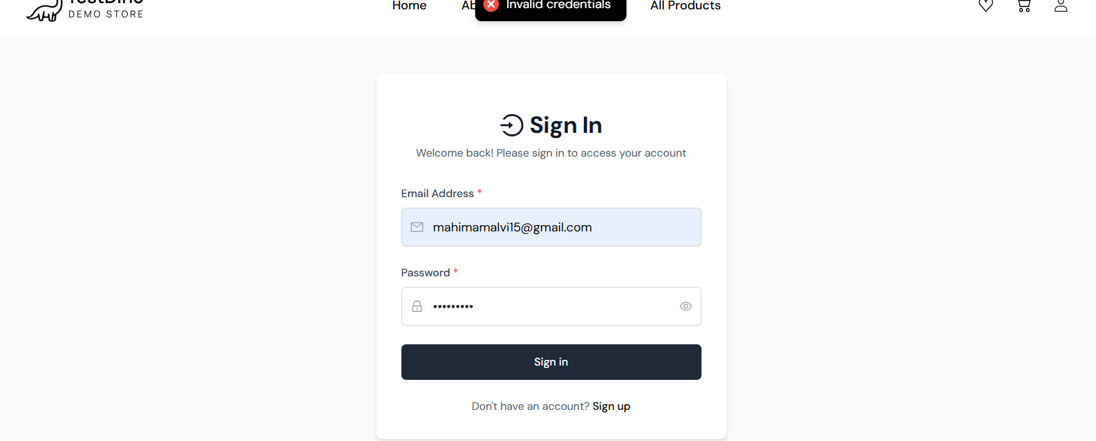
Test:8H
Scenario : Verify account lockout after 5 consecutive failed login attempts

Test Steps:
1. Enter valid email and incorrect password 5 times in a row

Screenshots
Test:9I
Scenario :
Verify login with invalid email

Test Steps:
1. Go to Login page
2. Enter invalid email & password
3. Click 'Sign In'

Screenshots
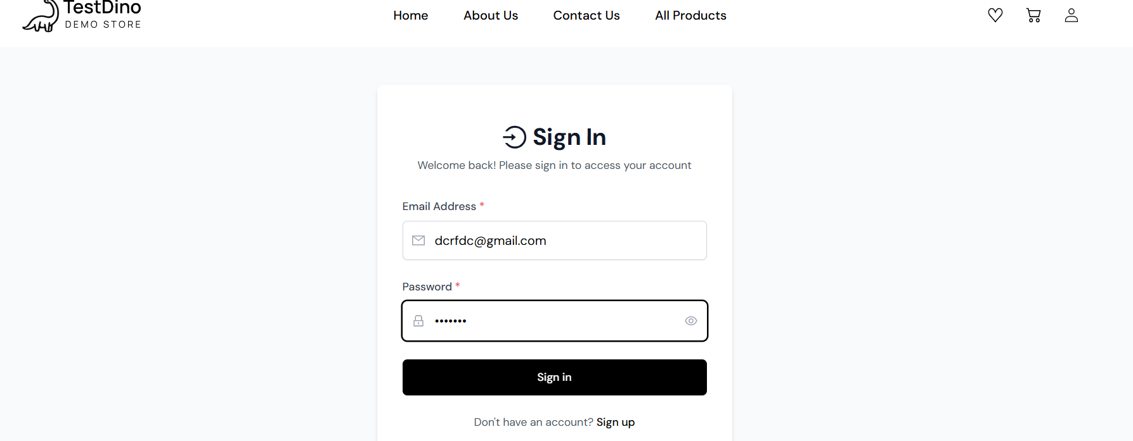
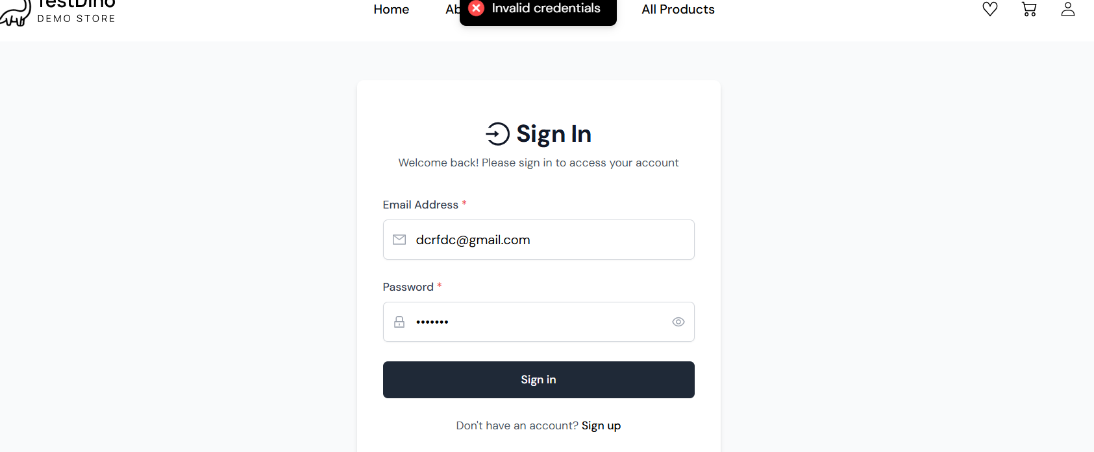
Test:10J
Scenario : Verify successful payment transaction via Credit Card

Test Steps:

1. Add items to Cart and proceed to Checkout
2. Input valid details
3. Select payment method
4. Click continue shopping

Screenshots: 