Module Name: Defect Reporting
Test Case ID: ST_05
Webpage URL: https://automationexercise.com/?utm_source=chatgpt.com

Test :1A
Scenario : sign up with valid credentials

Test Steps:
1. Enter valid username
2. Enter valid email address
3. Click 'signup' button
4. Enter name, email, password, date of birth, first name, last name, company, address, address2, country, state, city, zip code, mobile number
5. Click ‘Create Account’ button
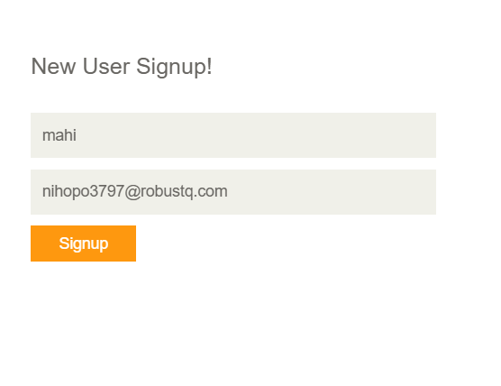
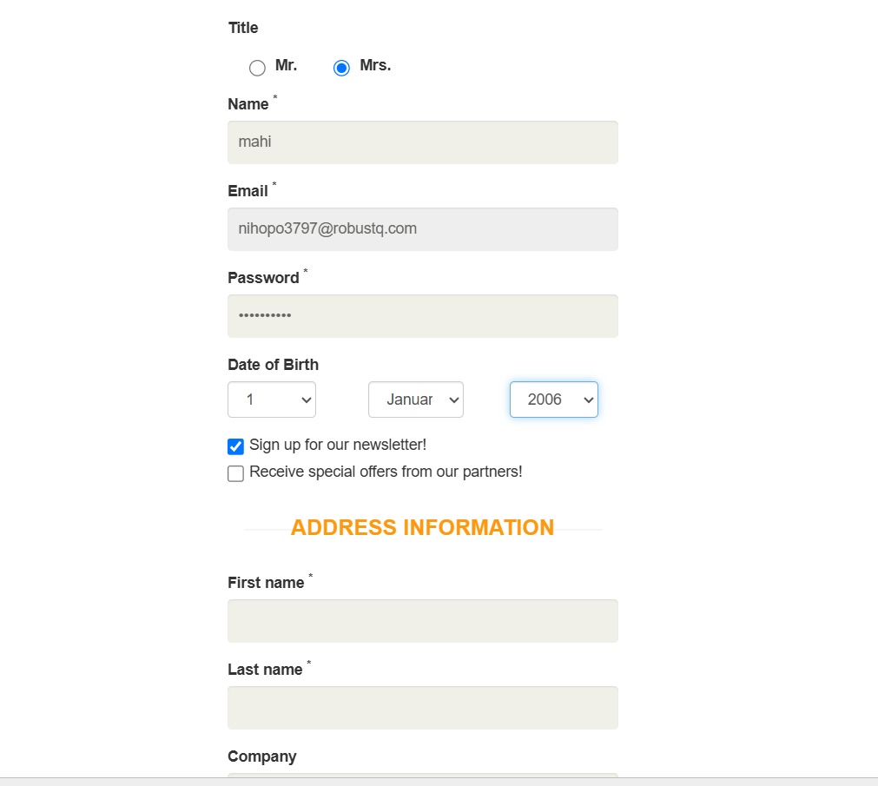
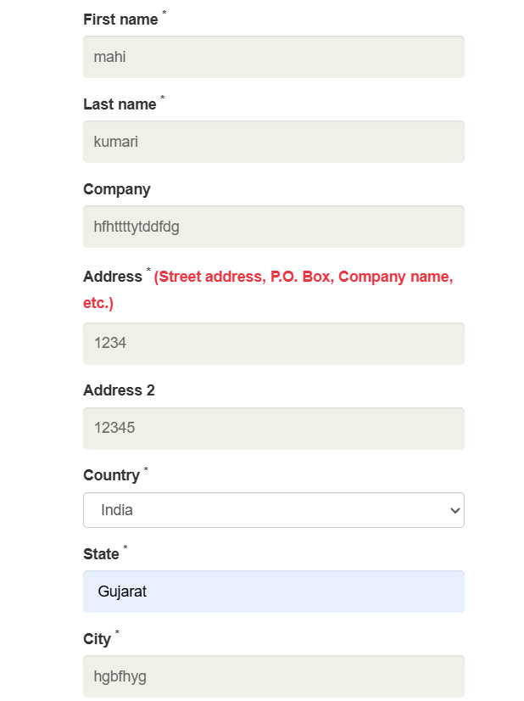
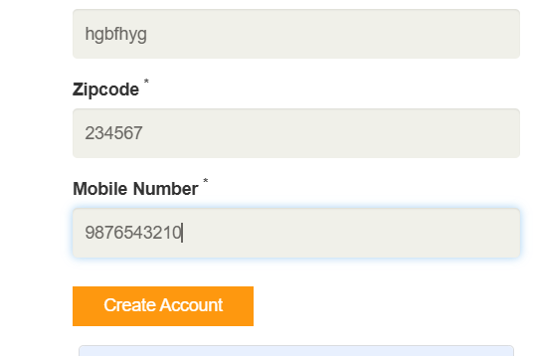
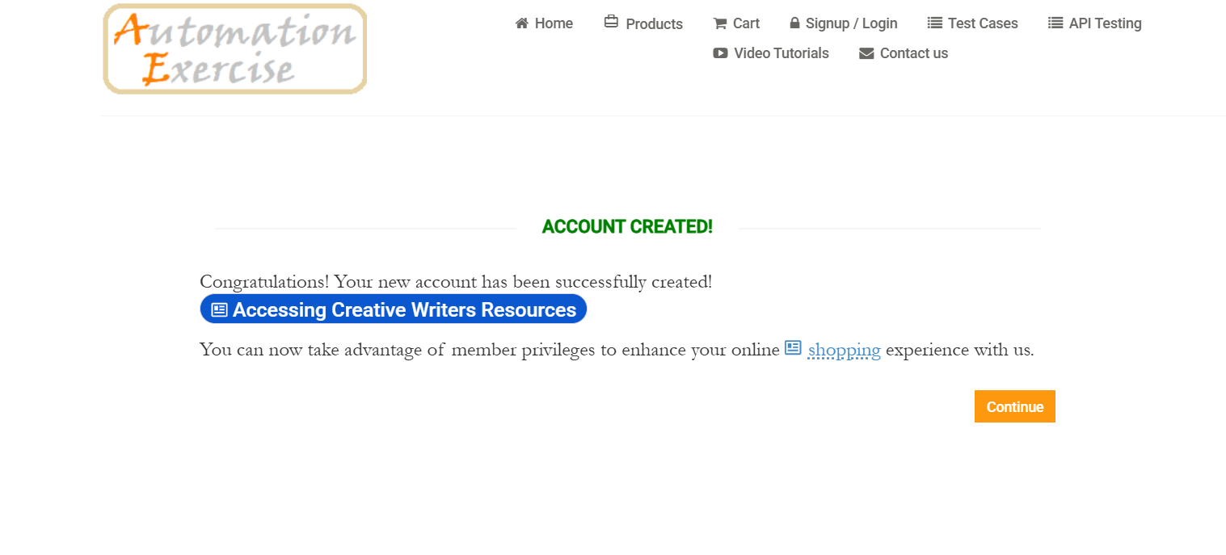

Test :2B
Scenario : Verify user login with valid credentials

Test Steps:
1. Enter valid username
2. Enter valid password
3. Click 'Login' button
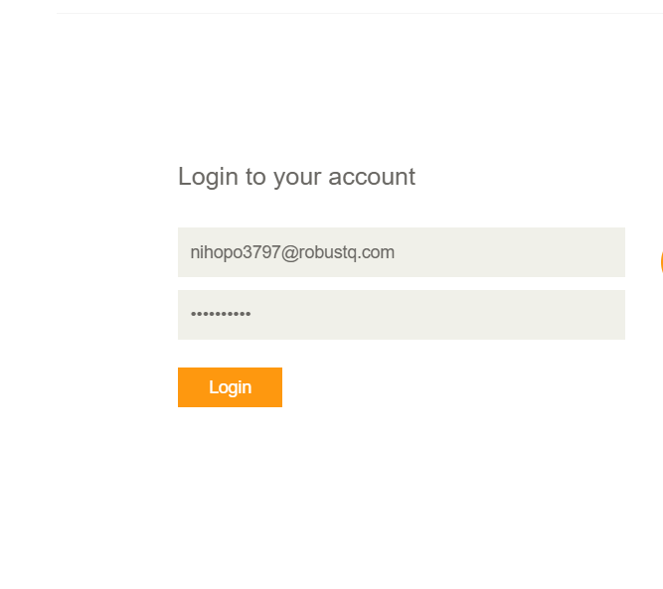
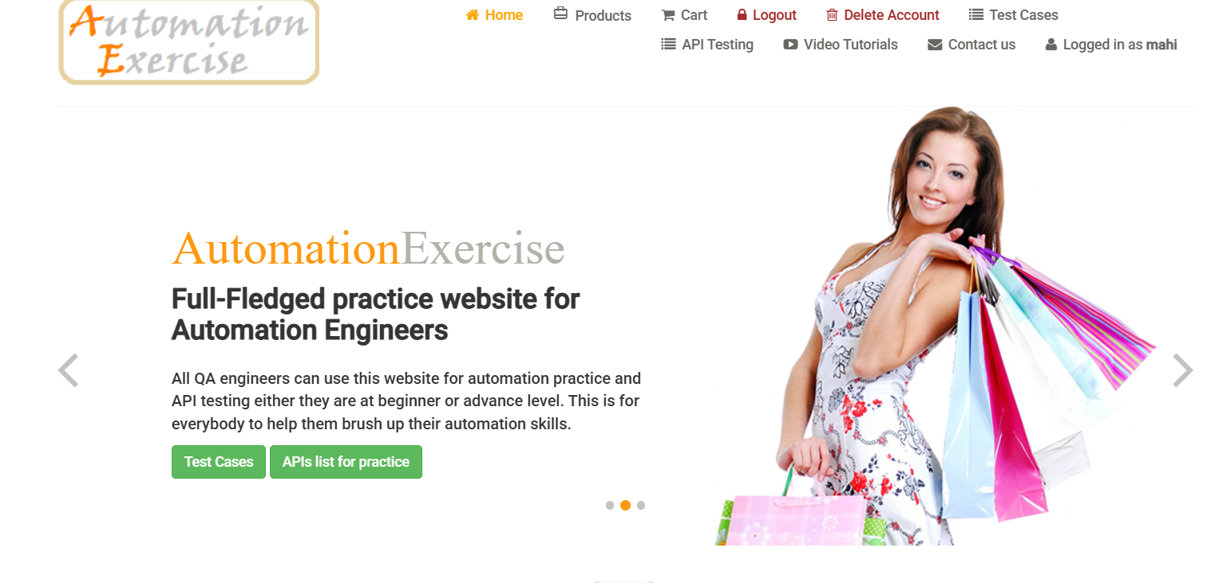
Test :3C
Scenario : Verify login with invalid password

Test Steps:
1. Enter valid email
2. Enter incorrect password
3. Click 'Login' button
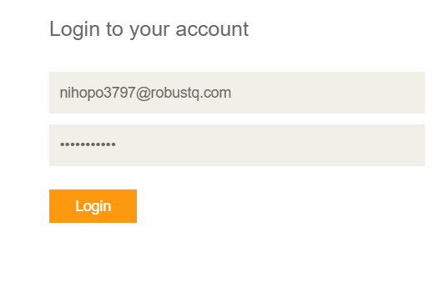
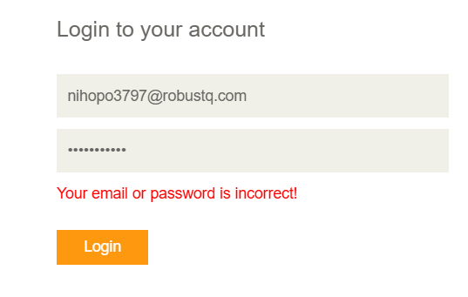
Test :4D
Scenario : Verify layout & display of product images

Test Steps:
1. Perform Login with valid credentials
2. Inspect product inventory images on catalogue page

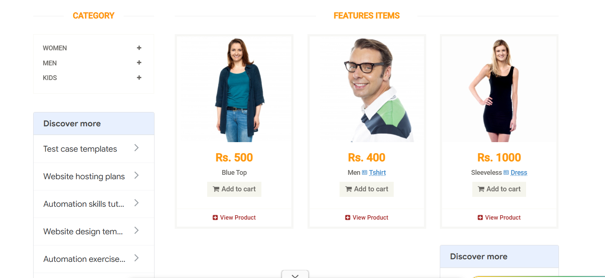


Test :5E
Scenario : Verify adding single item to shopping cart

Test Steps:
1. Navigate to catalog
2. Click 'Add to cart’
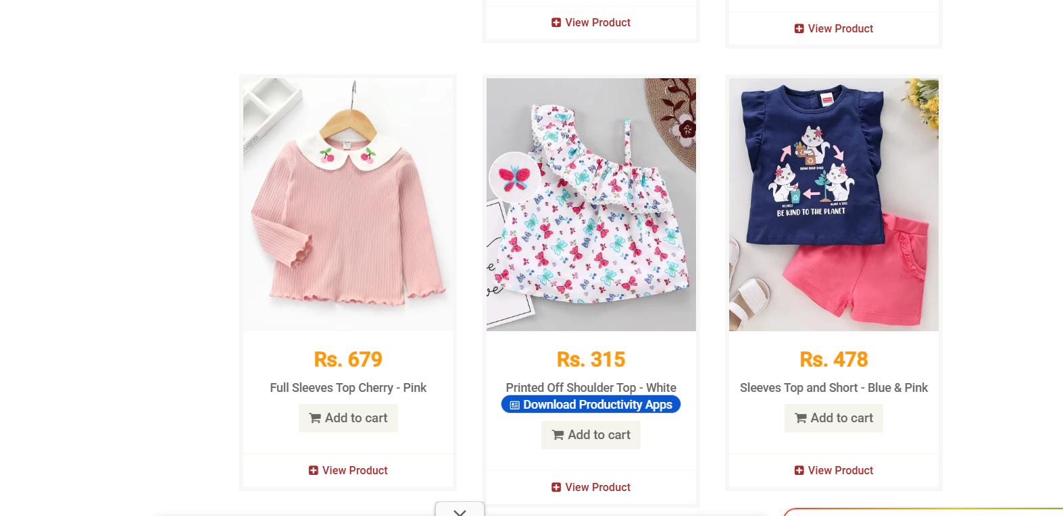
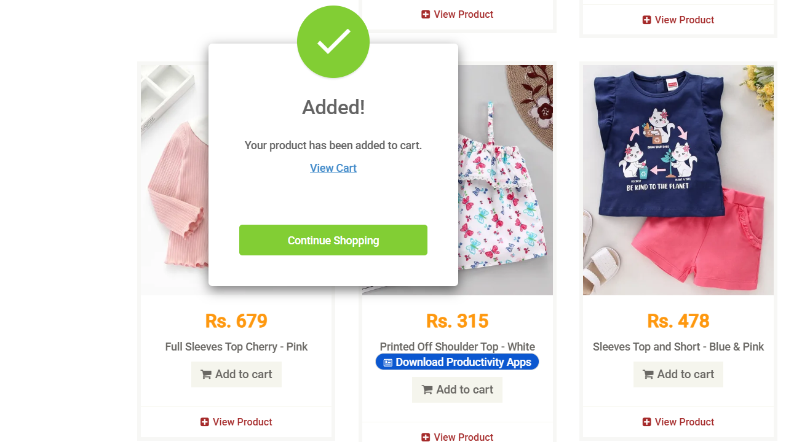
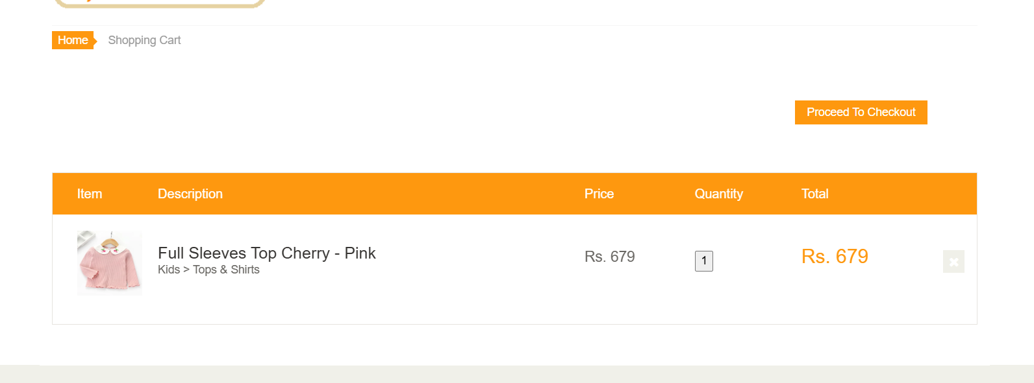
Test :6F
Scenario : Verify removing item from cart on inventory page

Test Steps:
1. Perform Login
2. Add item to cart
3. Click 'cross' button
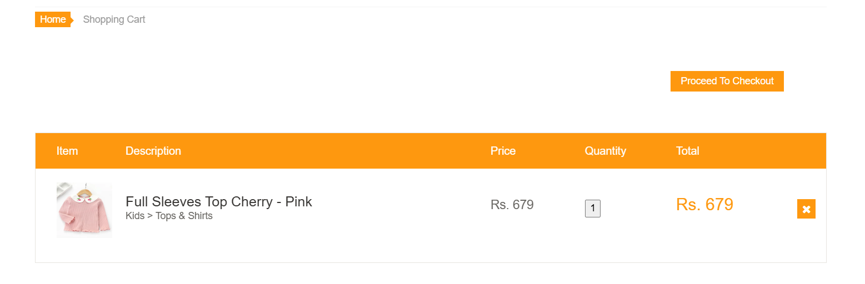
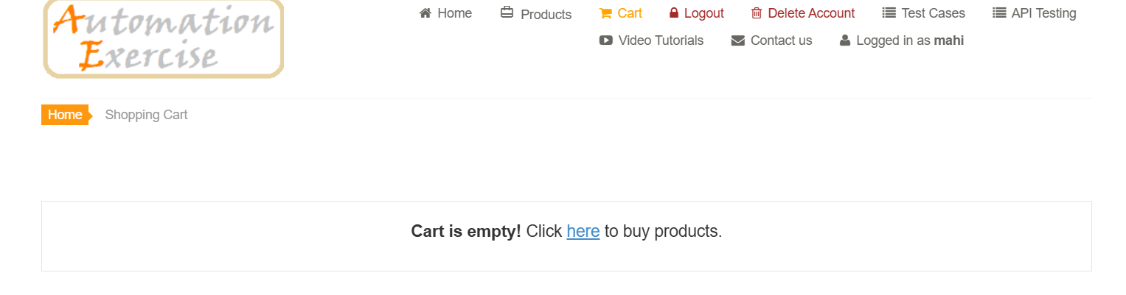

Test :7G
Scenario : Check whether the category is working or not.

Test Steps:
1.click ‘women’
2.Choose one from a dress, tops, or a saree.

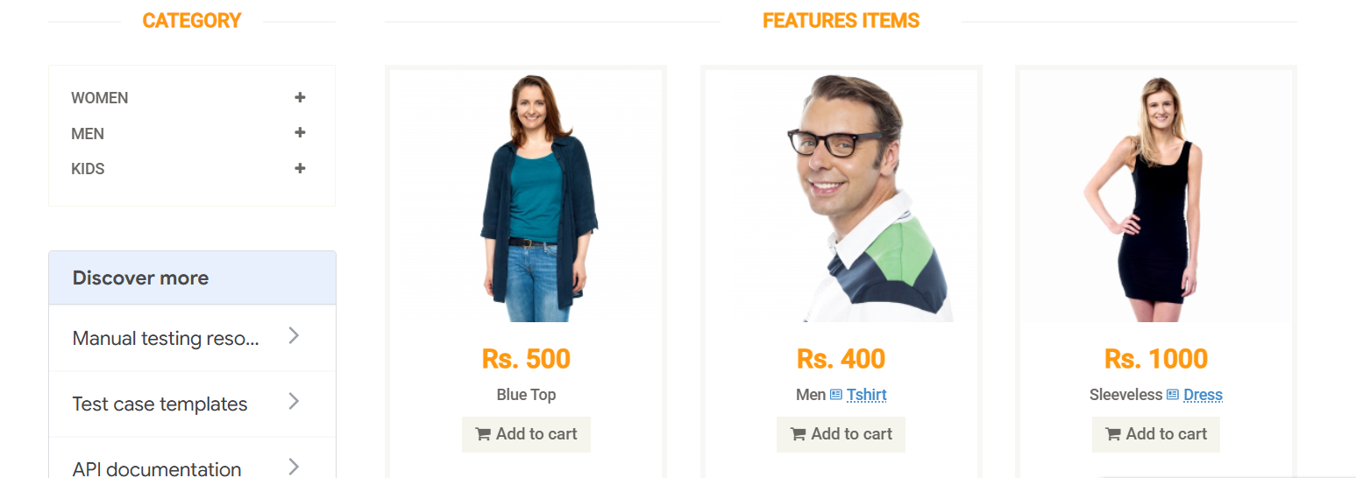
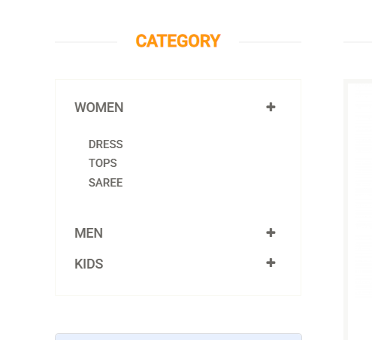


Test :8H
Scenario : Check whether the brands are available or not.

Test Steps:
1. login
2. click any one brand (like polo )


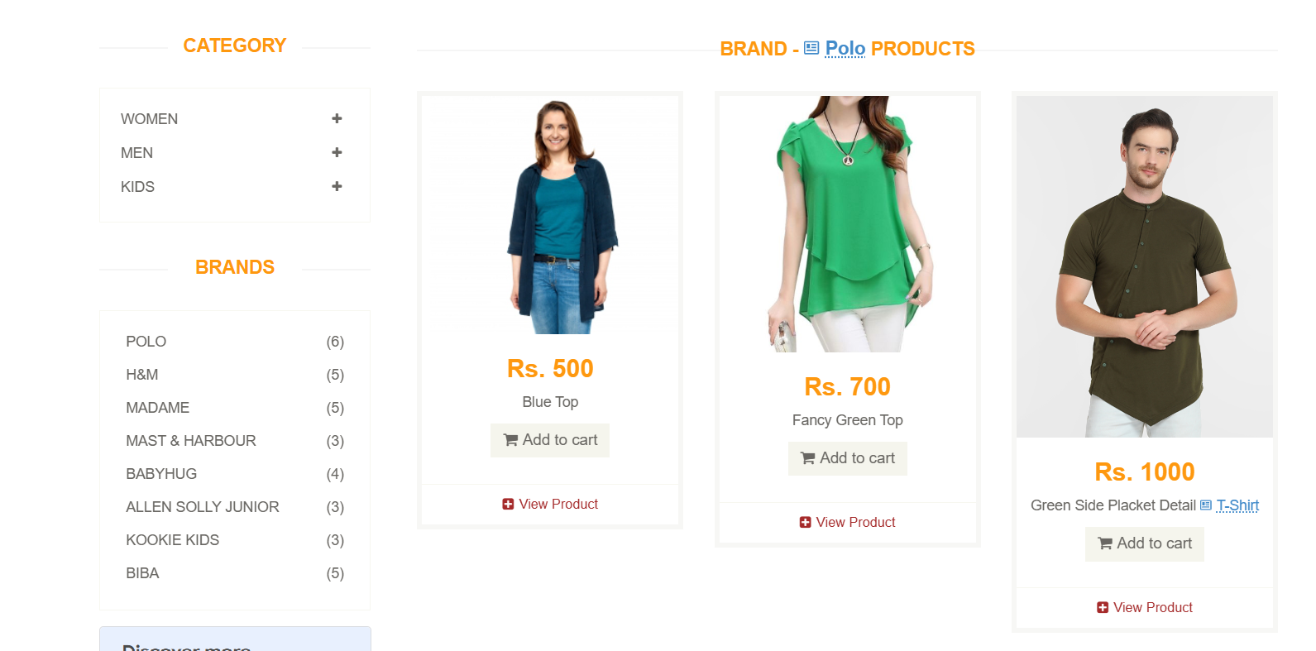
Test :9I
Scenario : place order

Test Steps:
1. Add product to cart
2. Click cart button
3. Click proceed to checkout
4. Click place order
5. Fill all detail
6. Click pay and confirm order

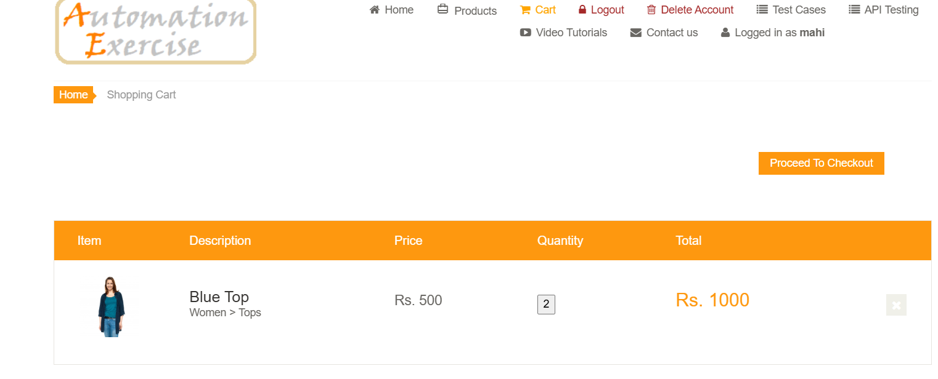
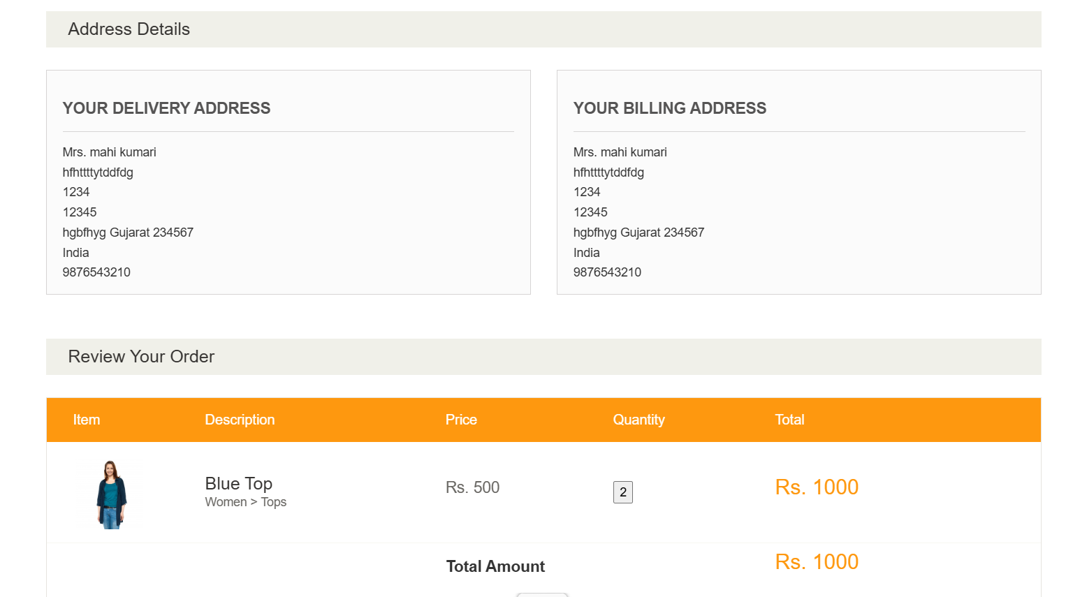
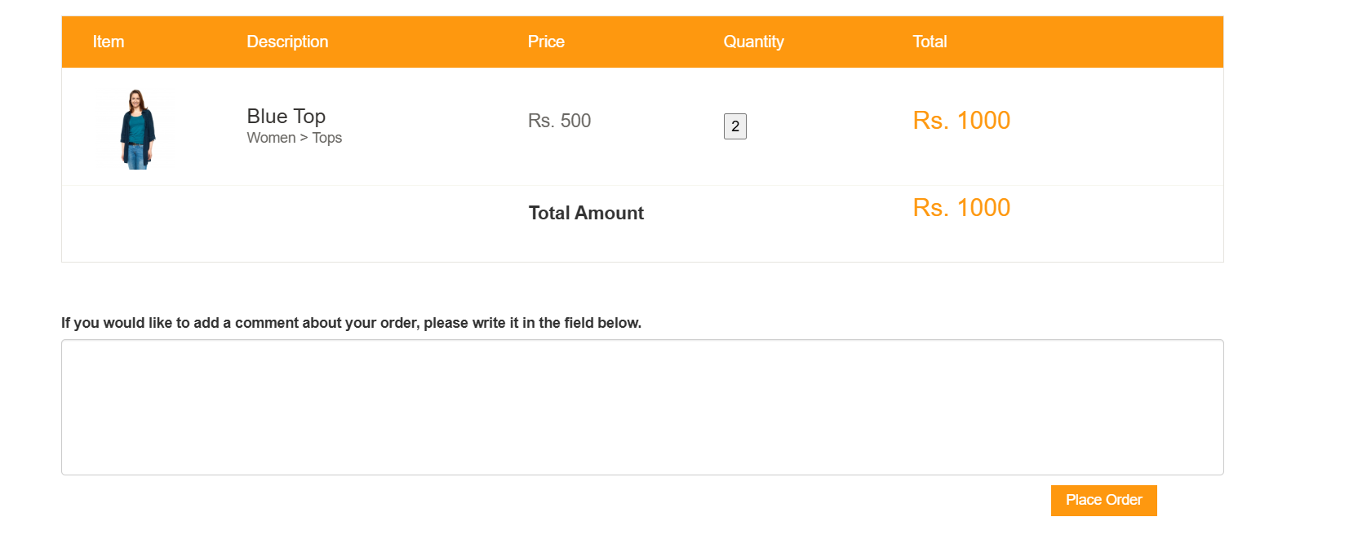
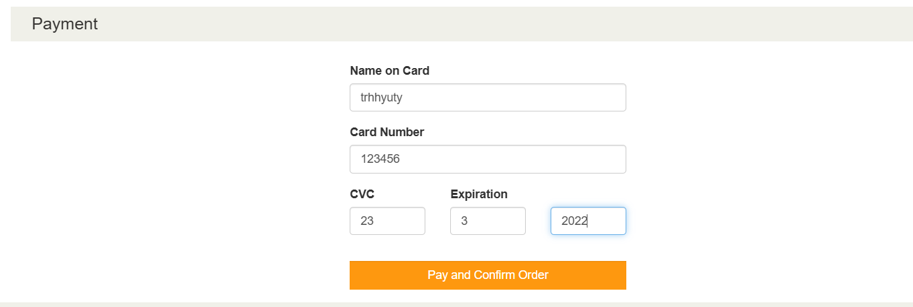
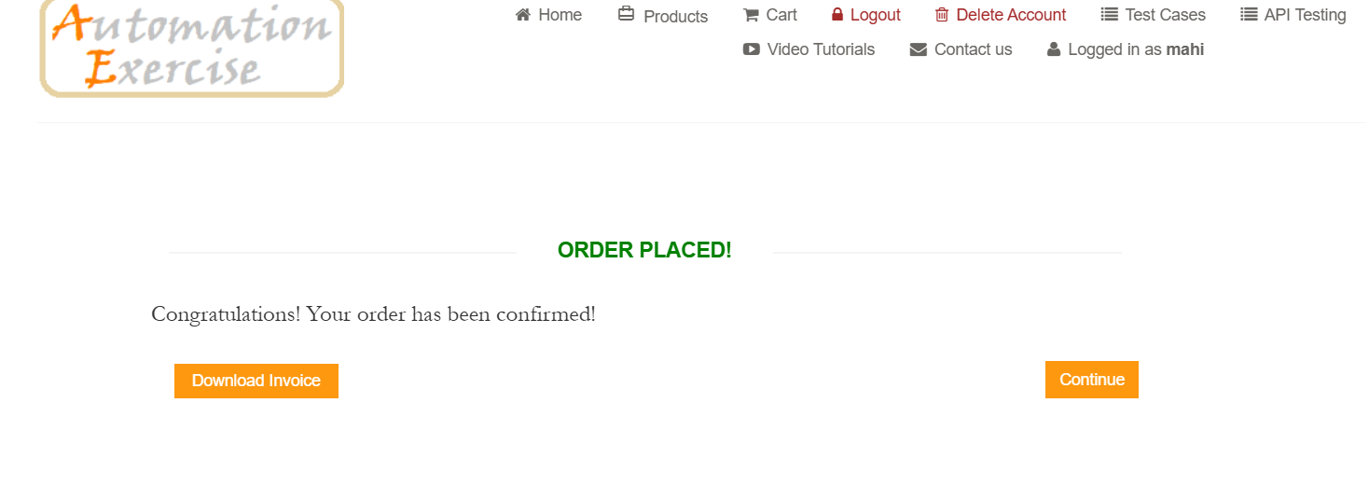
Test :10J
Scenario : Verify user can log out successfully

Test Steps:
1.Go to the home page.
2.click logout
3. Verify Login page is displayed again.
