Module Name: Manual Test Execution
Test Case ID: ST_06
Webpage URL: https://parabank.parasoft.com/parabank/index.htm?utm_source=chatgpt.com

Scenario ID: 1a
Scenario: Verify User Login with Valid Credentials
Test Steps: 1. Open ParaBank login page
2. Enter username
3. Enter password
4. Click 'LOG IN'
Screenshots:
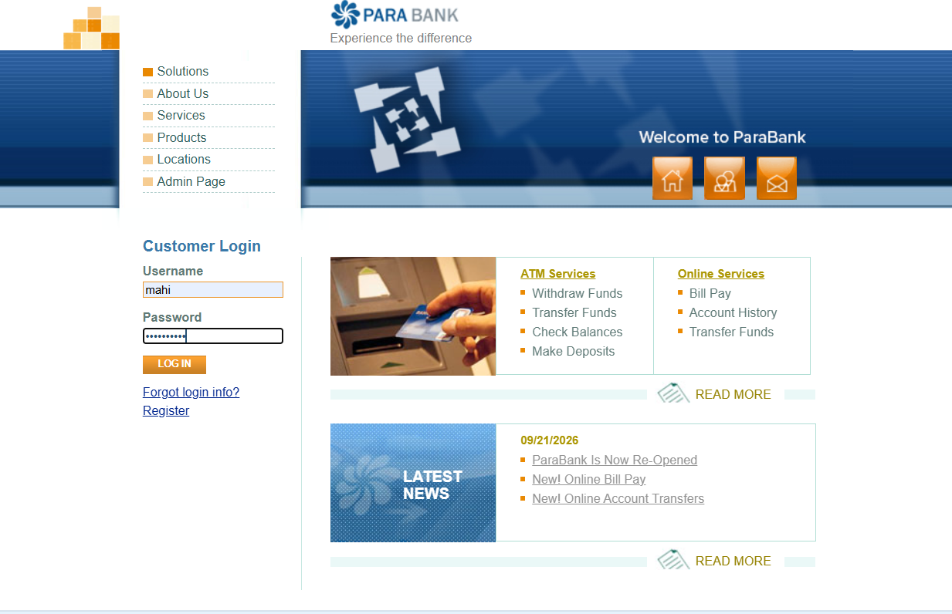
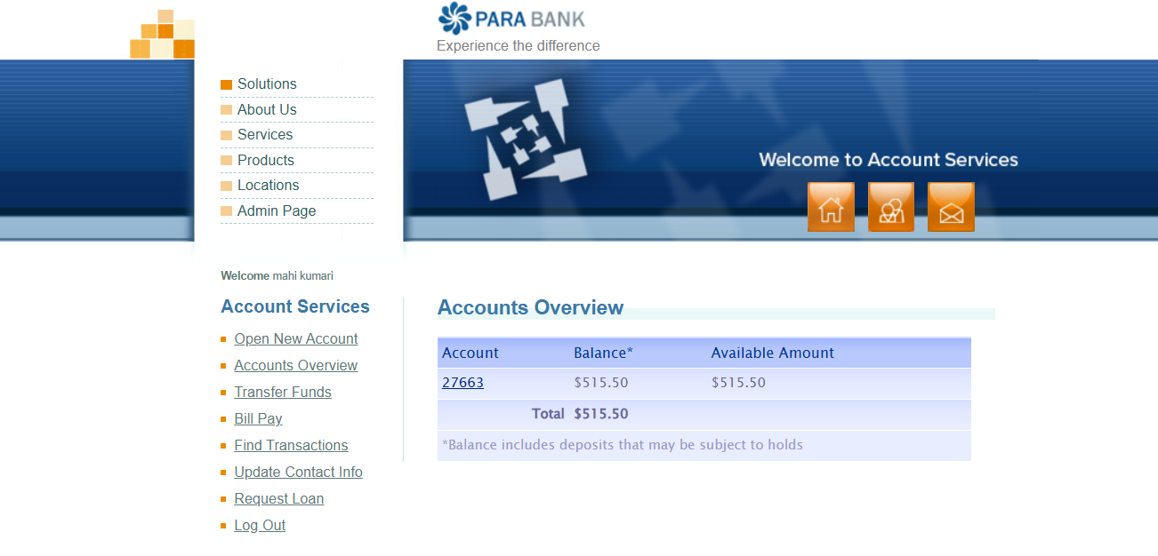

Scenario ID: 2b
Scenario: Verify Customer Login with Incorrect Password
Test Steps:
1. Open login page
2. Enter valid username
3. Enter incorrect password
4. Click 'LOG IN'
Screenshots: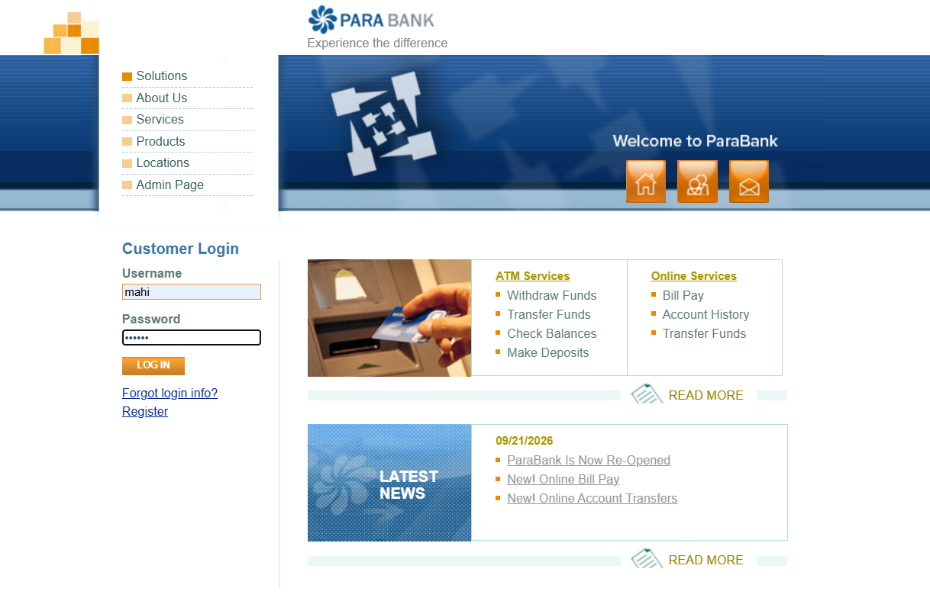
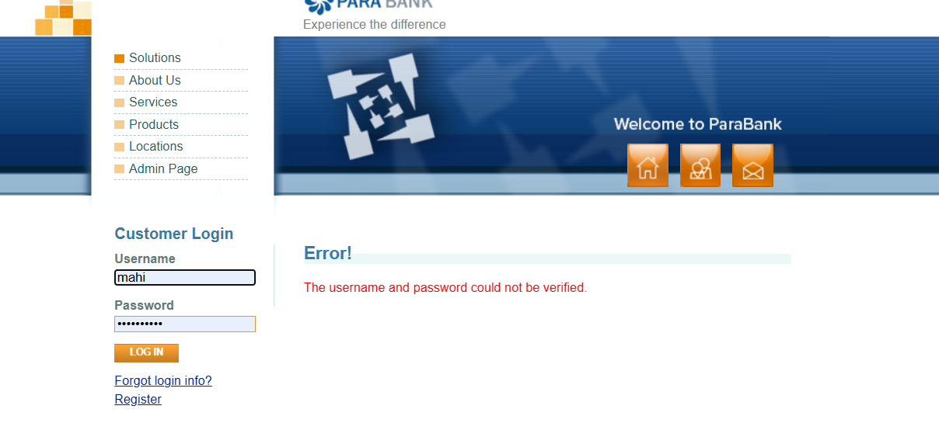

Scenario ID: 3c
Scenario: Verify Login Validation with Blank Fields
Test Steps:
1. Open login page
2. Leave Username and Password blank
3. Click 'LOG IN'
Screenshots: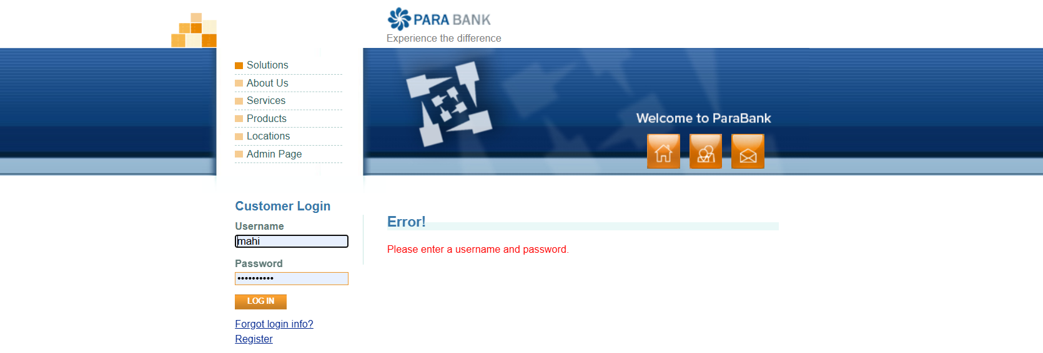

Scenario ID: 4d
Scenario: Verify New User Registration
Test Steps:
1. Click 'Register'
2. Enter all required customer details
3. Enter a unique username and password
4. Click 'Register'
Screenshots: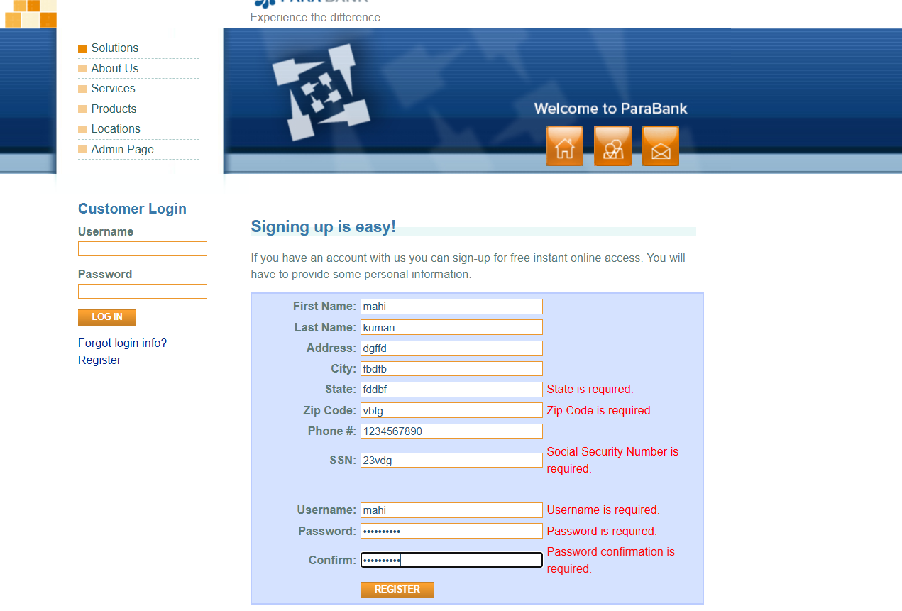

Scenario ID: 5e
Scenario:Verify Registration with Existing Username
Test Steps:
1. Open Register page
2. Enter valid customer details
3. Use an already registered username
4. Submit registration
Screenshots:

Scenario ID: 6f
Scenario: Verify Open New Account Functionality
Test Steps:
1. Log in
2. Open 'Open New Account'
3. Select account type
4. Select an existing account for funding
5. Click 'OPEN NEW ACCOUNT'
Screenshots: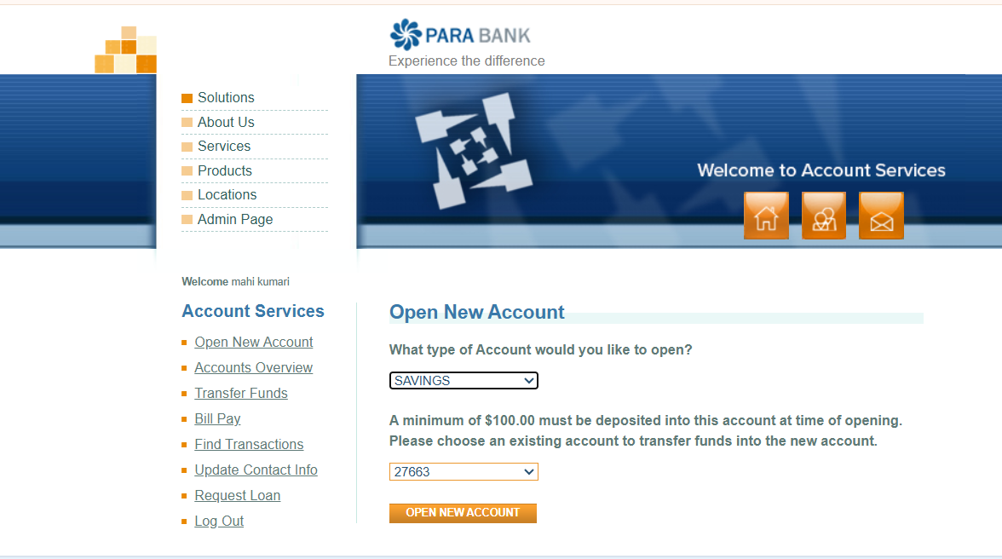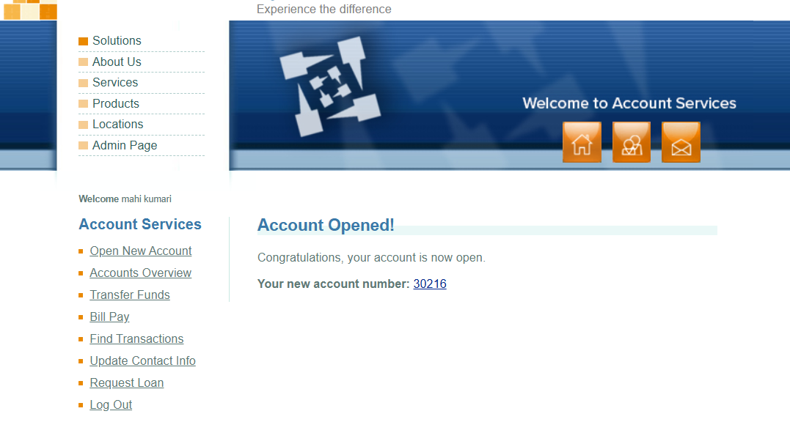

Scenario ID: 7g
Scenario: Verify Accounts Overview
Test Steps:
1. Log in
2. Click 'Accounts Overview'
3. Review listed accounts
Screenshots:
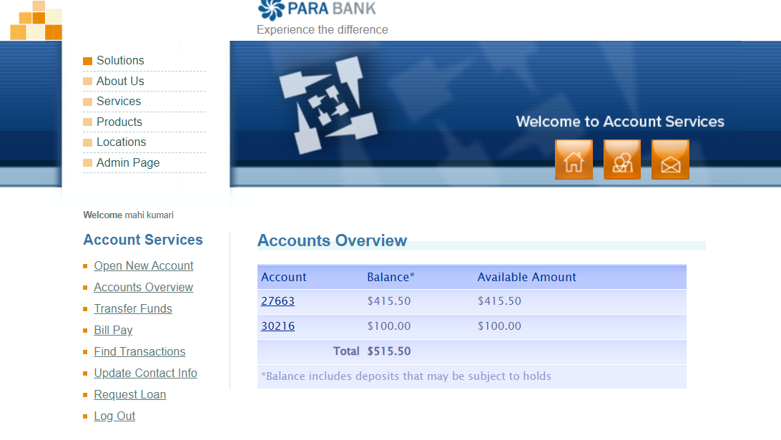

Scenario ID: 8h
Scenario: Verify Transfer Funds with Valid Amount
Test Steps:
1. Log in
2. Click 'Transfer Funds'
3. Select source and destination accounts
4. Enter transfer amount
5. Click transfer/submit
Screenshots: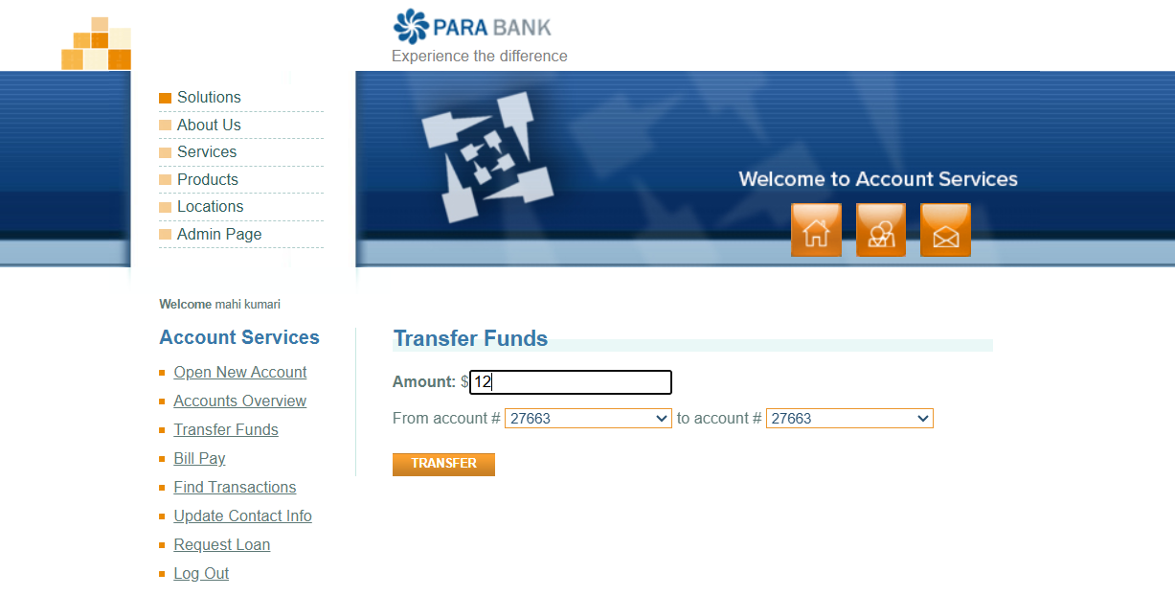
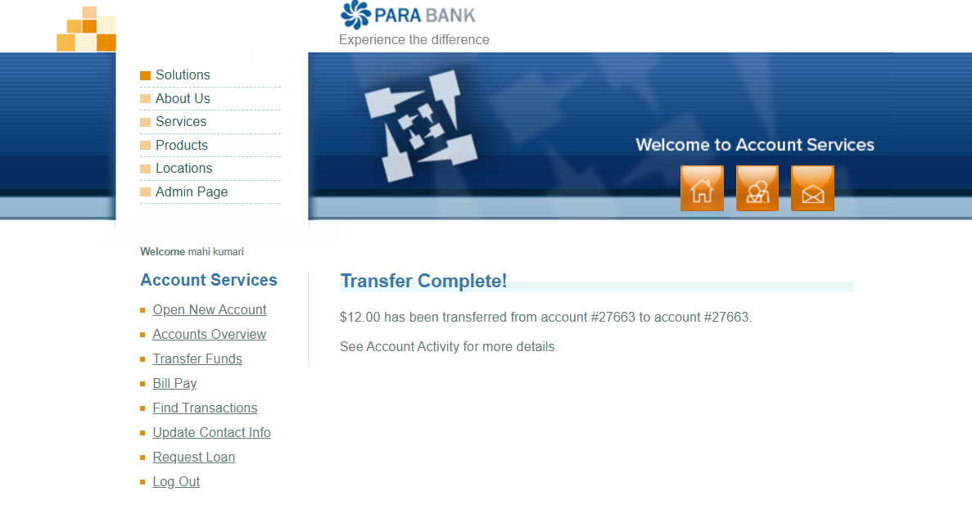

Scenario 9i:
Scenario: Verify Bill Pay with Valid Customer Information
Test Steps:
1. Log in
2. Click 'Bill Pay'
3. Enter payee and payment details
4. Enter valid amount
5. Submit payment
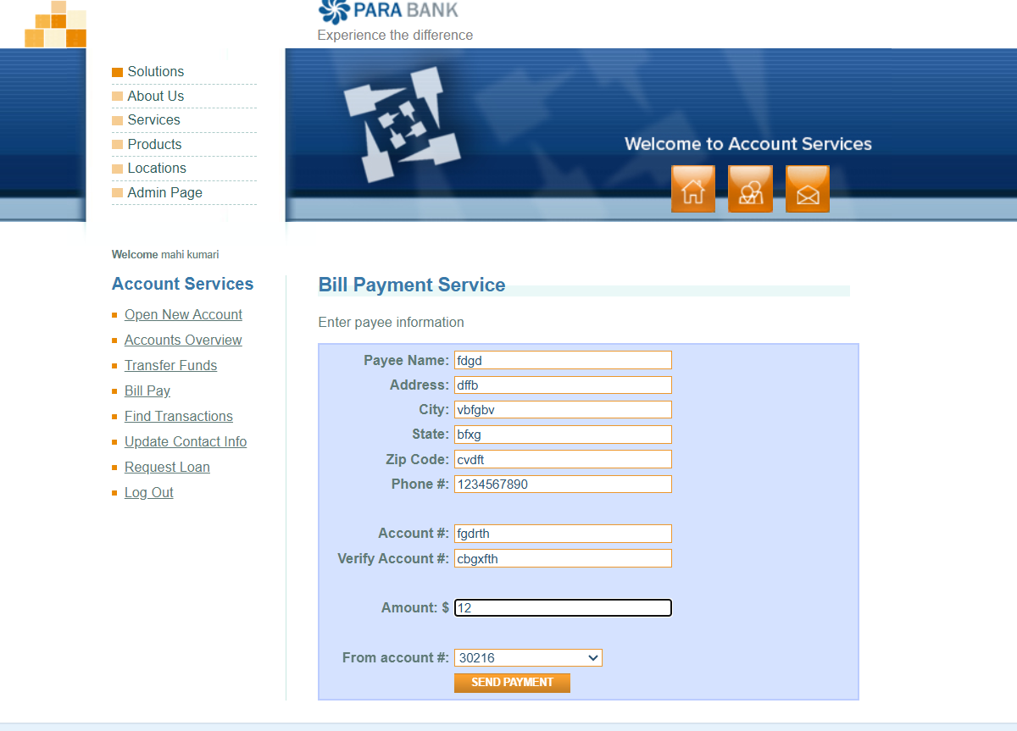

Scenario ID: 10j
Scenario: Verify Logout Functionality
Test Steps:
1. Log in with valid credentials
2. Click 'Log Out'
3. Observe the resulting page
Screenshots:
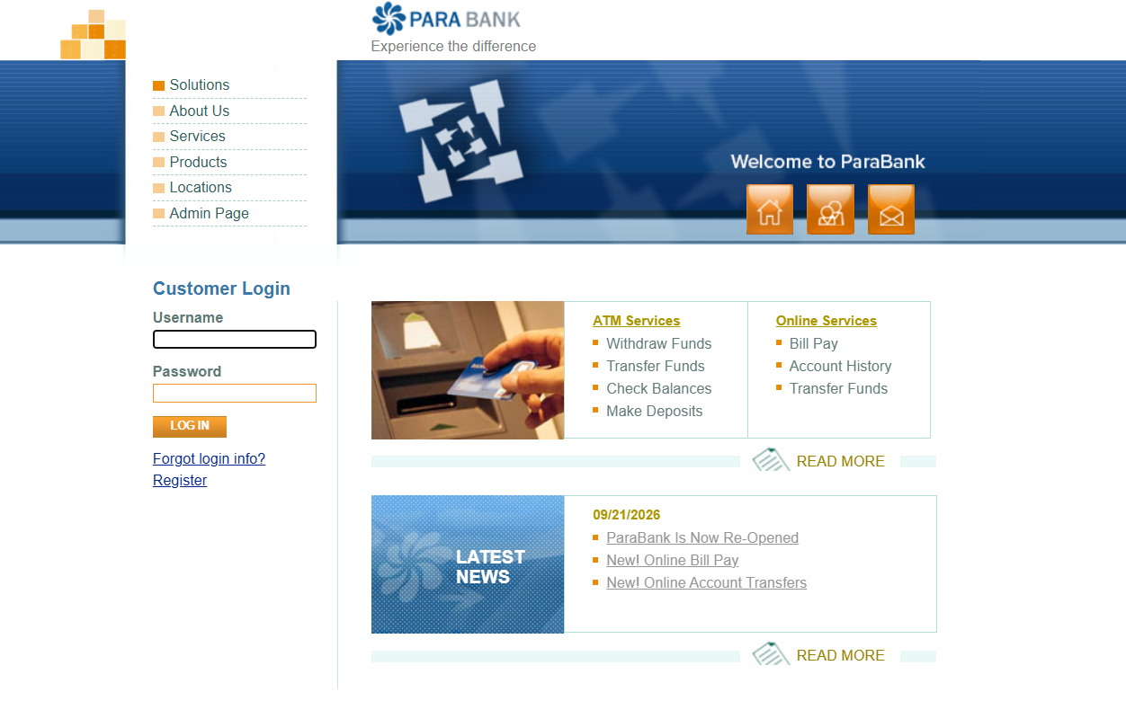

Summary
Execution Status Count Percentage (%)
Passed 10 100% Failed 0 0% Total Test Cases 10 100.00%

