Module Name: Login Module
Test Case ID: ST_07
Webpage URL: https://www.selenium.dev/selenium/web/web-form.html

● Test :1A
Scenario : Verify text input with a normal string (Equivalence Partitioning)
Test Steps:
- Open the Selenium Web Form website.
- Locate the Text Input field.
- Enter Quality Check.
- Click Submit.
- Observe the response page.
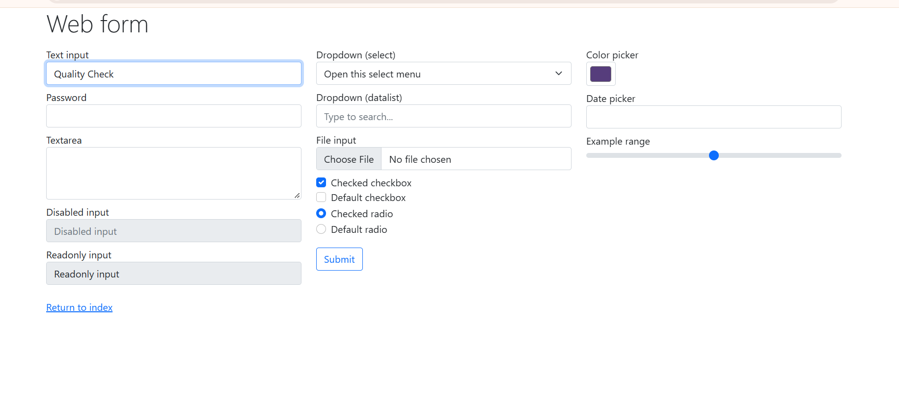
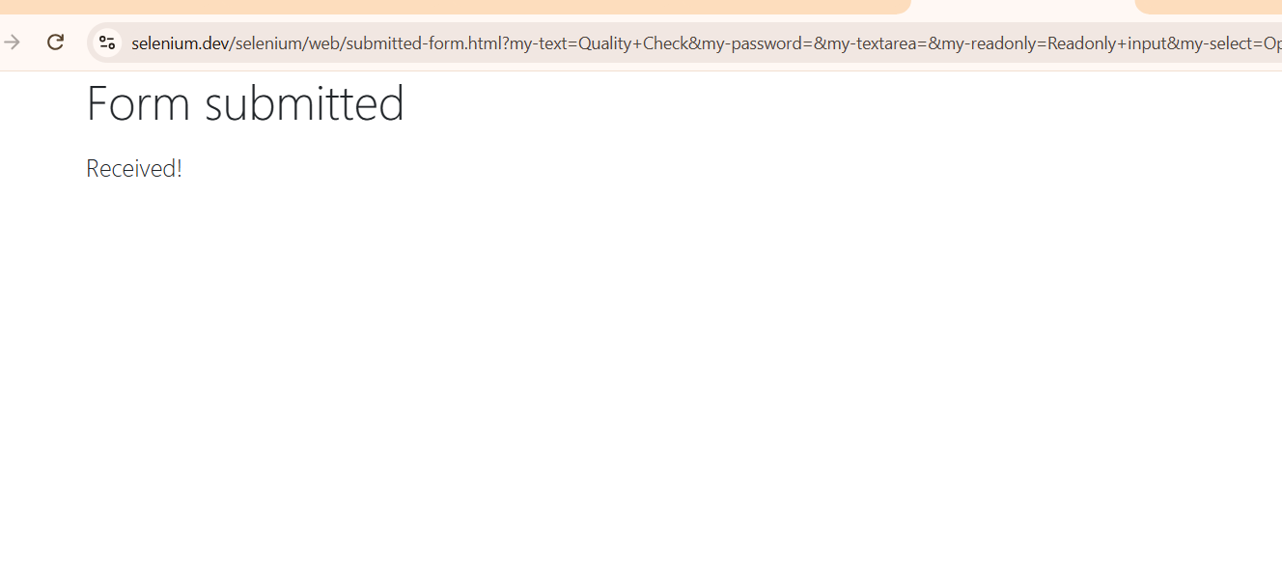
Test :2B
Scenario :Verify text input with a single character (Boundary Value Analysis)
Test Steps:
- Open the Selenium Web Form.
- Enter Q in the Text Input field.
- Click Submit.
- Observe the result.

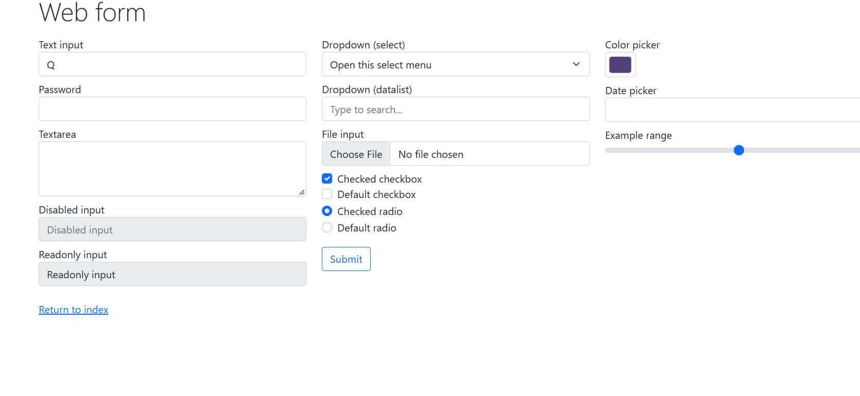
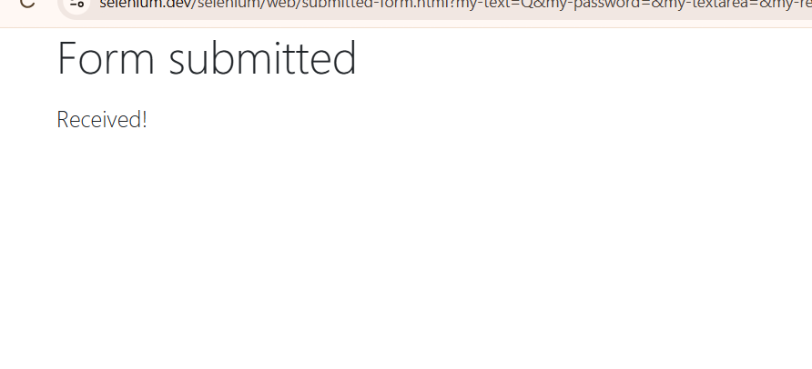
Test :3C
Scenario :Verify text input with a long string
Test Steps:
- Open the Selenium Web Form.
- Enter 40 Z characters in the Text Input field.
- Click Submit.
- Observe whether the text is accepted.
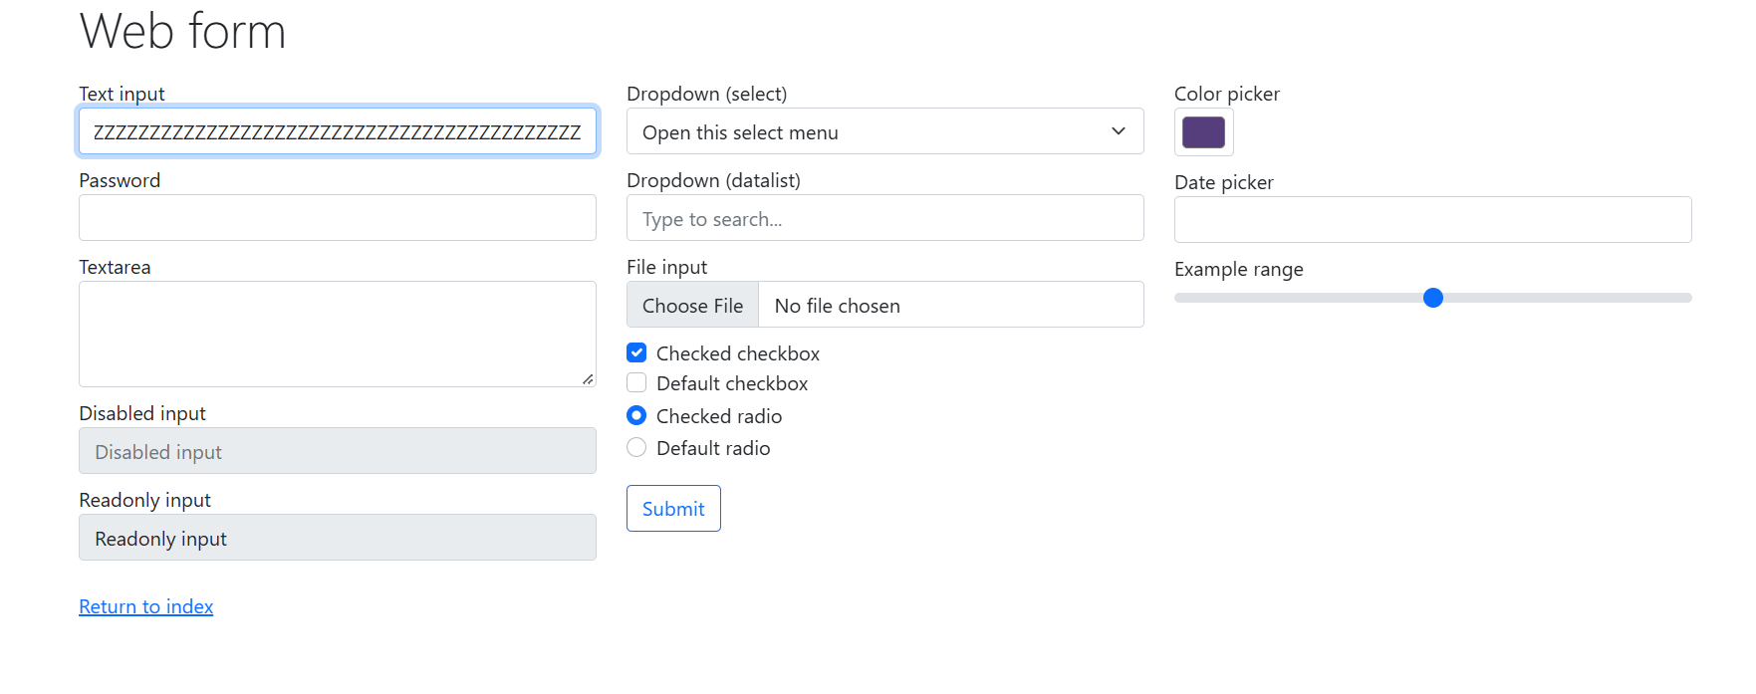

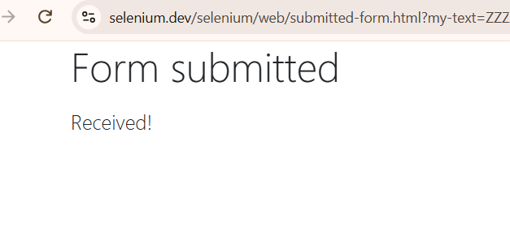
Test :4D
Scenario : Verify password field masking
Test Steps:
- Open the Selenium Web Form.
- Locate the Password field.
- Enter LabTest#42.
- Check whether the characters are masked.
- Click Submit.
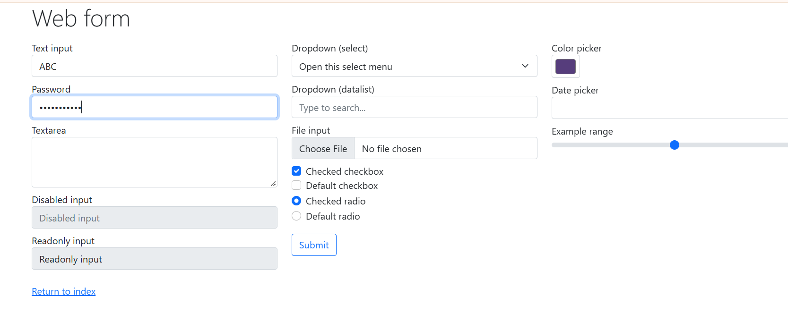
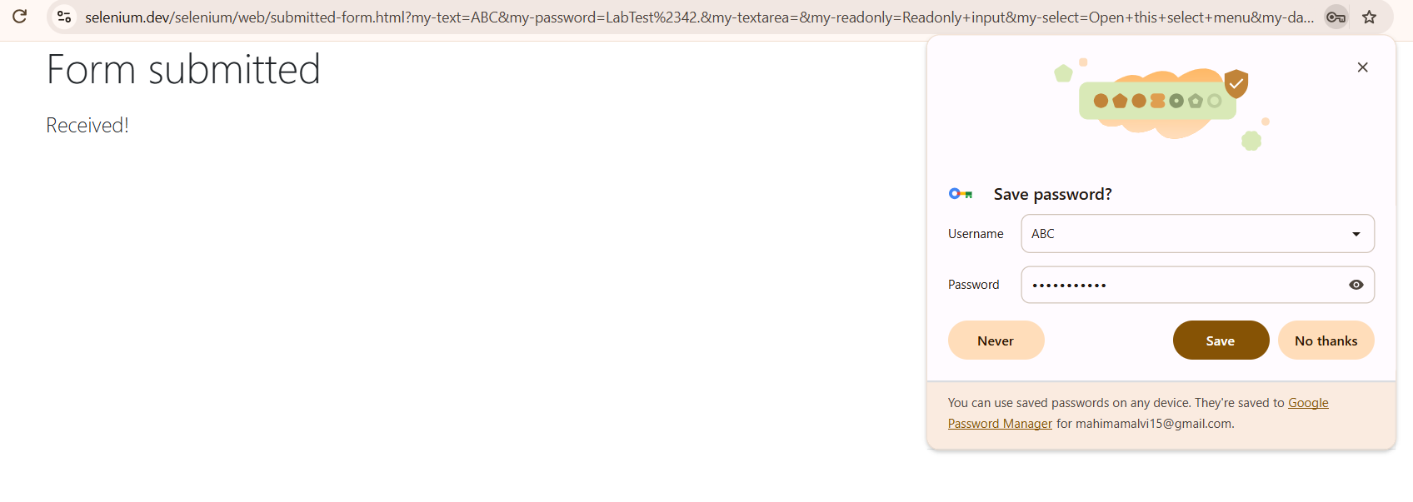
Test :5E
Scenario : Verify disabled input field
Test Steps:
- Open the Selenium Web Form.
- Locate the Disabled Input field.
- Try to enter ChangeMe.
- Observe whether the field value changes.
- 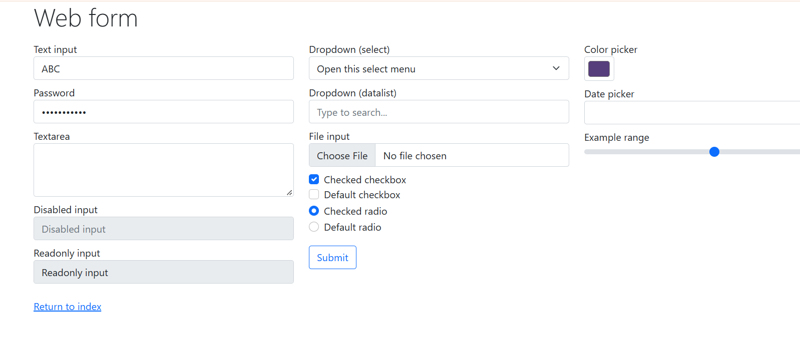
Test :6F
Scenario :

Verify read-only input field
Test Steps:
- Open the Selenium Web Form.
- Locate the Readonly Input field.
- Try to replace its existing text with NewValue.
- Observe the field
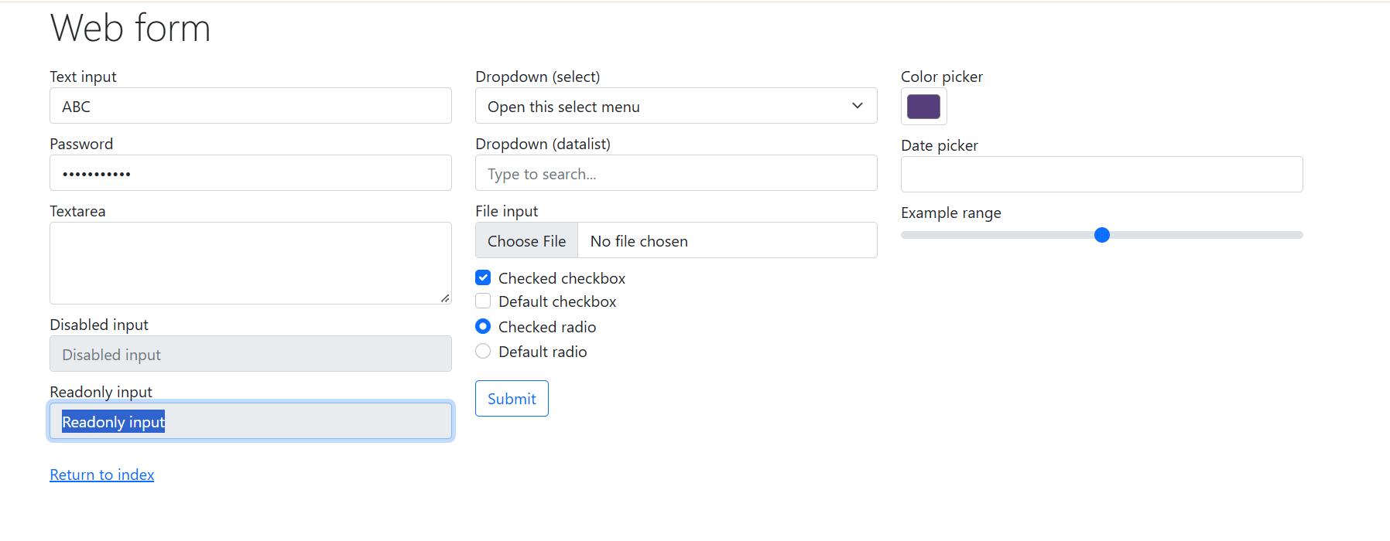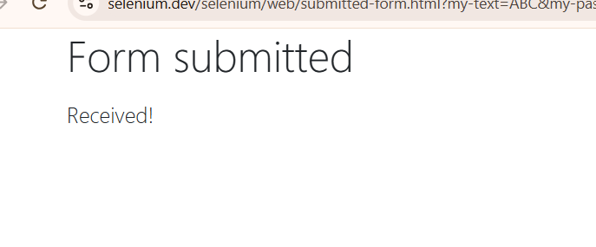.
Test :7G
Scenario : Verify a typical numeric input (Equivalence Partitioning)
Test Steps:
- Open the Selenium Web Form.
- Locate the Number Input field.
- Enter 6.
- Click Submit.
- Observe the response.

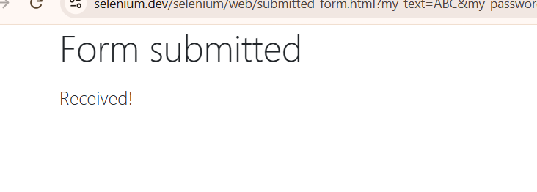
Test :8H
Scenario: Verify the lower numeric boundary
Test Steps:
- Locate the Number Input field.
- Enter 1.
- Click Submit.
- Observe the result.
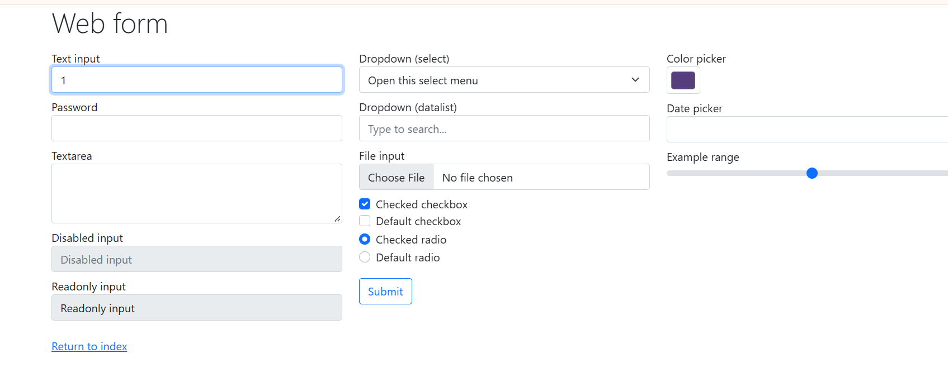

Test :9I
Scenario : Verify the upper numeric boundary
Test Steps:
- Locate the Number Input field.
- Enter 10.
- Click Submit.
- Observe the result.
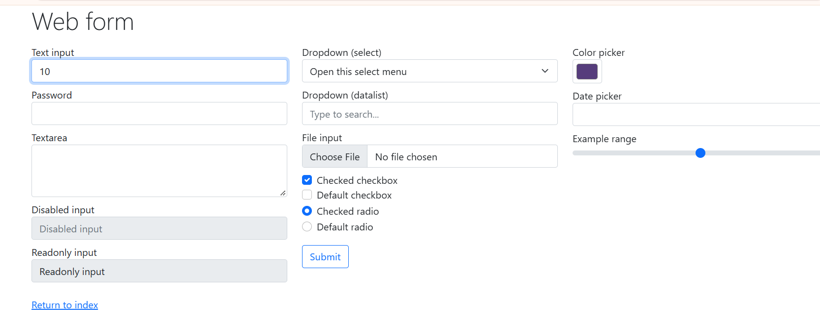

Test :10J
Scenario : Verify a value below the lower boundary
Test Steps:
- Locate the Number Input field.
- Enter 0.
- Click Submit.
- Observe browser validation or the response page.
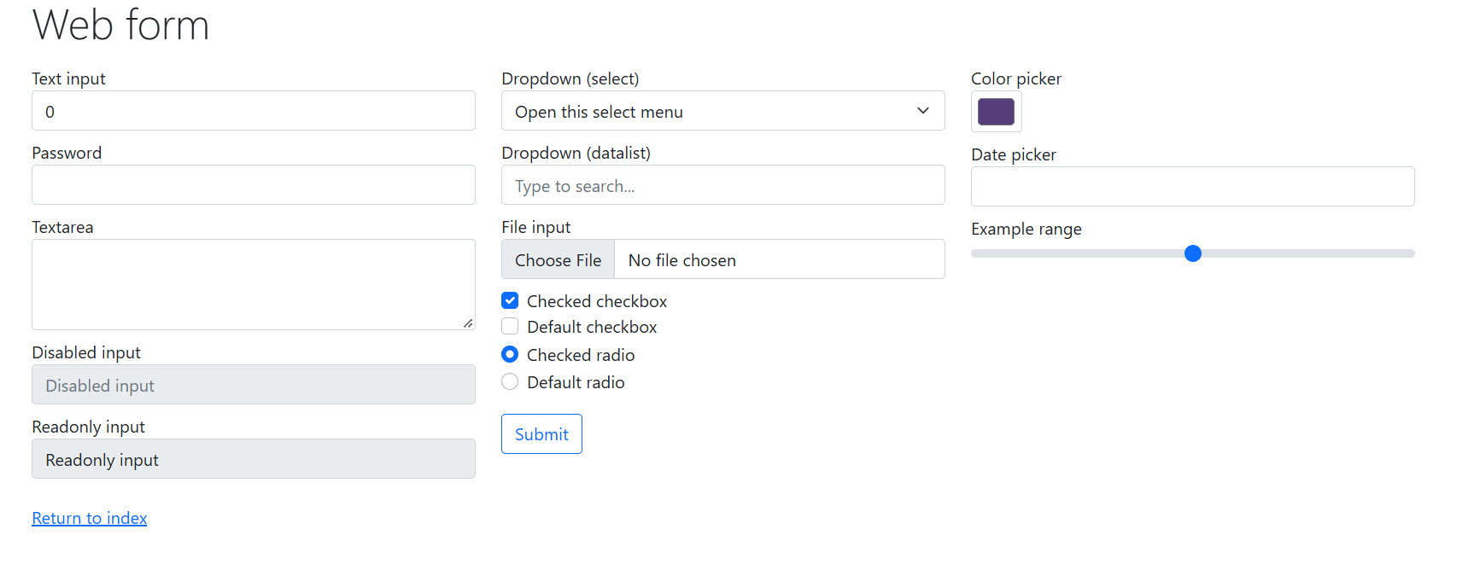
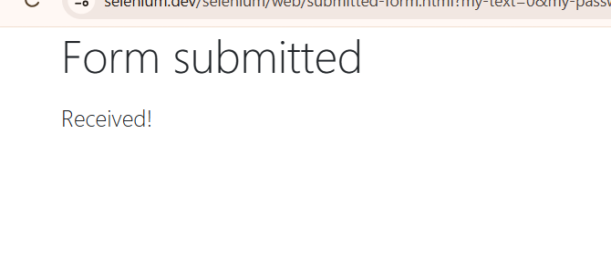
Test :11K
Scenario: Verify a value above the upper boundary
Test Steps:
- Locate the Number Input field.
- Enter 12.
- Click Submit.
- Observe the result.
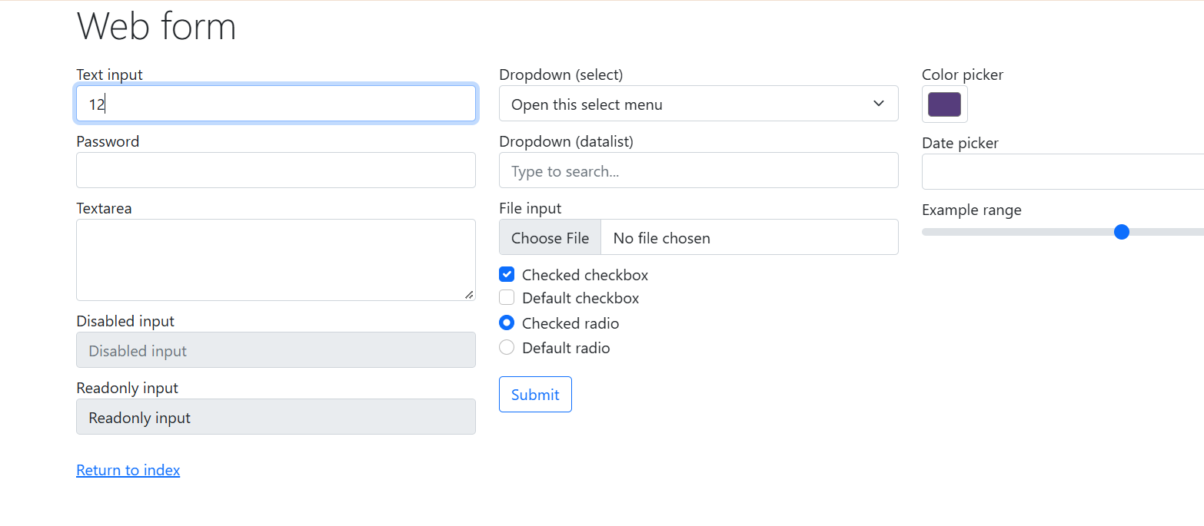

Test :12L
Scenario : Verify dropdown option selection
Test Steps:
- Open the Selenium Web Form.
- Locate the dropdown.
- Select Three.
- Click Submit.
- Observe the submitted value.

Test :13M
Scenario : Verify datalist suggestion selection
Test Steps:
- Locate the datalist input field.
- Type New.
- Check the available suggestions.
- Select a matching suggestion if available.
- Observe the selected value.
