Module Name: Registration, shopping cart, checkout and payment
Test Case ID: ST_08
Webpage URL: https://www.saucedemo.com/

● Test : 1A
Scenario: Check Login with Correct User Credentials
Test Steps:
- Launch the Swag Labs website.
- Enter username standard _user.
- Enter password secret _sauce.
- Select the Login button.
- Confirm that the Products page opens.
Screenshot: 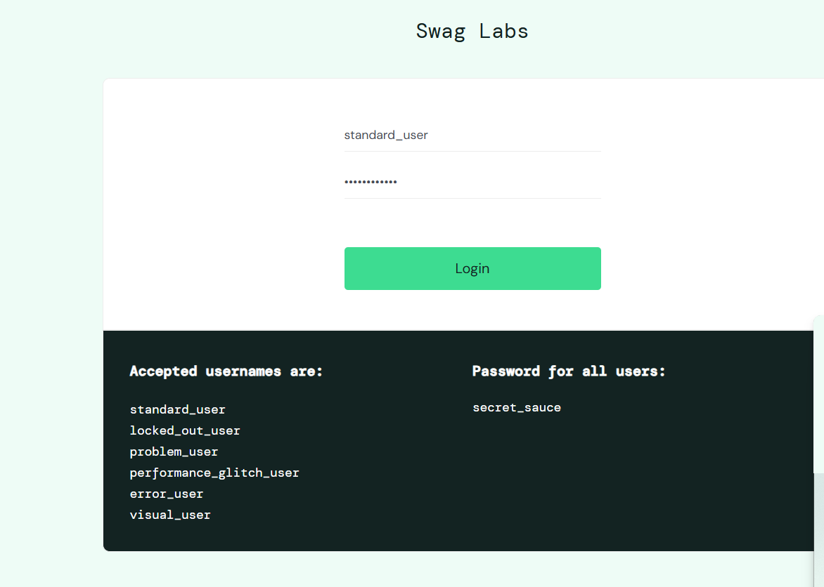
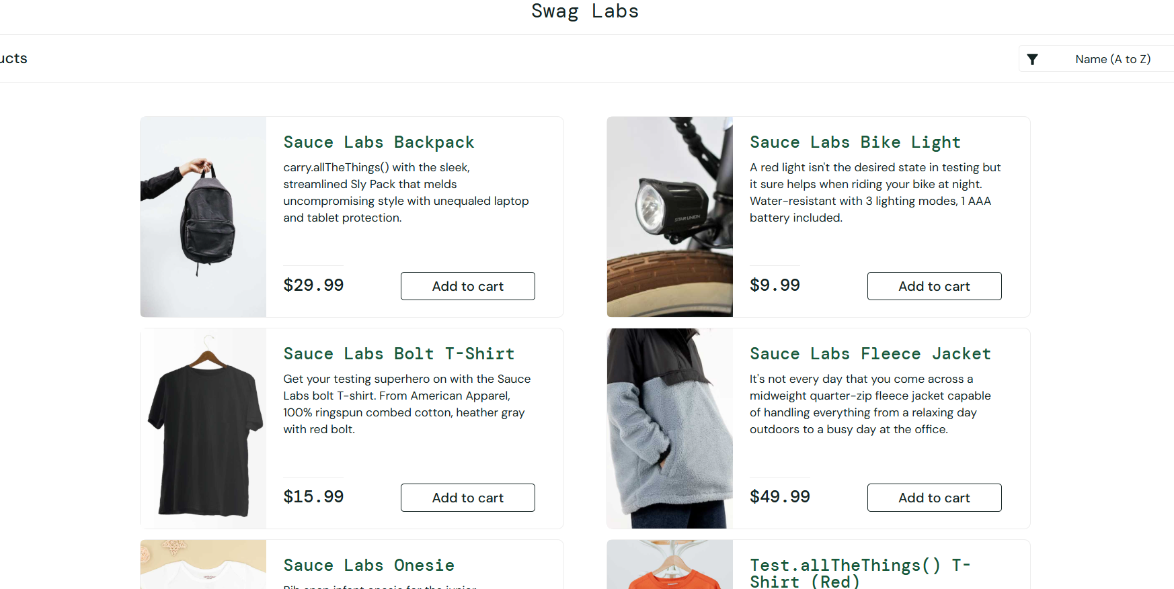

Test 2B
Scenario: Check Whether Incorrect Password Is Rejected
Test Steps:
- Open the login screen.
- Enter username standard_user.
- Type an incorrect password.
- Click Login.
- Observe the displayed message.
Screenshot: 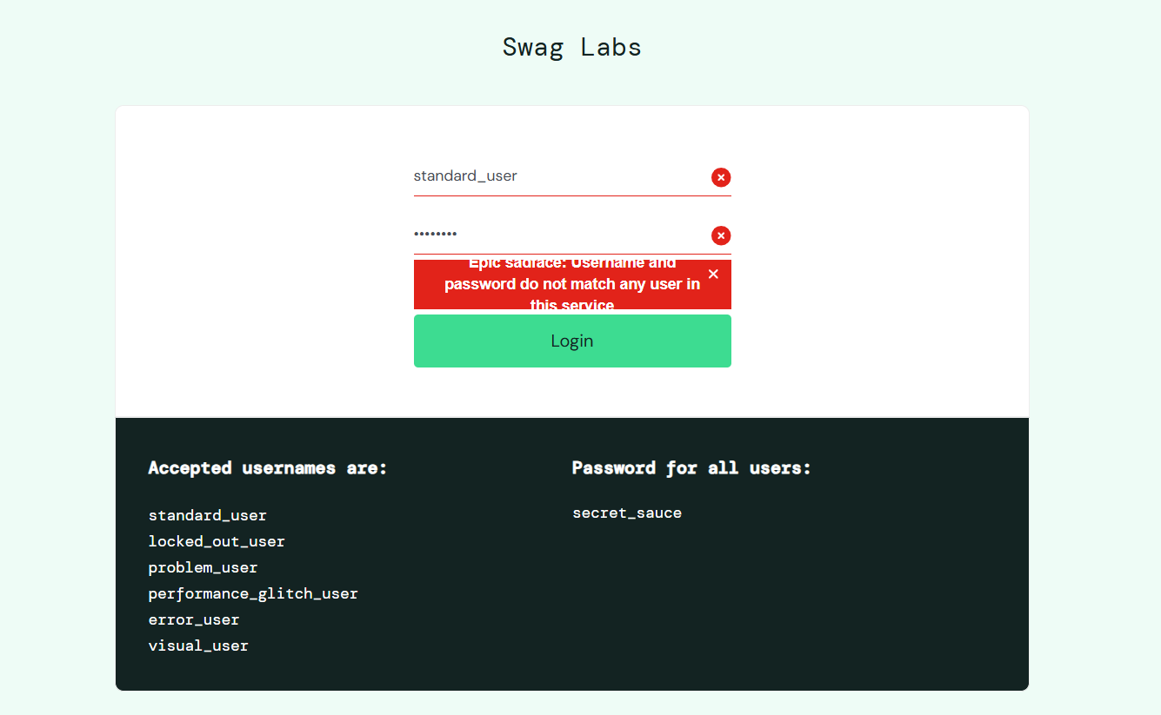

Test 3C
Scenario: Validate Access for a Locked Account
Test Steps:
- Open the Swag Labs login page.
- Enter username locked_out_user.
- Enter password secret_sauce.
- Click Login.
- Check the response shown on the screen.

Screenshot: 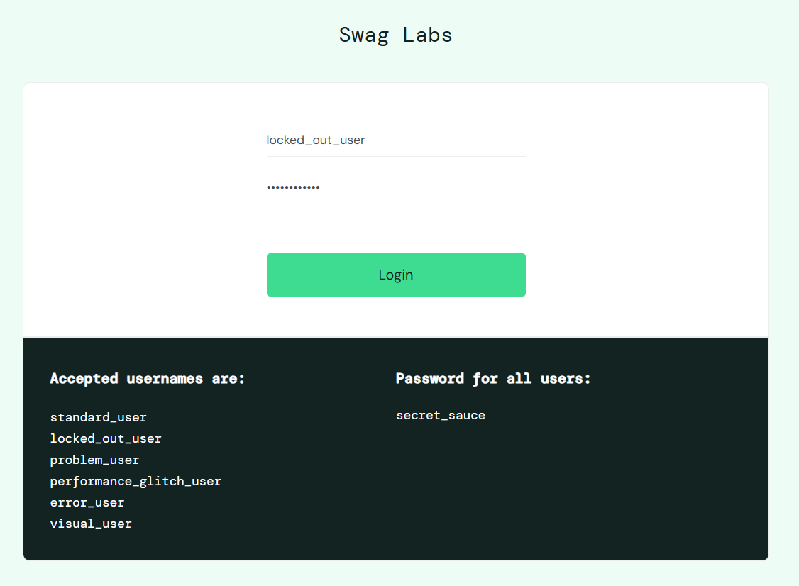
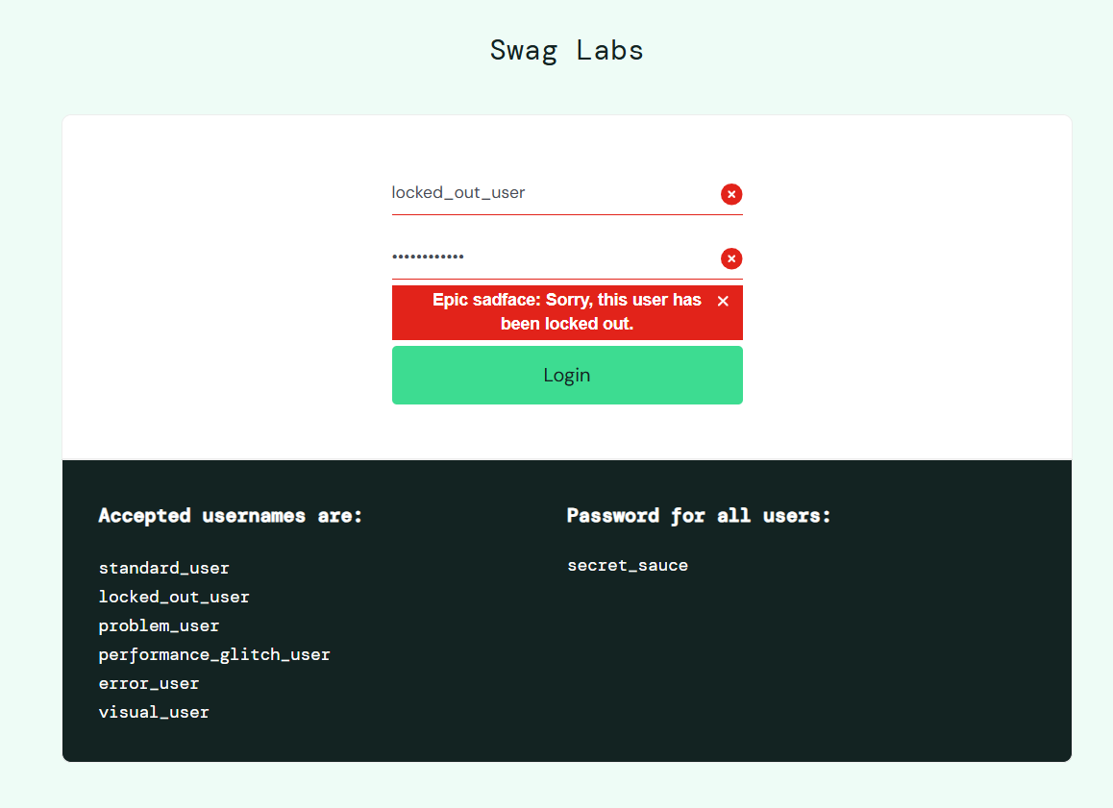

Test 4D
Scenario: Examine Product Images for an Unusual Display
Test Steps:
- Log in using problem_user.
- Open the inventory page.
- Compare the displayed product images with their names.
- Check whether any image appears incorrect.

Screenshot: 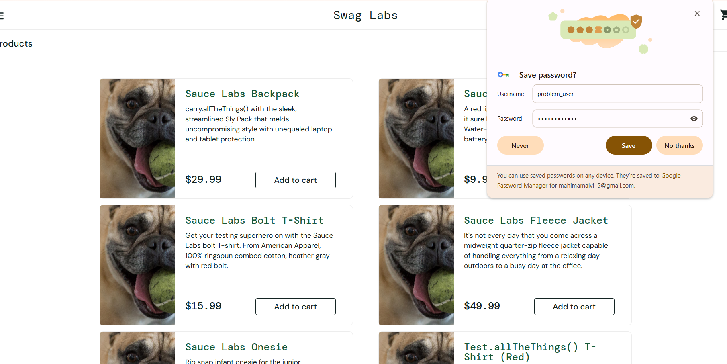
Test 5E
Scenario: Confirm Products Are Arranged by Increasing Price
Test Steps:
- Log in with standard_user.
- Locate the product sorting control.
- Choose Price (low to high).
- Compare the displayed prices from top to bottom.
Screenshot: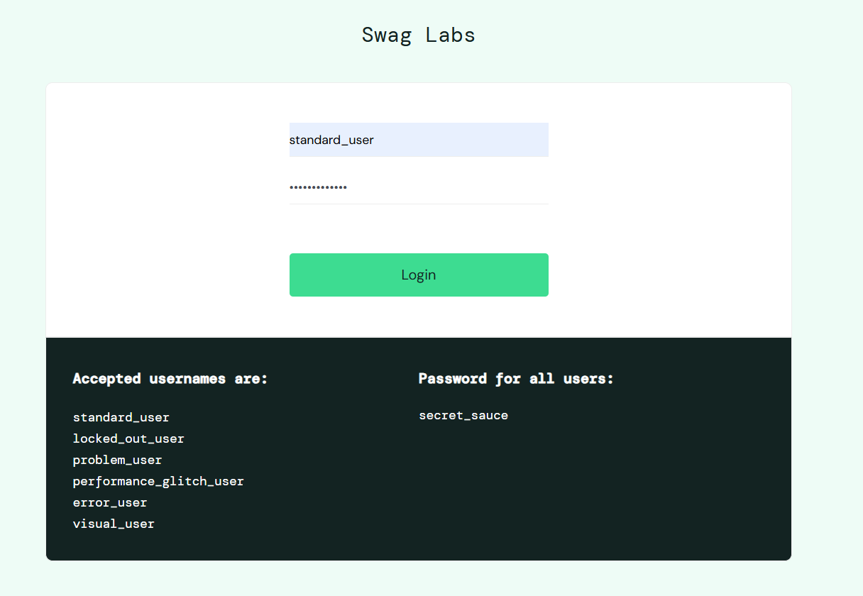
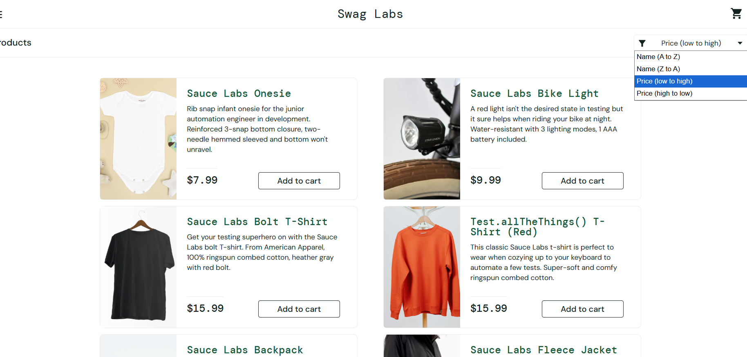

Test 6F
Scenario: Check Product Page Loading for a Slow-Response Account
Test Steps:
- Sign in as performance_glitch_user.
- Wait for the inventory page to finish loading.
- Open the Sauce Labs Backpack product.
- Observe the response time and page behavior.
Screenshot:
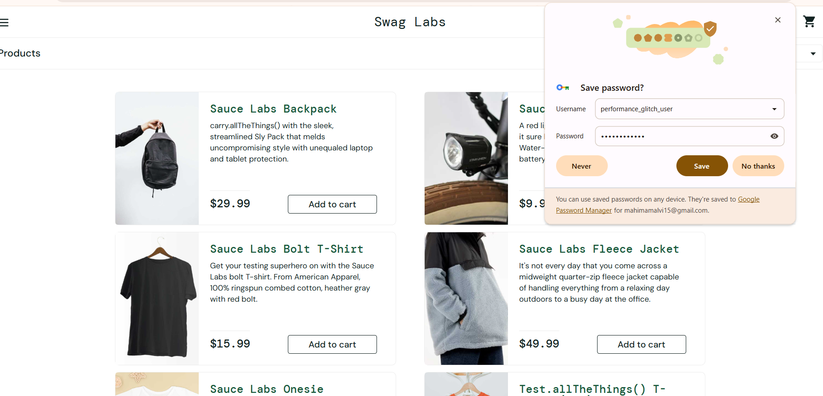
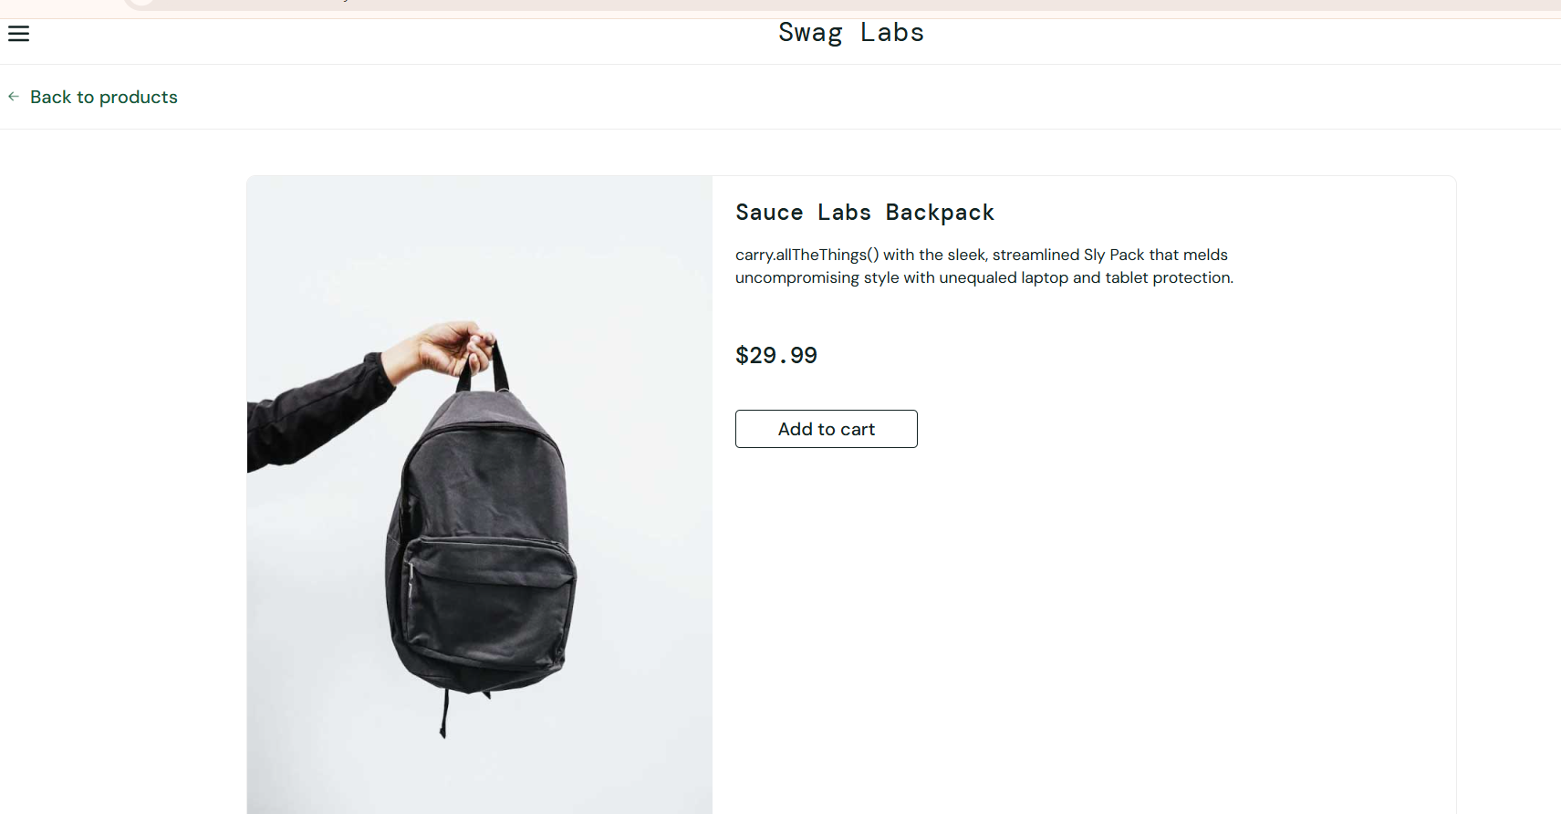
Test 7G
Scenario: Verify Cart Count After Selecting a Product
Test Steps:
- Sign in using standard_user.
- Find the Sauce Labs Backpack.
- Click Add to cart.
- Check the shopping-cart badge.
Screenshot:
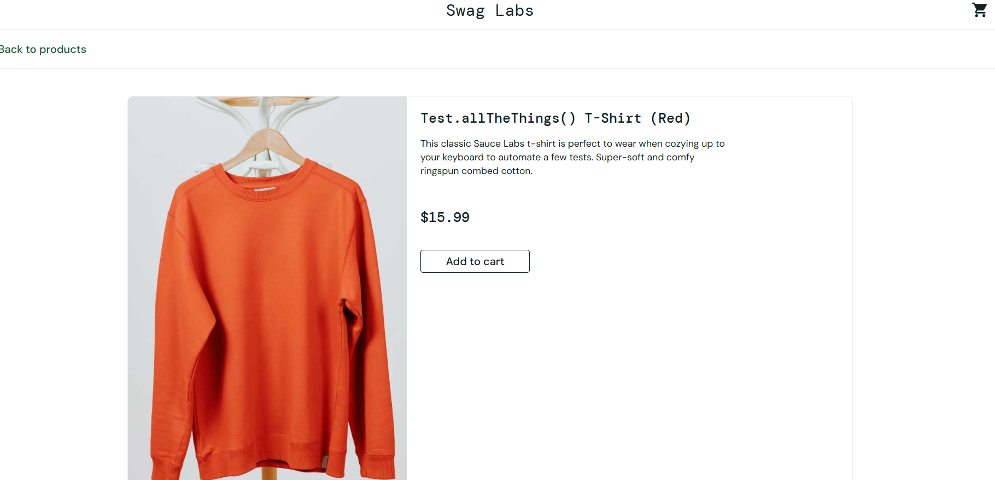
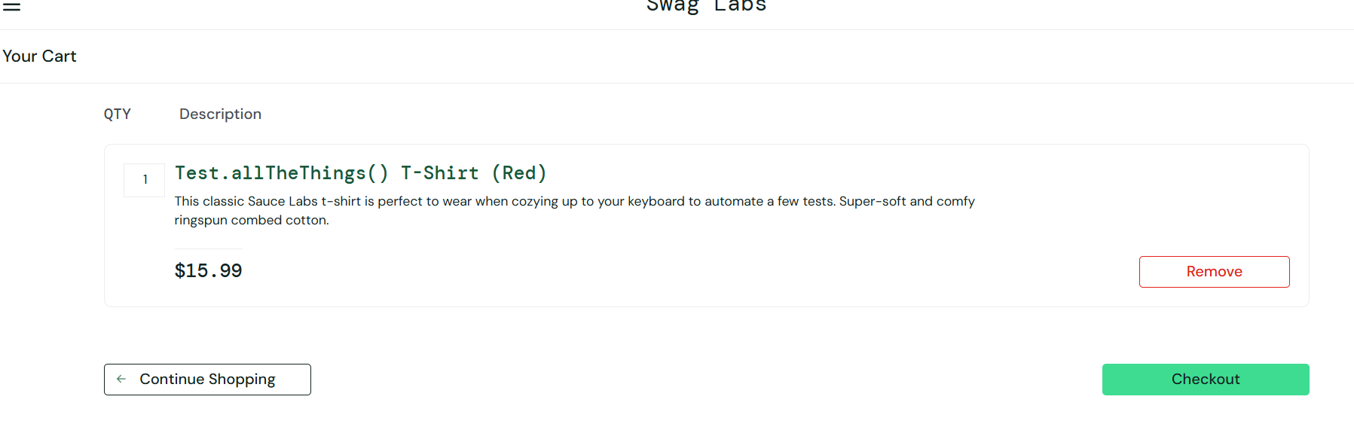

Test 8H
Scenario: Confirm Cart Count Updates After Item Removal
Test Steps:
- Add the Sauce Labs Backpack to the cart.
- Open the cart.
- Click Remove for the selected item.
- Check the cart contents and badge.
Screenshot:
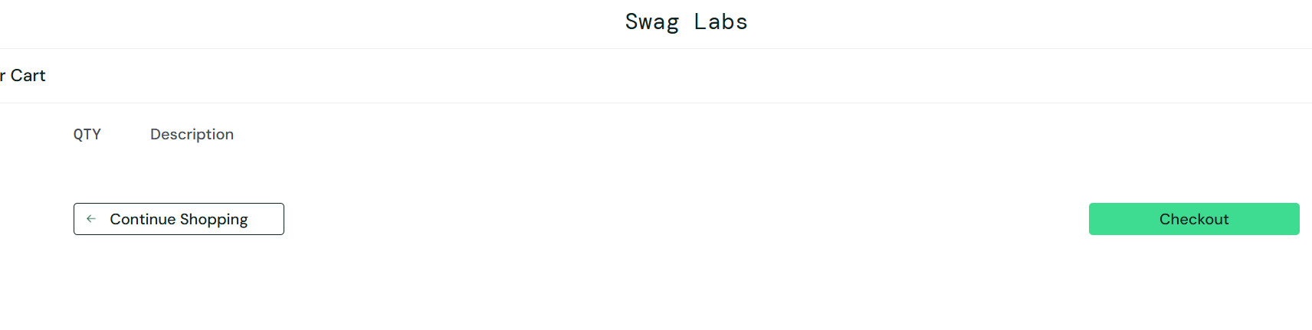
Test 9I
Scenario: Verify Multiple Selected Products Appear in the Cart
Test Steps:
- Sign in as standard_user.
- Add Sauce Labs Fleece Jacket to the cart.
- Add Sauce Labs Bolt T-Shirt.
- Open the shopping cart.
- Check the names and quantities of both products.
Screenshot: 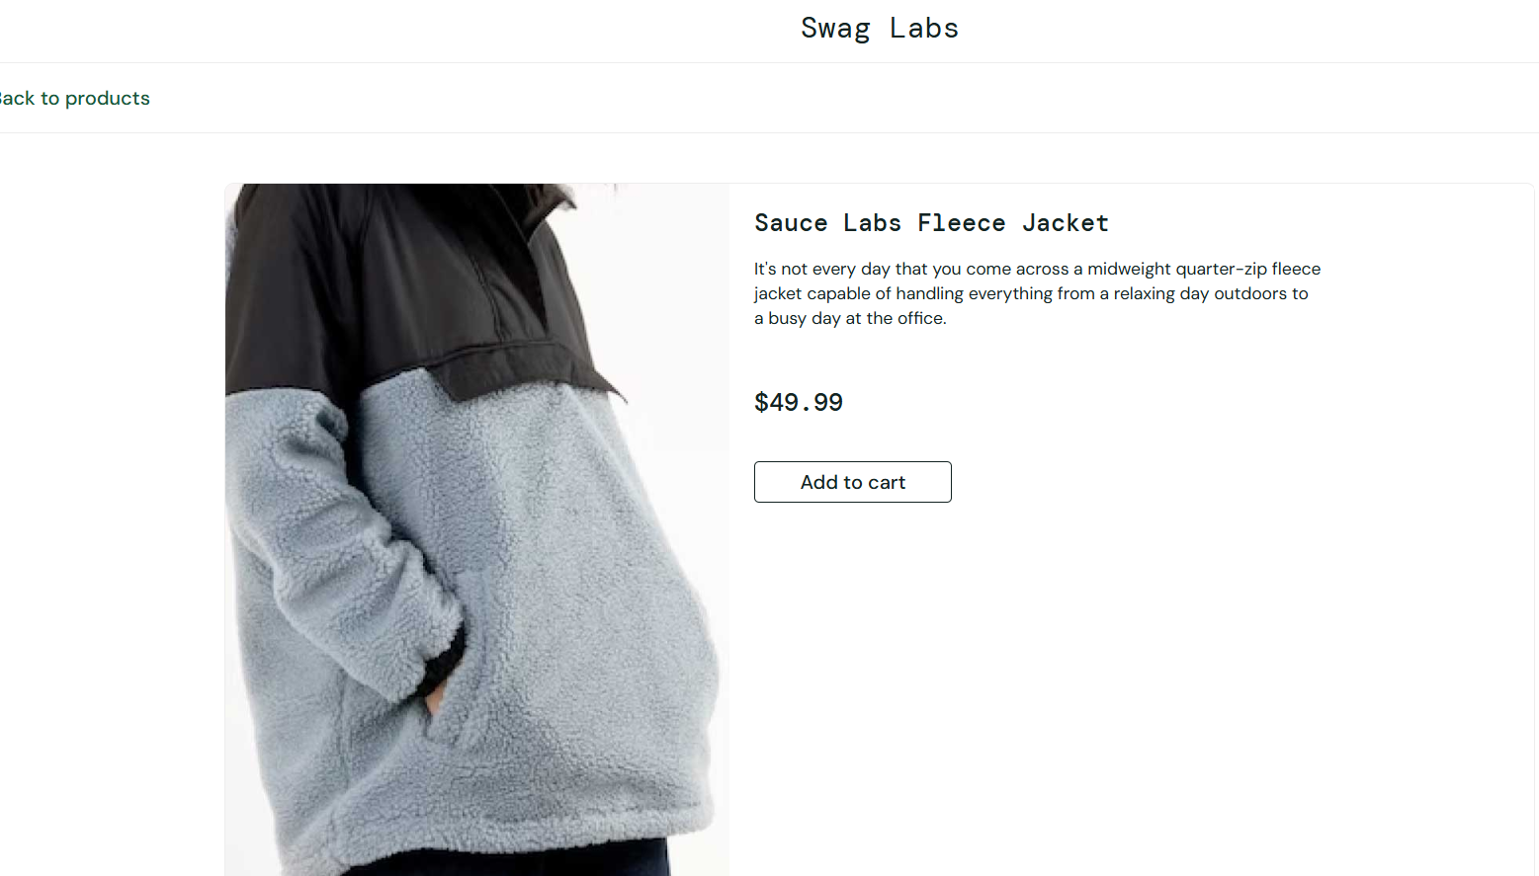
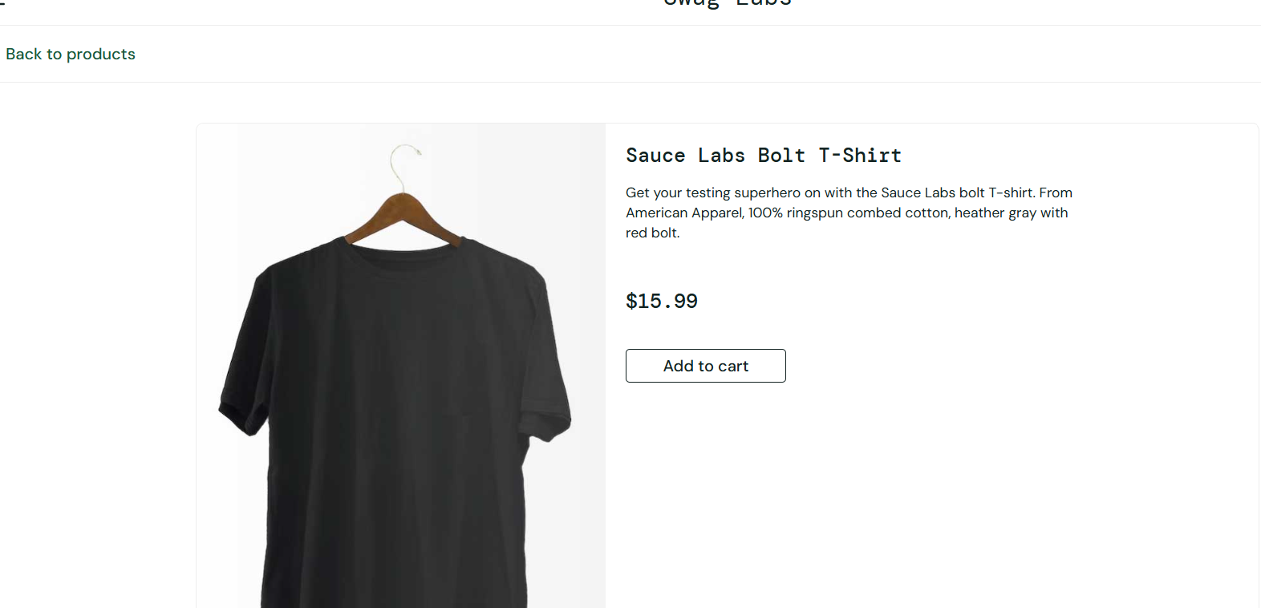
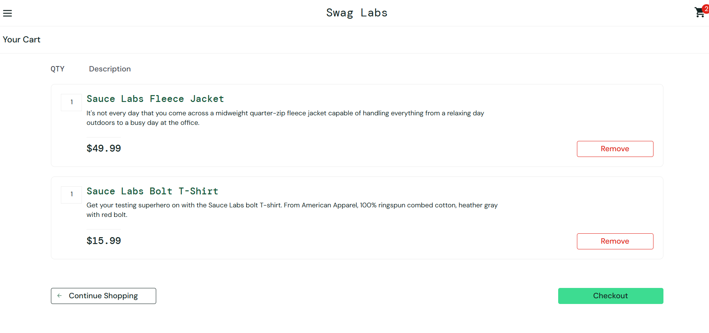
Test 10J
Scenario: Validate Required Customer Information at Checkout
Test Steps:
- Add a product to the cart.
- Open the cart and click Checkout.
- Leave First Name, Last Name, and Postal Code blank.
- Click Continue.
- Observe the validation message.
Screenshot: 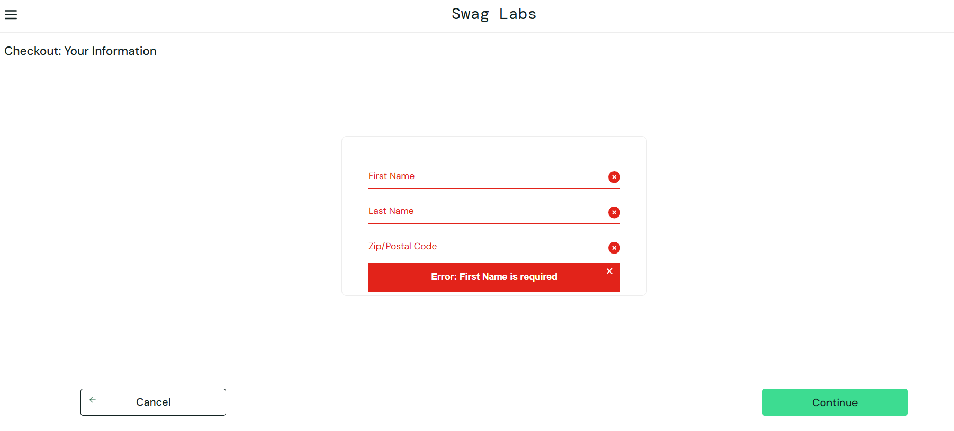
Test 11K

Scenario: Verify Purchase Completion and Confirmation
Test Steps:
- Add a product to the cart.
- Proceed to Checkout.
- Enter the required customer details.
- Continue to the order overview.
- Review the item total, tax, and total amount.
- Click Finish.
Screenshot: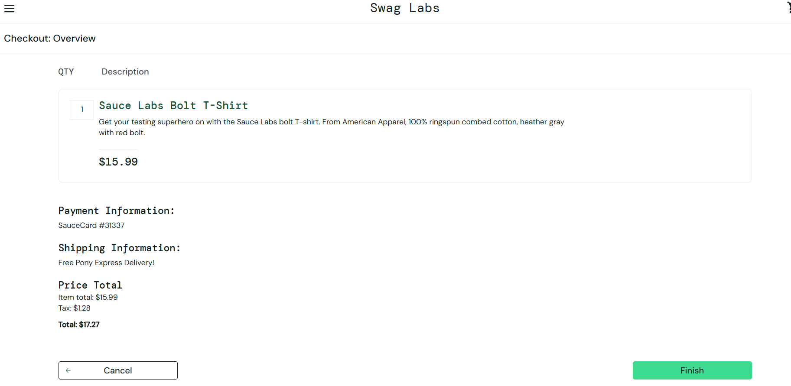
Test 12L
Scenario: Ensure Logout Ends the Current Session
Test Steps:
- Log in using standard_user.
- Open the navigation menu.
- Select Logout.
- Verify that the login screen appears.
Screenshot:
