Module Name: Login, Products, Cart, Checkout and Logout
Test Case ID: ST_09
Webpage URL: https://automationexercise.com/

Scenario ID: 1a
Scenario : Verify login with valid credentials.
Test Steps:
- Open the Automation Exercise website.
- Click Login.
- Enter the email address of a previously registered account.
- Enter the correct password.
- Click Login.
- Verify that Logged in as username appears.

Screenshot:
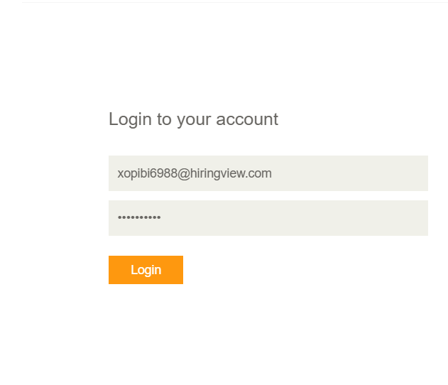

Scenario ID: 2b
Scenario : Verify login with invalid password
Test Steps:
1. Open the website and click Login.
2. Enter a registered email address.
3. Enter an incorrect password.
4. Click Login.
5. Observe the error message.

Screenshot:
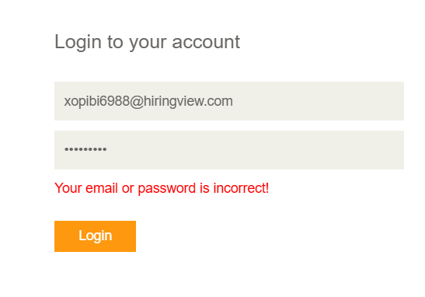

Scenario ID: 3c

Scenario : Verify login with an invalid username.
Test Steps:
1. Open Login.
2. Enter an unregistered email address.
3. Enter a password.
4. Click Login.
5. Observe the result.

Screenshot:
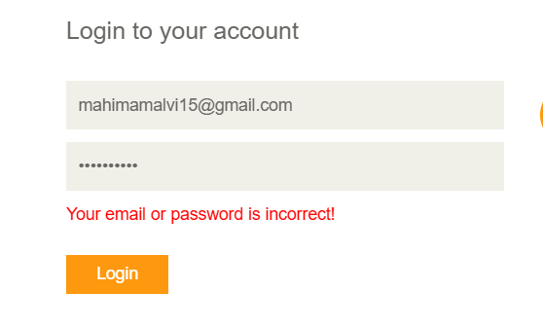

Scenario ID: 4d
Scenario : Verify login with blank username and password.
Test Steps:
1.Open Login.
2. Leave the email and password fields blank.
3. Click Login.
4. Observe browser validation or the resulting behavior.

Screenshot:
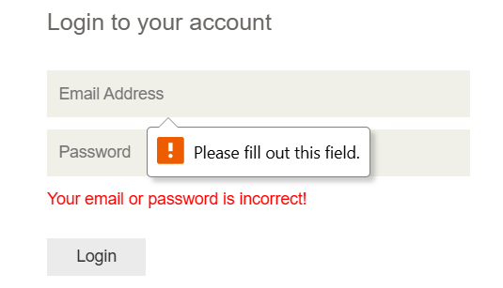

Scenario ID: 5e
Scenario : Verify adding a product to the cart.
Test Steps:
1. Open the website.
2. Click Products.
3. Select a product.
4. Click Add to cart.
5. Click View Cart.
6. Verify that the product is displayed.

Screenshot:

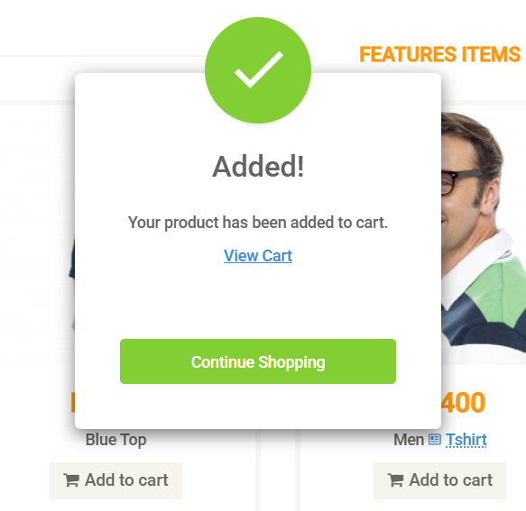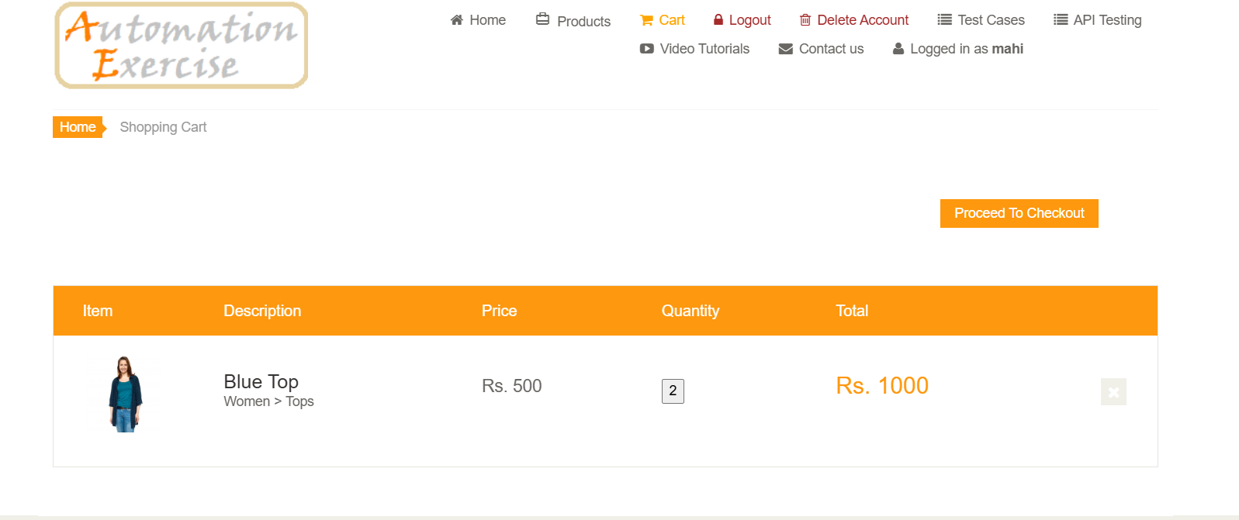

Scenario ID: 6f
Scenario : Verify removing a product from the cart.
Test Steps:
1.Add a product to the cart.
2. Open Cart.
3. Click the X (remove) button beside the product.
4. Observe the cart.

Screenshot:

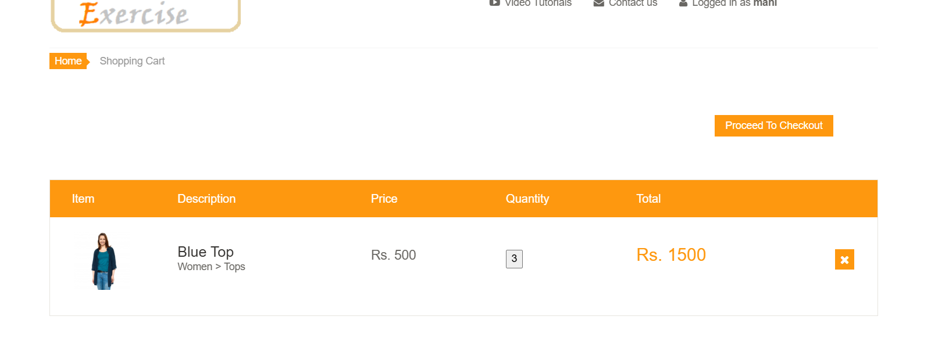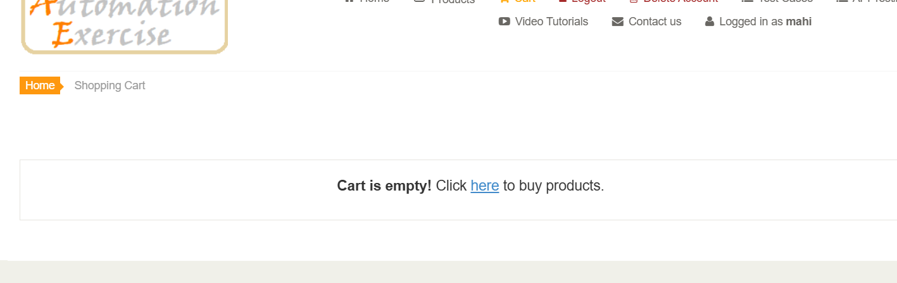

Scenario ID: 7g
Scenario : Verify the successful-login branch.
Test Steps:
1. Inspect the login-related source code available for the practical.
2. Identify the successful authentication path, if accessible.
3. Trace the valid-login behavior.
4. Verify the successful login result.

Screenshot:
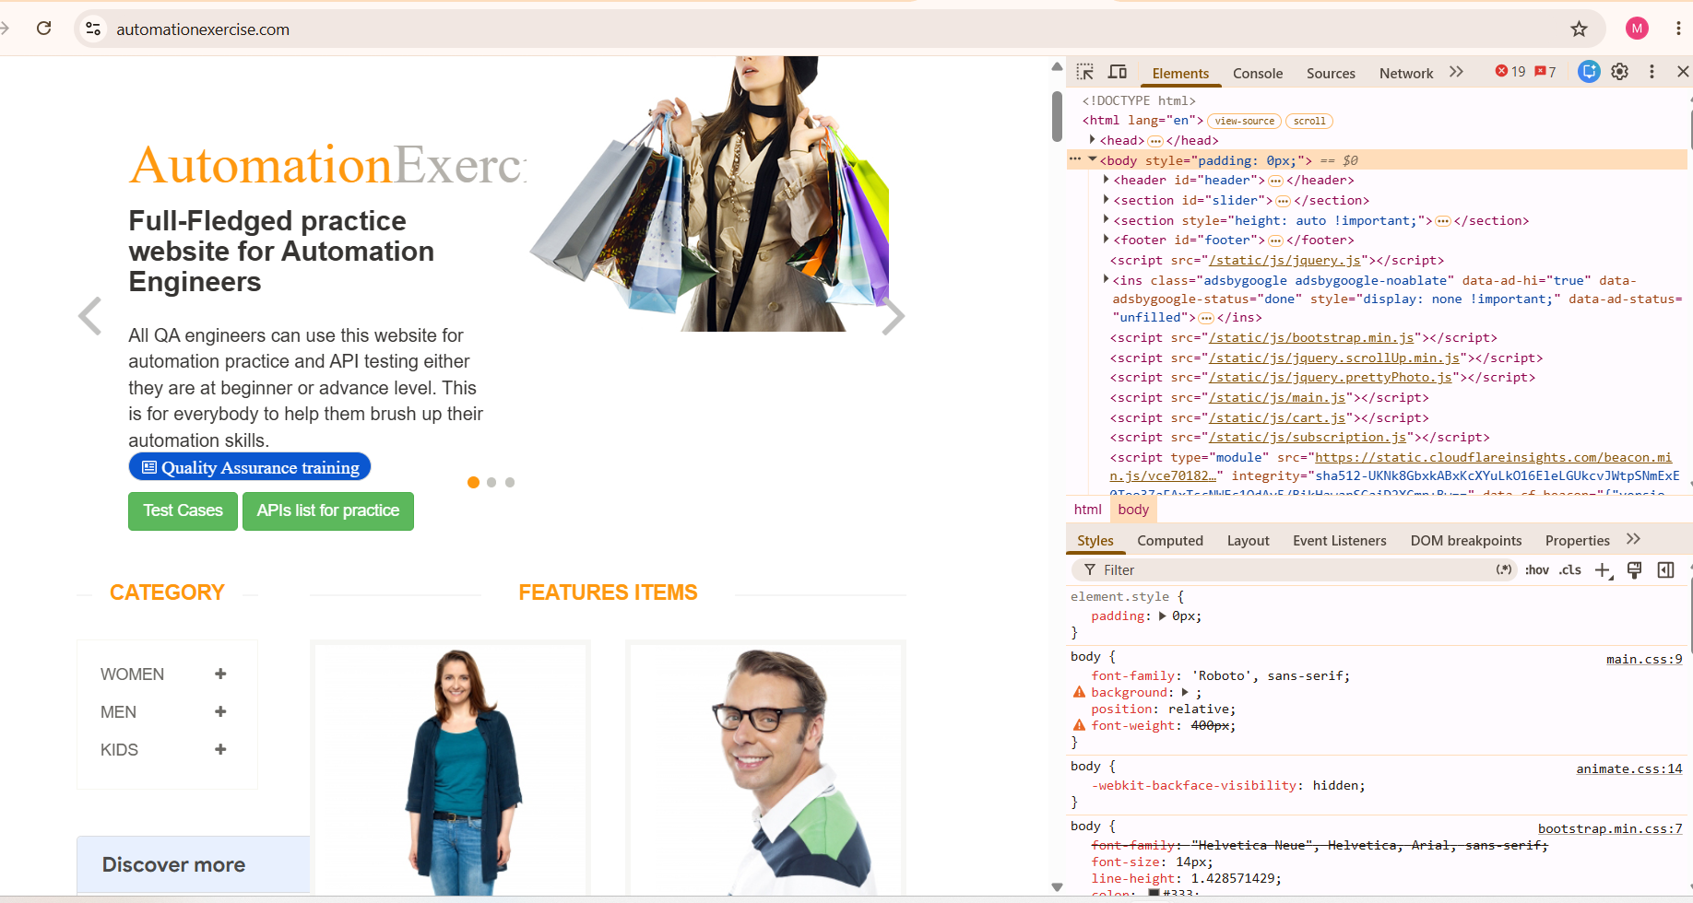

Scenario ID: 8h
Scenario : Verify the invalid-login branch Test Steps:
1. Inspect the available login-related source code.
2. Identify the error-handling path, if accessible.
3. Submit invalid login credentials.
4. Observe the failure behavior.
.

Screenshot:
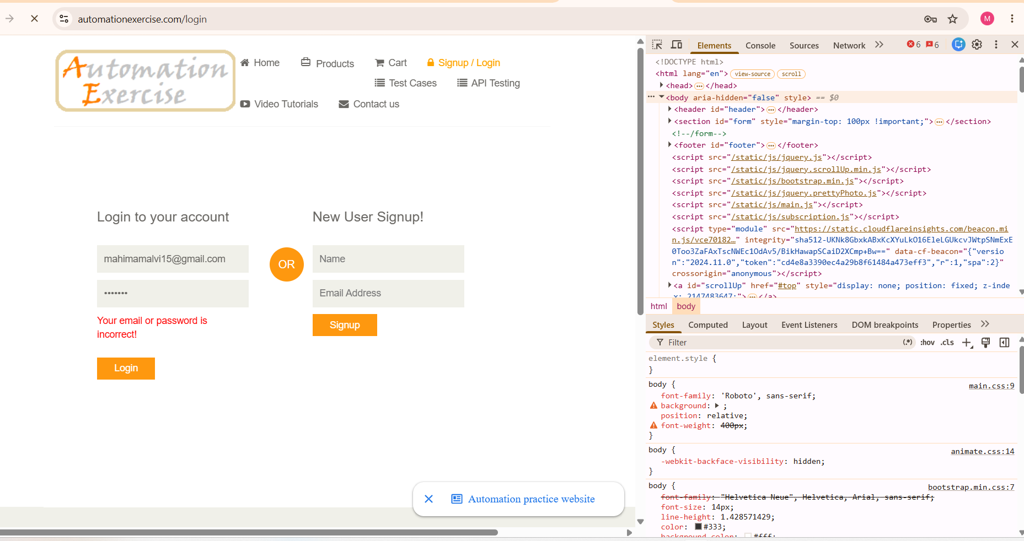

Scenario 9i:
Scenario : Verify login condition and branch coverage.
Test Steps:
1. Open the login page.
2. Test valid registered credentials.
3. Test an incorrect password.
4. Test an unregistered email address.
5. Test blank fields.
6. Record the observed results.

Screenshot: 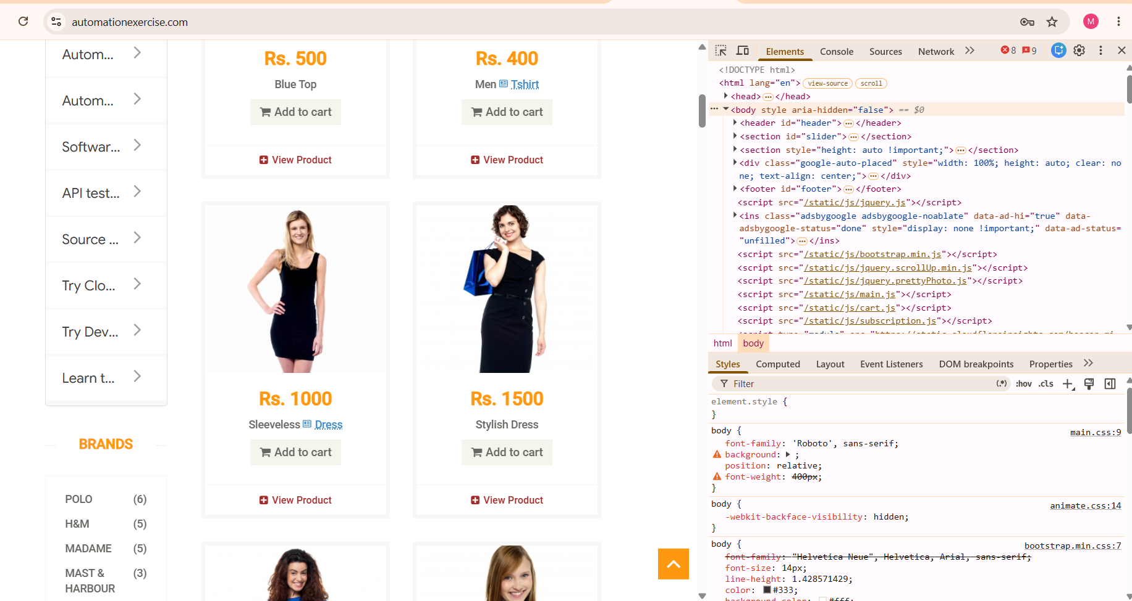
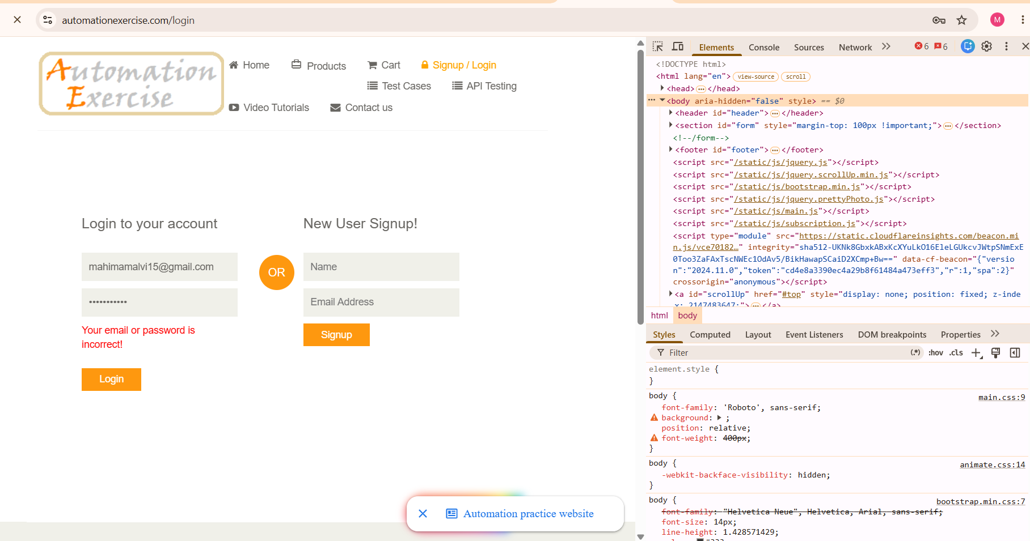

Scenario ID: 10j
Scenario : Verify integration between Login and Products modules. Test Steps:
1. Open the website.
2. Click Signup / Login.
3. Enter valid registered credentials.
4. Click Login.
5. Click Products.
6. Verify that the product listing opens.

Screenshot
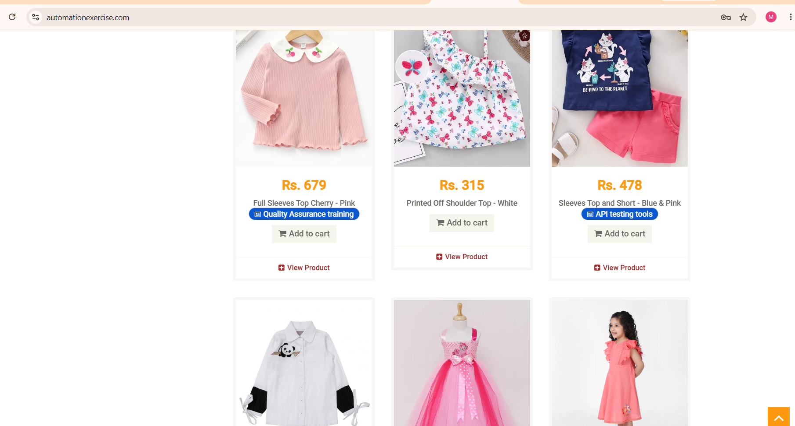

Scenario ID: 11K

Scenario: Verify integration between Products and Cart modules
Test Steps:
- Open Products.
- Select a product.
- Click Add to cart.
- Confirm the alert if displayed.
- Click View Cart.
- Verify that the selected product appears.
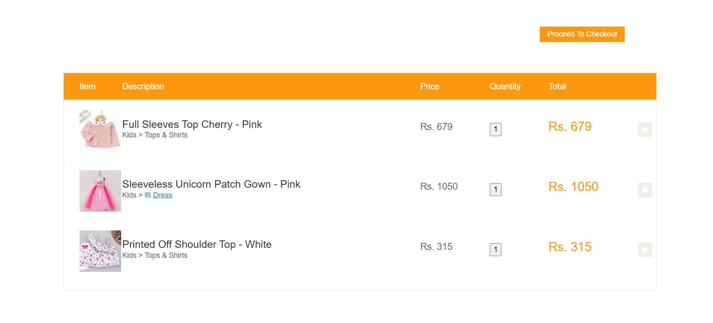

Scenario ID: 12L
Scenario : Verify user can log out successfully

Test Steps:
1.Go to the home page.
2.click logout
3. Verify Login page is displayed again.
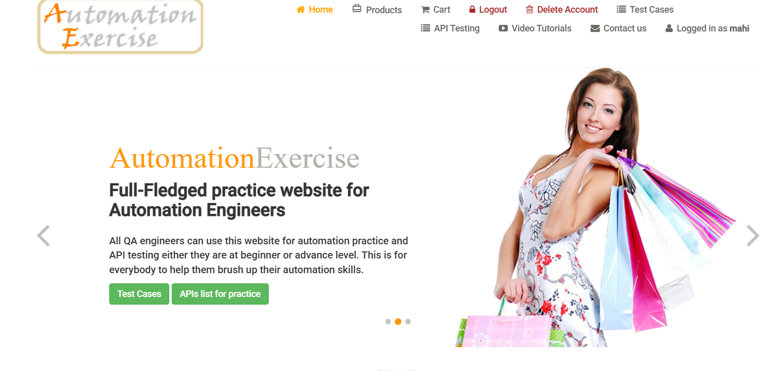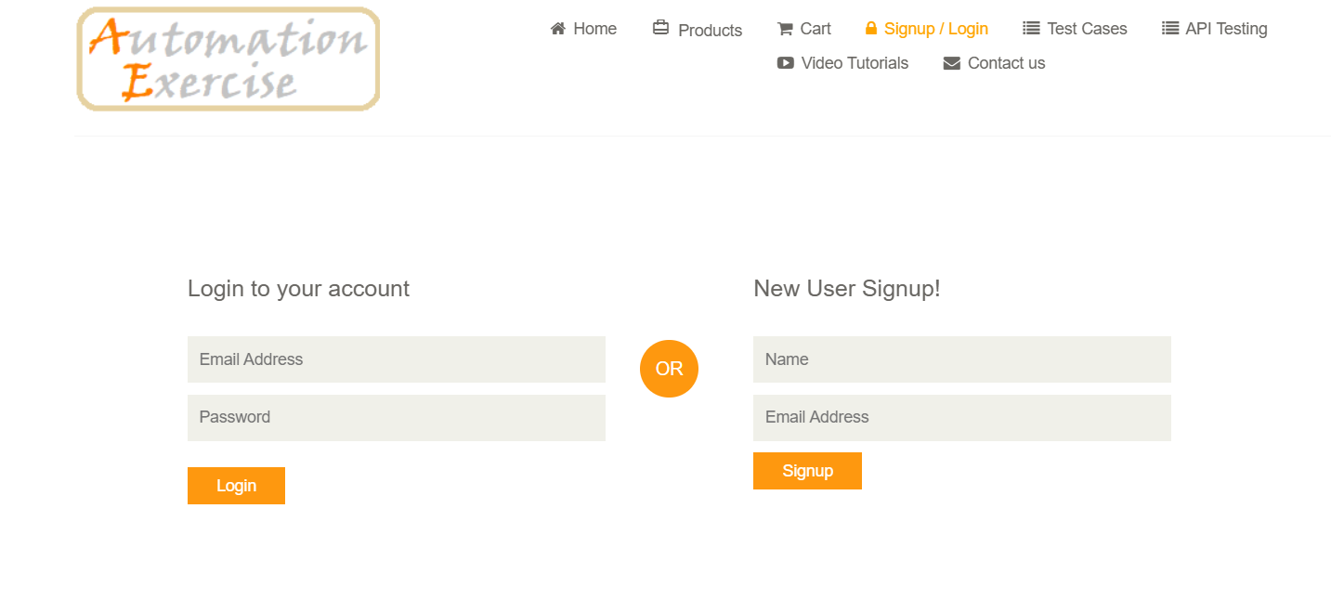

CONCLUSION
The testing of the Automation Exercise website was planned and performed using Black-Box Testing, White-Box Testing, Integration Testing, and System Testing. The selected test scenarios cover login validation, product selection, cart operations, checkout, order placement, and order confirmation.
Black-Box Testing was used to verify the website's behavior for valid and invalid inputs. Integration Testing focused on the interaction between the Login, Products, Cart, Checkout, and Order Confirmation modules. System Testing covered the complete shopping workflow. White-Box Testing was considered for examining login conditions and branches wherever relevant source code was accessible.
This practical helped demonstrate functional testing, input validation, module integration, and end-to-end testing of a web application. The final results were recorded based on the actual behavior observed during test execution.

