Module Name: Test plan and requirement traceability matrix (RTM)
Test Case ID: st_02
Webpage URL : https://storedemo.testdino.com/
- Scenario ID: 1a
Scenario: Sign up with valid credentials
Test Steps:
- Click on Sign Up
- Enter email address
- Enter password
- Click sign in
Screenshots:

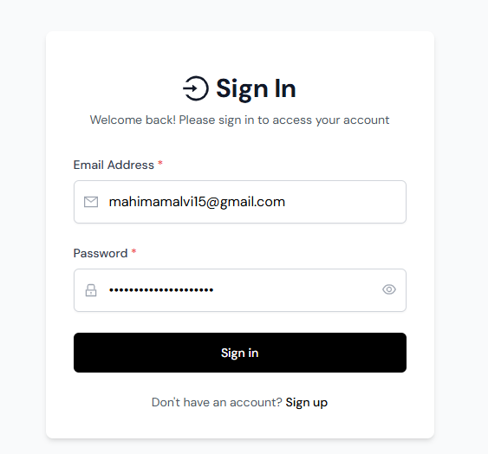
- Scenario ID: 1b
Scenario: Sign up with invalid password
Test Steps:
1. Click on Sign Up
2. Enter valid email address
3. Enter wrong password
Screenshots:
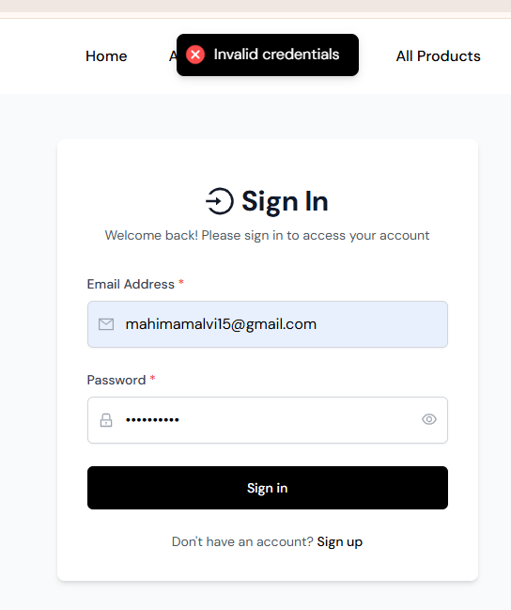

- Scenario ID: 1c
Scenario: sign up with invalid email
1. Click on Sign Up
2. Enter invalid email address
3. Enter right password
Screenshots: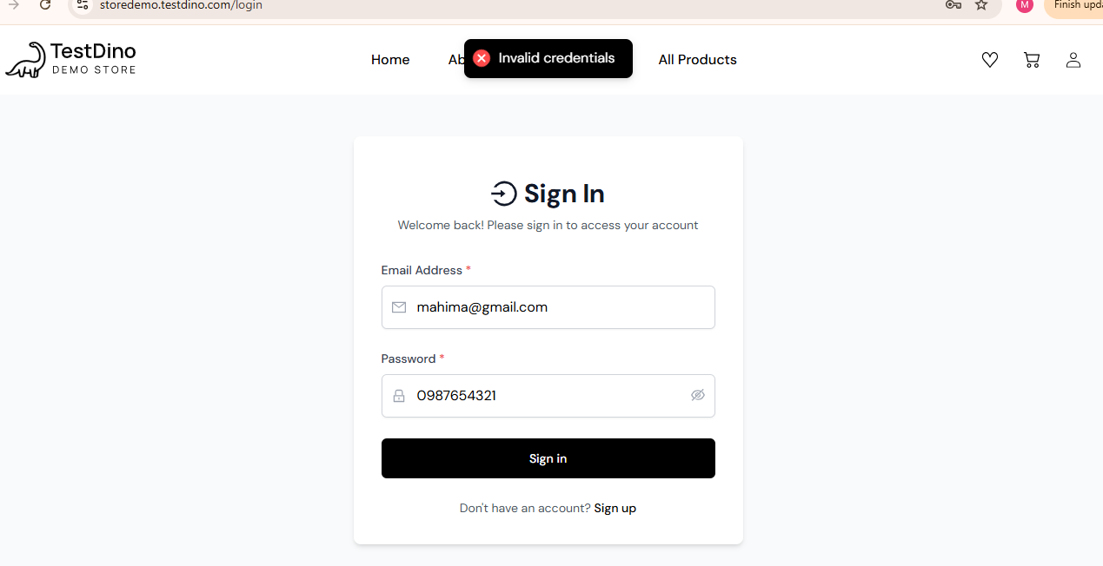

Scenario ID: 1d
Scenario: Sign up with only whitespace inputs
Test Steps:
- Click on sign up logo
- Enter space characters in required fields
- Click on sign in
Screenshots:

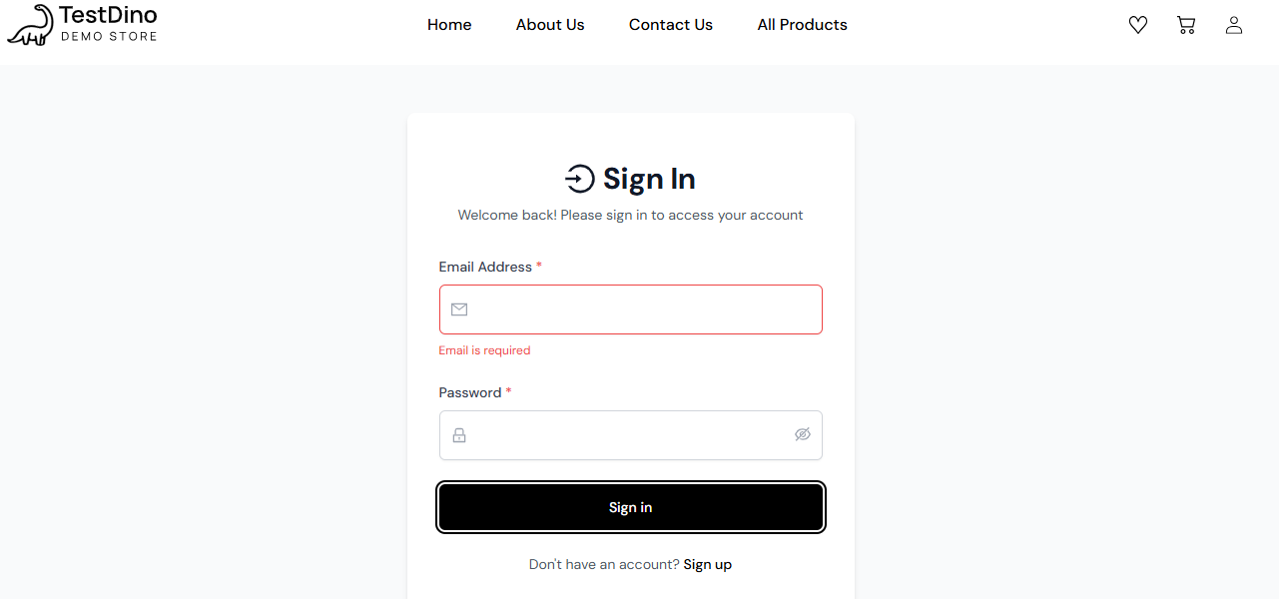

Scenario ID: 1e
Scenario: Email blank, password entered
Test Steps:
1. Click on sign up logo
2. Enter password
3. click on sign in
Screenshots:

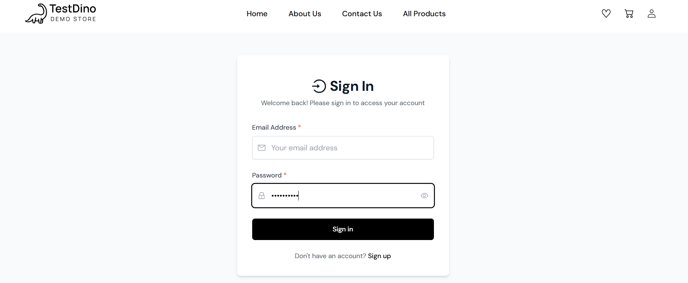

Scenario ID: 1f
Scenario: Password blank, valid email entered
Test Steps:
1. Click on sign up logo
2. Enter valid email
3. click on sign in
Screenshots: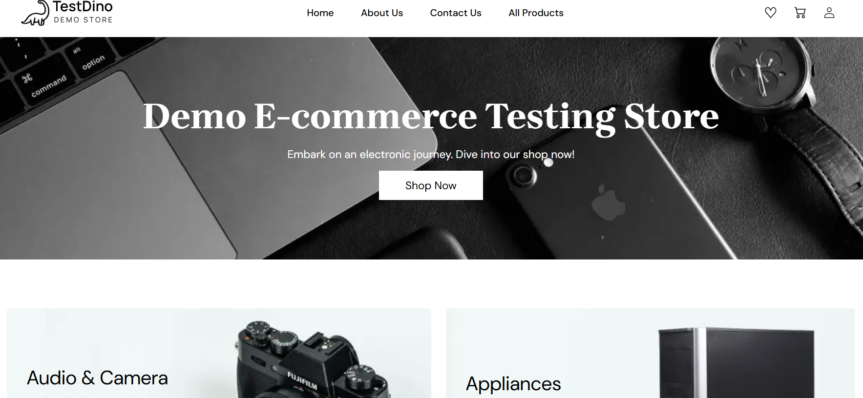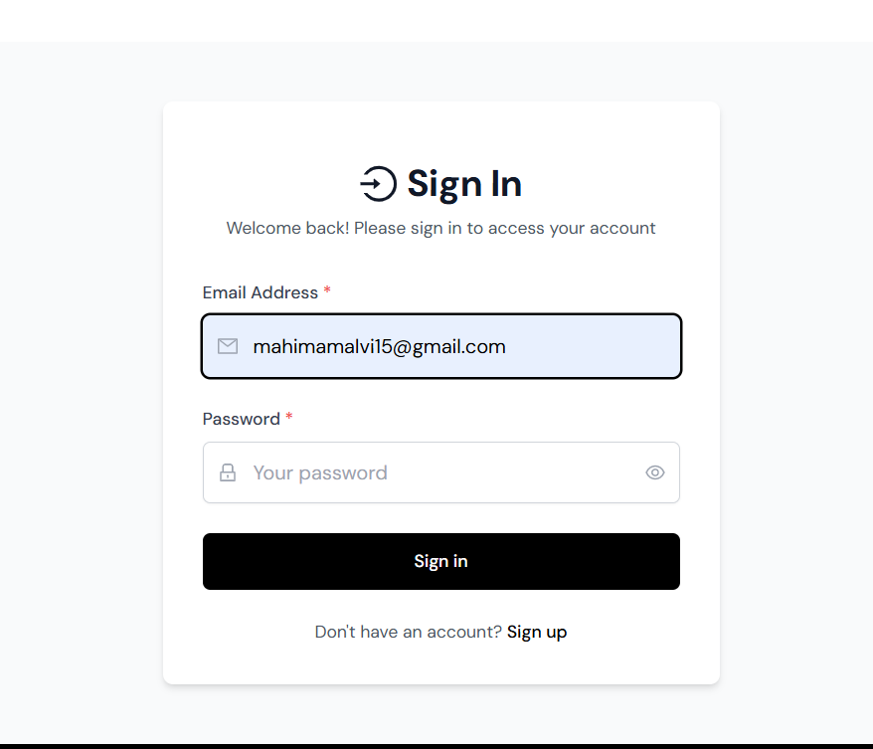

Scenario ID: 1g
Scenario: Add address with valid details
Test Steps:
1. Click on shop now
2. Select item
3. click buy now
4. Fill all details
5. Click save address

Screenshots: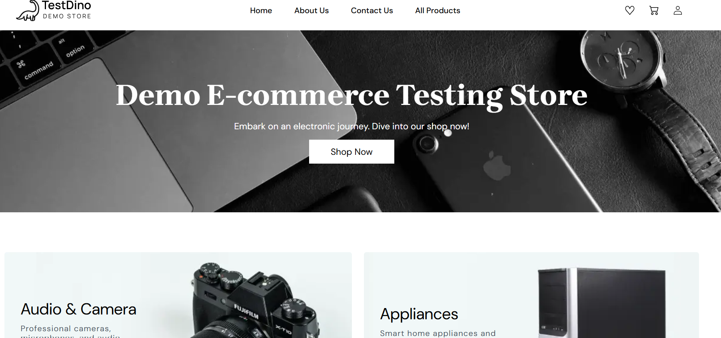
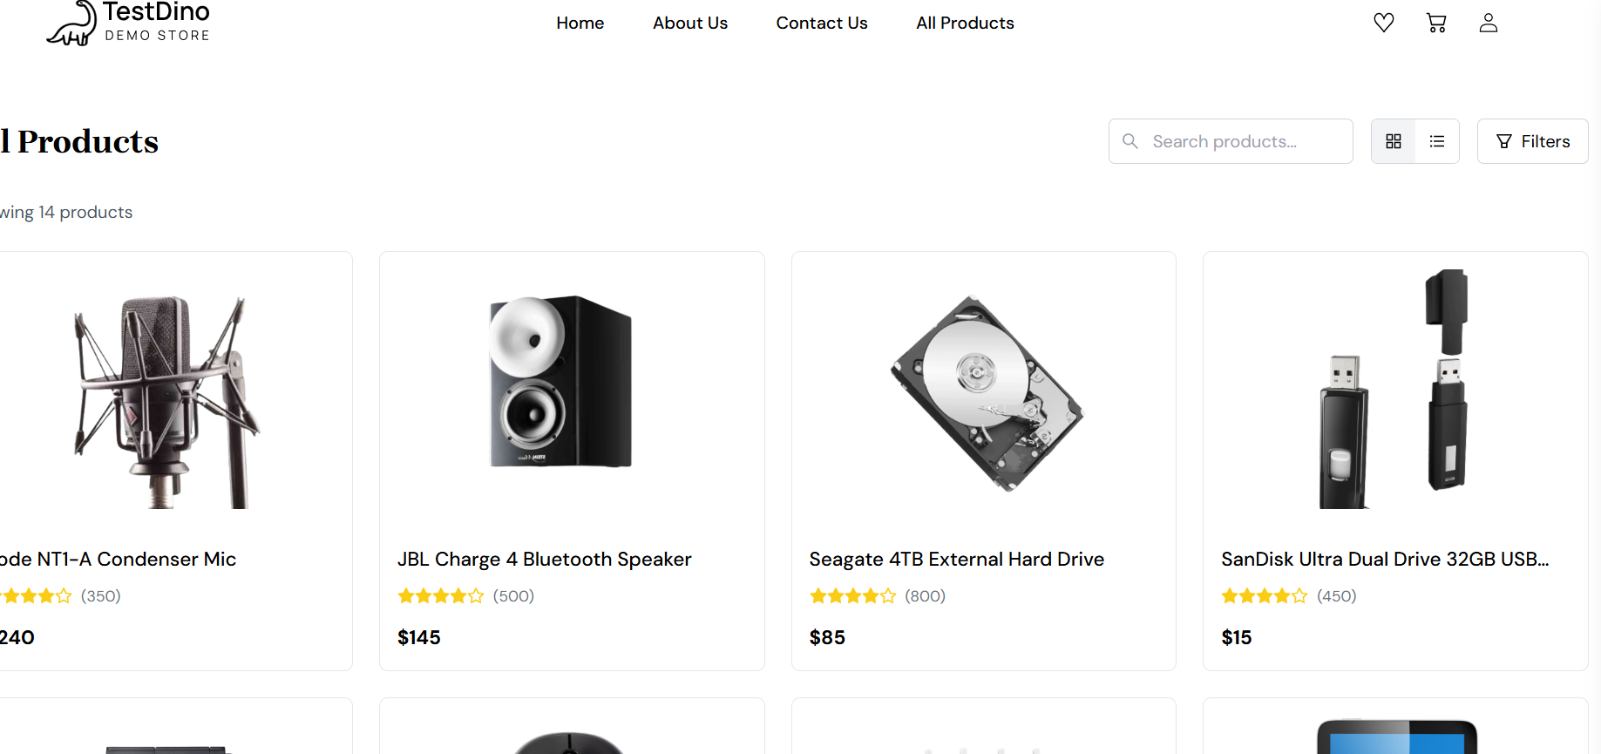
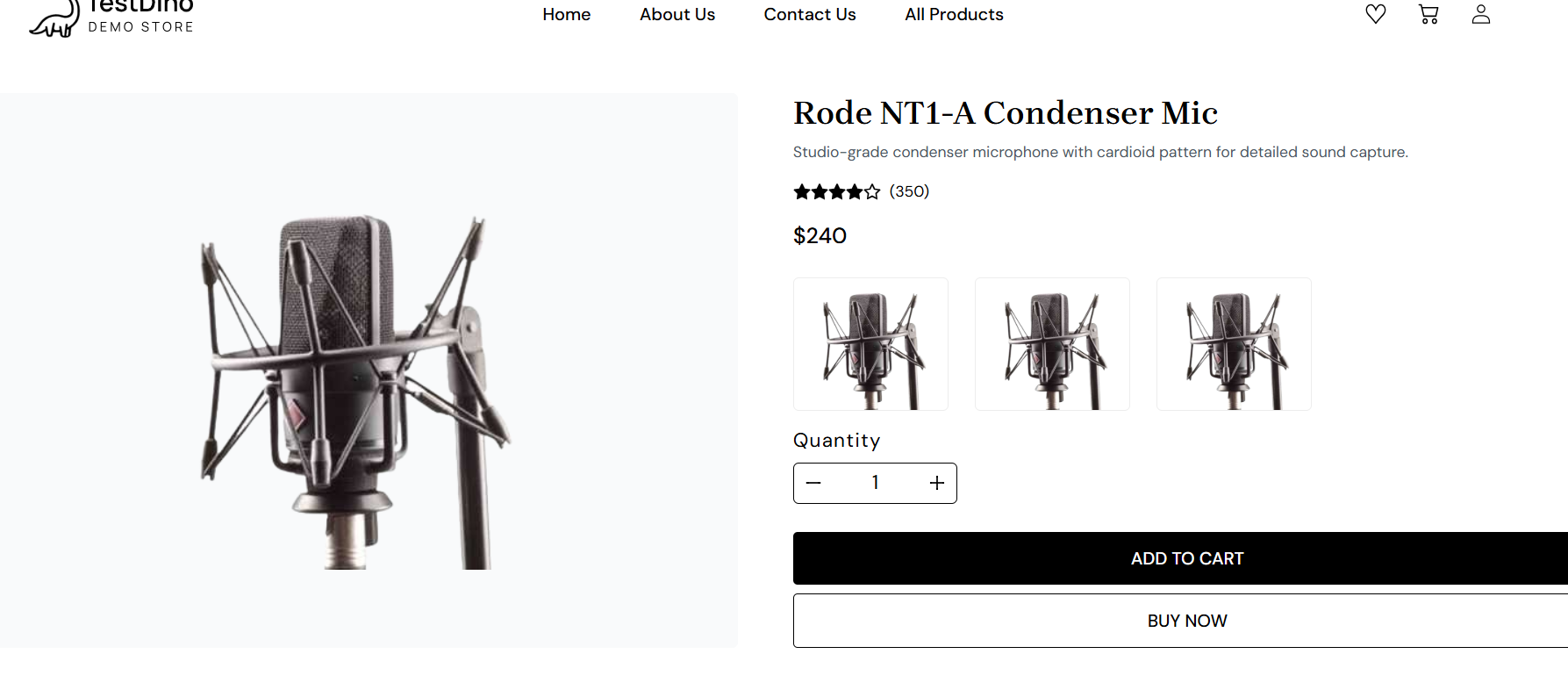
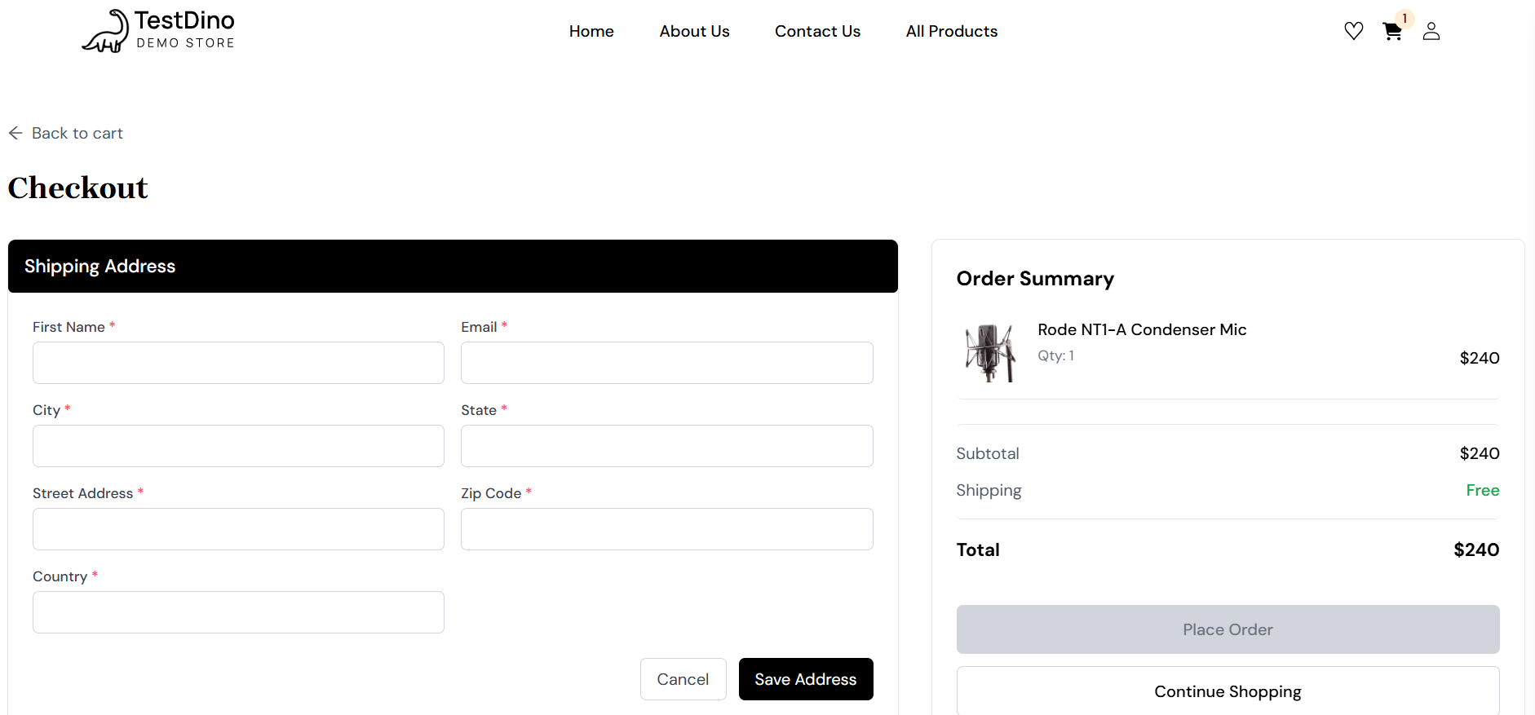
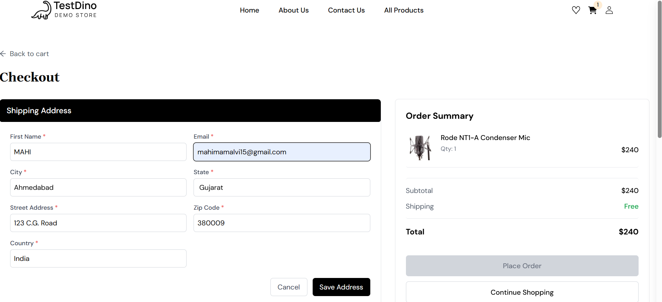
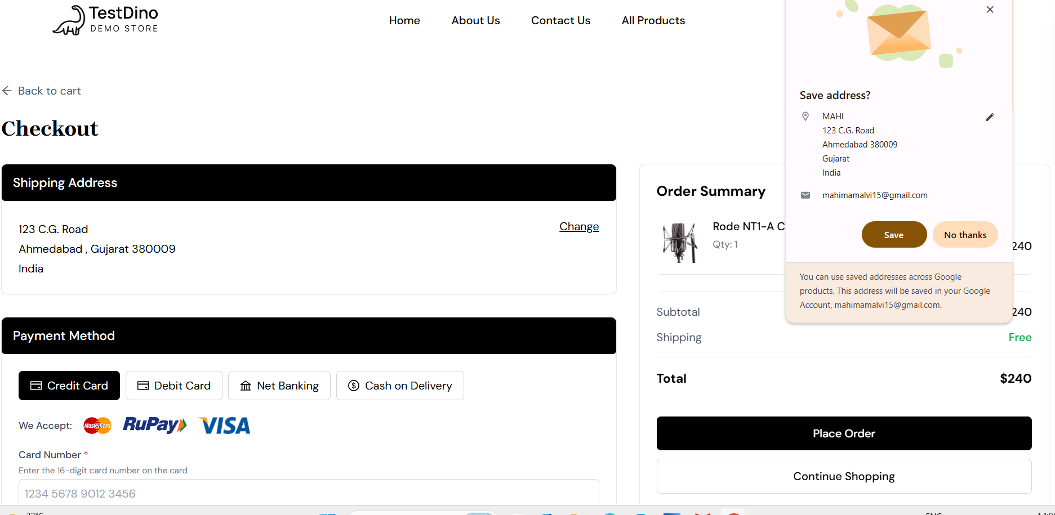

Scenario ID: 1h
Scenario: Purchase a product with valid details
Test Steps:
1. Click on shop now
2. Select item
3. click buy now
4. Fill all details
5. Click on place order

Screenshots:
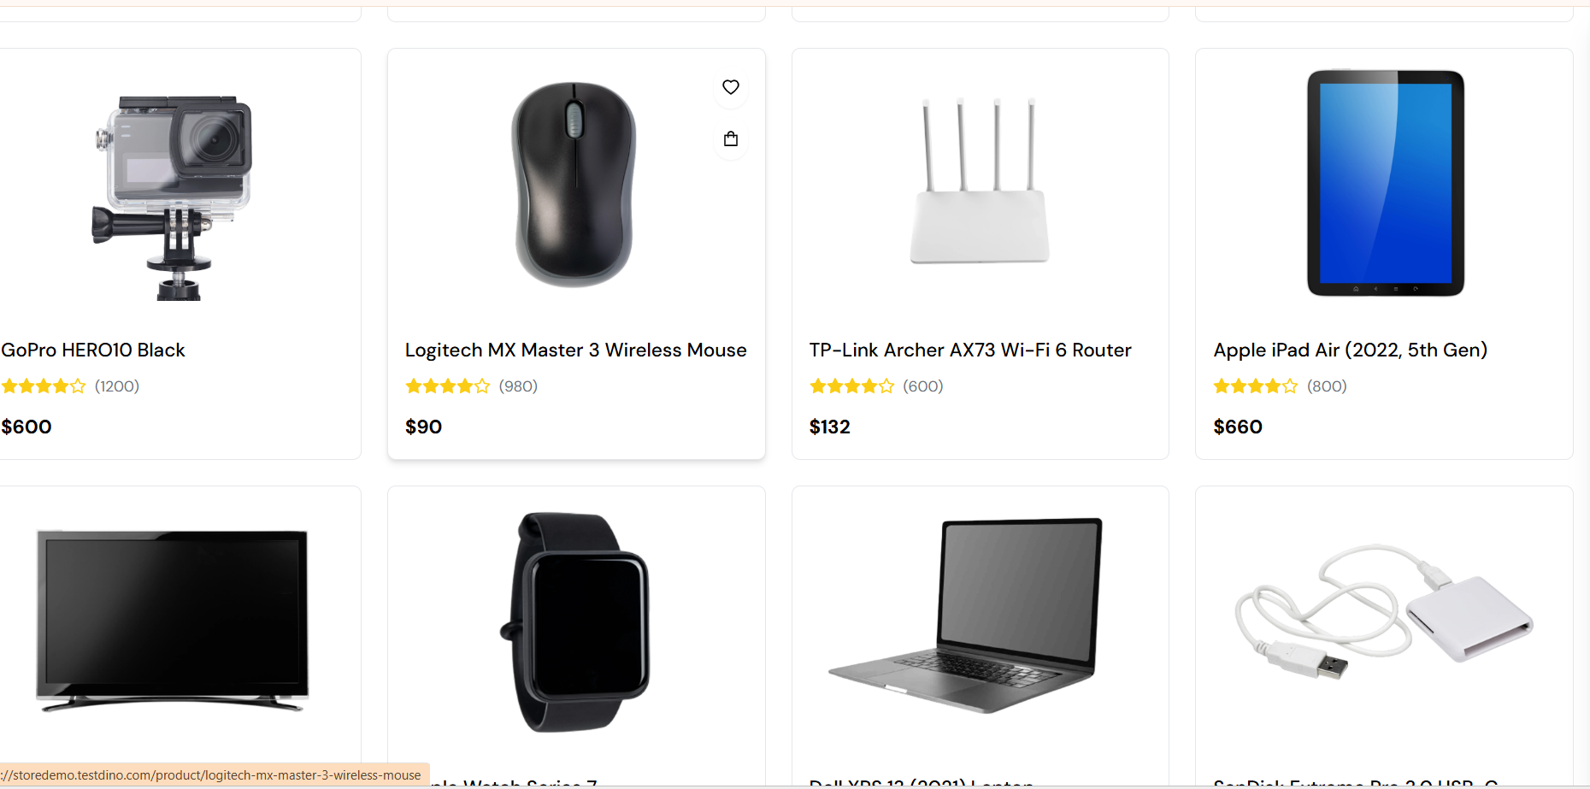

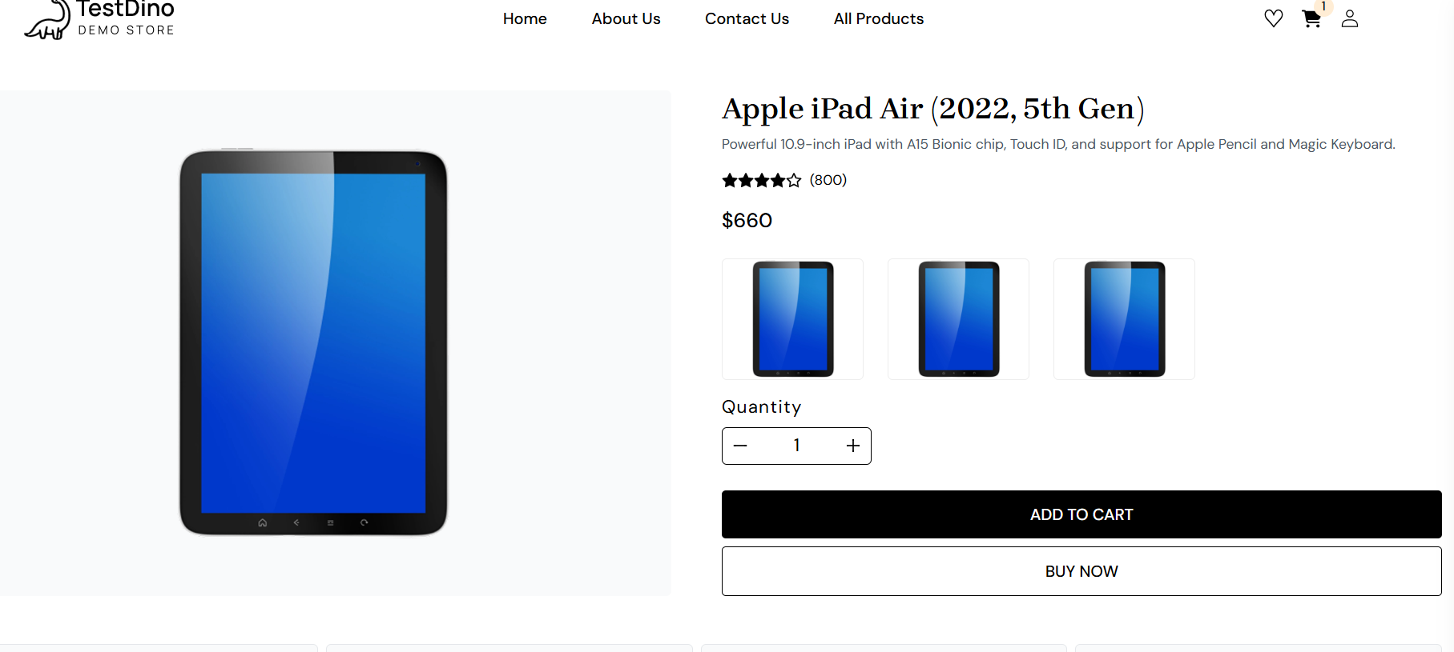
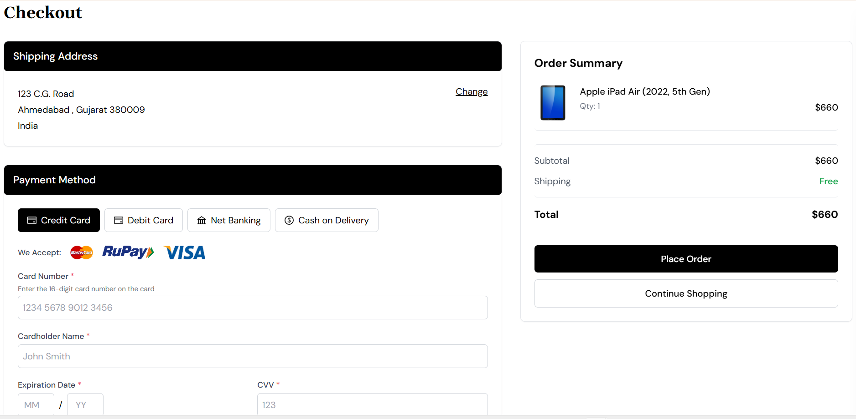
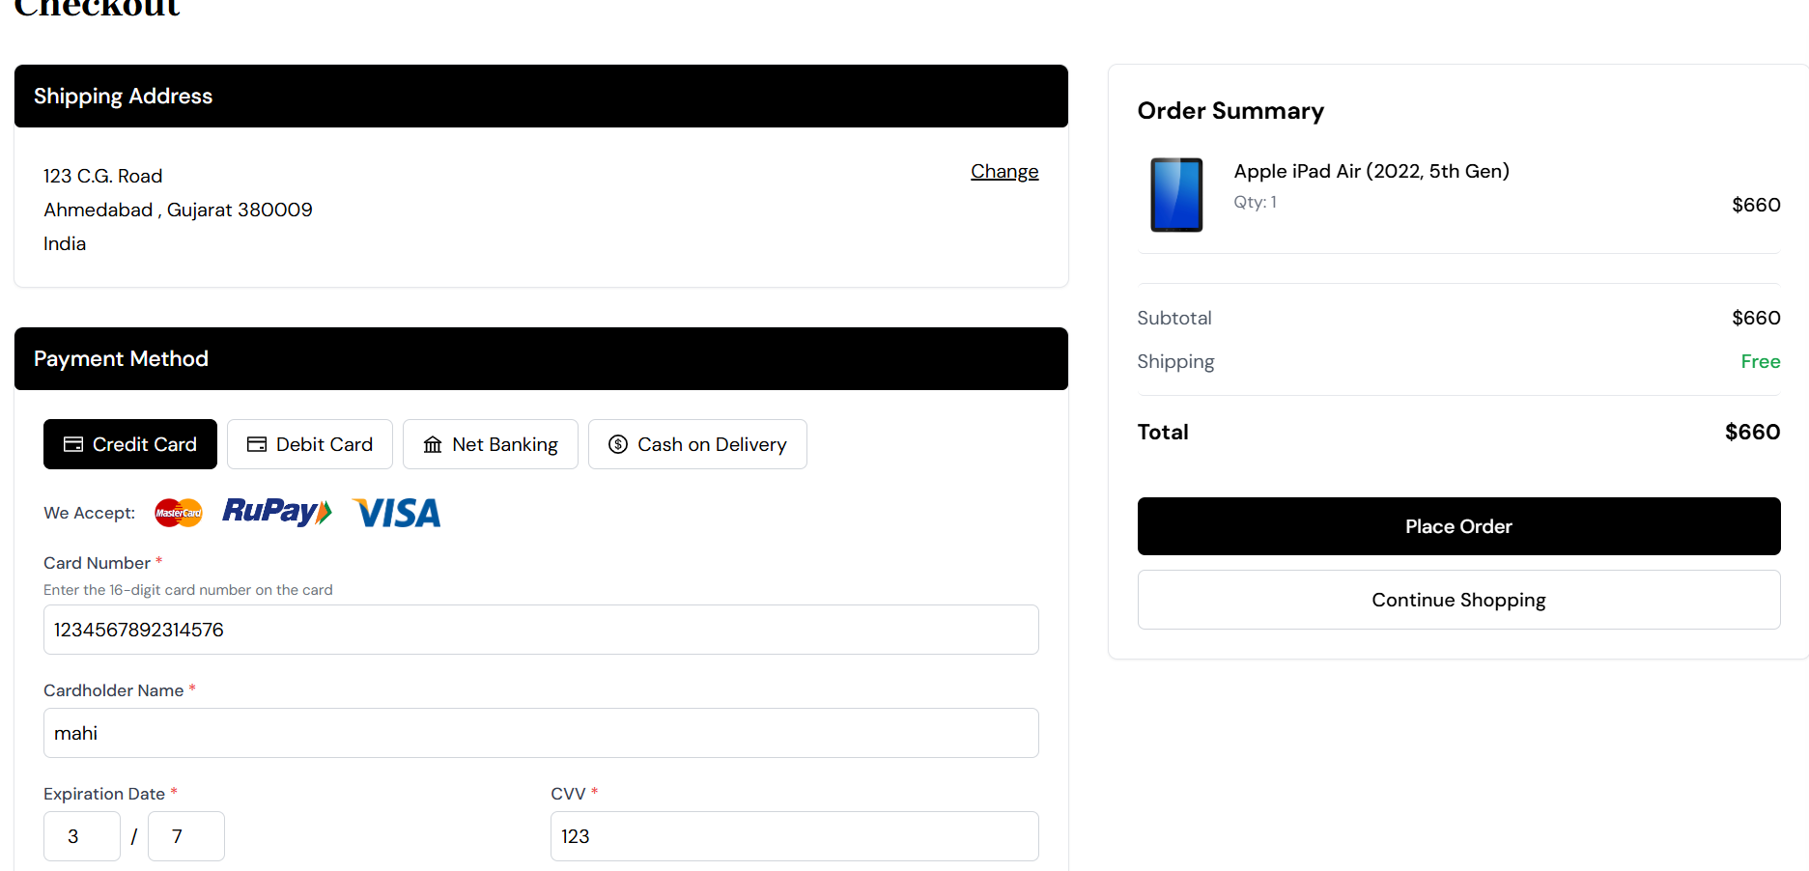
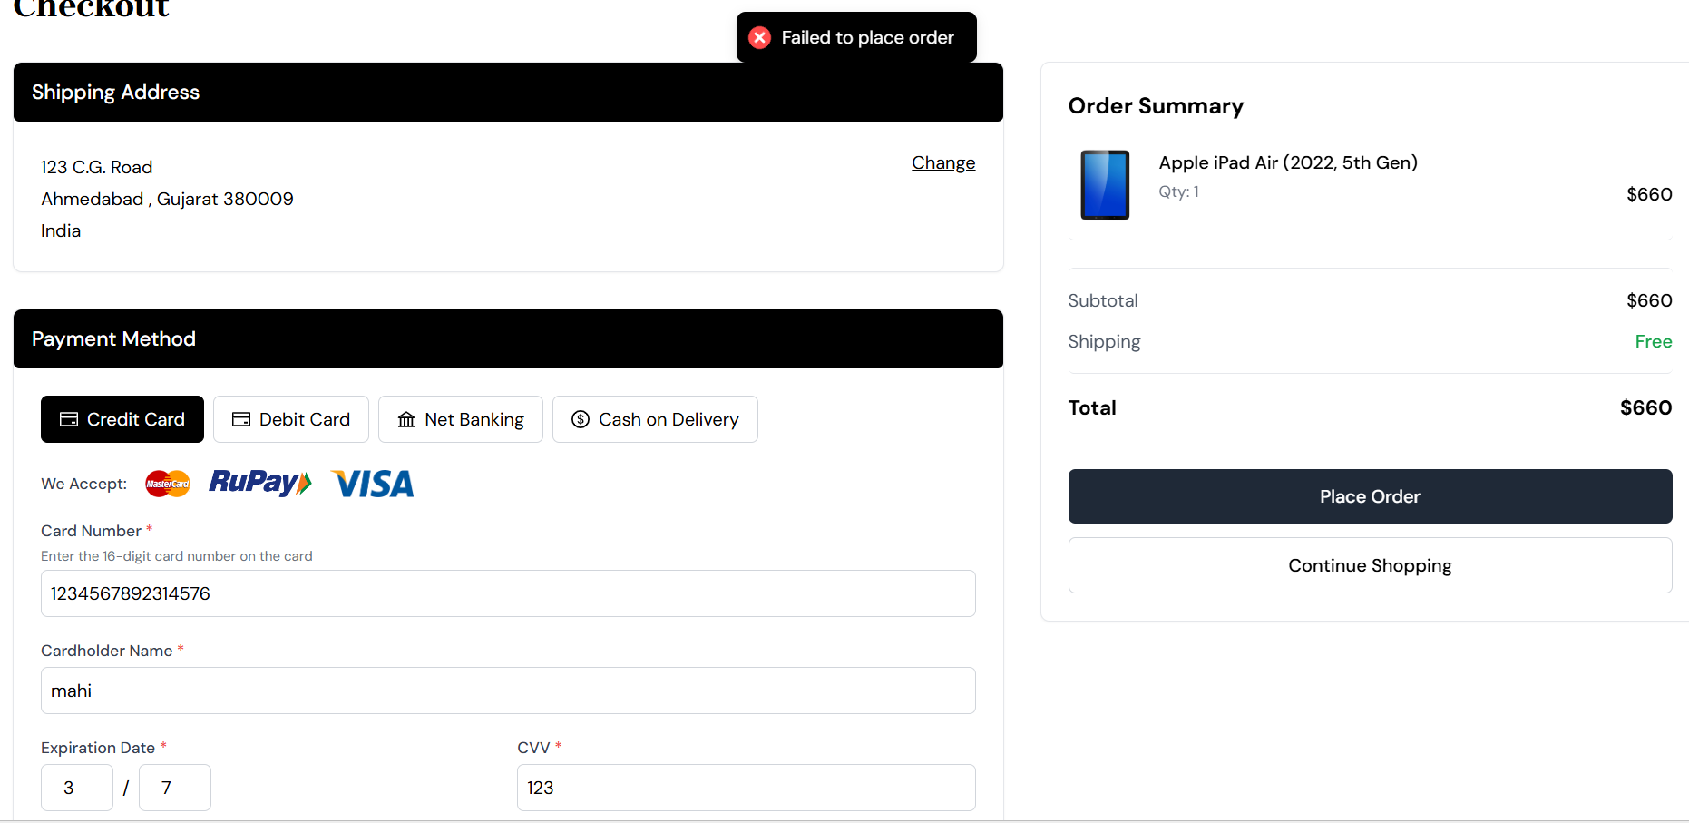

Scenario ID: 2a
Scenario: Select different payment methods with valid Detail
Test Steps:
1. Click on shop now
2. Select item
3. click buy now
4. Fill all details
5. Click net banking
6. Select bank
7. Place order

Screenshots:
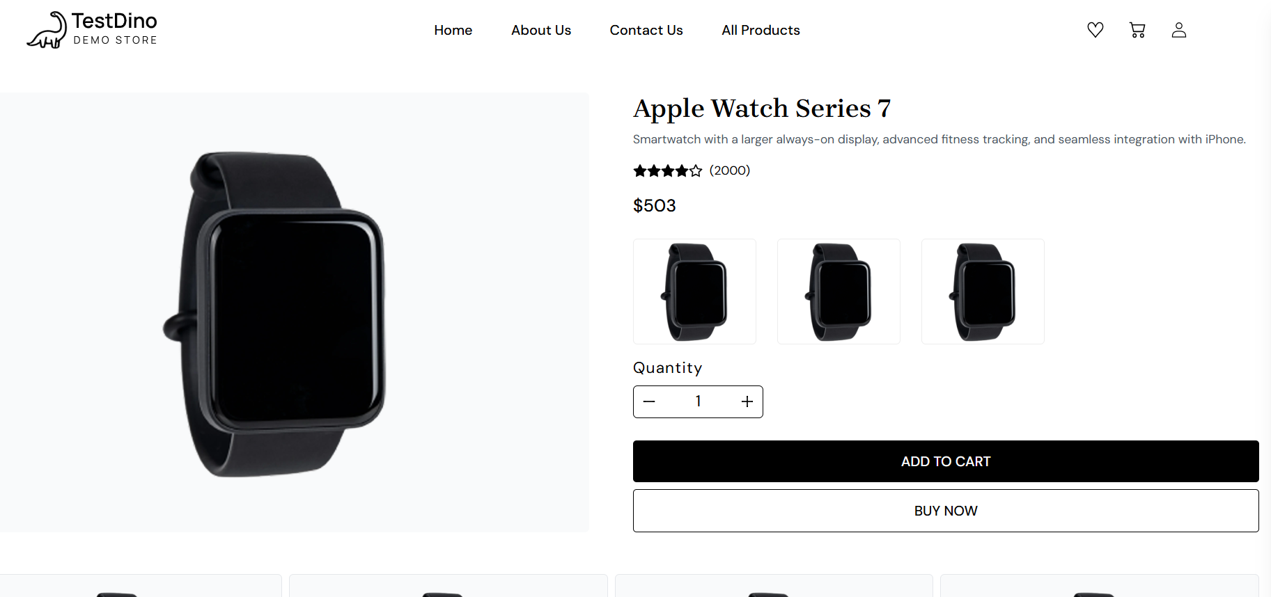
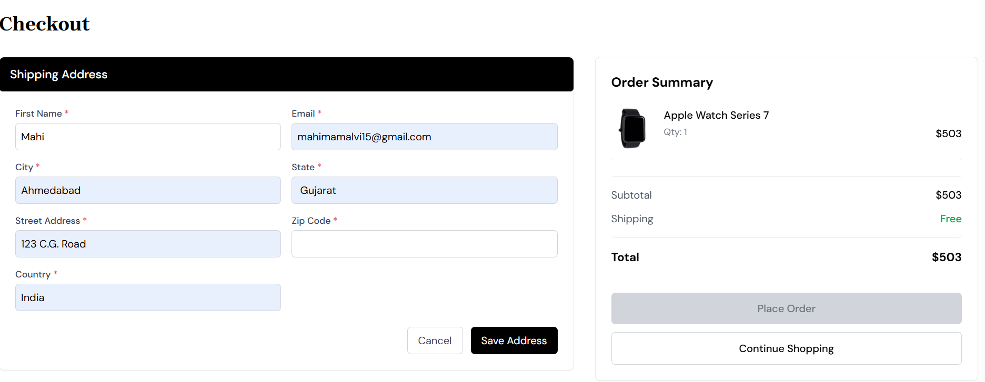

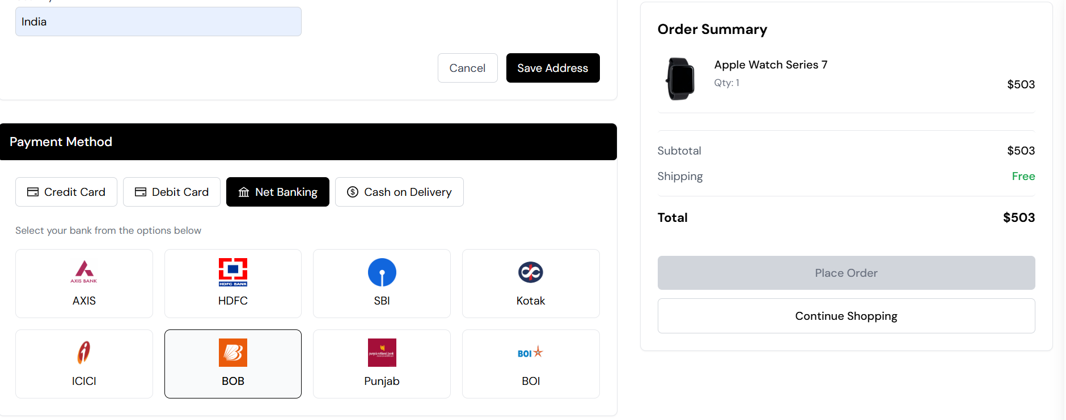

- Scenario ID: 2b
Scenario: Proceed to checkout with an empty cart
Test Steps:
1. Click on shop now
2. Select item
3. click buy now
4. Click credit card
5. Not fill any detail
6. Place order

Screenshots:
