Project Report

1. Selected Problem Statement and Reason for Selection
Problem: Weak and predictable passwords are a major cause of cyber security breaches.
This project focuses on helping users create strong and secure passwords.
This issue is important because weak passwords can lead to hacking, data theft, and privacy loss.

2. Problem Statement Explanation
What is the problem?
Users often create weak passwords that are easy to guess.
Where does this problem exist?
On websites, apps, and online platforms where authentication is required.
Who is affected?
All internet users, especially those unaware of security practices.
Why is it serious?
It can lead to unauthorized access and data breaches.
What could happen if not solved?
Accounts may get hacked, personal data stolen, and financial loss may occur.

3. Proposed Solution
This project is a Password Strength Checker and Random Password Generator.
It checks the strength of a password and generates strong passwords automatically.
How the system works:
- User enters a password
- System analyzes length, characters, symbols
- Displays strength level (Weak/Medium/Strong)
- Generates secure password on request
Who will use it:
General users, students, and developers.

4. Project Features
- Password Strength Checker: Evaluates password security.
- Random Password Generator: Creates strong passwords.
- User-Friendly Interface: Easy to use design.
- Real-time Feedback: Instant strength results.

5. Technology Stack
HTML: Structure of the web page
CSS: Styling and layout
JavaScript: Logic for password checking and generation

6. Project Screenshots
Include screenshots of:
- Homepage
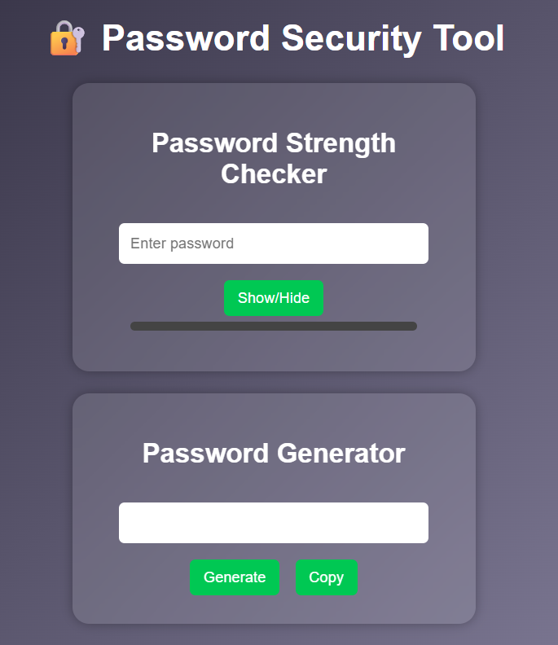
- Password checking feature
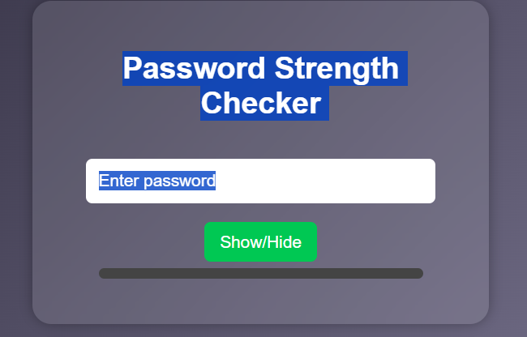
- Generated password output
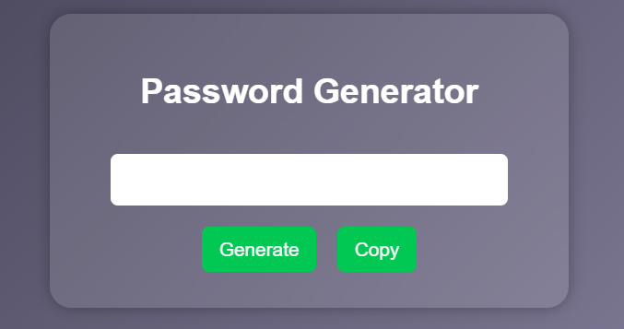

7. Open Source Repository
Upload the project on GitHub and provide the repository link here.

8. Future Scope
- Add password saving feature
- Integrate with browser extensions
- Use AI for better password suggestions
- Mobile application development

