1. A screenshot of a computer

   Description automatically generated
2. A screenshot of a computer

   Description automatically generated
3. A screenshot of a computer

   Description automatically generated
4. A screenshot of a computer

   Description automatically generated
5. A screenshot of a computer

   Description automatically generated
6. A screenshot of a computer

   Description automatically generated
7. A screenshot of a computer

   Description automatically generated
8. A screenshot of a computer program

   Description automatically generated
9. A screenshot of a survey

   Description automatically generated
10. A screenshot of a computer

    Description automatically generated
11. A screenshot of a computer

    Description automatically generated
12. 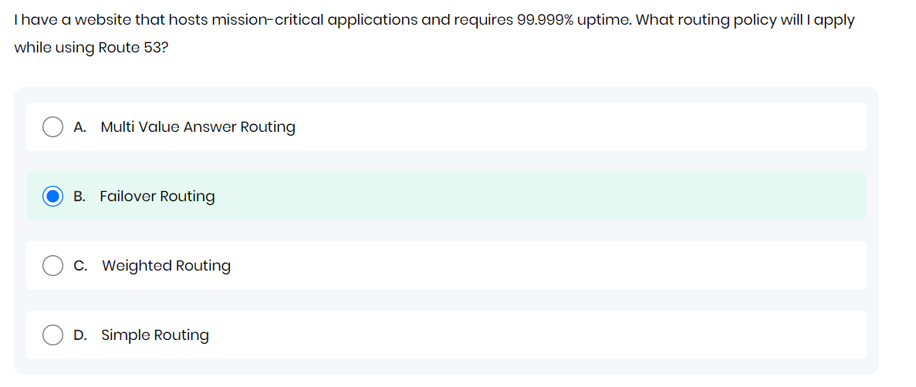
13. A screenshot of a computer

    Description automatically generated
14. A screenshot of a computer

    Description automatically generated
15. A screenshot of a computer

    Description automatically generated
16. A screenshot of a computer

    Description automatically generated
17. 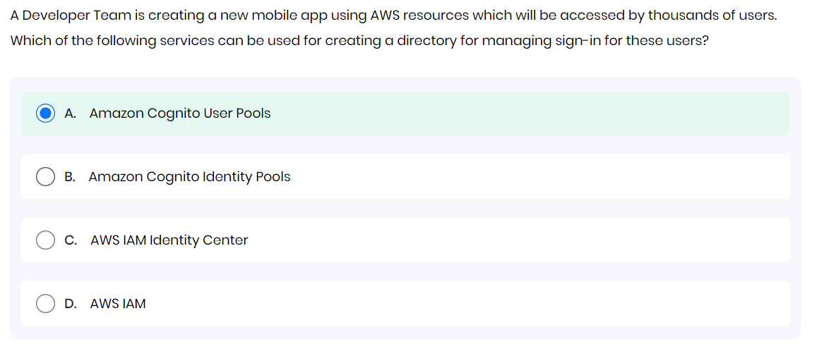
18. 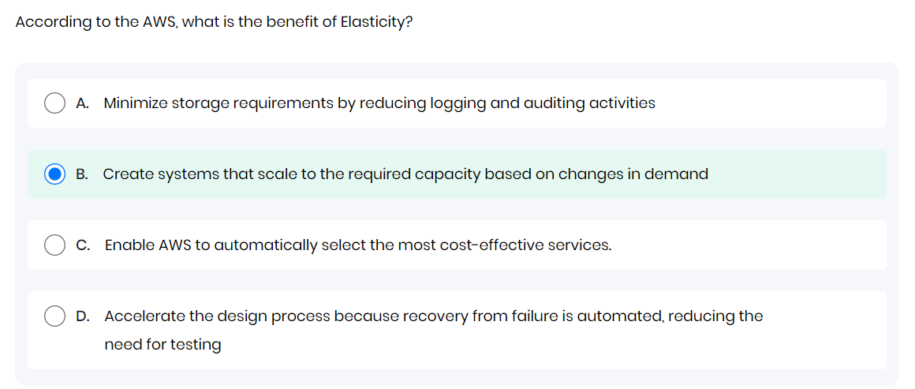
19. A white text with black text

    Description automatically generated
20. A screenshot of a computer

    Description automatically generated
21. A screenshot of a computer

    Description automatically generated
22. A screenshot of a computer

    Description automatically generated
23. A screenshot of a computer

    Description automatically generated
24. 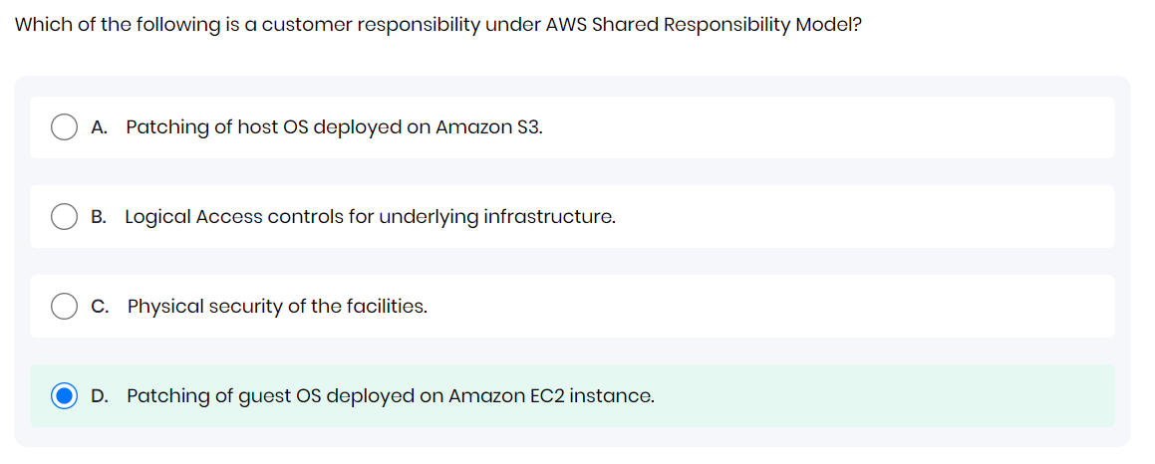
25. A screenshot of a computer

    Description automatically generated
26. A screenshot of a computer

    Description automatically generated
27. A screenshot of a computer

    Description automatically generated
28. A screenshot of a computer

    Description automatically generated
29. A screenshot of a computer

    Description automatically generated
30. A screenshot of a computer

    Description automatically generated
31. A screenshot of a computer

    Description automatically generated
32. A screenshot of a computer

    Description automatically generated