EasyCircular

AI-Assisted Web System for Summarising Sri Lanka Ministry of Education (MOE) Circulars
ශ්‍රී ලංකා අධ්‍යාපන අමාත්‍යාංශ චක්‍රලේඛ සාරාංශක AI වෙබ් පද්ධතිය
G G M P Kusumsiri (2540881) · Supervisor: Mr. Anuruddha Abeysinghe · The University of Bedfordshire · August 2026

INTRODUCTION  MOE educational circulars are long, complex PDF documents (often 5–20 pages) distributed to principals, teachers, and education officers. They contain critical deadlines, legal references, and action items buried in administrative language. Misinterpretation risks compliance failures. EasyCircular is a purpose-built AI web system that extracts text (including scanned Sinhala/Tamil/English OCR), lets users review extracted text, and produces structured summaries with highlighted entities. | AIM  Develop an AI-powered web application using NLP to extract and summarise complex MOE circulars, improving administrative efficiency in Sri Lanka schools. | OBJECTIVES  1. Evaluate NLP and summarisation techniques for administrative documents  2. Build secure PDF ingestion with OCR fallback and human-in-the-loop text review  3. Implement NER for dates, organisations, and legal references  4. Deliver a dynamic summarisation engine with hallucination guardrails  5. Evaluate accuracy (ROUGE, automated tests) and stakeholder needs (n=41 survey)

METHODOLOGY
Agile SDLC across 5 phases (10 weeks): Foundation → Ingestion → AI Core → MVP → Validate & Release. Primary research: Google Forms survey (n=41 school stakeholders). Evaluation: ROUGE on 6 MOE circulars, 91+ AI pytest, phase exit-gate scripts.
Phase 1 Foundation → Phase 2 Ingestion → Phase 3 AI Core → Phase 4 MVP → Phase 5 Validate

SYSTEM ARCHITECTURE  User Browser → Next.js Frontend (3002)  → Express Backend (4000: JWT, cache, rate limit)  → FastAPI AI Service (5000: OCR, SpaCy NER, LangChain/Ollama, guardrails)  → MongoDB (27017)  Pipeline: Upload PDF → Extract/OCR → Human Edit → Process → Display  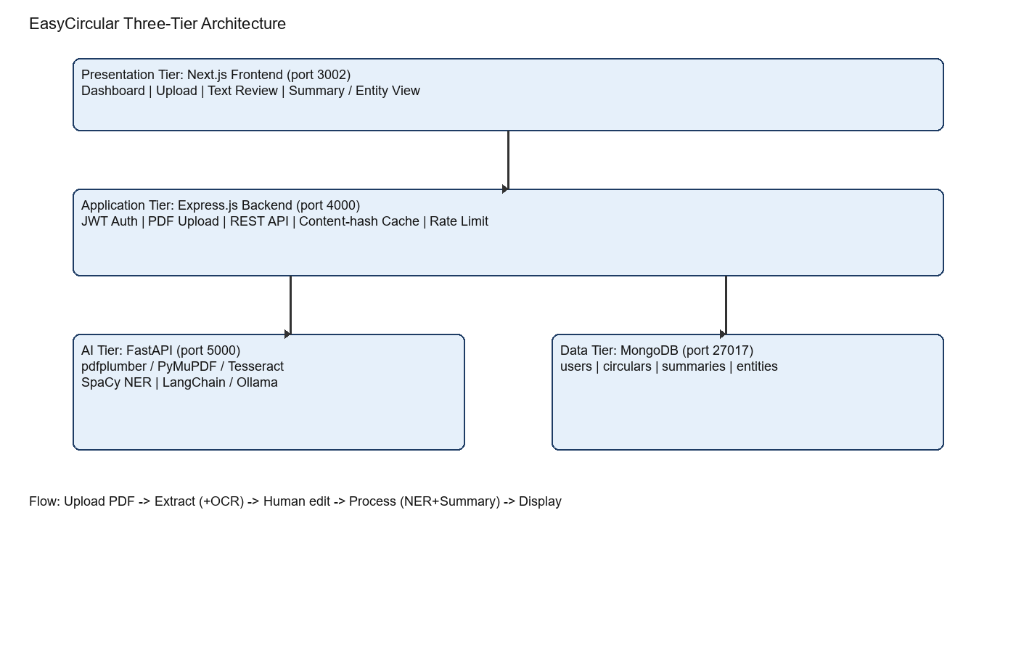 | APPLICATION SCREENSHOTS  Sign-in  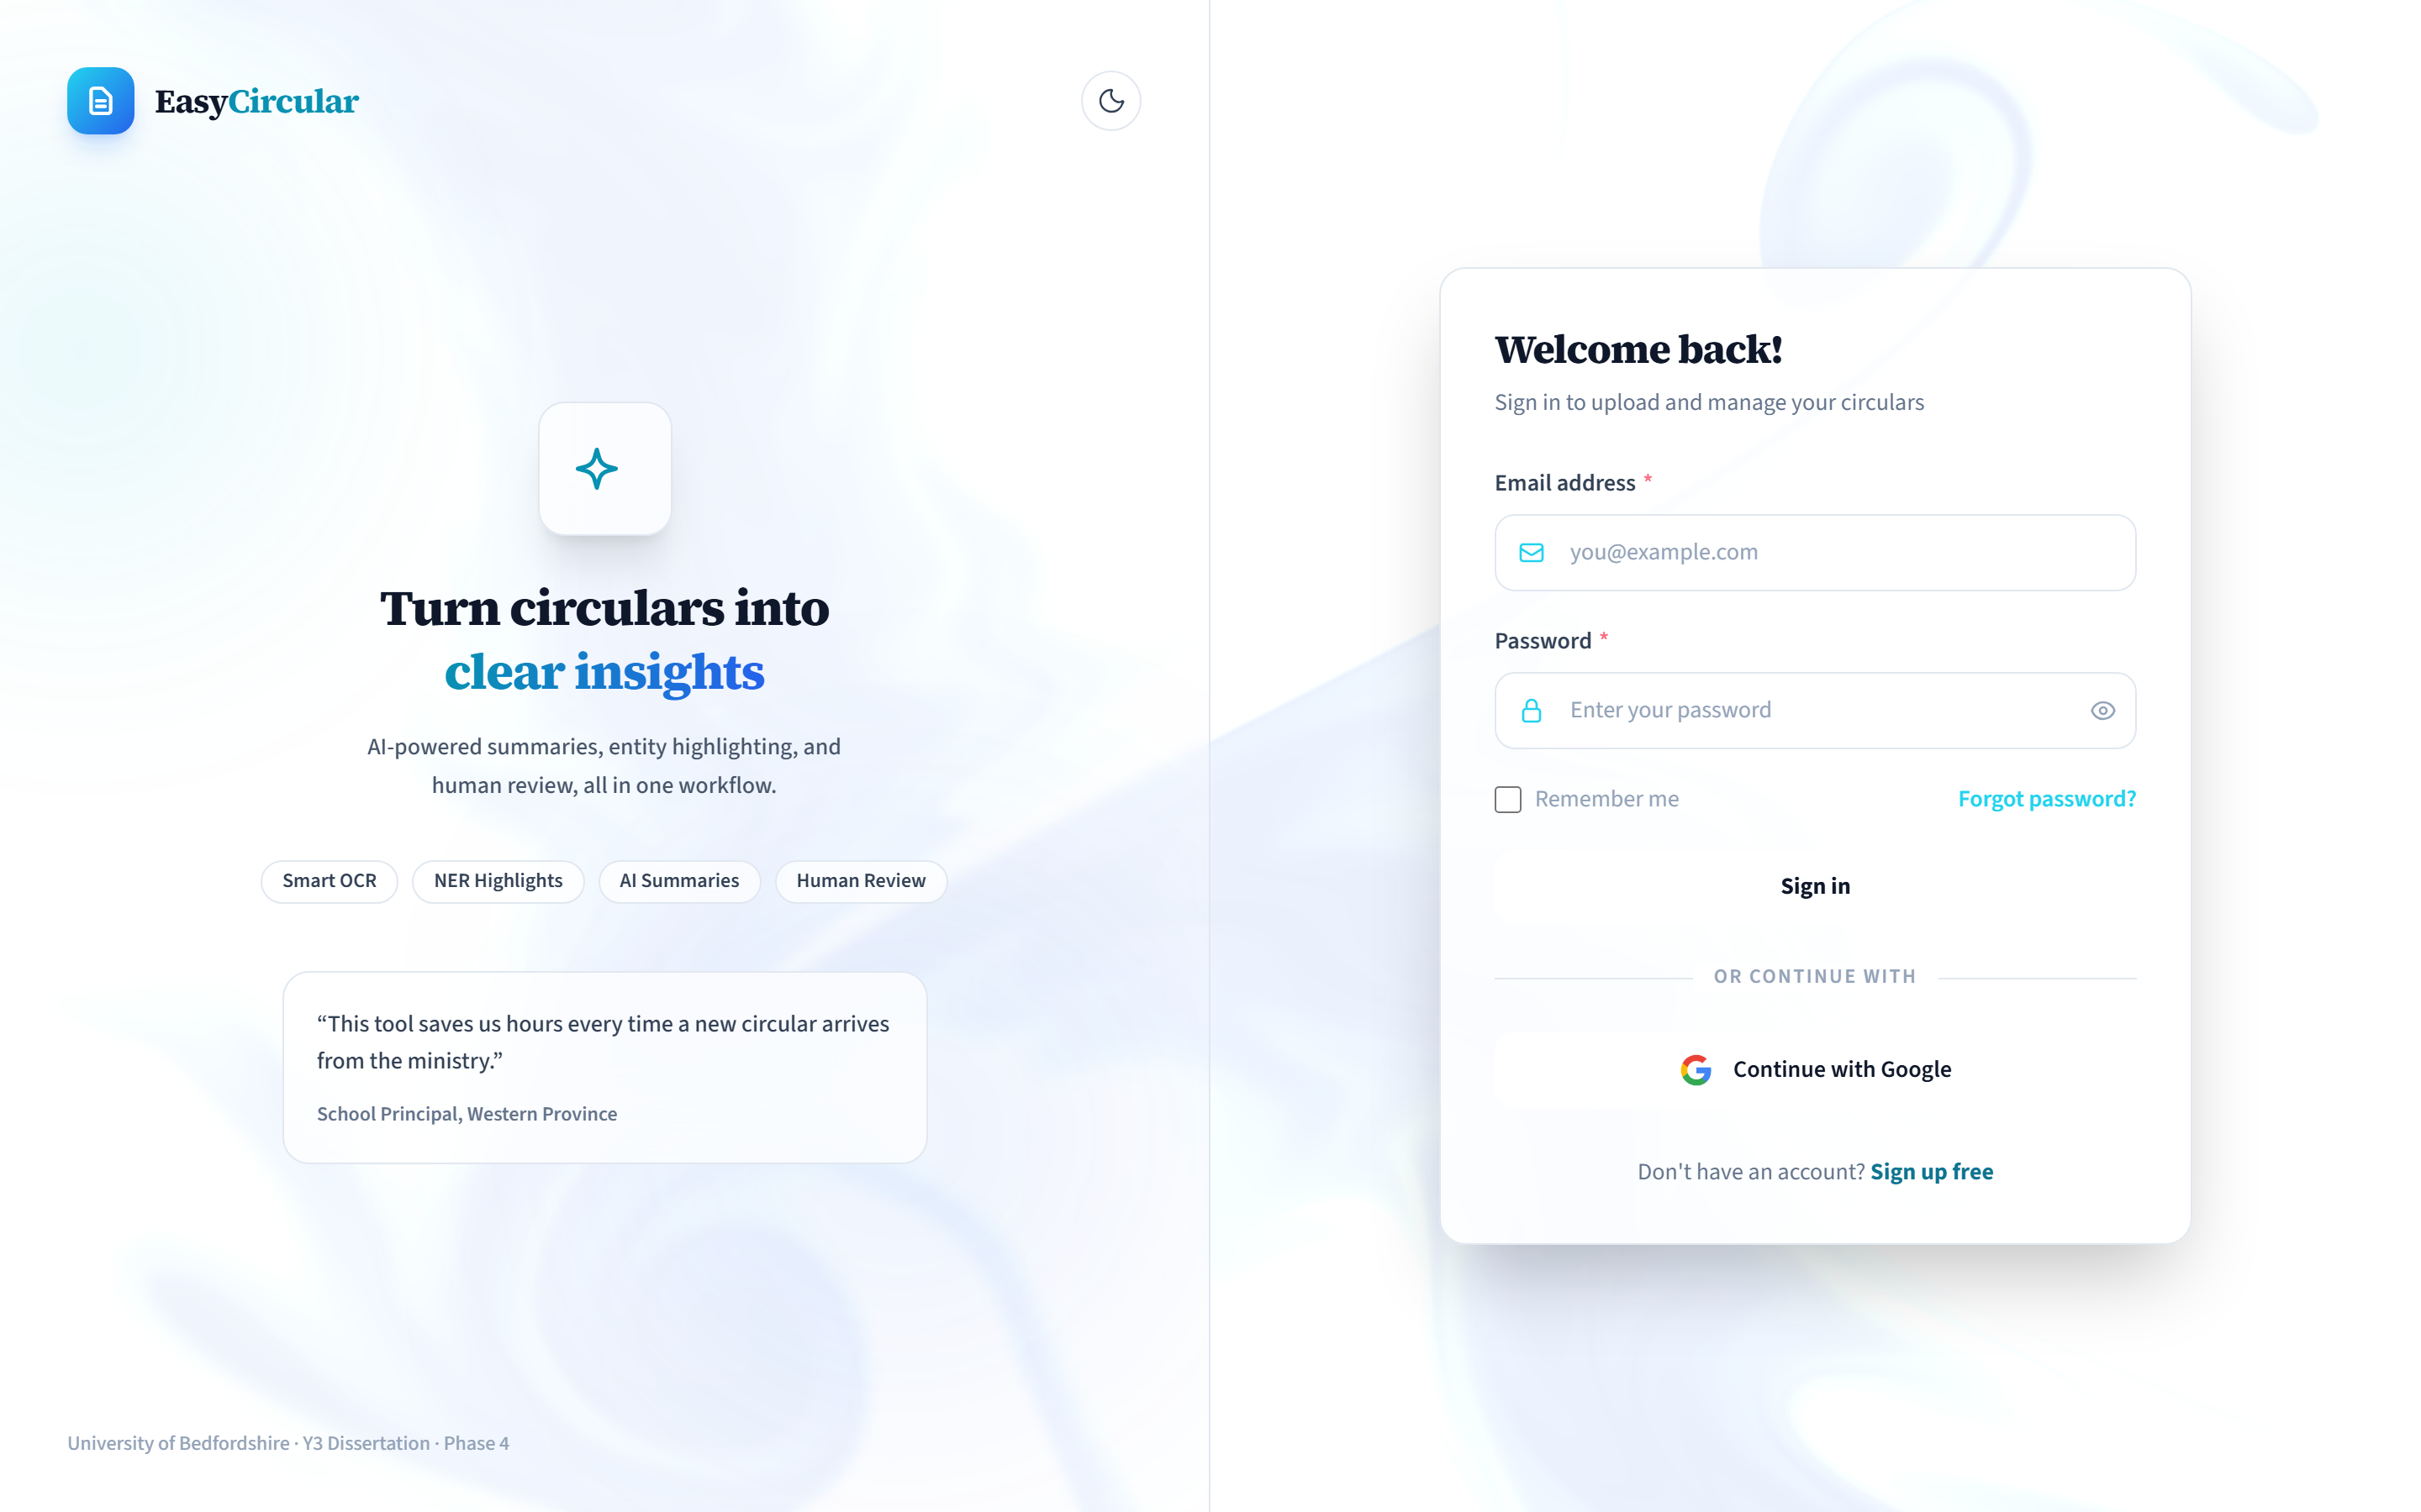  PDF upload  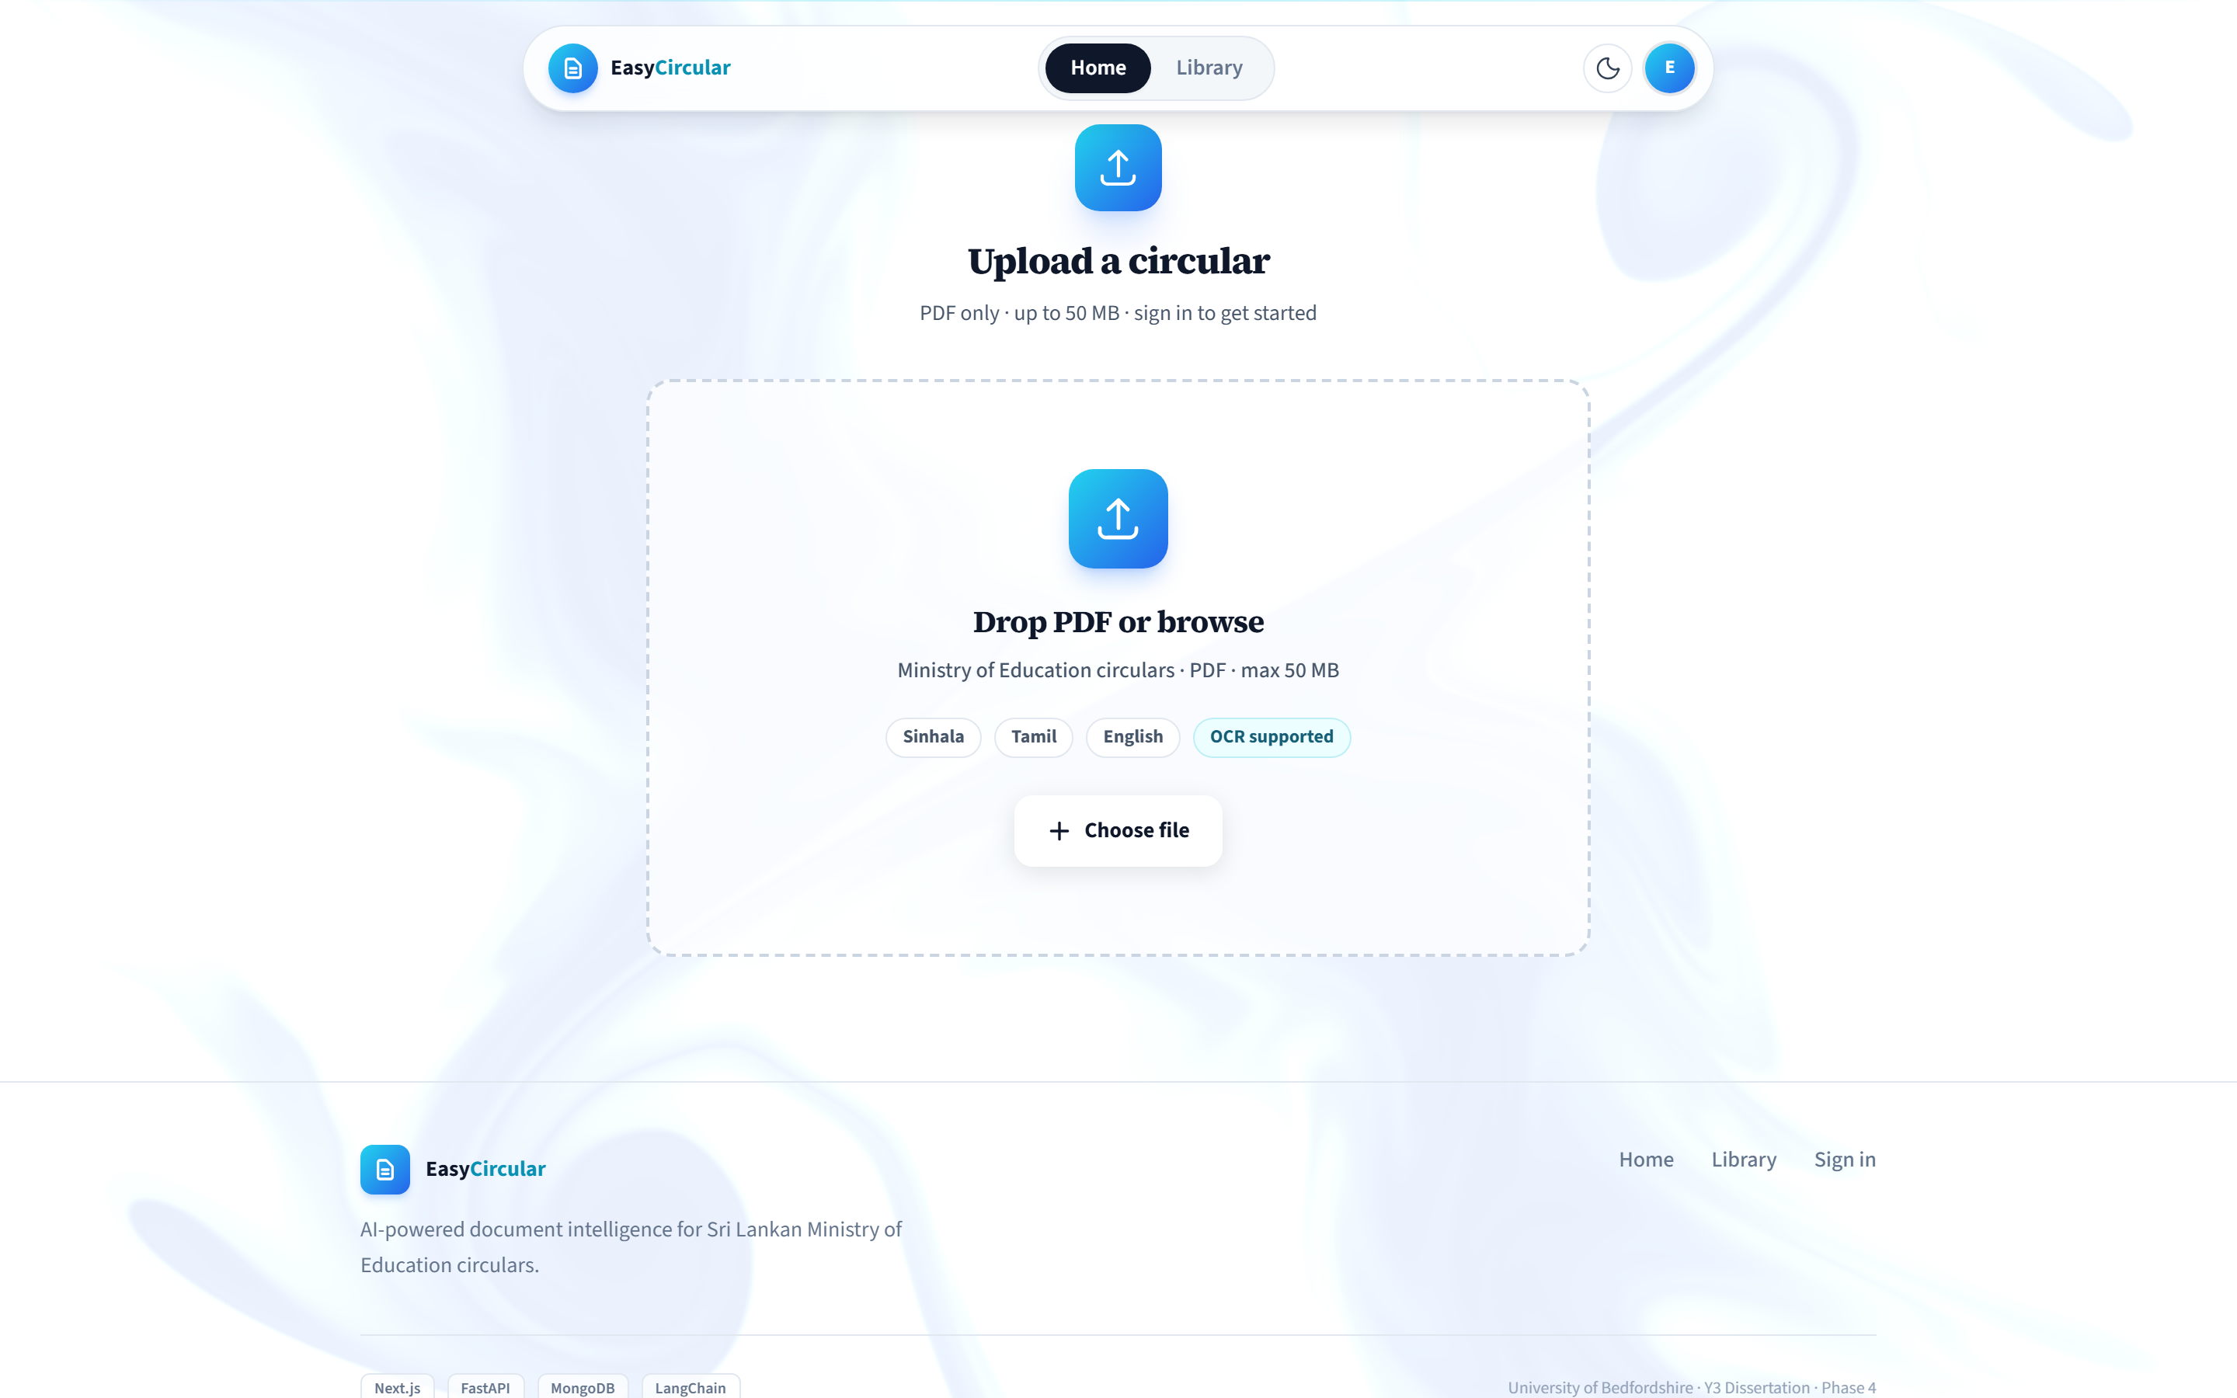  Human-in-the-loop review  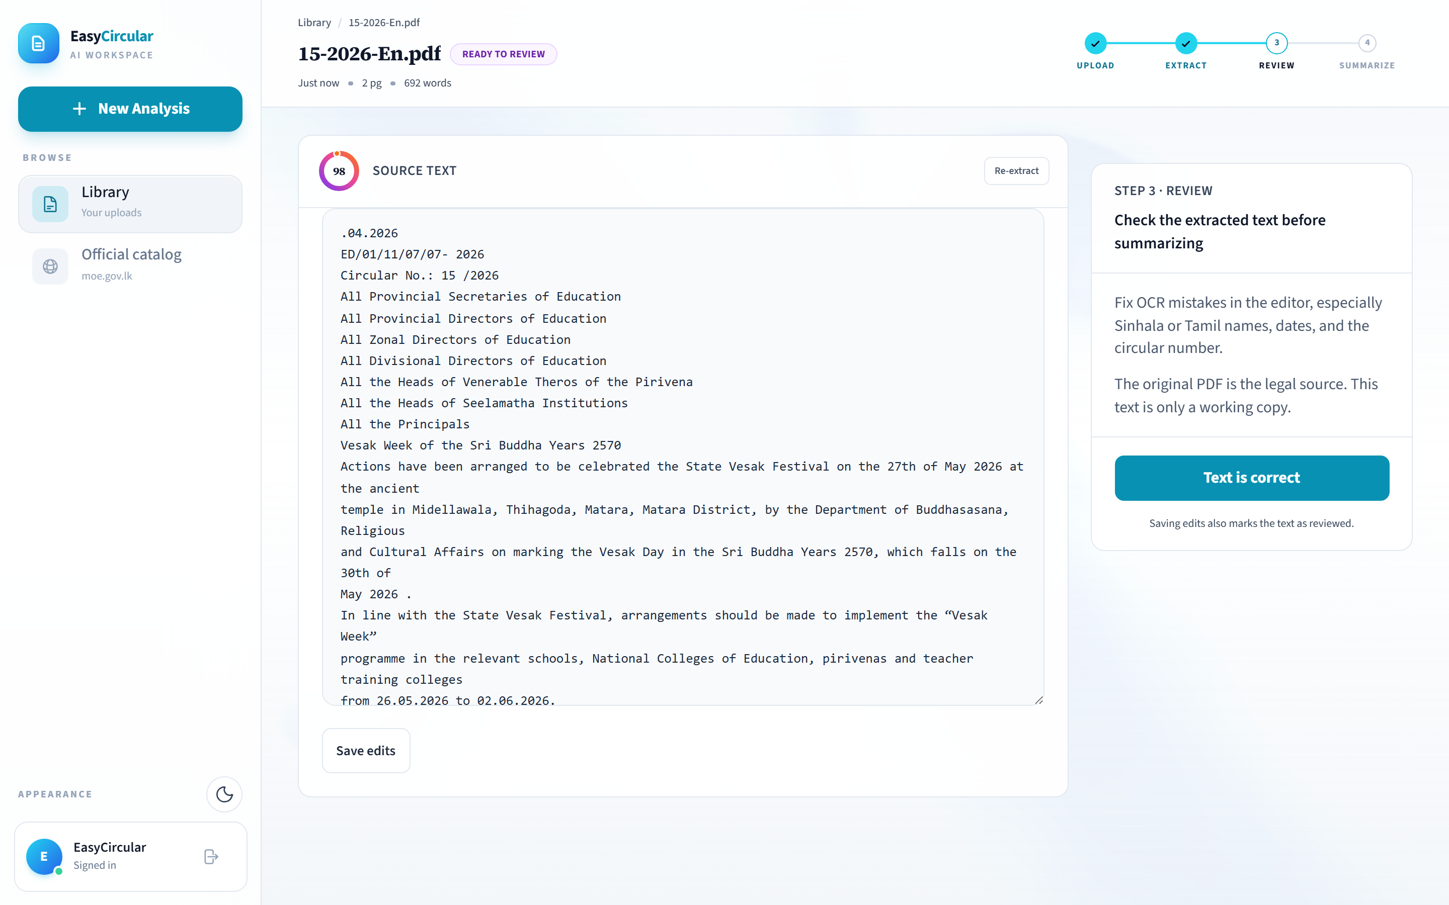  Summary + entity highlights  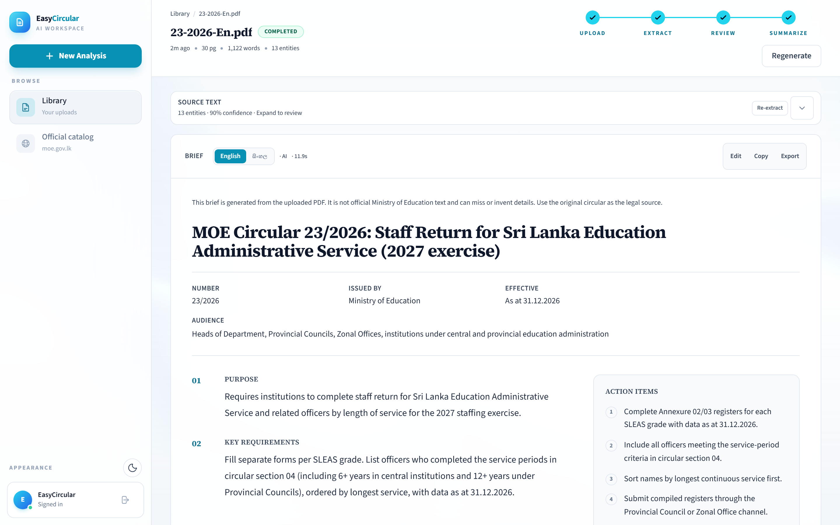  Mobile summary view  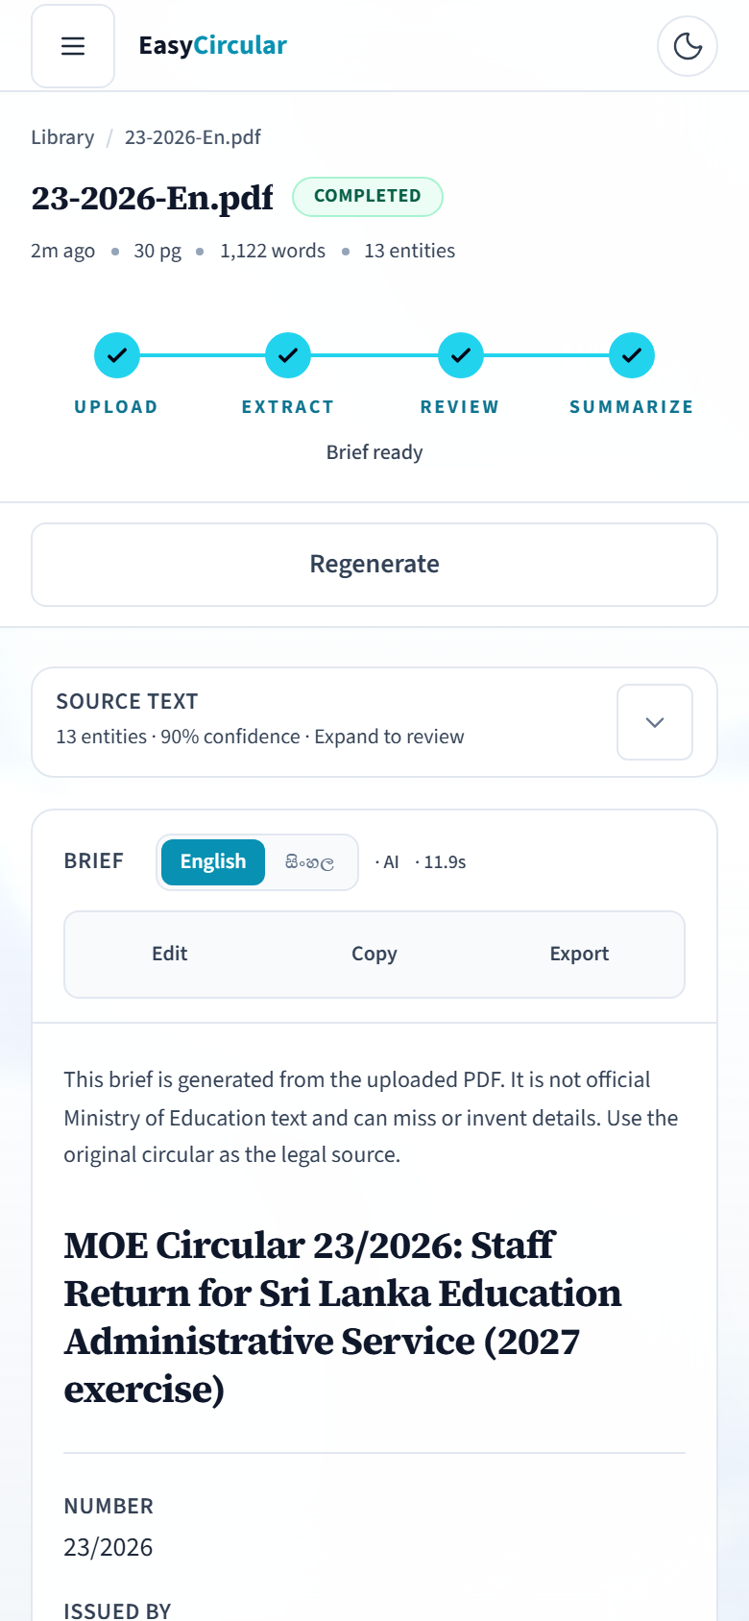

TECHNOLOGY STACK  Next.js · Express.js · FastAPI · MongoDB · Docker · SpaCy · LangChain · Ollama · Tesseract OCR · pdfplumber · PyMuPDF · JWT · GitHub Actions CI | KEY REQUIREMENTS  • PDF upload with tri-library extraction + Tesseract OCR (sin+eng+tam)  • Human-in-the-loop mandatory text review before AI processing  • Date guardrails reject hallucinated dates; extractive TextRank fallback  • Content-hash caching (~114ms cached response)  • JWT auth, rate limiting, mobile-responsive UI  • Local Ollama deployment for privacy | EVALUATION & RESULTS  Survey (n=41): 97.6% want summaries | 78% want entity highlighting | 78% expect efficiency gain | 68.3% hesitant about AI  ROUGE macro F1: ROUGE-1 0.414 | ROUGE-2 0.215 | ROUGE-L 0.292  Testing: 91/91 AI pytest | 13/13 backend tests | Phase 1 & 4 verified  Formal school staff UAT pending  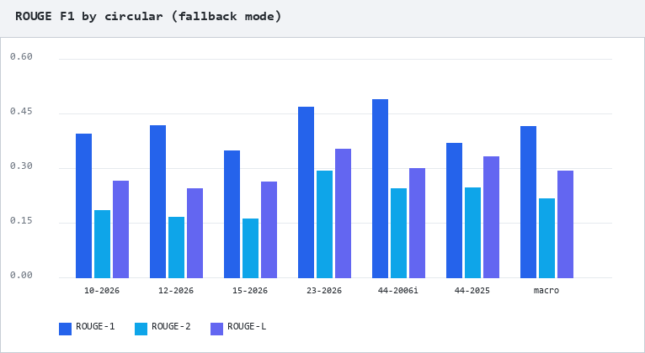

ACHIEVEMENTS  • End-to-end MVP: upload → extract → edit → summarise → display  • Tri-tier Docker deployment with health checks  • Guardrails reduce date hallucination (~15% rejection rate)  • MOE official catalog import endpoint  • Full thesis documentation + AI-assisted development disclosure | CHALLENGES  • Scanned Sinhala PDF OCR quality varies — mitigated by human review  • Full Sinhala/Tamil NER not yet available (English NER achieved)  • LLM summarisation quality vs. privacy trade-off addressed via local Ollama  • Single-developer scope; formal UAT not completed before submission | FUTURE WORK (PHASE 6)  • Full Sinhala/Tamil NER and bilingual UI  • Formal school staff UAT and expanded ROUGE corpus  • Async job queue for long documents  • Role-based access control and admin analytics dashboard  • Production cloud deployment with MOE integration

REFERENCES
Lin, C.Y. (2004) ROUGE: a package for automatic evaluation of summaries
Nadkarni, P.M. et al. (2011) Natural language processing: an introduction
Ministry of Education Sri Lanka (2026) Official circulars portal — moe.gov.lk
Honnibal, M. and Montani, I. (2017) spaCy
Sumathi, S. et al. (2025) A LangChain integration approach
OpenAI (2024) ChatGPT — AI-assisted development disclosure

G G M P Kusumsiri | 2540881 · Supervisor: Mr. Anuruddha Abeysinghe · The University of Bedfordshire | BSc (Hons) Computer Science | August 2026

