EASYCIRCULAR
User Manual
A short guide for people in schools who have to
read Ministry of Education circulars
English · August 2026
Principals, teachers, office staff
Read the PDF | Check the text | Get a summary | Keep the original

 | Reading the pages  It pulls text out of ordinary PDFs and from scans, including Sinhala and Tamil. | A short brief  What the circular is about, who it is for, and a list of things the school has to do.
 | You check first  Nothing is summarised until you have looked at the extracted text. OCR gets names wrong. | Ministry list  You can import a file from moe.gov.lk instead of hunting for a copy in email.
Please read this
The summary is a shortcut, not the circular. If a date or a circular number looks wrong, open the PDF. If you imported from the catalog, the ministry page is still the official one.

00 Contents

01 What this is Why you would use it
02 What you need Browser, login, PDF size
03 The usual path Upload, check, summarise
04 Accounts Sign up, Google, sign out
05 Home The first screen
06 Uploading a PDF The drop box and the 50 MB limit
07 Checking the text Editor, then Text is correct
08 The summary What you get, and when it fails
09 Coloured labels in the text Dates, names, circular numbers
10 Saving and translating Export, Copy, language tabs
11 Library Your files
12 Official catalog Import from moe.gov.lk
13 On a phone Same account, smaller screen
14 Those little status labels Uploaded through Failed
15 When something goes wrong The usual snags

01 What this is

If you work in a school and you get MOE circulars as PDFs, this is for you. You either drop in a file you already have, or you pull one from the ministry site. The system reads the pages (including scans in English, Sinhala, or Tamil), shows you the text, and then writes a short brief.
You still have to look at that text before the summary runs. That is on purpose. OCR misreads names. Scans pick up stamps. Better you catch it than the summary invent a deadline.
After that you can copy the brief, download it as a PDF, or switch it to Sinhala or Tamil if the original was in English (and the other way round).
Figure 1 · Home. Start Processing if you have a file, Official circulars for the ministry list.
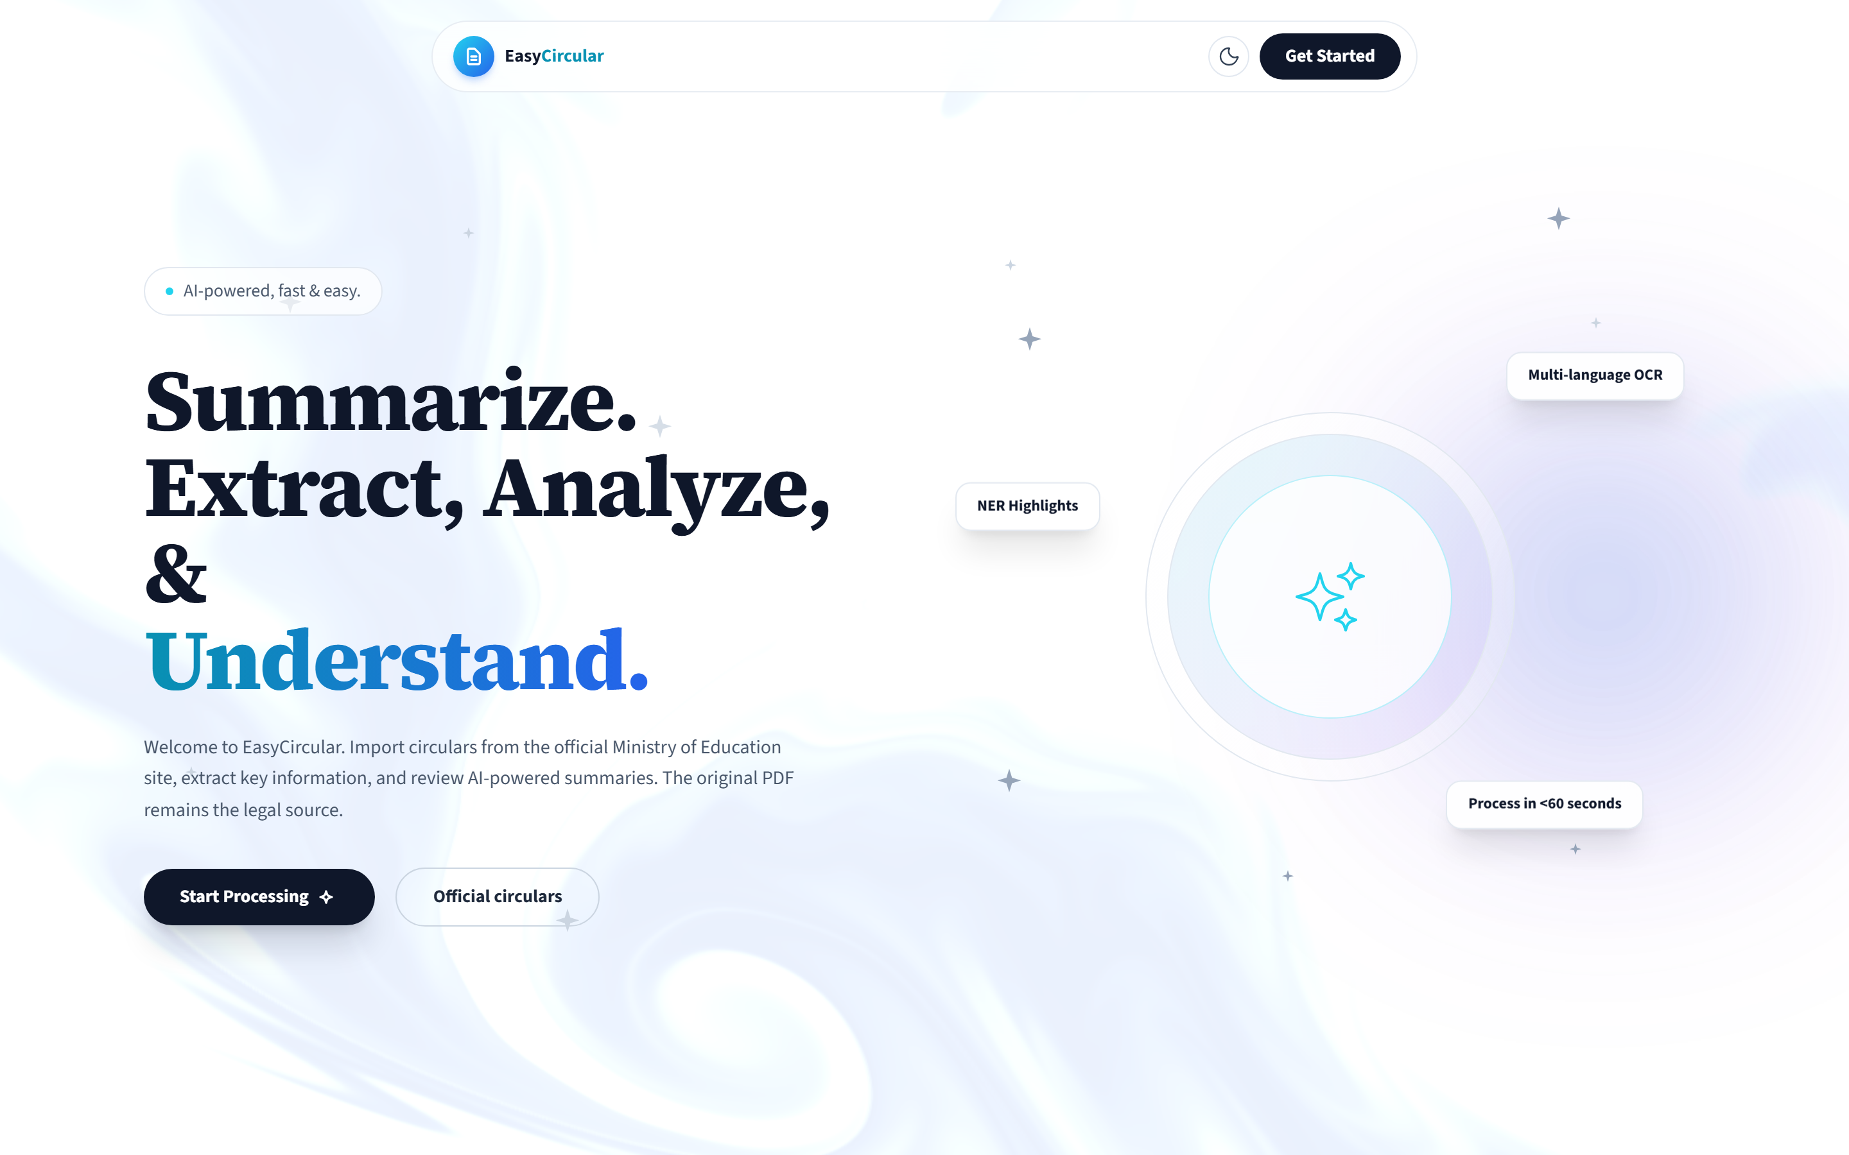

02 What you need

Chrome, Edge, Firefox, or Safari is fine. You need an account — email and a password, or Google. The file has to be a real PDF, not bigger than 50 MB.
You can look around without signing in. You cannot upload or import until you do.
NOTE · Keep the original
EasyCircular does not replace the circular, and it does not send anything to the Ministry on your behalf. File the PDF with whatever summary you export.

03 The usual path

Along the top of a document you will see four steps: Upload, Extract, Review, Summarize. That is the whole job, in order.
1  Upload  Sign in. Drop a PDF, or import one from the catalog. | 2  Extract  Wait. Scanned pages take longer. | 3  Review  Fix the number and the dates. Then Text is correct. | 4  Summarize  Read the brief. Export it if you need a copy.

From home, Start Processing or New Analysis gets you a file in. Then: Editor, Save edits, Text is correct, Generate summary. The two things worth checking by hand are the circular number and the dates. Staff act on those.
Figure 2 · Signed in — the upload box is available
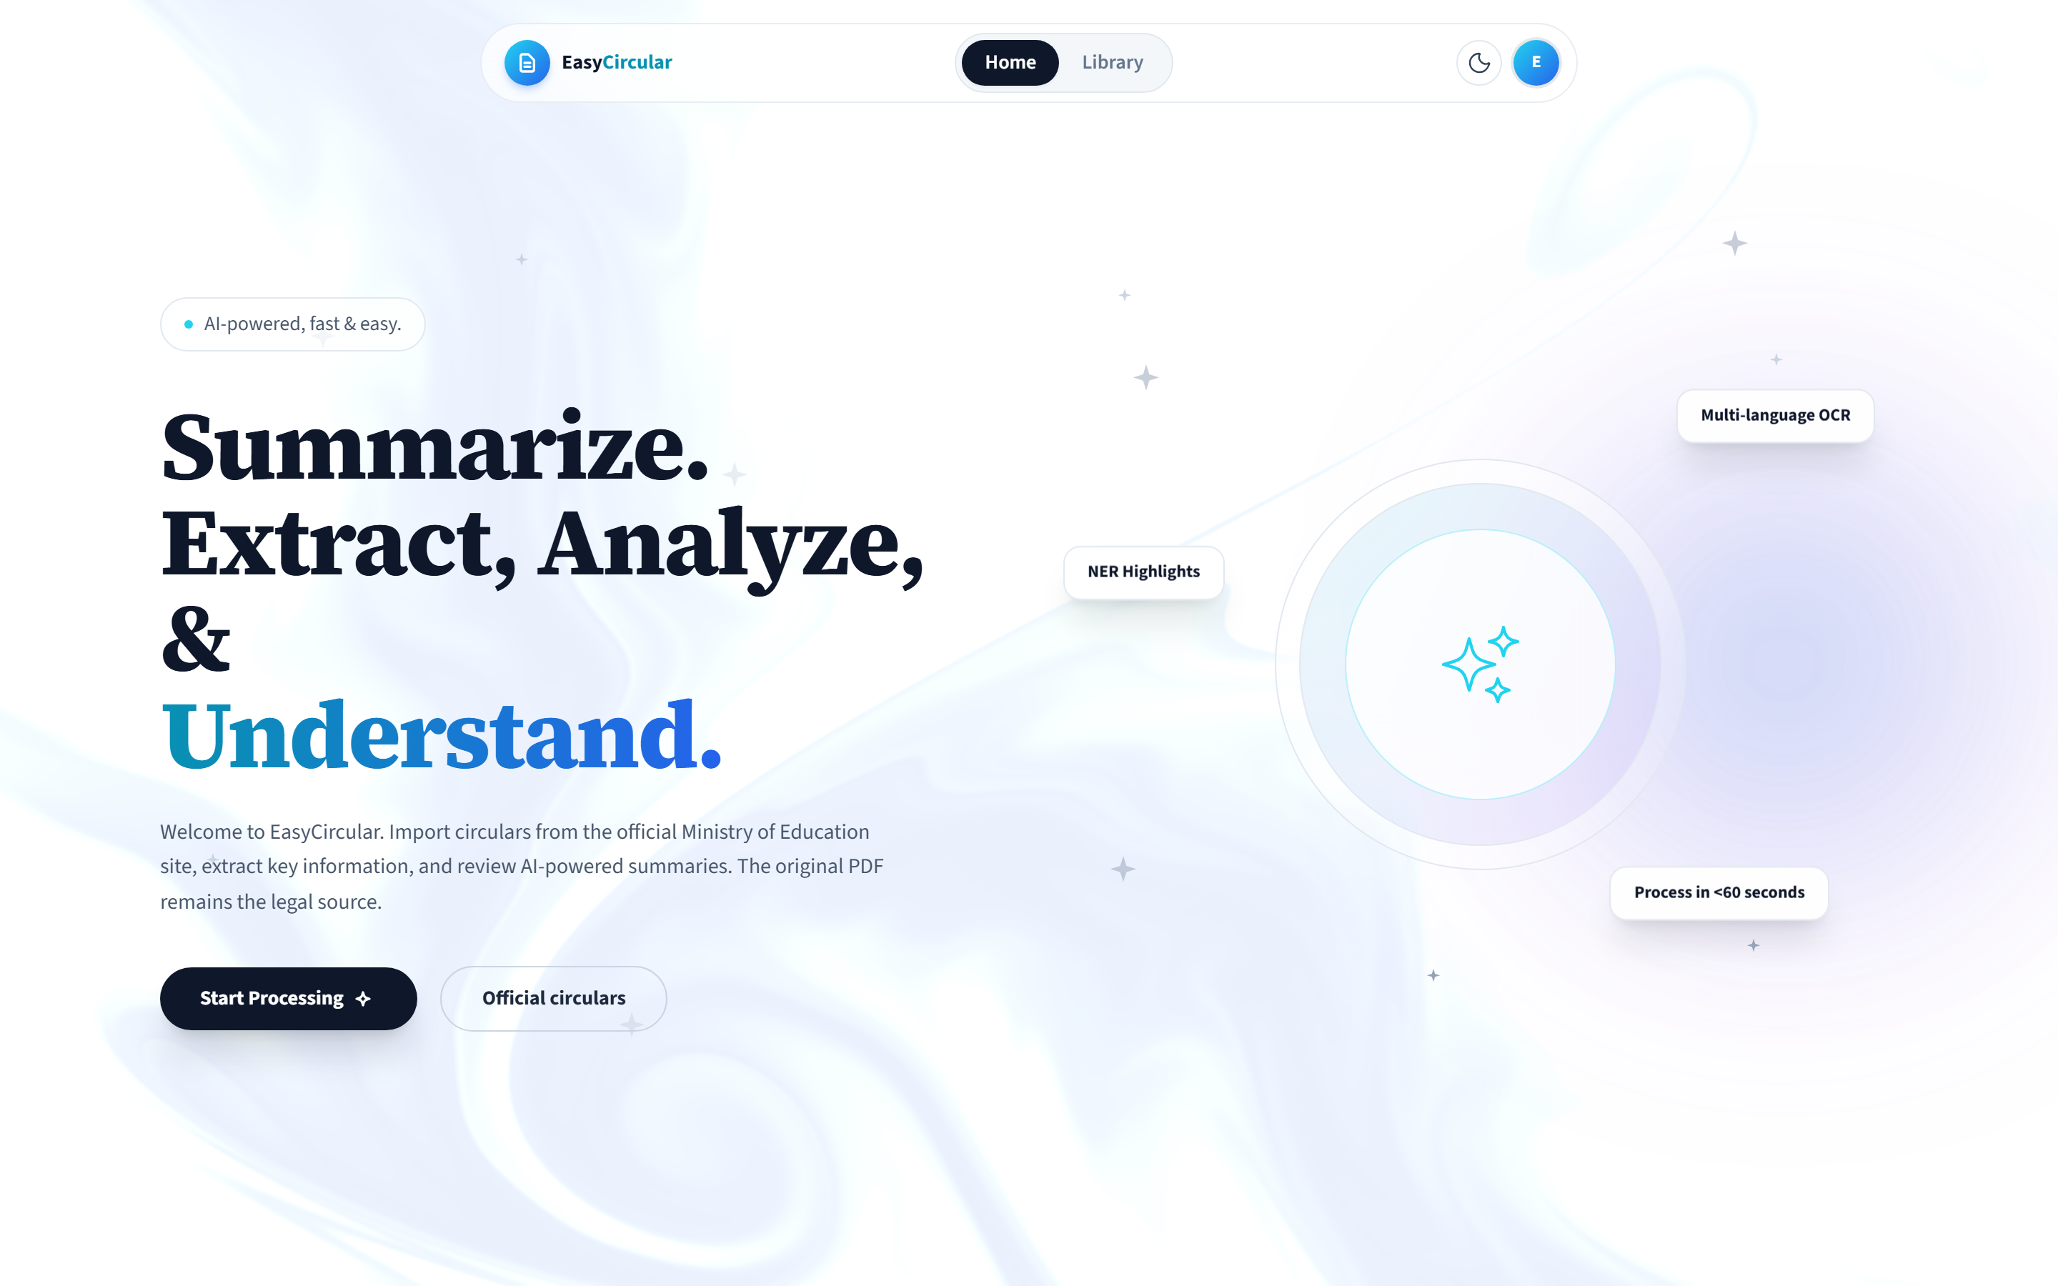

04 Accounts

New account
Click Get Started or Sign up. You will be asked for your name, email, a password of at least eight characters, and your job role (Teacher, Principal, or Education administration). District is optional; type a few letters and pick from the list.
Create account, or Continue with Google if that is easier. After that you land back at upload.
Figure 3 · Sign-up form
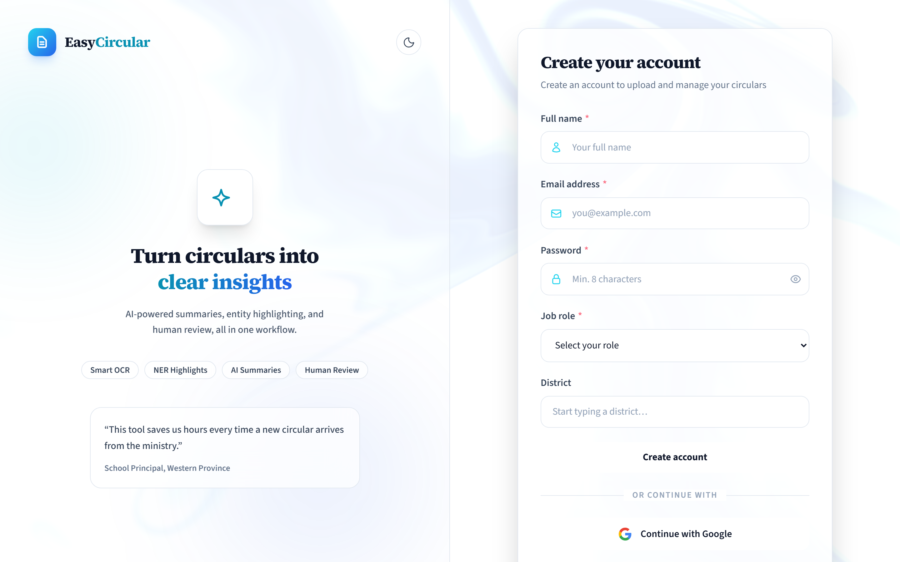

Coming back
Use Sign in. Same email and password, or Google again. Remember me is there if you want it.
NOTE · Forgot password?
The link is on the form. It does not actually reset anything yet. If you are stuck, try Google, or get someone to make a new account.

Figure 4 · Sign-in
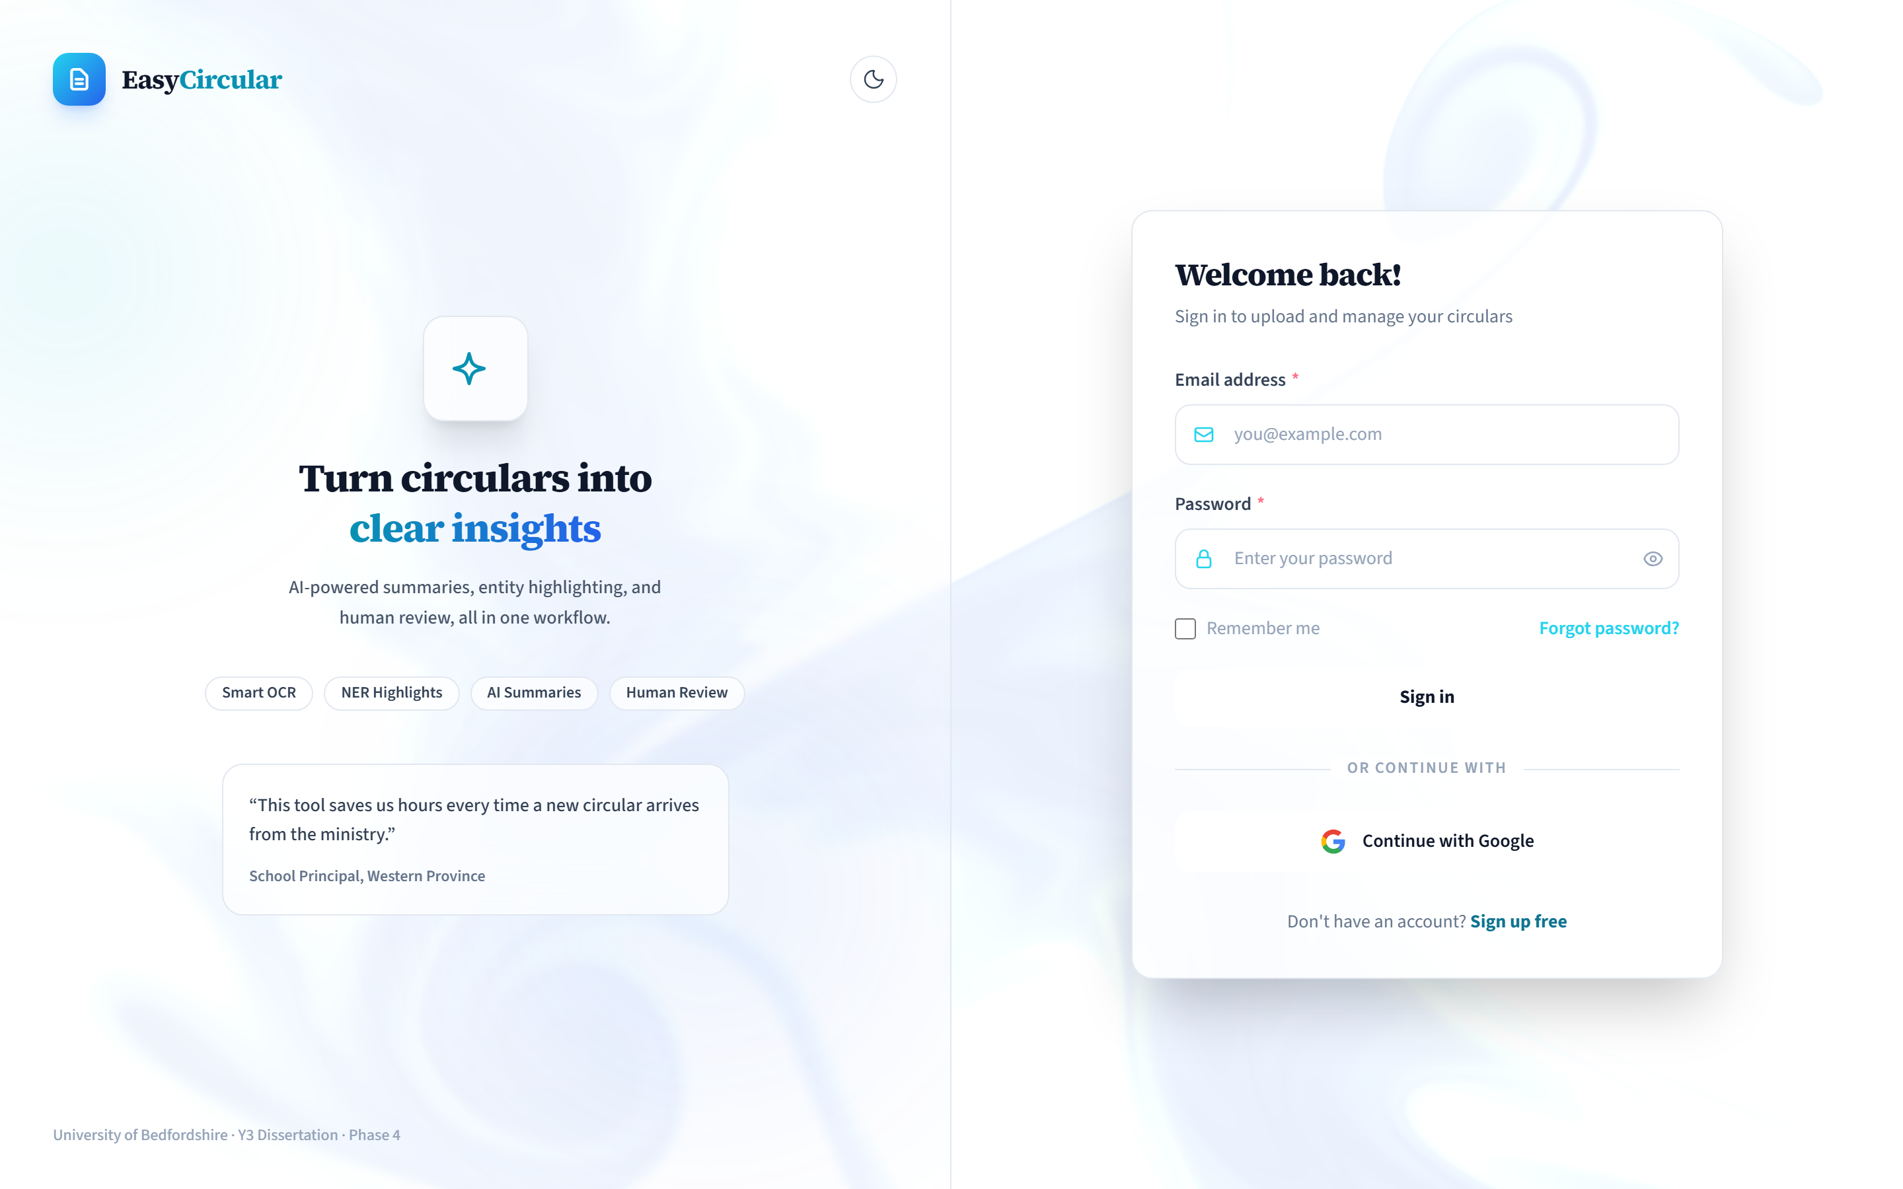

Sign out is in the top bar on the home page, and in the left sidebar once you are in a document.
05 Home

This is the first screen. The dark Start Processing button takes you to upload (it will send you to sign in if you have not). Official circulars opens the moe.gov.lk list inside EasyCircular.
Get Started is sign in / sign up. The moon (or sun) icon switches dark mode. Library is your own files. The four cards under the fold are just a description of the product. You do not click them to do the work.
06 Uploading a PDF

If you are not signed in, the box says Sign in to upload. Fair enough.
From home, scroll down to the drop area, or once you are in the workspace use New Analysis on the left. Drop the file, or click to browse. You should see Uploading your circular…, then the document screen opens.
Limit | What happens
Has to be a PDF | Renaming a Word file to .pdf will not work
50 MB | Anything larger is rejected
One file at a time | There is no upload-this-whole-folder button

Figure 5 · The upload box on the home page
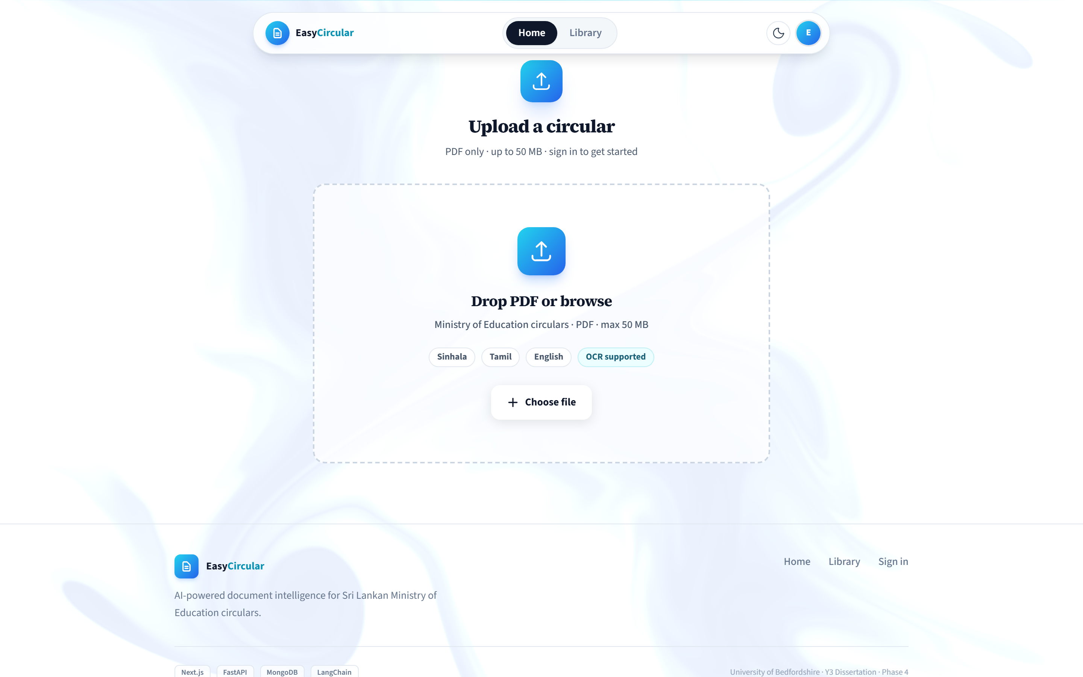

07 Checking the text

Extraction usually starts on its own. If it does not, use Extract text. Re-extract runs it again if the first pass looked empty or garbled. Sinhala and Tamil scans can sit there for a while. Leave the tab open.
You cannot generate a summary until you have said the text is all right. That is the Review step.
Open Source text. Editor is where you type. Highlights shows coloured tags later, after a summary exists.
Correct the obvious stuff: circular number, dates, school names, anything OCR mangled in Sinhala or Tamil.
Save edits (that also counts as reviewed). Then Text is correct, then Generate summary.
IMPORTANT · Working copy
The text on screen is a working copy. The PDF is still the circular. Fix the number and the dates here before you trust the brief.

Figure 6 · Review. Read the text, then confirm it before you summarise.
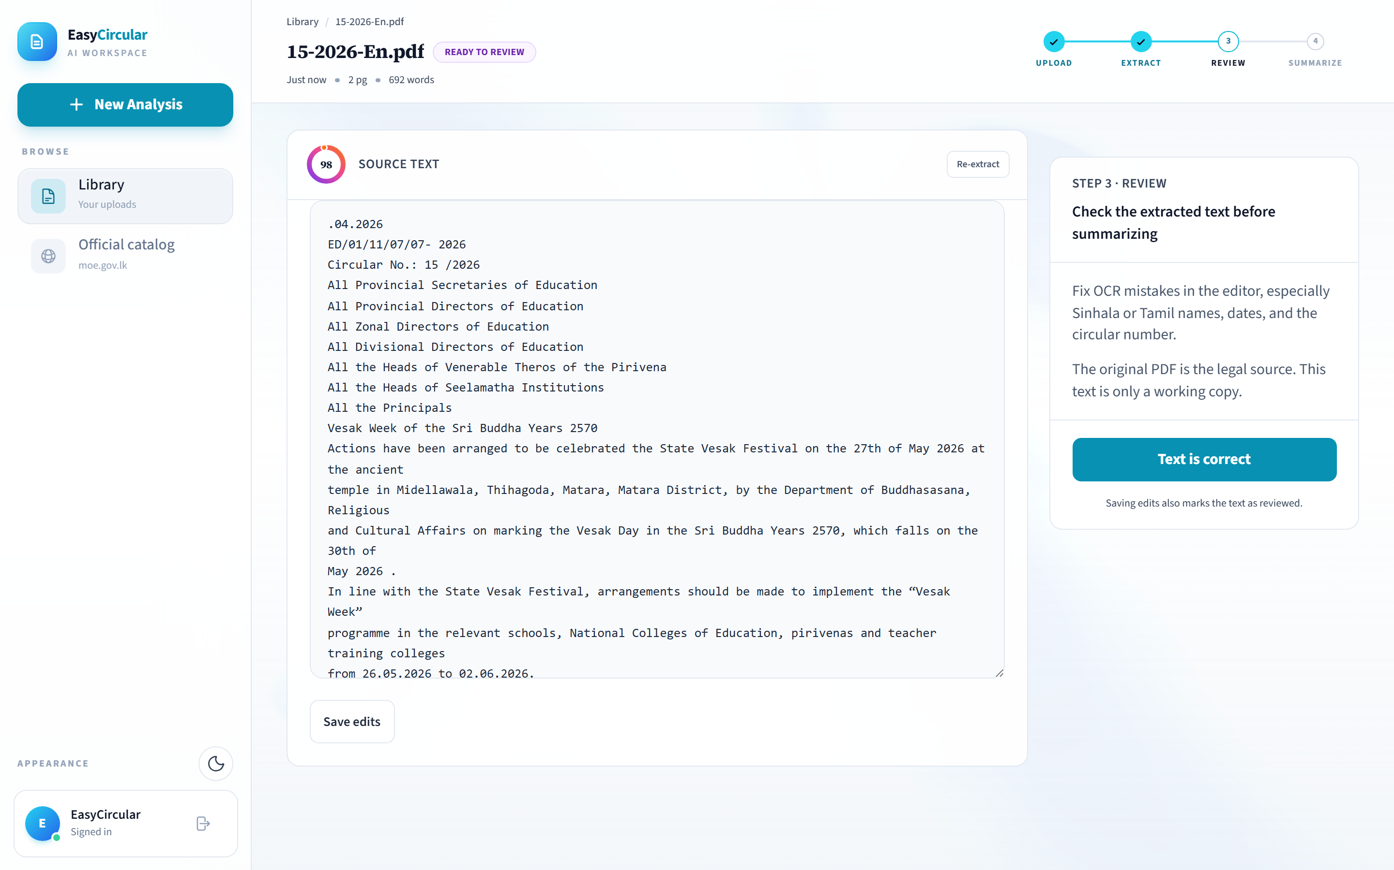

08 The summary

Generate summary shows Building brief… for a bit. What you get is a title, the number, who issued it, who it is for, when it takes effect, a purpose, the main requirements, Action items, and sometimes Key references.
Button | What it is for
Edit | Change the wording, then Save changes or Cancel. Original language only.
Copy | Puts it on the clipboard
Export | Downloads a PDF of the brief — not the original circular
Regenerate | Runs it again from the text you have now
Language tabs | English / සිංහල / தமிழ், depending on the source

There is a small disclaimer on every brief. Read it. The model can skip things or make things up. If the file came from the catalog, Open on moe.gov.lk is a link back to the ministry page. Use it.
Figure 7 · A finished brief. Action items are on the right.
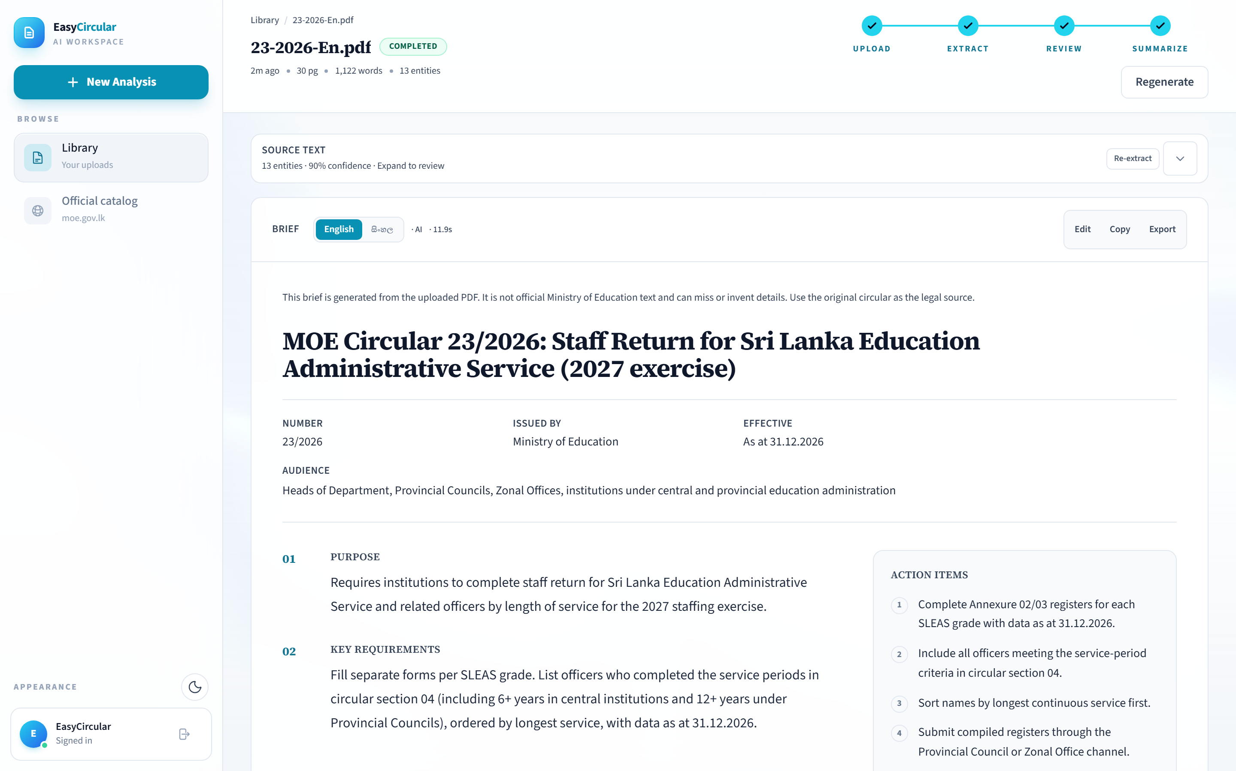

When the summary is not quite right
You will see | What happened | Sensible next step
AI summary unavailable | The model did not run. You get a plainer extract instead. | Try Regenerate in a few minutes.
Review suggested | It thought a date was invented, or two circulars got mixed. | Open the PDF. Do not act on the brief yet.
Unreadable brief | The text came out as a mix of scripts. | Regenerate.

09 Coloured labels in the text

After a summary, expand Source text and switch to Highlights. Dates, organisations, people, and legal-looking phrases are marked. You might see something like “13 entities · 90% confidence” on the bar. Treat that as a hint, not a score you report to anyone.
Colour | Tag | Usually
Yellow / amber | DATE | Deadlines and issue dates
Blue | ORG | Ministry, a school, a provincial office
Pink | PERSON | A name on the letter
Teal | LAW | Circular numbers, acts
Grey | OTHER | Anything else it tagged

Figure 8 · Highlights on the source text
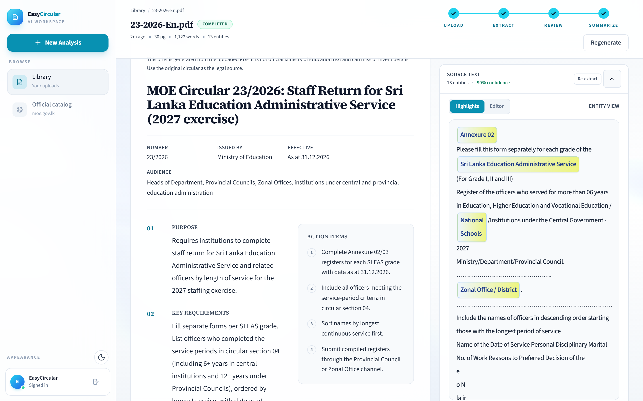

10 Saving and translating

Export
Export is on the brief toolbar. That PDF is the summary, for a staff meeting or an email. If you only need a paste, use Copy.
Translate
The language tabs are on the left of the same toolbar. English circulars usually offer Sinhala as well. A Sinhala or Tamil original will offer English. Click the tab and wait for Translating brief…
TIP · Translations
Handy for sharing with staff. Not more official than the circular you uploaded.

Figure 9 · Language tabs, Edit, Copy, Export
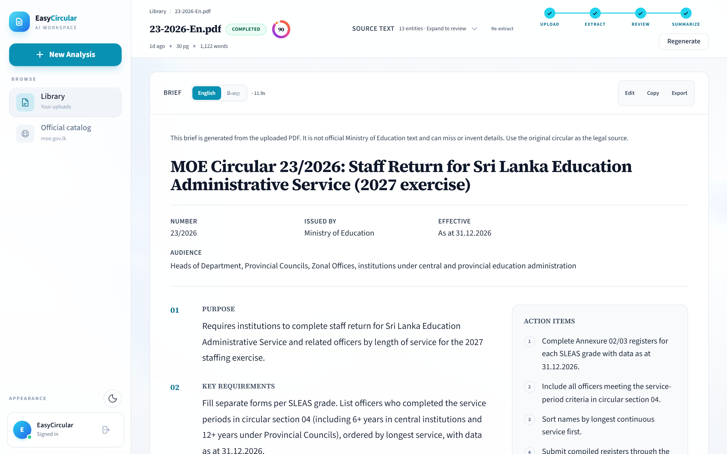

11 Library

Library in the sidebar (or from home) is your pile of work. Uploads and catalog imports both land here. The switch at the top is Your library versus Official catalog. On your library you can filter All, Summarized, or In progress, and you can search by file name or a bit of the summary.
Click a card to open it. Each card shows how old it is, pages, words, and how many tags it found. Imports from the ministry are marked Official moe.gov.lk. Delete is on the card. It asks once. After that the file is gone.
If you are not signed in you can still see the layout, but you will be asked to sign in before anything is saved against you.
Figure 10 · Library
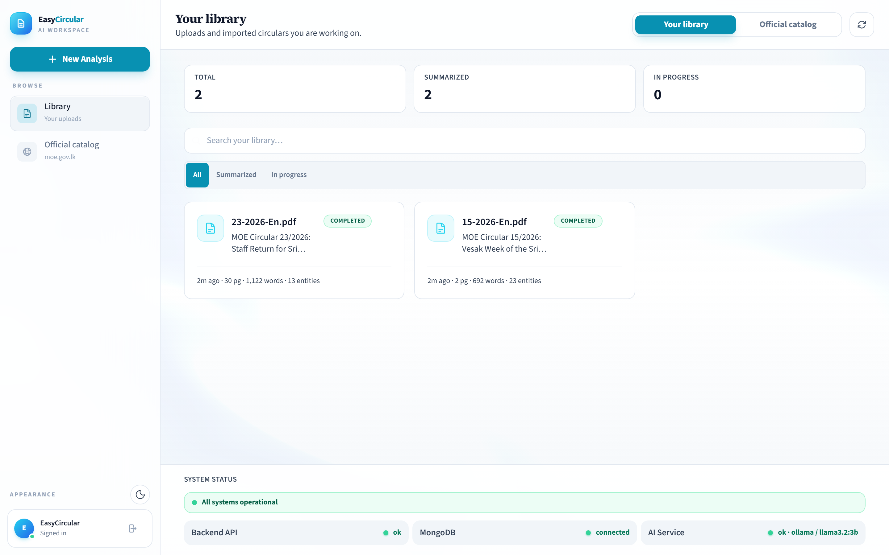

12 Official catalog

This is the list from moe.gov.lk, shown inside EasyCircular. Importing a PDF does not mean EasyCircular is the ministry. The summary is still made here, from that file.
Open Official catalog (home has Official circulars as well). Search. On an entry, open PDFs, then Import. If you are not signed in it will say Sign in to import. Importing… takes a moment. After that it is the same as an upload: extract, review, summarise. Previous and Next move through the list.
Figure 11 · Catalog search and import
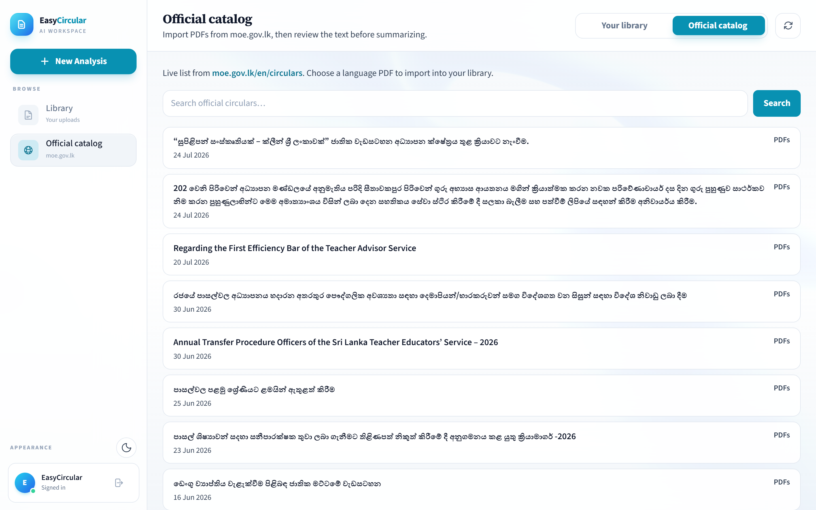

13 On a phone

It works in the phone browser with the same login. Buttons stack. New Analysis is still how you upload. If you are going to sit and correct a long Sinhala scan, a laptop is less painful.
Figure 12 · Home on a phone | Figure 13 · A brief on a phone
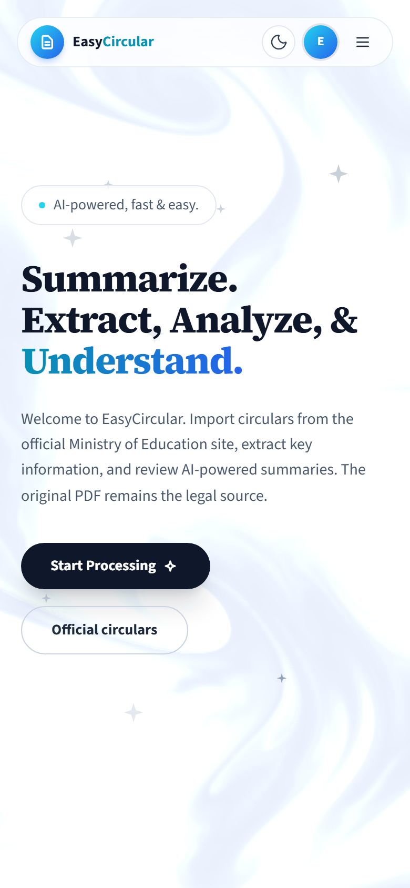 | 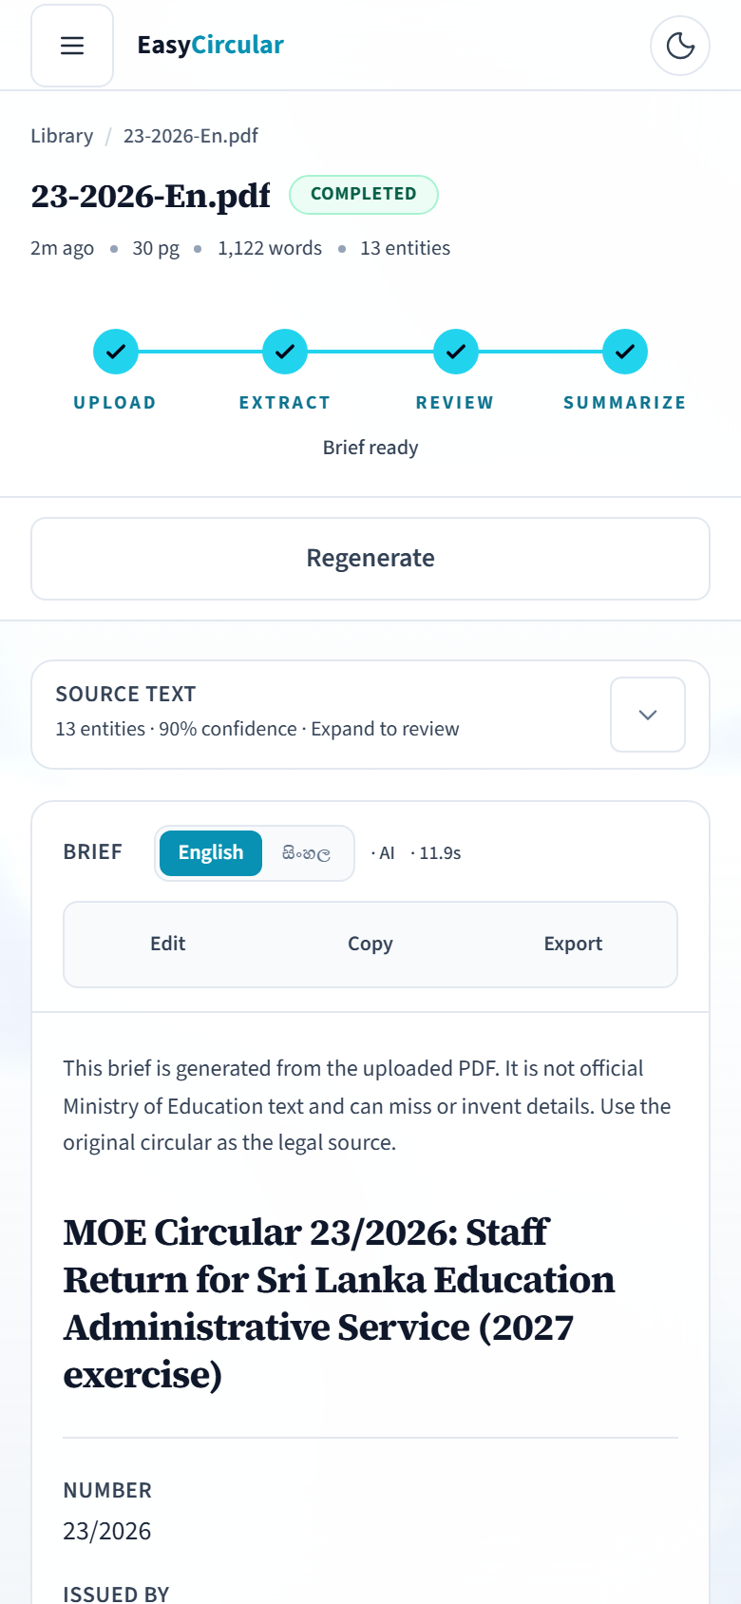

14 Those little status labels

Label | Colour | Meaning
Uploaded | Cyan | File is in. Text not out yet.
Ready to review | Purple | Text is there. You still have to check it.
Processing | Amber | Summary is running.
Completed | Green | Brief is ready.
Failed | Red | It broke. Try again or Retry.

15 When something goes wrong

Check the circular number and the dates first. If those are wrong, fix them in the editor and regenerate. Prefer Official catalog when you can, so you are not working from a photocopy someone emailed last year. Export once you are happy, and file that PDF with the original circular.
Problem | Try this
Sign in to upload | You are not logged in.
File rejected | It is not a real PDF, or it is over 50 MB.
Blank or messy text | Wait, then Re-extract. Edit what you can.
Summary is nonsense | Fix the source, Save edits, Regenerate.
AI summary unavailable | The model is down or busy. Try later.
Forgot password? | Does not work. Use Google, or a password you still know.
A long scan is slow | That is normal. Do not close the tab.

EasyCircular will not email the Ministry for you, will not file your staff return, and will not take a whole folder of PDFs in one go. If a date matters, read it in the original circular. The home page has a System Status strip. If that looks unhealthy, the summary may fail until someone brings the services back up.

