# JavaScript HTML DOM

[❮ Previous](https://www.w3schools.com/js/js_function_closures.asp)[Next ❯](https://www.w3schools.com/js/js_htmldom_methods.asp)

With the HTML DOM, JavaScript can access and change all the elements of an HTML document.

## **The HTML DOM (Document Object Model)**

When a web page is loaded, the browser creates a **D**ocument **O**bject **M**odel of the page.

The **HTML DOM** model is constructed as a tree of **Objects**:

### **The HTML DOM Tree of Objects**

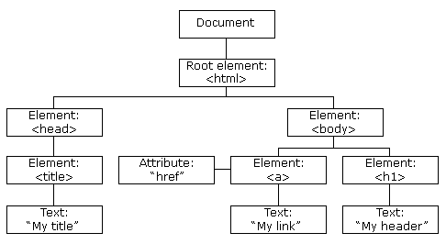

* JavaScript can change all the HTML elements in the page
* JavaScript can change all the HTML attributes in the page
* JavaScript can change all the CSS styles in the page
* JavaScript can remove existing HTML elements and attributes
* JavaScript can add new HTML elements and attributes
* JavaScript can react to all existing HTML events in the page
* JavaScript can create new HTML events in the page

*"The W3C Documen*

*The W3C Document* Domain *Object Model (DOM) is a platform and language-neutral interface that allows programs and scripts to dynamically access and update the content, structure, and style of a document."*

**The HTML DOM is a standard for how to get, change, add, or delete HTML elements.**

JavaScript - HTML DOM Methods

## **The DOM Programming Interface**

The HTML DOM can be accessed with JavaScript (and with other programming languages).

In the DOM, all HTML elements are defined as **objects**.

The programming interface is the properties and methods of each object.

HTML DOM methods are **actions** you can perform (on HTML Elements).

HTML DOM properties are **values** (of HTML Elements) that you can set or change.

<html>  
<body>  
  
<p id="demo"></p>  
  
<script>  
document.getElementById("demo").innerHTML = "Hello World!";  
</script>  
  
</body>  
</html>

[Try it Yourself »](https://www.w3schools.com/js/tryit.asp?filename=tryjs_dom_method)

JavaScript Function Definitions

function myFunction(a, b) {  
    return a * b;  
}

[Try it Yourself »](https://www.w3schools.com/js/tryit.asp?filename=tryjs_function_return)

## **Function Expressions**

A JavaScript function can also be defined using an **expression**.

**anonymous function** (a function without a name).

A function expression can be stored in a variable:

### **Example**

<!DOCTYPE html>

<html>

<body>

<p id="demo"></p>

<script>

var myFunction = function (a, b) {return a * b}

document.getElementById("demo").innerHTML = myFunction(4, 3);

</script>

</body>

</html>

## **Function Hoisting**

Earlier in this tutorial, you learned about "hoisting".

Hoisting is JavaScript's default behavior of moving **declarations** to the top of the current scope.

Hoisting applies to variable declarations and to function declarations.

Because of this, JavaScript functions can be called before they are declared:

myFunction(5);  
  
function myFunction(y) {  
    return y * y;  
}

# onclick Event

<!DOCTYPE html>

<html>

<body>

<p>Click the button to trigger a function that will output "Hello World" in a p element with id="demo".</p>

**<button onclick="myFunction()">Click me</button>**

**<p id="demo"></p>**

**<script>**

**function myFunction() {**

**document.getElementById("demo").innerHTML = "Hello World";**

**}**

**</script>**

</body>

</html>

## **The <form> Element**

The HTML **<form>** element defines a form that is used to collect user input:

## **The <input> Element**

The **<input>** element is the most important form element.

The <input> element can be displayed in several ways, depending on the **type** attribute.

Here are some examples:

|  |  |
| --- | --- |
| **Type** | **Description** |
| <input type="text"> | Defines a one-line text input field |
| <input type="radio"> | Defines a radio button (for selecting one of many choices) |
| <input type="submit"> | Defines a submit button (for submitting the form) |

<form action="/action_page.php">  
  First name:<br>  
  <input type="text" name="firstname" value="Mickey"><br>  
  Last name:<br>  
  <input type="text" name="lastname" value="Mouse"><br><br>  
  <input type="submit" value="Submit">  
</form>

[Try it Yourself »](https://www.w3schools.com/html/tryit.asp?filename=tryhtml_form_submit)