1. *Creating Table Structure and Data* – Create the tables in the schema, including all of their columns, datatypes, and constraints, and populate the tables with data. Most but not all the data is given to you in the table below; ***you should also insert information for one additional dinosaur discovery of your choosing.*** Although the data is in flattened representation below, you will need to insert the data relationally into the schema with foreign keys referencing the appropriate primary keys. You may choose any primary key values you would like for each table. We will learn in a later lab how to automatically generate primary key values.

|  |  |  |  |  |  |
| --- | --- | --- | --- | --- | --- |
| **Location** | **Dig Name** | **Dig Cost** | **Dinsosaur Common Name** | **Weight**  **(in pounds)** | **Paleontologist** |
| Stonesfield | Great British Dig | $8,000 | Megalosaurus | 3000 | William Buckland |
| Stonesfield | Great British Dig | $8,000 | Apatosaurus | 4000 | William Buckland |
| Stonesfield | Great British Dig | $8,000 | Triceratops | 4500 | William Buckland |
| Stonesfield | Great British Dig | $8,000 | Stegosaurus | 3500 | William Buckland |
| Utah | Parowan Dinosaur Tracks | $10,000 | Parasaurolophus | 6000 | John Ostrom |
| Utah | Parowan Dinosaur Tracks | $10,000 | Tyrannosaurus Rex | 5000 | John Ostrom |
| Utah | Parowan Dinosaur Tracks | $10,000 | Velociraptor | 7000 | John Ostrom |
| Arizona | Dynamic Desert Dig | $3,500 | Tyrannosaurus Rex | 6000 | John Ostrom |
| Stonesfield | Mission Jurassic Dig |  | Spinosaurus | 8000 | Henry Osborn |
| Stonesfield | Mission Jurassic Dig |  | Diplodocus | 9000 | Henry Osborn |
| Stonesfield | Ancient Site Dig | $5,500 | Tyrannosaurus Rex | 7500 | Henry Osborn |

Note that the Dig Cost for “Mission Jurassic Dig” is null (has no value).

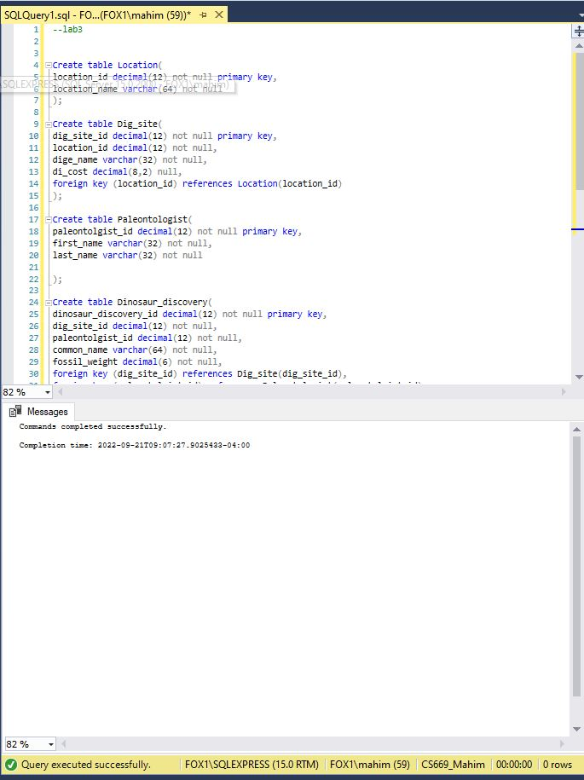

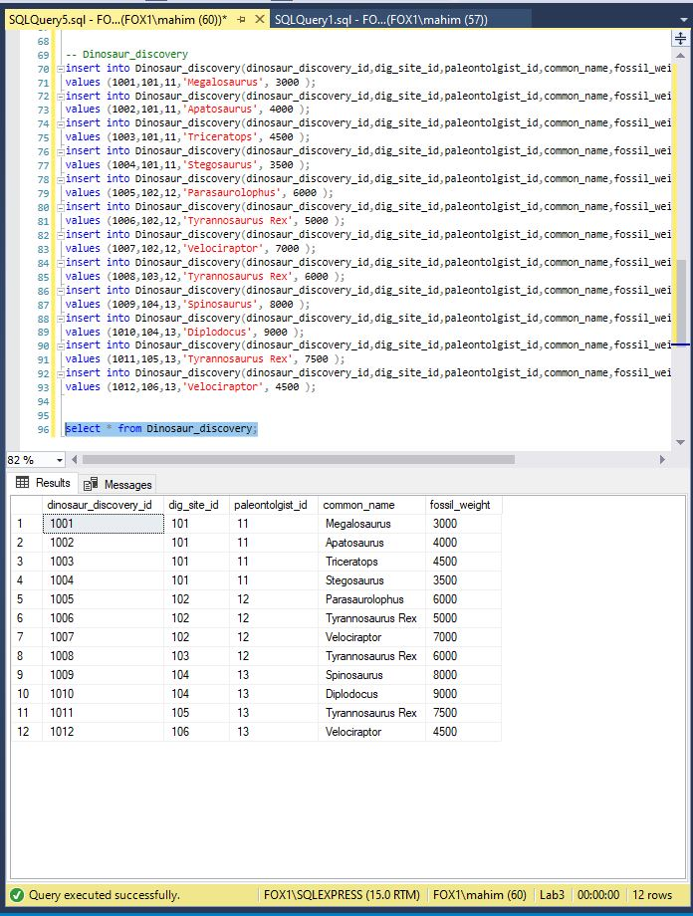

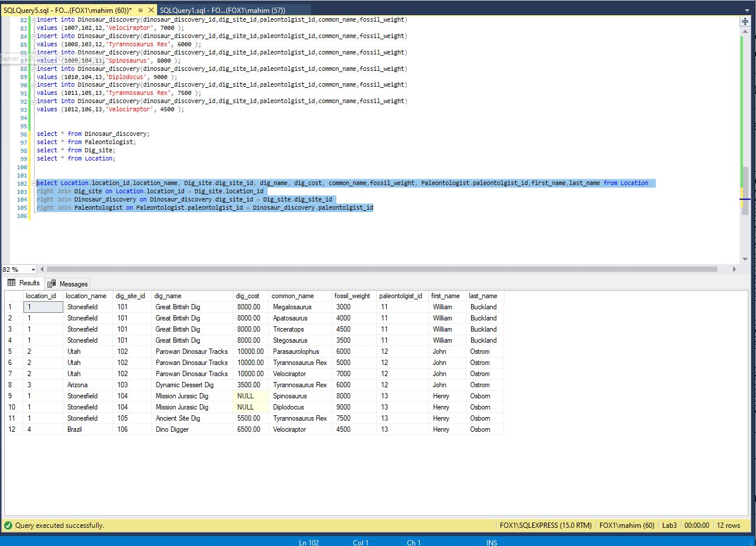

1. *Counting Matches* – A museum wants to know how many dinosaur discoveries weigh at least 4,200 pounds. Write a single query to fulfill this request.  
   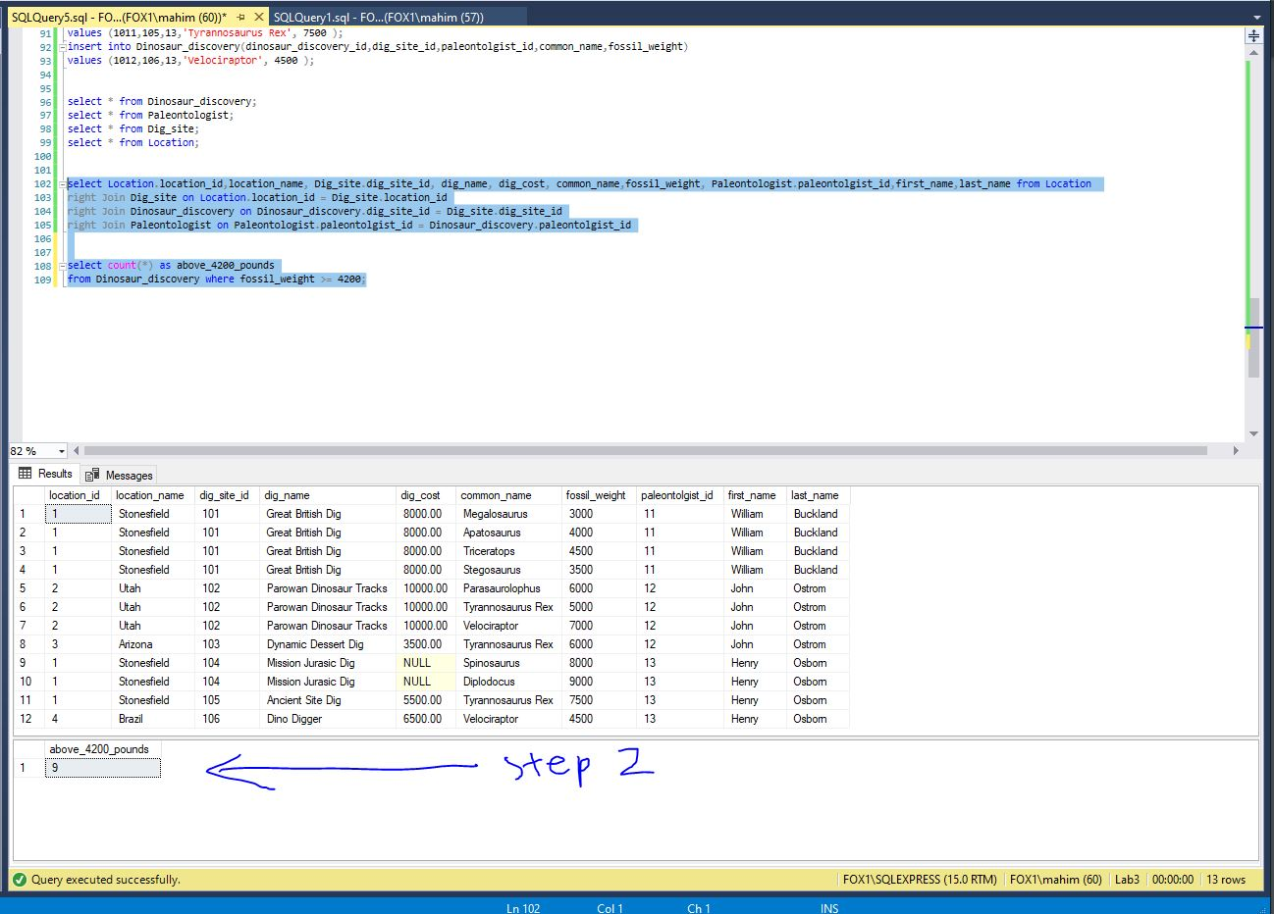
2. *Determining Highest and Lowest –* The same museum needs to know the cost of the most expensive and least expensive dinosaur digs. Write a single query to fulfill this request. Explain how the SQL processer treated the dig costs for the “Mission Jurassic Dig” differently than the other cost values.

Explanation: According to the lab3 explanation, The Min function ignores null values and therefore, even though Mission Jurassic Dig has null in the Dig_cost column, it is ignored by the Min function.

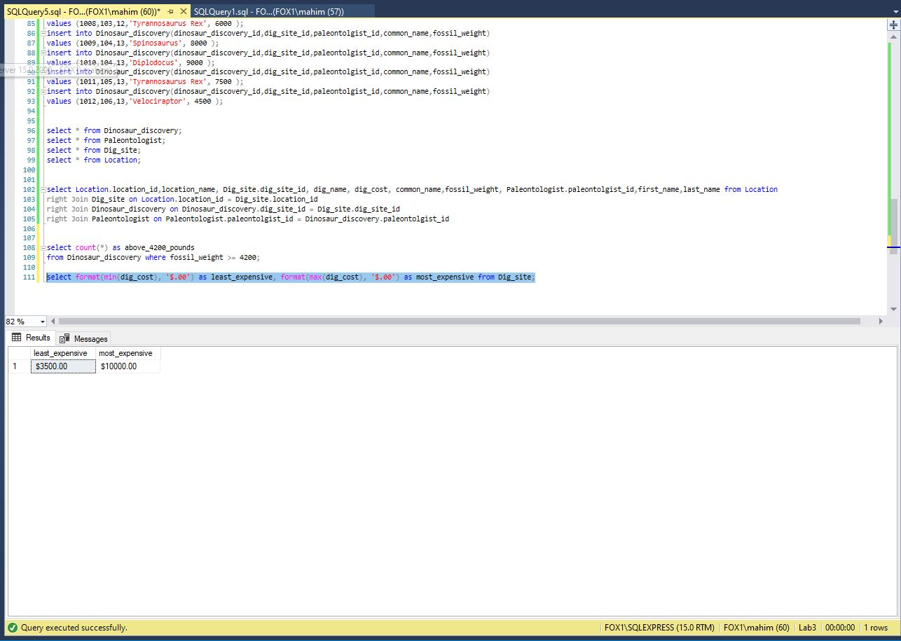

1. *Grouping Aggregate Results –* A museum is considering supporting their own paleontological expedition and needs to know the dig site name and cost, along with the number of dinosaur discoveries at each site. Write a single query to fulfill this request.  
   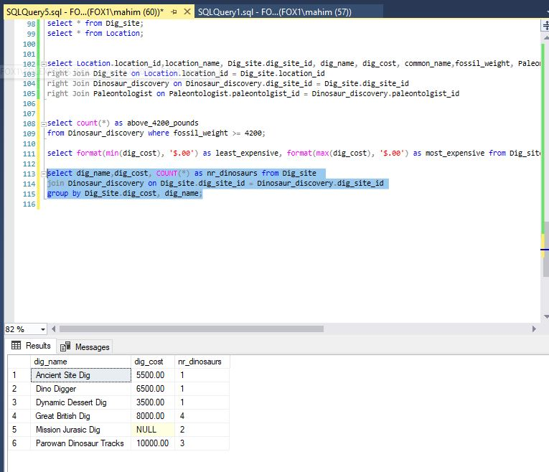
2. *Limiting Results by Aggregation* – A paleontologist, looking to dig at a location ripe with discoveries, wants to search for locations with at least 6 dinosaur discoveries. Write a single query to fulfill this request.

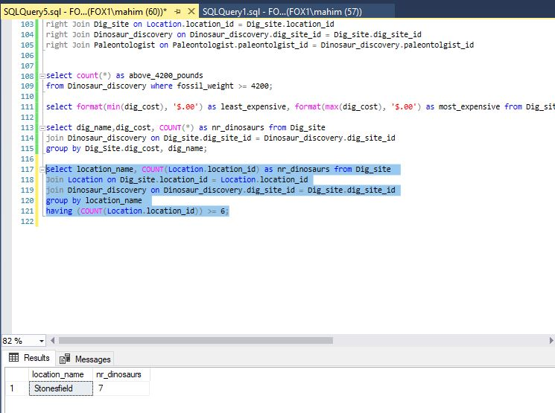

1. *Adding Up Values –* A museum needs to know which dig sites had at least 15,000 pounds of discovered dinosaur remains. Write a single query that gives this information, with useful columns.

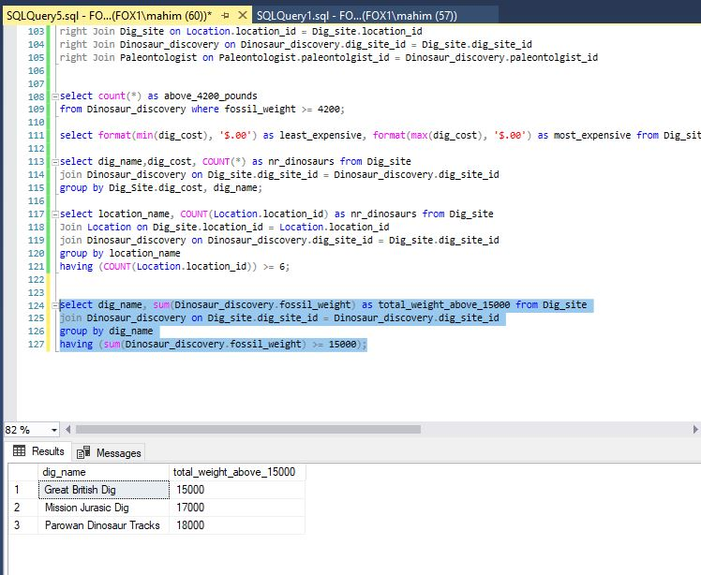

1. *Integrating Aggregation with Other Constructs –* A research institution requests the names of all paleontologists, as well as the number of digs they participated in at the “Stonesfield” location (even if they participated in no Stonesfield digs). The institution wants the list to be ordered from most to least; the paleontologist who discovered the most Stonesfield dinosaurs will be at the top of the list, and the one with the least will be at the bottom. Write a single query that gives this information, with useful columns.

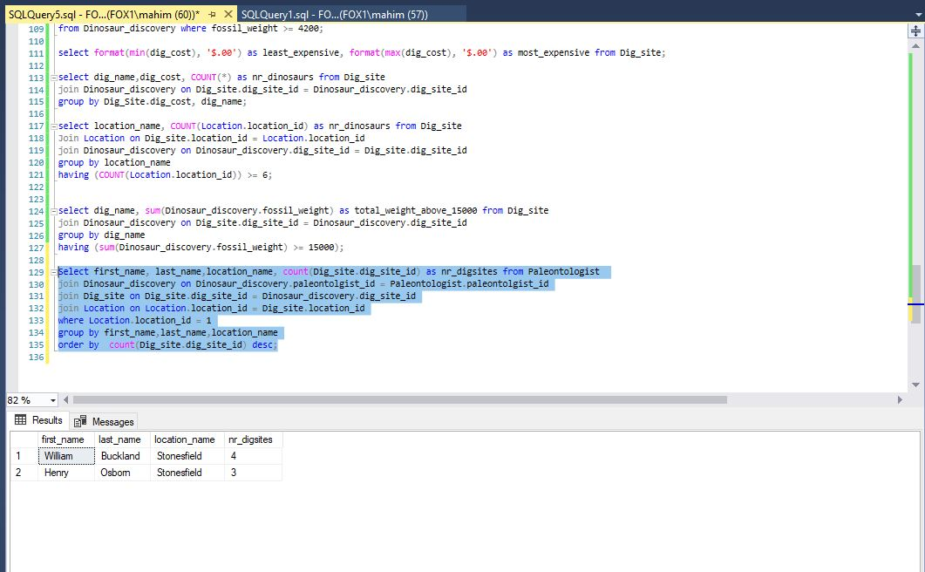

**Section Two –****Data Visualization**

**Section Steps**

1. *Visualizing Data with One or Two Measures –* Use the SQL results obtained for Step #4 to address the following.  
   1. Create a bar chart with the dig name as one axis, and the dig cost as another axis. Explain the story this visualization describes.

This bar graph visualizes the information about the costs per various digging companies. The story of this chart is to help someone understand Mission Jurassic Dig does not have any cost and that Parowan Dinosaur Tracks costs the highest.

* 1. Create a scatterplot with the dig cost as one axis, and the number of dinosaurs found as another axis. Ensure that each dig name is labeled with its name, either directly or with a legend. Explain the story this visualization describes.

This visualization helps to identify which digging company discovered most number of dinosaurs and which ones are still very new or inexperienced. Clearly, Great British Dig discovered most number of dinosaurs followed by Parowan Dinosaur Tracks.

1. *Another Data Visualization –* Create a visualization of your choosing for data in the Dinosaur schema. The visualization should tell a useful story. If you find that you need more dinosaurs in the schema to tell the story well, feel free to add them. Make sure to explain the data story, and to explain why you chose that particular chart or visualization.  
   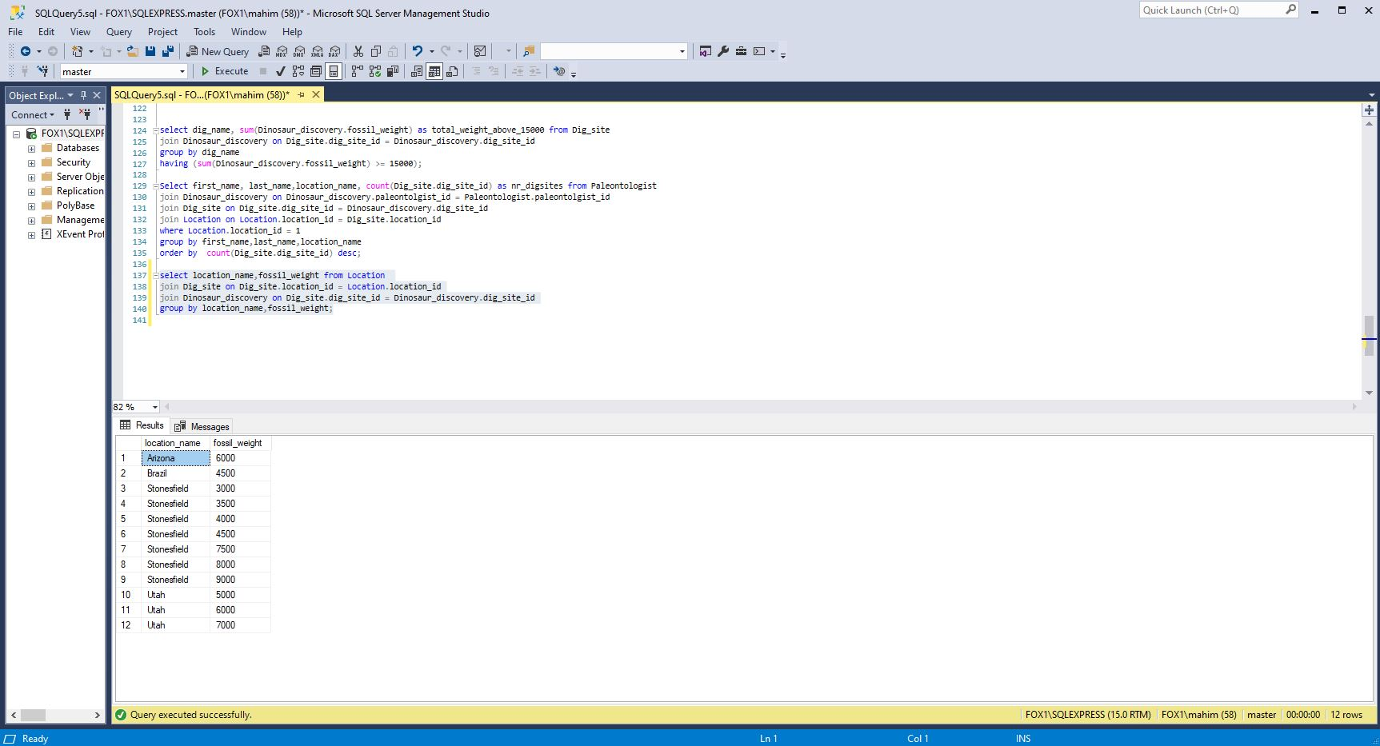

This visualization would help someone to understand the history of dinosaurs’ weight that was discovered in a specific location. This also visualizes where was the heaviest dinosaur discovered from.