NAME : MAHIM DASHORA
SRN : PES1UG19CS251
SECTION : D

DBMS LAB WEEK – 6

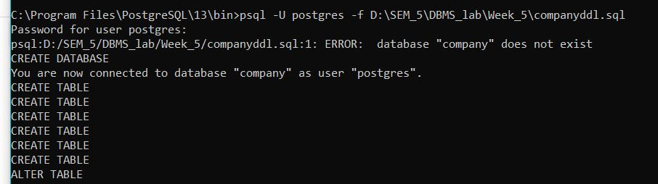

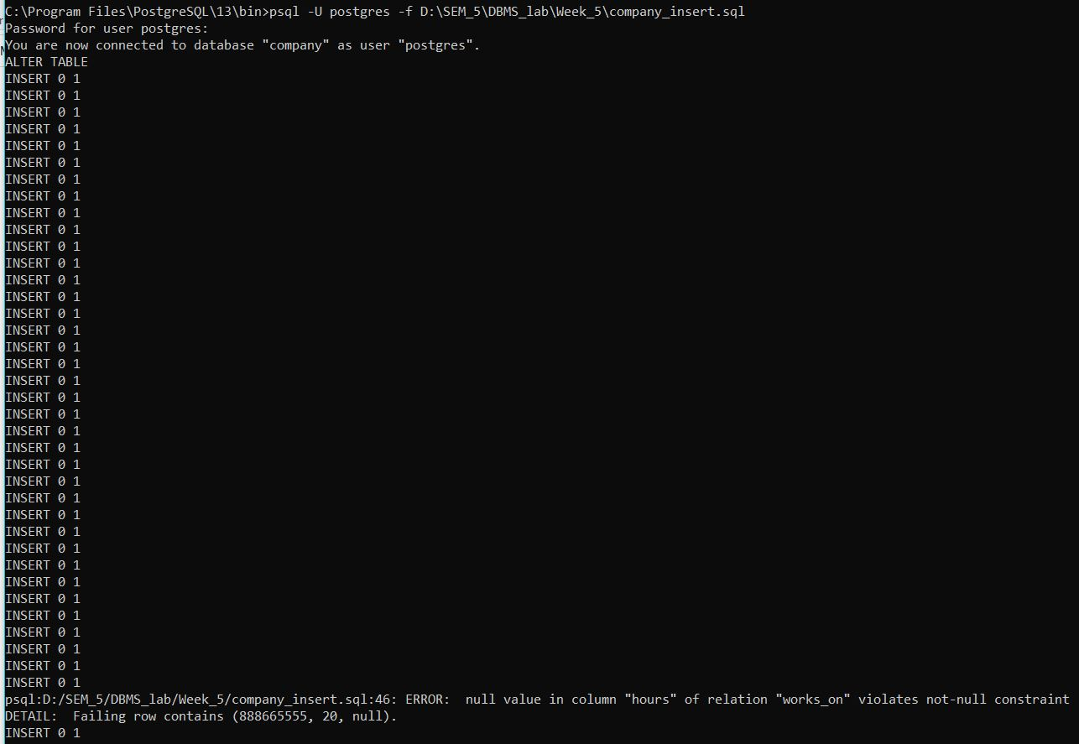
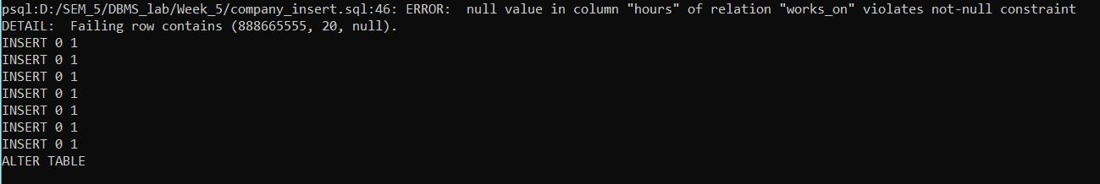
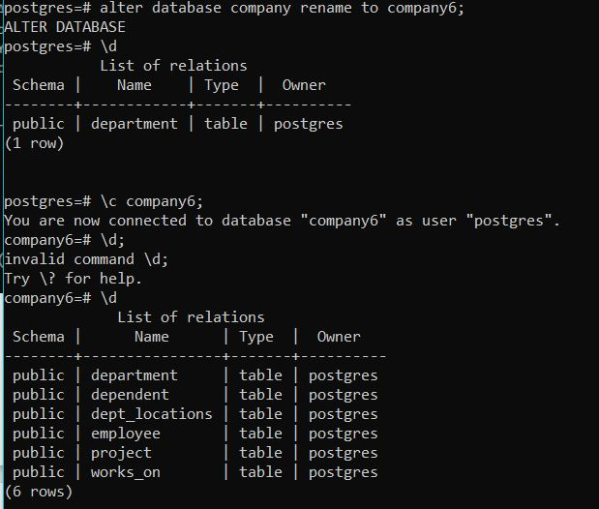
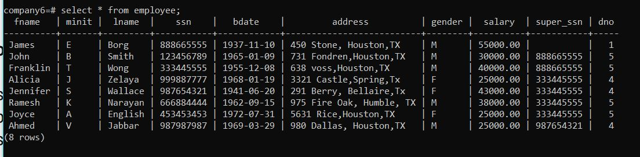

1. Show the resulting salaries if every employee working on the ‘ProductX’ project is given a 10% raise.

2. Find the sum of the salaries of all employees of the ‘Research’ department, as well as the maximum salary, the minimum salary, and the average salary in this department.

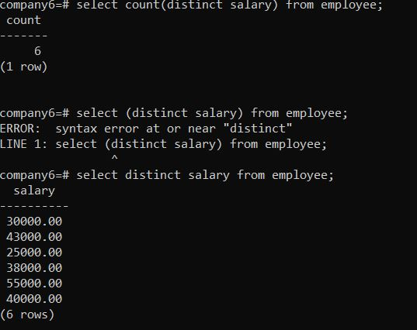
3.Count the number of distinct salary values in the database.

4.Retrieve the names of all employees who have two or more dependents.
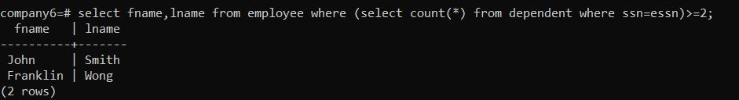
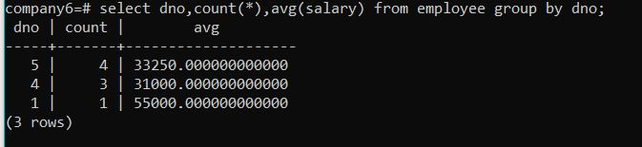
5.For each department, retrieve the department number, the number of employees in the department, and their average salary.

6.Retrieve the names of employees who make at least $10,000 more than the employee who is paid the least in the company.

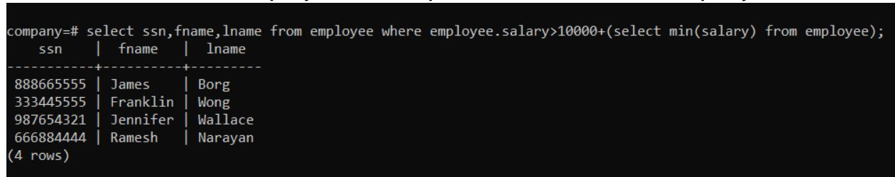

7.Retrieve the names of all employees who work in the department that has the employee with the highest salary among all employees.

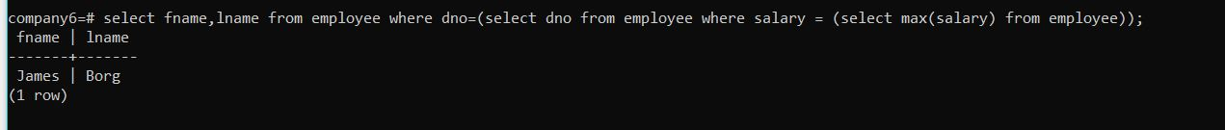

8. Count the total number of employees whose salaries exceed $40,000 in each department .
