Create custom exception class:

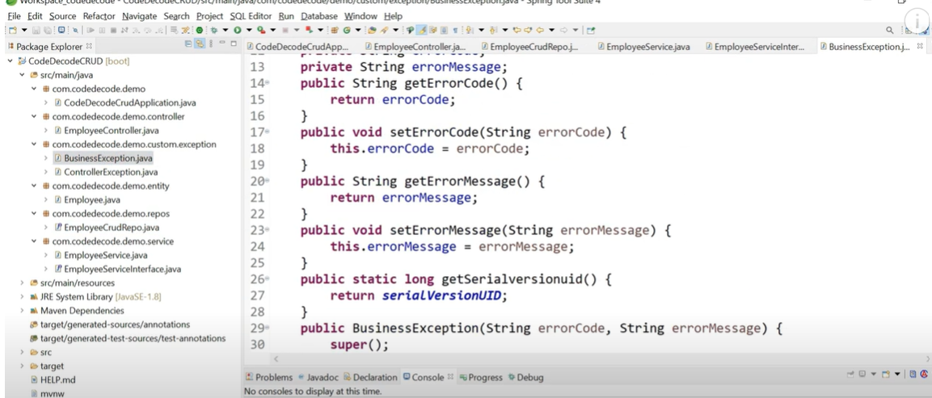

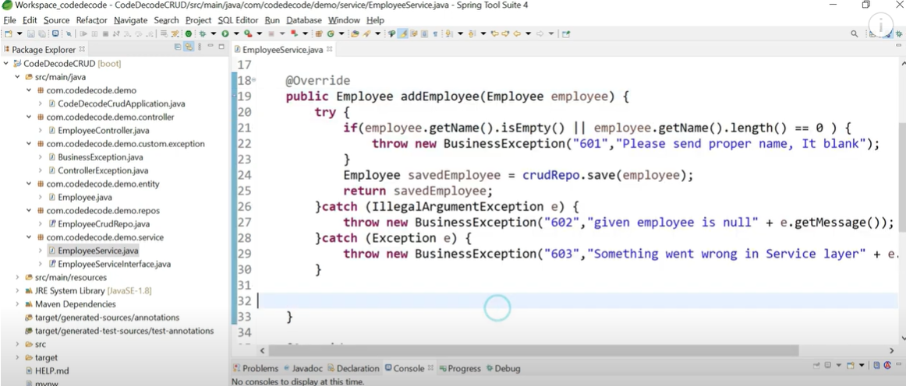

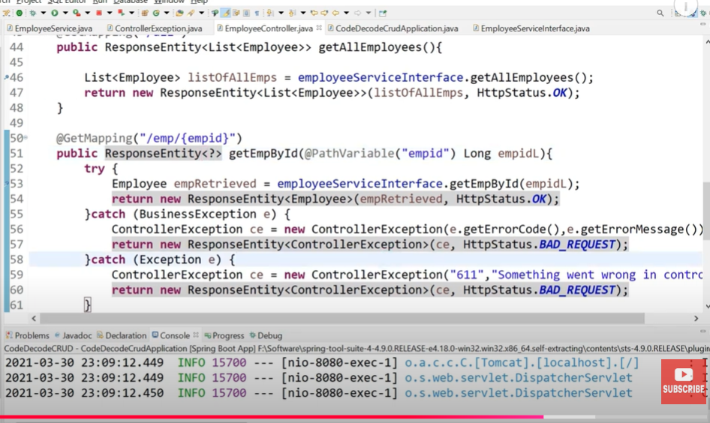

Global exception handling:
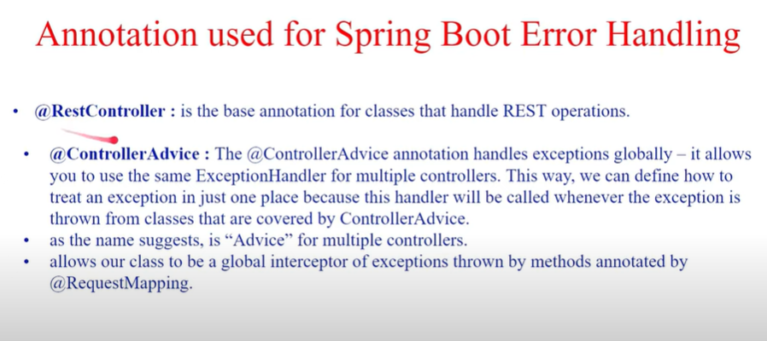

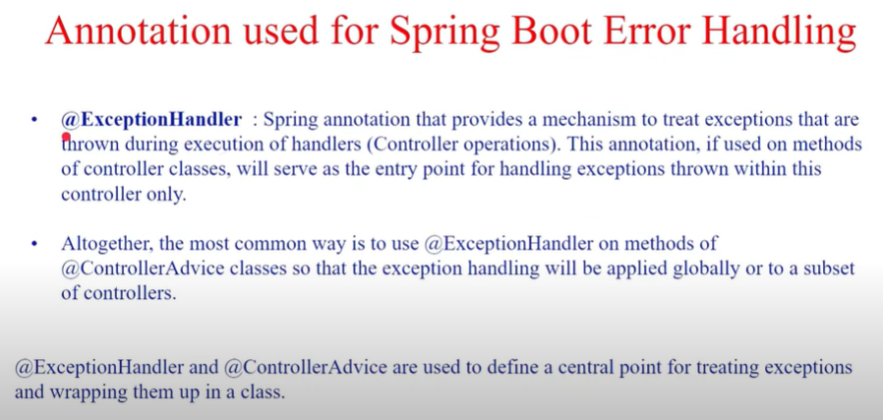

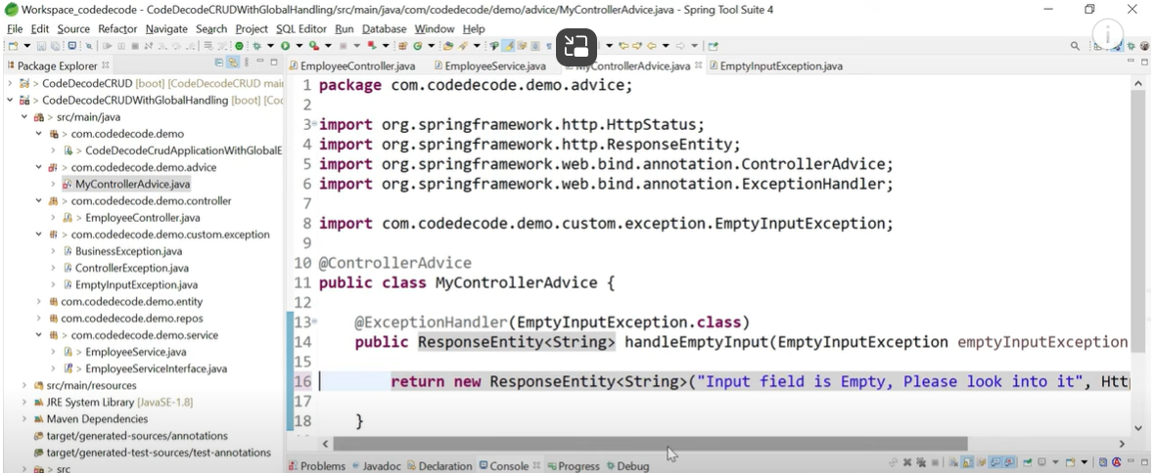

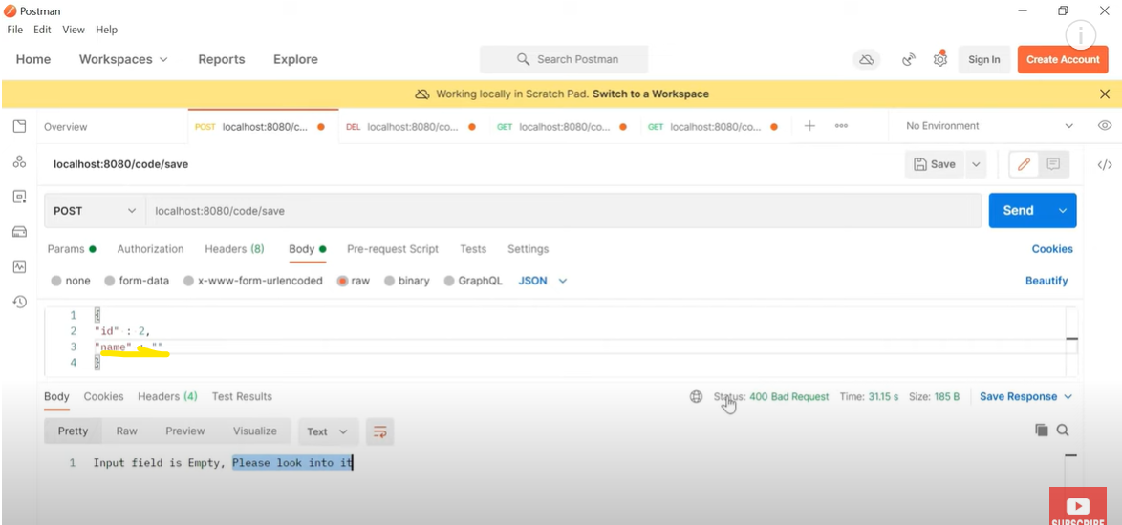

Global Exception Handling (Recommended Approach)
Use @RestControllerAdvice to centralize exception handling.
@RestControllerAdvice
public class GlobalExceptionHandler {
@ExceptionHandler(UserNotFoundException.class)
public ResponseEntity<ErrorResponse> handleUserNotFound(UserNotFoundException ex) {
return ResponseEntity
.status(HttpStatus.NOT_FOUND)
.body(new ErrorResponse("USER_NOT_FOUND", ex.getMessage()));
}
@ExceptionHandler(Exception.class)
public ResponseEntity<ErrorResponse> handleGeneric(Exception ex) {
return ResponseEntity
.status(HttpStatus.INTERNAL_SERVER_ERROR)
.body(new ErrorResponse("INTERNAL_ERROR", "Something went wrong"));
}
}

