Difference Between BeanFactory and ApplicationContext:
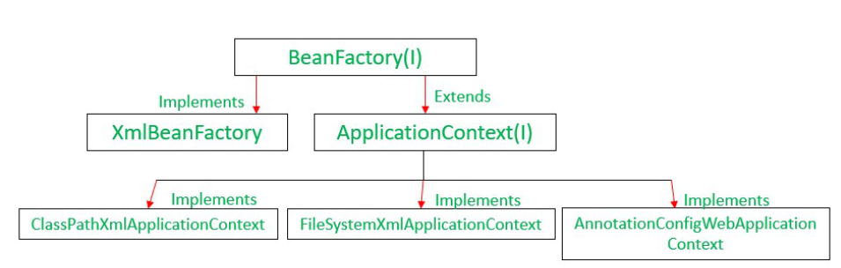

Feature | BeanFactory | ApplicationContext
Definition | Fundamental container providing basic functionality for managing beans. | Advanced container extending BeanFactory with additional features.
Usage | Suitable for building standalone applications. | Suitable for building web applications, integrating with AOP modules, ORM, and distributed applications.
Bean Scopes Supported | Supports only Singleton and Prototype bean scopes. | Supports all types of bean scopes, including Singleton, Prototype, Request, Session, etc.
Annotation Support | Does not support annotations; requires configuration in XML files. | Supports annotation-based configuration for bean autowiring.
Internationalization | Does not provide internationalization (i18n) functionality. | Extends MessageSource interface to provide internationalization (i18n) functionality.
Event Handling | Does not support event publication. | Supports event handling via the ApplicationEvent class and ApplicationListener interface.
Bean Post Processing | Requires manual registration of BeanPostProcessors and BeanFactoryPostProcessors. | Automatically registers BeanFactoryPostProcessor and BeanPostProcessor at startup.
Initialization | Creates bean objects on demand using lazy initialization. | Loads all beans and creates objects at startup using eager initialization.
Resource Usage | Provides basic features requiring less memory, suitable for memory-critical standalone applications. | Provides basic and advanced features, suitable for enterprise applications, requiring more memory.

Setter Injection vs Constructor Injection
Spring Framework is built on top of servlets and one of its main features is Dependency Injection (DI) it’s one of the most common principles of modern software development and it allows us to achieve the principle of Inversion Of Control (IoC) i.e. shifting the creation, management and the lifecycle of objects from the programmer to the framework. This approach helps relieve the programmer from the responsibility of managing and creating objects and allows them to focus mainly on the business logic thereby effectively managing the objects. It’s also one of the core features of the spring-core module and aids in promoting decoupling among the components of our system. There are various ways in which we can do this, however, in this article, we’ll focus on Constructor and Setter Injections.
The below image briefly explains the principle of IoC, that we only need to ask for what object we want, and our spring container will return an instance of it.

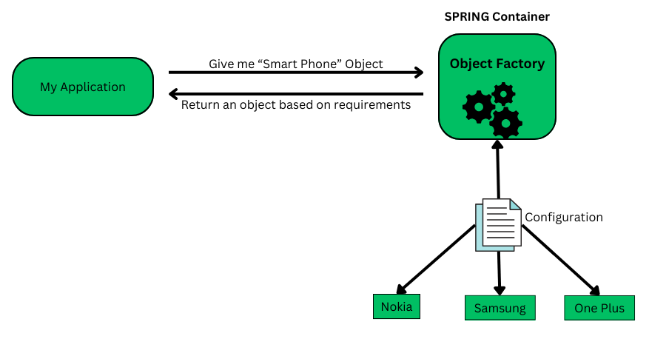

Types of Configuration
There are 3 types of configuration mainly used :
- XML Based Configuration (Legacy)
- Java-Based Configuration (Modern)
- Annotation Based Configuration (Modern)

In this article, we’ll be using Annotation based configuration.
Step-by-Step Procedure
1. Go to Spring Initializr tool.
2. Create a package with following details – ( See image – you can modify accordingly)
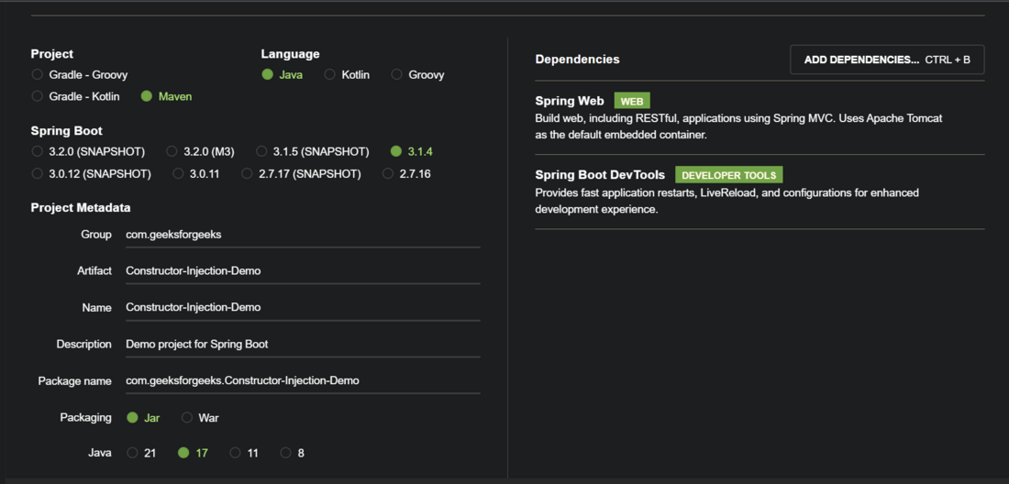
3. Download the file and open it in your preferred IDE.
4. And then finally start the coding.

Constructor Injection
In this method, dependencies are passed as a parameter to the class’s constructor. This ensures that all the dependencies are injected upon the instantiation of an object. We utilise the @Autowired Annotation on top of the constructors to achieve this.
Let’s understand with code example:
We’ll have following components in the code : Interface, concrete class that provide its implementation. And a REST Controller.
1. Interface SmartPhone
Java
package com.geeksforgeeks.ConstructorInjectionDemo;

public interface SmartPhone {
String getSmartPhoneName();
}
Code explanation:
We’ve simply created an interface – ‘SmartPhone’ having a single method inside it.
2. Concrete Class – Nokia
Java
package com.geeksforgeeks.ConstructorInjectionDemo;
import org.springframework.stereotype.Component;
@Component
public class Nokia implements SmartPhone {
@Override public String getSmartPhoneName()
{
return "This is NOKIA Smart Phone";
}
}
Code Explanation:
- This is a concrete class that implements the SmartPhone interface and overrides the method defined in the interface.
- The @Component annotation indicates to the Spring framework that this is a Java bean and it should be registered for component scanning so that it can be injected into other beans when required.
3. REST Controller
Java
package com.geeksforgeeks.ConstructorInjectionDemo;
import org.springframework.beans.factory.annotation.Autowired;
import org.springframework.web.bind.annotation.GetMapping;
import org.springframework.web.bind.annotation.RequestMapping;
import org.springframework.web.bind.annotation.RestController;
@RestController
@RequestMapping("/api")
public class RESTController {
private final SmartPhone mySmartPhone;
//* Constructor Injection *//
@Autowired
public RESTController(SmartPhone theSmartPhone)
{
this.mySmartPhone = theSmartPhone;
}
@GetMapping("/smartphone/name")
public String getSmartPhoneName()
{
return mySmartPhone.getName();
}
}
Code Explanation:
- This is a rest controller containing API calls.
- The @RestController Annotation is a specialized version of @Controller and it signifies that this class is a CONTROLLER and inside it, end-points are defined and these end-points return data either in JSON or XML Format.
- SmartPhone interface Reference is here, to hold an object of concrete implementation.
- @Autowired Annotation – This is the real hero here which injects dependency. The constructor will receive the object of SmartPhone upon instantiation and the @Autowired annotation will inject it into current Rest controller’s instance.
Here’s how the @Autowired injects dependencies behind the scenes !
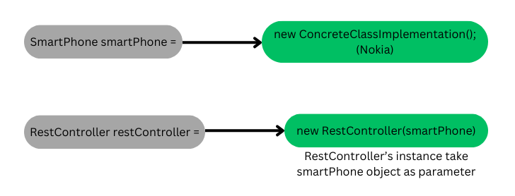
@Autowired working in layman’s term
Spring will scan for @Component, and ask – Hey, is there any concrete class implementing the interface? In our case the interface is ‘SmartPhone’. If there exists one (or more), then inject it.
And finally, our @SpringBootApplication class.
4. Application class:
Java
package com.geeksforgeeks.ConstructorInjectionDemo;
import org.springframework.boot.SpringApplication;
import org.springframework.boot.autoconfigure.SpringBootApplication;
@SpringBootApplication
public class ConstructorInjectionDemoApplication {
public static void main(String[] args)
{
SpringApplication.run(ConstructorInjectionDemoApplication.class,args);
}
}

After creating all the classes and interfaces, our package structure will look something like this :
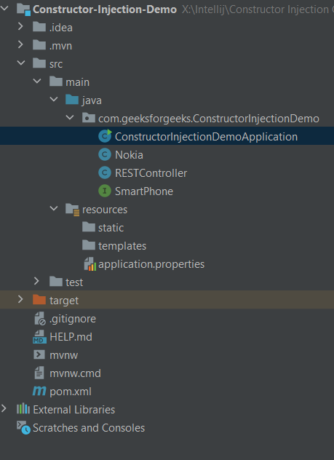

And when we run our application, the output will be :

A key point to note here is that, if we have more than 1 concrete implementation for our interface then our application won’t RUN!
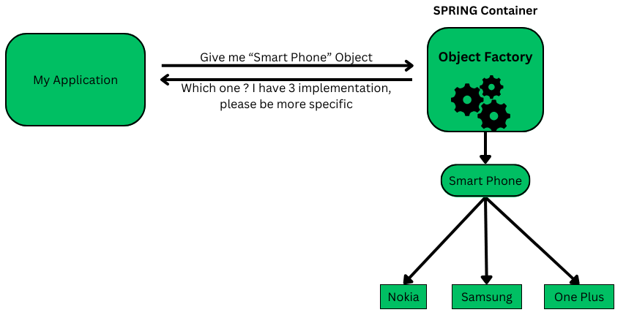
In the above case, we can utilize both of these Annotations – @Qualifier or @Primary.
Setter Injections
This is another way to inject dependencies, done by using setter methods. We annotate a setter method with @Autowired and it will work. A key point here is that dependencies will only be injected when the setter methods are called.
Assume that all the code will remain the same as we previously wrote for constructor injections, except for a new concrete implementation Vivo and the REST Controller. There are only subtle modifications required in the REST Controller:
Java
package com.geeksforgeeks.SetterInjectionDemo;

import org.springframework.beans.factory.annotation.Autowired;
import org.springframework.web.bind.annotation.GetMapping;
import org.springframework.web.bind.annotation.RequestMapping;
import org.springframework.web.bind.annotation.RestController;

@RestController
@RequestMapping("/api")
public class RESTController {
private SmartPhone mySmartPhone;

//* Setter Injection *//
@Autowired
public void setSmartPhone(SmartPhone theSmartPhone) {
this.mySmartPhone = theSmartPhone;
}

@GetMapping("/smartphone/name")
public String getSmartPhoneName() {
return mySmartPhone.getSmartPhoneName();
}
}
Code Explanation:
- Instead of having a constructor, here we have a setter method that injects the dependency because its annotated with @Autowired.
- Breaking down how @Autowired is working here:
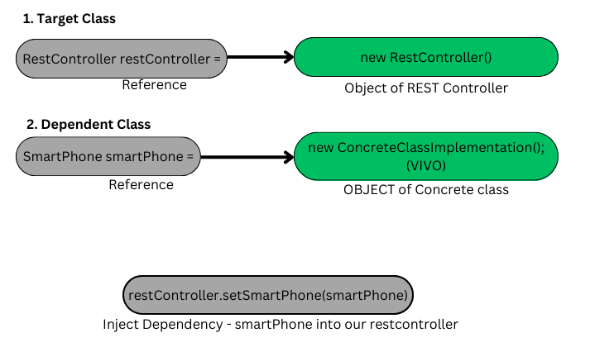
Code Explanation:
- Firstly, the target class object is created
- Secondly, the dependent class object is created
- And finally, the dependencies are injected through setter method.
Output:

Setter Injections vs Constructor Injections
Parameter | Setter Injections | Constructor Injections
Type of dependency | Recommended to use when we have some optional dependency. Else our application can provided default business logic code. | Recommended to use when Mandatory/required dependencies are there
Injection method | Through methods | Through Constructors
Creation time | IoC Container first creates the dependent object then the Target Class Object | IoC Container first create the target class object then the dependent object
Efficiency | Slow – because dependencies are injected after object of target class is created | Fast – because Dependencies are injected as soon as the object of target class is created
Recommendation | Not recommended as the first choice | Recommended by spring.io team as your first choice
Use cases when to use which one?
1. Constructor Injections
They are most useful when we need an object along with all its dependencies. For example, a CAR can have various dependencies like engine, gear, steering, and other relevant components without which a CAR is useless. So, we need all those components wired together in the object of a car.
2. Setter Injections
They are preferred when we have some optional dependencies that are not mandatorily required but can assist in some ways. For example, let’s say we have a new user in our application, and they have their phone number as an optional field in their profile details.

