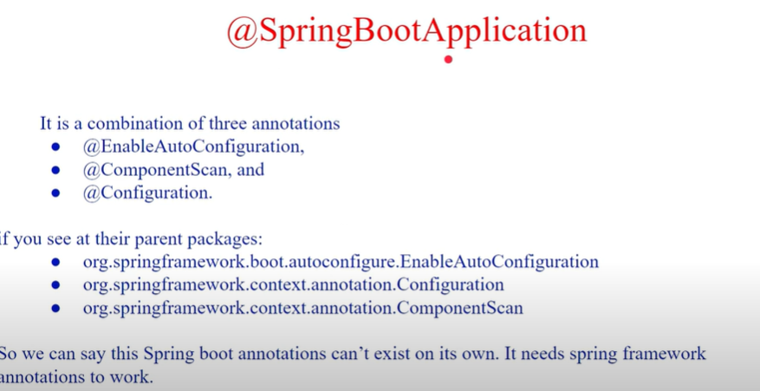

@SpringBootApplication is used to kickstart the application.
@ComponentScan will scan all the classes from its sub packages and creates beans in the container.
@EnableConfiguration enables bean creation.

1. @SpringBootApplication Annotation
This annotation is used to mark the main class of a Spring Boot application. It encapsulates @SpringBootConfiguration , @EnableAutoConfiguration , and @ComponentScan annotations with their default attributes.
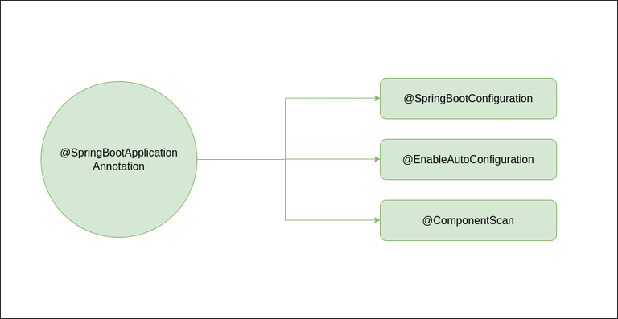

@EnableAutoConfiguration Annotation
This annotation auto-configures the beans that are present in the classpath. It simplifies the developer’s work by assuming the required beans from the classpath and configure it to run the application. This annotation is part of the spring boot framework. For example, when we illustrate the spring-boot-starter-web dependency in the classpath, Spring boot auto-configures Tomcat , and Spring MVC . The package of the class declaring the @EnableAutoConfiguration annotation is considered as the default. Therefore, we need to apply the @EnableAutoConfiguration annotation in the root package so that every sub-packages and class can be examined.

@ComponentScan Annotation
@ComponentScan tells Spring in which packages you have annotated classes that should be managed by Spring. So, for example, if you have a class annotated with @Controller which is in a package that is not scanned by Spring, you will not be able to use it as a Spring controller. So we can say @ComponentScan enables Spring to scan for things like configurations, controllers, services, and other components that are defined. Generally, @ComponentScan annotation is used with @Configuration annotation to specify the package for Spring to scan for components.
Request Handling and Controller annotations:
Some important annotations comes under this category are:
- @Controller
- @RestController
- @RequestMapping
- @RequestParam
- @PathVariable
- @RequestBody
- @ResponseBody
- @ModelAttribute

1. @Controller Annotation
This annotation provides Spring MVC features. It is used to create Controller classes and simultaneously it handles the HTTP requests. Generally we use @Controller annotation with @RequestMapping annotation to map HTTP requests with methods inside a controller class.
Example:
Java
//Create a Java class and use @Controller annotation to make it controller class
@Controller
public class MyController{
public String GFG(){
//insert code here
}
}
2. @RestController Annotation
This annotation is used to handle REST APIs such as GET, PUT, POST, DELETE etc. and also used to create RESTful web services using Spring MVC.
It encapsulates @Controller annotation and @ResponseBody annotation with their default attributes.
@RestController = @Controller + @ResponseBody
Example:
Java
//Create a Java class and use @RestController annotation
// to make the class as a request handler
@RestController
public class HelloController{
public String GFG(){
//insert code here
}
}
3. @RequestMapping Annotation
This annotation is used to map the HTTP requests with the handler methods inside the controller class.
Example:
Java
//Java program to demonstrate @RequestMapping annotation
@RestController
public class MyController{
@RequestMapping(value=" ",method=RequestMapping.GET)
public String GFG(){
//insert code here
}
}
For handling specific HTTP requests we can use
- @GetMapping
- @PutMapping
- @PostMapping
- @PatchMapping
- @DeleteMapping
NOTE : We can manually use GET, POST, PUT and DELETE annotations along with the path as well as we can use @RequestMapping annotation along with the method for all the above handler requests
4. @RequestParam Annotation
This annotation is basically used to obtain a parameter from URI. In other words, we can say that @RequestParam annotation is used to read the form data and binds the web request parameter to a specific controller method.
Example:
Java
//Java code to demonstrate @RequestParam annotation
@RestController
public class MyController{

@GetMapping("/authors")
public String getAuthors(@RequestParam(name="authorName") String name){
//insert code here
}
}
5. @PathVariable Annotation
This annotation is used to extract the data from the URI path. It binds the URL template path variable with method variable.
Example:
Java
//Java Program to Demonstrate @PathVariable annotation
@RestController
public class MyController{

@GetMapping("/author/{authorName}")
public String getAuthorName(@PathVariable(name = "authorName") String name){
//insert your code here
}

}
6. @RequestBody Annotation
This annotation is used to convert HTTP requests from incoming JSON format to domain objects directly from request body. Here method parameter binds with the body of the HTTP request.
Example:
Java
// Java Code to Demonstrate @RequestBody annotation
@RestController
public class MyController{

@GetMapping("/author")
public void printAuthor(@RequestBody Author author){
//insert code here
}
}
7. @ResponseBody Annotation
This annotation is used to convert the domain object into HTTP request in the form of JSON or any other text. Here, the return type of the method binds with the HTTP response body.
Java
//Java code to demonstrate @ResponseBody annotation
@Controller
public class MyController{

public @ResponseBody Author getAuthor(){
Author author = new Author();
author.setName("GFG");
author.setAge(20);
return author;
}
}
8. @ModelAttribute Annotation
This annotation refers to model object in Spring MVC. It can be used on methods or method arguments as well.
Example:
@ModelAttribute("author")
public Author author(){
//insert code here
}
Here, we don’t need to add object explicitly to the model, because automatically object will be the part of the attribute.

