**AHSANULLAH UNIVERSITY OF SCIENCE &**

**TECHNOLOGY**



**Cse-2100**

**Software DEVELOPMENT Lab**

**Language : java**

**Platform : netbeans ide 8.1**

**Submitted by :**

name : mahimul islam akash

id : 15.02.04.047

name : fariha nuzhat majumder

id : 15.02.04.054

name : fariha tahsin chowdhury

id : 15.02.04.043

**PROJECT NAME**

LORAX

(The Huffman coding simulator)

**Introduction :**

**Lorax** is mainly a **Huffman coding simulator**. In this simulator we can encode and decode text in files.

**Features :**

*Compress

*Decompress

*Animation

**Huffman coding :**

**Huffman coding** is a great algorithm for data compression and works by limiting the number of bits that are required by a character, this type of algorithm is very useful in such fields as bio-informatics, that have a small number of letters but a large amount of data that needs to be compressed.

**Methods used in this project :**

* frequencyCounter( );
* nodeCreation ( );
* encode( );
* Replacement( );
* Byteconversion( );
* Bitcall( );
* Decode( );

**frequncyCounter( );**

In this method we have counted the frequencies i.e. how many times each character appears in the text.

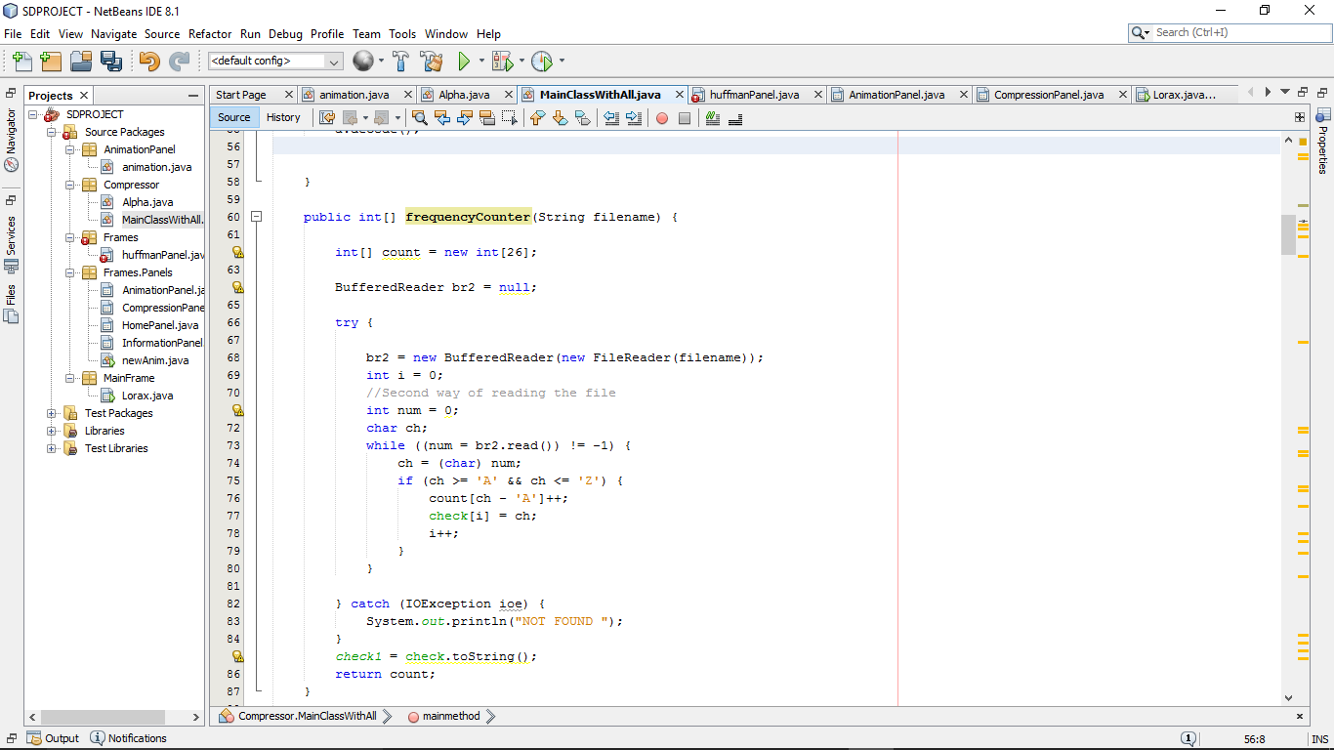

**nodeCreation( );**

We are creating the nodes and activating them.

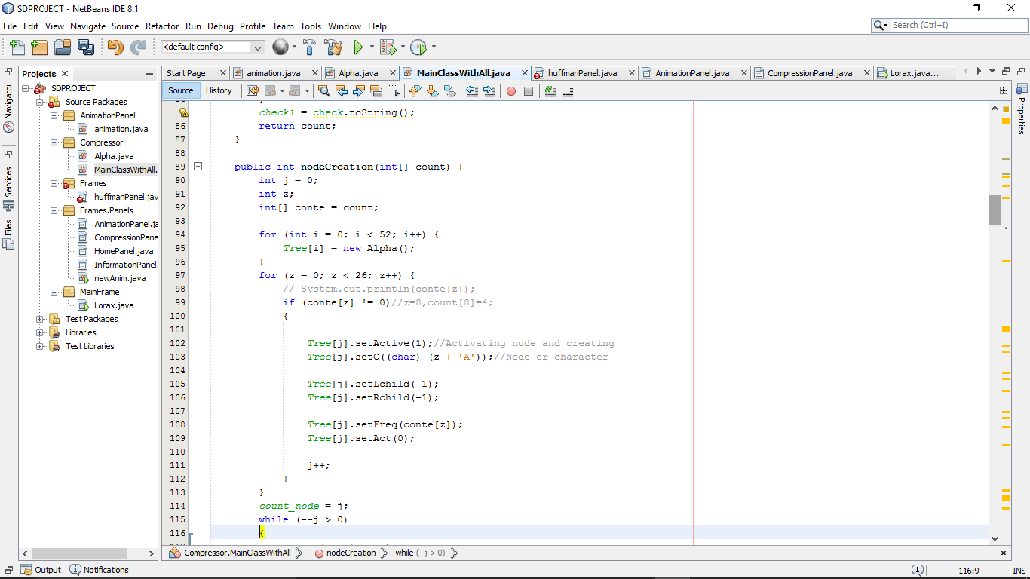

**Encode ( ) ;**

In this method we have got the codes of each character in the text. Firstly we made a tree considering the left nodes as 0 and the right nodes as 1. Then we have reprented the characters with 0 and 1.

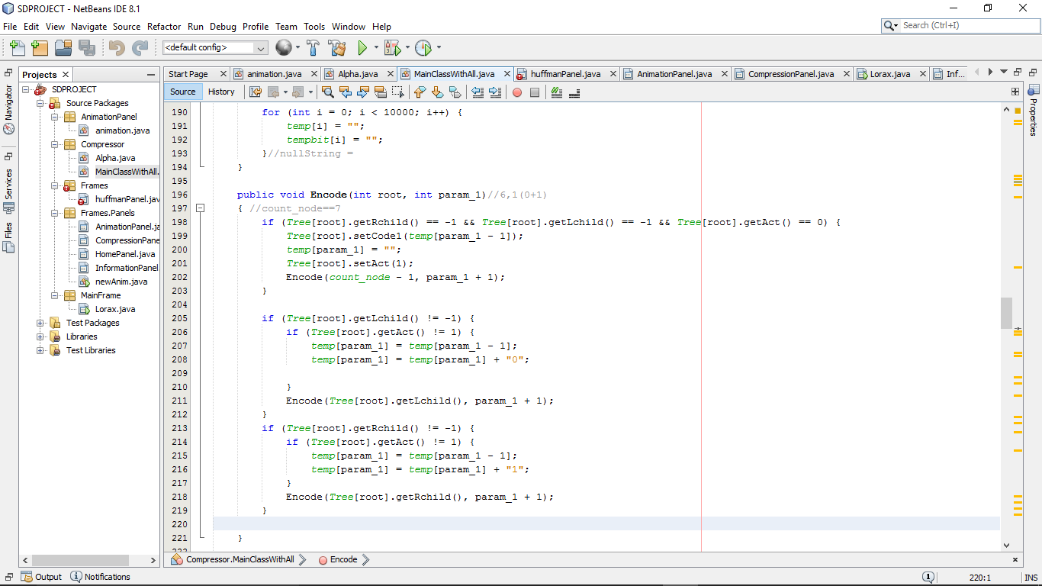

**Replacement ( ) ;**

In this method we have stored the string. The main work of this method is to replace the code into binary.

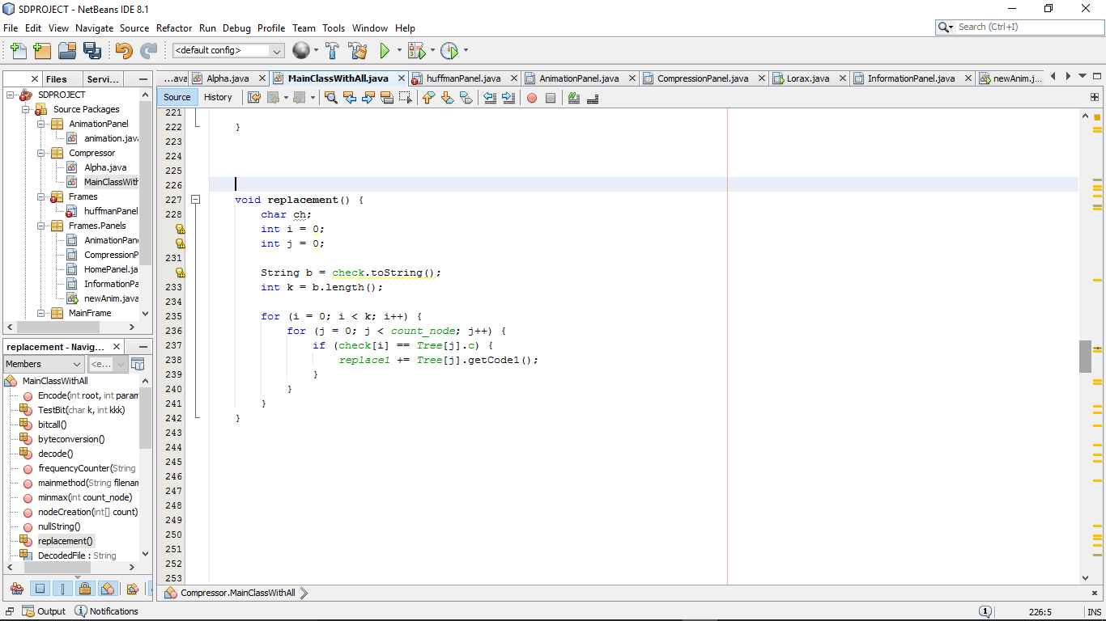

**byteConversion ( ) ;**

In this method we have encoded the main text and represented the characters of the text with special characters.

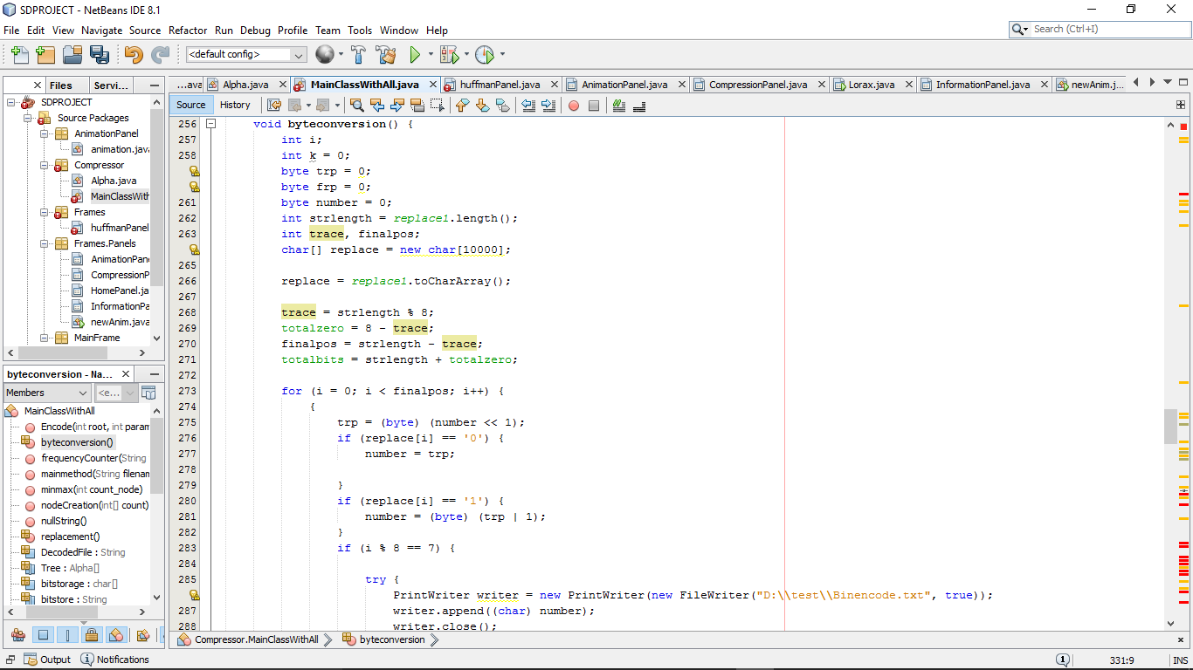

**bitCall ( );**

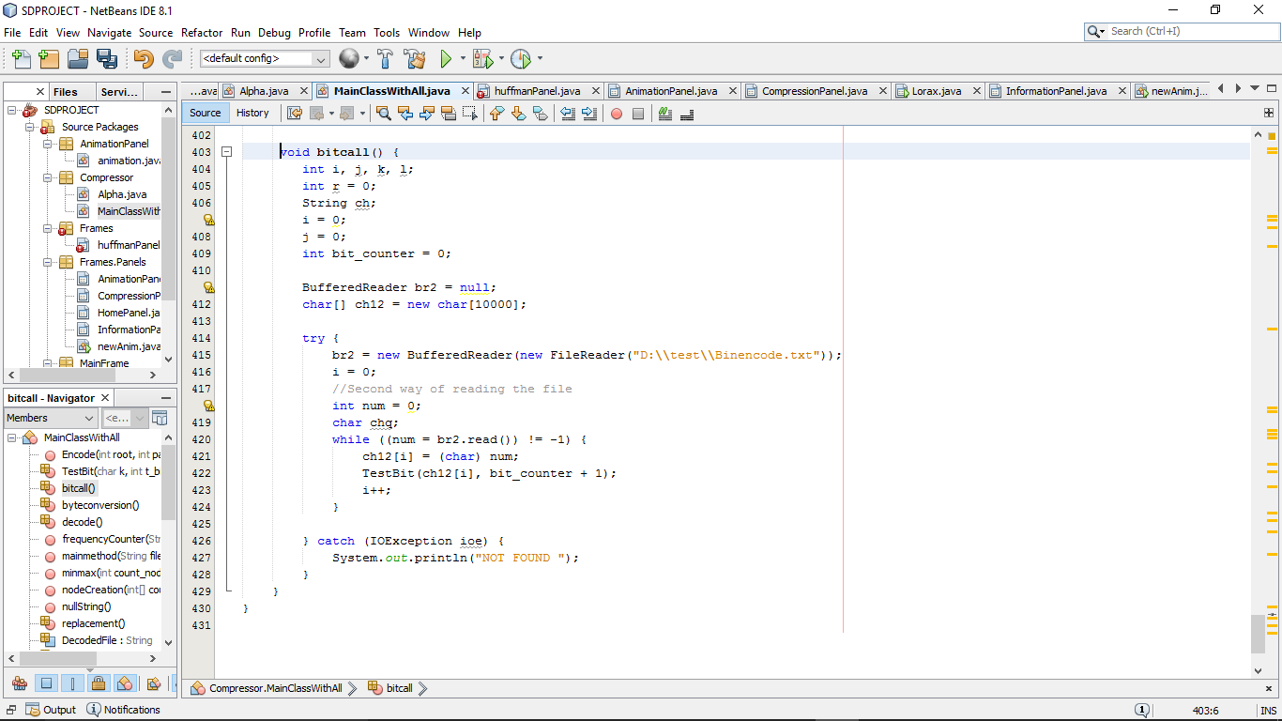

**Decode( );**

