EAST WEST UNIVERSITY

An Assignment
ON
Database Indexing

Submitted By:
Name: Md. Mahfuzur Rahman
ID: 2025-1-60-148
Course Code: CSE302
Section: 12
Semester: Summer 26
Group: 09

Instructor: Nishat Tasnim , Lecturer, Dept. of CSE
Submission Date: 21 August 2026

Topic: Indexing Application and Optimization in the EWU Innovation Hub Database.

Database Schema
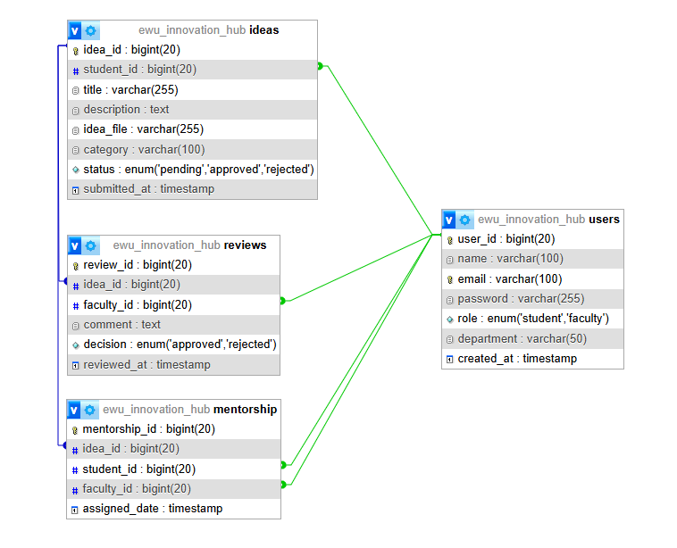
Fig: Database Schema of EWU Innovation Hub

Introduction
In a relational database, as the volume of data grows, searching through tables row by row (a full table scan) becomes inefficient and highly resource-intensive. Indexing is a critical optimization technique used by Database Management Systems (DBMS) to drastically reduce the number of disk accesses (I/O cost) needed to find records. This report outlines the strategic application of Primary, Secondary, and Clustering indexes across the four core tables of the EWU Innovation Hub database (users, ideas, reviews, and mentorship), alongside an analysis of the underlying B+ Tree data structure.

1. Primary Indexes (Auto-Applied)
A primary index is created based on the primary key of a table. It maintains a strictly 1:1 relationship with the records. Because primary keys are constraints that uniquely identify a record, the DBMS automatically generates a primary index to efficiently locate records based on this search key.
In the database schema, primary indexes are automatically structured for the following tables upon creation:
- Users Table: user_id
- Ideas Table: idea_id
- Reviews Table: review_id
- Mentorship Table: mentorship_id

SQL Query:
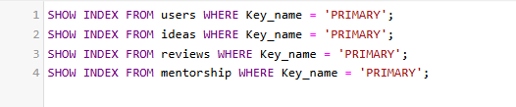

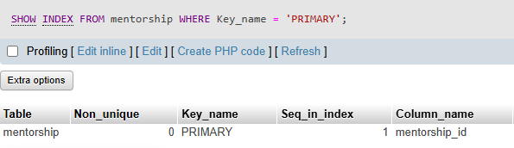

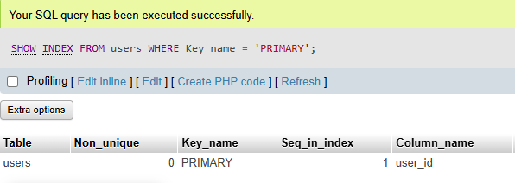
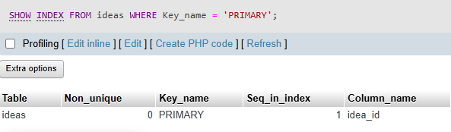
Outputs:

2. Secondary Indexes (For Fast Lookups)
A secondary index is built on a non-primary key attribute. While the physical data records are not ordered by this secondary key, the index itself maintains an ordered structure pointing to the actual records which is essential for quickly retrieving records using a non-ordering attribute.
For the Innovation Hub, secondary indexes must be applied to optimize filtering:

1. Table: users
- Column Indexed: department
- Reasoning: The system will often need to generate lists of students or faculty from a specific department (CSE or EEE). Creating a secondary index on this non-unique attribute allows the database to instantly locate all users within that department without scanning the entire user directory.
- SQL Query:
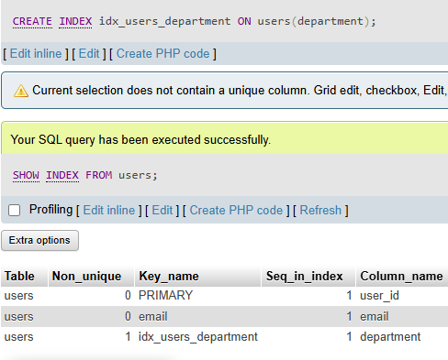

- Benefit after Creation: When querying the database for all CSE students, the disk read/write operation is significantly reduced. The DBMS retrieves the exact pointers from the index, skipping irrelevant records and speeding up directory loading times.

1. Table: ideas
- Column Indexed: category
- Reasoning: In the Innovation Hub system, users will frequently filter and search for projects based on their specific category (Software, Hardware). Without a secondary index, the DBMS would have to perform a full table scan, checking every single row one by one to find matching categories.
- SQL Query:
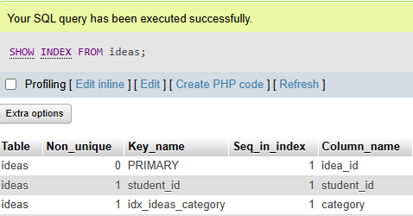
- Benefit after Creation: The primary benefit is a massive reduction in disk I/O cost. When a user searches for a specific category, the DBMS uses the B+ Tree index structure to instantly locate the exact memory pointers for those specific records. This makes the search operation highly efficient and reduces retrieval time.

3. Clustering Indexes (For Grouping and Joins)
A clustering index stores related records together in the same file, reducing search time and improving performance for JOIN operations. It is particularly useful for quickly retrieving groups of records having similar values.
3. Table: reviews
- Column Indexed: idea_id (Foreign Key)
- Reasoning: When a user opens a specific project on the platform, the application needs to fetch all the reviews associated with that single idea_id. Indexing this foreign key helps the database manage these related records efficiently, grouping them for quick access.
- SQL Query:
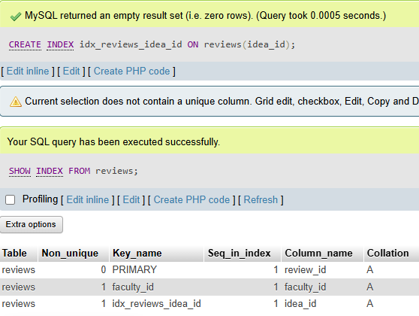

- Benefit after Creation: This drastically improves performance for JOIN operations between the ideas and reviews tables. By keeping related review records logically grouped together, the DBMS can fetch all reviews belonging to a specific idea in one fast operation, rather than hunting for individual records scattered across the data file.

4. Table: mentorship
- Column Indexed: faculty_id (Foreign Key)
- Reasoning: In the mentorship system, a single faculty member may have multiple students assigned to them. When a faculty member views their dashboard, the system must retrieve the group of students assigned to their specific faculty_id. A clustering index ensures these related mentorship records are grouped.
- SQL Query:
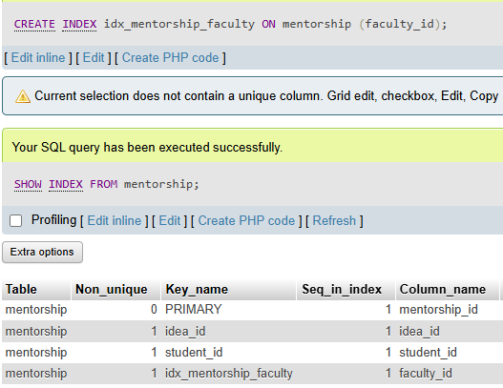
- Benefit after Creation: When executing a JOIN between the users and mentorship tables to display a mentor's student list, the clustered index minimizes the I/O cost. The system can retrieve the entire group of assigned students rapidly, ensuring a smooth and responsive dashboard experience.

Conclusion
The strategic implementation of Primary, Secondary, and Clustering indexes transforms the EWU Innovation Hub database from a basic storage schema into a highly optimized platform. The auto-applied primary indexes on columns like user_id and idea_id establish the foundational, 1:1 rapid retrieval structure. Building upon this, adding secondary indexes to frequently filtered attributes such as category and department successfully prevents resource-heavy full table scans. Finally, leveraging clustering indexes on foreign keys like idea_id and faculty_id minimizes disk I/O costs by grouping related records for efficient JOIN operations. Supported by the B+ Tree architecture underlying these MySQL indexes, this comprehensive strategy ensures the application will remain fast, responsive, and scalable as student enrollment and project submissions grow.

..…Thank You......

