Real Estate CRM & Project Pipeline
Monthly Performance Report
REPORTING PERIOD  September 2026 | PREPARED BY  Princess Erika Mahinay
FUNCTION  CRM, project tracking & follow-up support | STATUS  Portfolio demonstration
Note: All company names, project names, amounts, and performance figures in this report are fictional sample data created to demonstrate reporting and CRM support skills.
Monthly snapshot
32  Active projects  Up from 29 in August | 12  New opportunities  Up from 9 in August | 6  Proposals sent  Up from 5 in August
4  Projects awarded  Same as August | 5  Projects closed  Up from 3 in August | $72K  Closed project value  Up from $48K in August
Pipeline status
The pipeline remained active across bidding, proposal, and in-progress stages. Five projects were moved to Closed during the month.
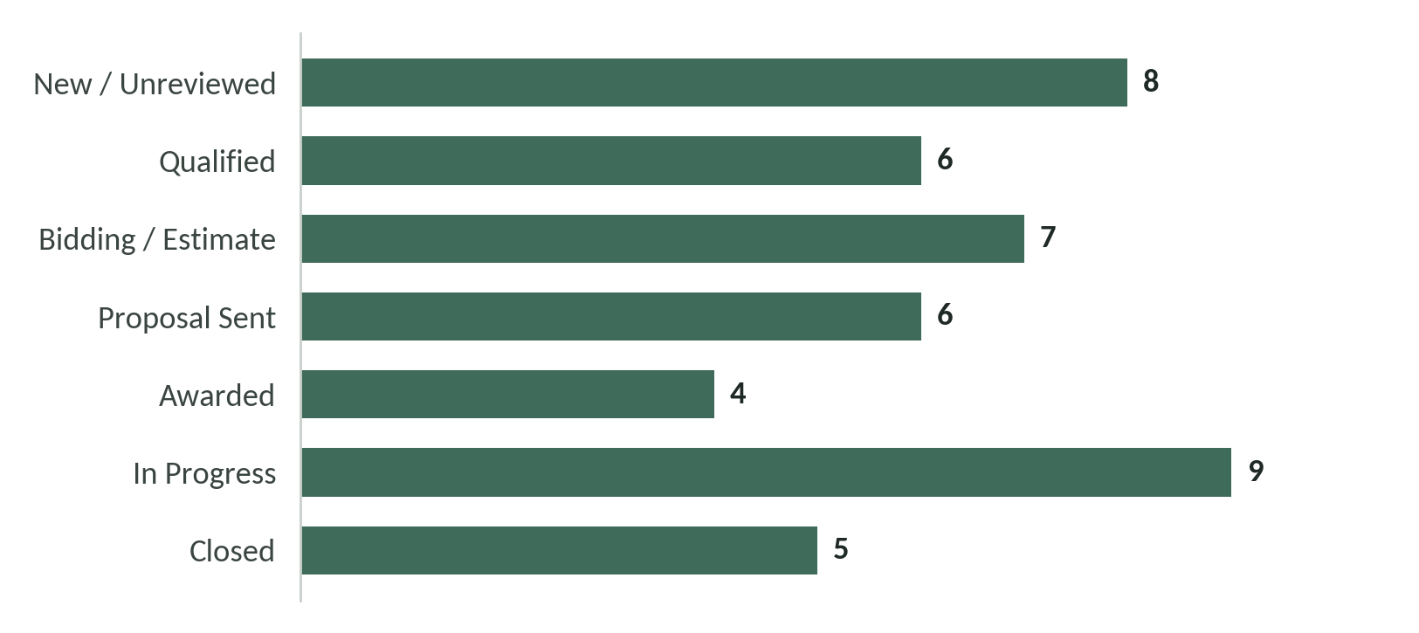
Projects by pipeline stage. Active projects are those from Qualified through In Progress.
In Progress is the largest stage at nine projects, and eight newly logged items are still waiting for review.
Closed projects
Five projects were completed and closed during the reporting period. Records were updated to reflect final status and project value.
PROJECT | PROJECT TYPE | VALUE | STATUS
Pine Street Renovation | Residential | $18,500 | Closed
Harbor View Unit 14 | Rental Turnover | $9,800 | Closed
Oakridge Exterior Works | Residential | $15,700 | Closed
Riverside Building 2 | Commercial | $16,400 | Closed
Maple Court Unit 6 | Rental Turnover | $11,600 | Closed
Follow-up & CRM activity
Follow-ups completed | 34 | Client, proposal, and project status checks
Pending follow-ups | 8 | Carried into next reporting period
CRM records updated | 27 | Status, notes, dates, or contact details
Priority items flagged | 11 | Time-sensitive proposals, client replies, or project actions
Month-end review
- Moved the 4 awarded projects into the active workflow and confirmed the next required action for each account.
- Reviewed the 6 proposal-stage records and maintained follow-up dates for opportunities still awaiting a decision.
- Updated all 5 closed project records so status, notes, and values were complete and easy to reference ($72K total).
- Kept project records organized across all 7 pipeline stages to make open work, pending decisions, and completed projects easier to track.
Next-month priorities
- Follow up on the 8 pending items and document outcomes in the CRM.
- Review the 7 bidding and 6 proposal-stage projects first to prevent missed deadlines or stalled opportunities.
- Confirm that the 4 newly awarded projects have complete contact details, scope notes, and scheduled next steps.
- Continue closing out completed work promptly so active pipeline totals remain accurate.
Skills demonstrated
CRM data management / Pipeline tracking / Project status updates / Follow-up coordination / Reporting / Record organization / Administrative support
Prepared as a portfolio work sample to demonstrate real estate administrative and CRM support capability.

