Standard Operating Procedure
Pipedrive CRM Updates, Follow-Up Tracking & Monthly Reporting
DOCUMENT  SOP-CRM-01 | Version 1.1 | OWNER  Princess Erika Mahinay
EFFECTIVE  October 2026 | APPLIES TO  Pipedrive CRM support
Note: This SOP is an independent portfolio practice project. All company names, project names, amounts, and timeframes are fictional sample content. Pipedrive menu names and available features can vary by plan and account setup.
1. Purpose and scope
This procedure keeps every deal in Pipedrive accurate, current, and easy to find, so follow-ups are not missed and the monthly report can be built straight from Pipedrive without manual reconciliation. It covers every sales and project opportunity from first inquiry to closeout. Each figure in the monthly report is pulled from records kept to this standard.
2. How the report maps to Pipedrive
IN THE REPORT | IN PIPEDRIVE
Project / opportunity | Deal, linked to a Person and an Organization
Pipeline stage | Open stage in the project pipeline
Closed project | Deal marked Won, with the final value entered
Declined or dead opportunity | Deal marked Lost, with a Lost reason
Follow-up | Activity (call, email, task, or deadline) scheduled on the deal
Pending follow-up | Open activity with a due date earlier than the reporting cutoff date that has not been marked as done
Priority item | Deal with the Priority label
Stalled record | Rotting deal (no update within the stage's rotting days)
Monthly figures | Saved filters and Insights reports
3. Pipeline stages
Every open deal sits in exactly one of six stages and is moved the same day its status changes. Won and Lost are closed deal outcomes, not stages (see Deal closure below).
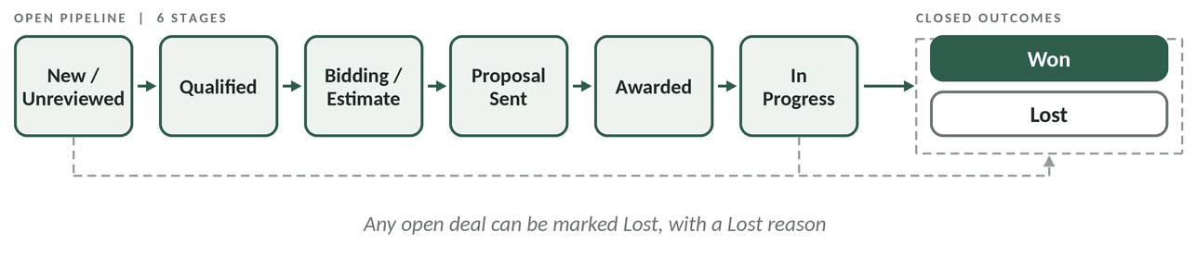
DEAL CLOSURE
- Won: work is complete and the final value is entered. The deal leaves the open pipeline and appears in the closed projects table.
- Lost: the opportunity was declined or went cold, and a Lost reason is recorded. Any open deal can be marked Lost.

STAGE | WHAT IT MEANS | REQUIRED NEXT ACTION | ROTTING
New / Unreviewed | Inquiry logged, not yet reviewed | Review within 1 business day | 1 day
Qualified | Fit and scope confirmed | Assign owner; schedule estimate | 3 days
Bidding / Estimate | Estimate or bid being prepared | Set Bid deadline; add deadline activity | 5 days
Proposal Sent | Proposal out, awaiting decision | Follow up per Section 5 | 7 days
Awarded | Client has approved the work | Add scope notes; schedule next step | 2 days
In Progress | Work is underway | Add a status note weekly | 7 days
4. Routine updates
DAILY
- Add new inquiries. Use + Deal, link the Person and Organization, add project type, source, and value, and place it in New / Unreviewed.
- Work the Activities list. Open everything due today and overdue, complete it, and click Mark as done with a short outcome note.
- Schedule the next activity on every deal you touch, so no open deal is left without a next step.
- Apply the Priority label to time-sensitive proposals, client replies, and project actions.
- Drag the deal to its new stage as soon as its status changes.
WEEKLY
- Open the saved filter for rotting deals and update or reschedule each one.
- Open the saved filter for deals with no next activity and schedule one.
- Check the Bid deadline field on Bidding / Estimate deals for the next two weeks.
- If Pipedrive automations are in use (for example, creating a follow-up activity when a deal moves to Proposal Sent), confirm they are still firing correctly.
5. Follow-up standards
SITUATION | TIMING | LOG IN PIPEDRIVE
New inquiry | First response within 1 business day | Call or email activity marked done, with a note
Proposal sent | 3 business days after sending, then every 5 business days | Note on the outcome; next activity scheduled
Waiting on a client reply | After 2 business days | Activity marked done with the method used
Newly awarded project | Next step confirmed within 1 business day | Next activity with a due date
Every follow-up ends with an outcome note and a next activity. Anything not completed stays as an open activity. If its due date is earlier than the reporting cutoff date, it is counted as a pending follow-up in the monthly report.
6. Record standards and closeout
EVERY OPEN DEAL MUST HAVE
- Title, Person, Organization, owner, and current stage.
- Value, project type, and source (custom fields), plus Bid deadline where it applies.
- Scope notes and at least one scheduled activity with a due date.
CLOSEOUT CHECKLIST
- Final value entered in the Value field.
- Closing note added summarizing the outcome.
- Open activities completed or reassigned; key files attached.
- Deal marked Won. If it was declined or went cold, mark it Lost and choose a Lost reason.
7. Month-end reporting
- Clean up. Confirm all stage moves are made and no deals are rotting or missing a next activity.
- Pull the pipeline counts. Use one filter for Total Open Deals (all open deals, including New / Unreviewed) and one for Active Qualified Opportunities (open deals from Qualified through In Progress, excluding New / Unreviewed). Use Insights deal reports for deals created, moved to Proposal Sent or Awarded, and won this month.
- Pull the activity counts. Use an Insights activity report (activities done), a filter for Pending Follow-Ups (open activities with a due date earlier than the reporting cutoff date that are not marked as done), a deal filter on Update time (records updated), and a filter on the Priority label.
- Build the closed projects table from deals marked Won this month: title, project type, value.
- Compare to the previous month by changing each filter's date range to last month.
- Write the review and priorities, with numbers, then run the quality checks below and send.
8. Quality checks before sending
DONE | CHECK
☐ | Snapshot figures match the Pipedrive filters and the pipeline chart, and Total Open Deals less Active Qualified Opportunities equals the New / Unreviewed count.
☐ | Closed project value equals the total of the Won deals in the closed projects table.
☐ | Pending Follow-Ups equals the number of open activities due before the reporting cutoff date and not marked as done.
☐ | No open deal is missing a next activity or has gone rotting.
☐ | All reports use the same date range and reporting cutoff date, and names and amounts are consistent.
9. Escalation
- Missing client contact or unclear scope: ask the deal owner the same day.
- A bid is due within 2 business days and no estimate is ready: tell the manager right away.
- Duplicate Persons, Organizations, or deals: do not delete; confirm with the owner, then use Pipedrive's merge option.
10. Document control
VERSION | DATE | CHANGE | AUTHOR
1.1 | October 2026 | Adapted for Pipedrive CRM | Princess Erika Mahinay
1.0 | October 2026 | Initial release | Princess Erika Mahinay

