Allianz Insurance

Valiant Towers  
Level 3A/B, 46/7,  
Nawam Mawatha,   
Colombo 02.



***Progress DB Diagnosis and the Report***

**Prepared For:** Allianz Insurance

**Prepared By:** ModularFour Solutions

**Table of Contents**

Progress DB and the Application Point of View 3

Application Point of View 4

DB Server Point of View 5

Conclusion 9

Reference 10

Workaround 10

Contact Us 10

# Progress DB and the Application Point of View

We have done an analysis on Following Item on the Progress DB and the Application

**DB Point Of View**

1. DB Hit Ratio
2. DB Buffer Ratio
3. Number of Lock Tables (SHARE LOCKS, DEAD LOCKS)

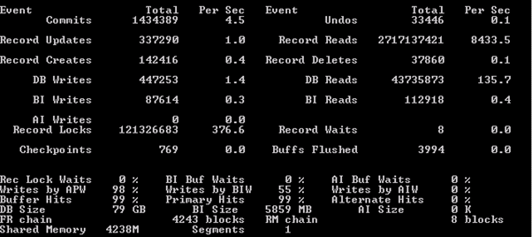

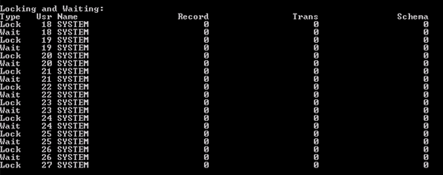

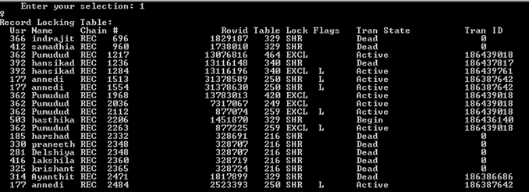

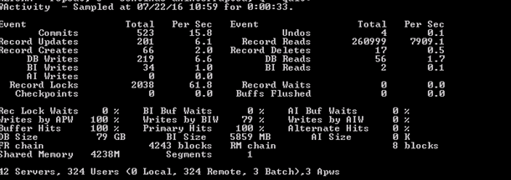

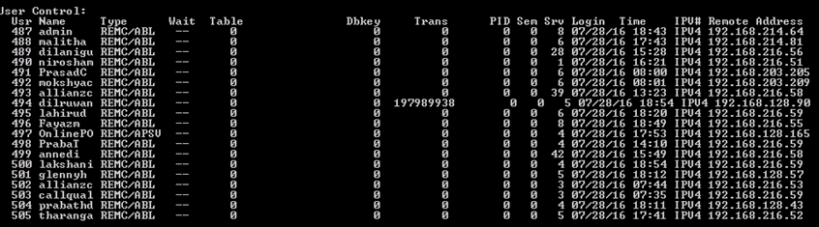

# Application Point of View

1. WHOLE INDEX
2. DB Reads
3. INDEX USAGE

Other than few places rest of the application stat cannot be retrieved due to the Source Code Not Available but, we found that fairly slowness on some part of the application i.e.

[16/07/28@14:25:02.064+2300] P-003324 T-001044 3 4GL 4GLTRACE Return from DisplayPremium [insur\PolCancl.r]

[16/07/28@14:27:27.567+2300] P-003324 T-001044 2 4GL 4GLTRACE Run DisplayPremium [USER-INTERFACE-TRIGGER - insur\PolCancl.r @ 2117]

[16/07/28@14:35:57.116+2300] P-003324 T-001044 3 4GL 4GLTRACE Return from OnQueryChange [insur\PolCom.r]

[16/07/28@14:54:10.691+2300] P-003324 T-001044 2 4GL 4GLTRACE Run OnShowChange [USER-INTERFACE-TRIGGER - insur\PolCom.r @ 3751]

# DB Server Point of View

1. CPU Usage
2. Memory Usage
3. Network Usage

**CPU Usage**

**Memory Usage**

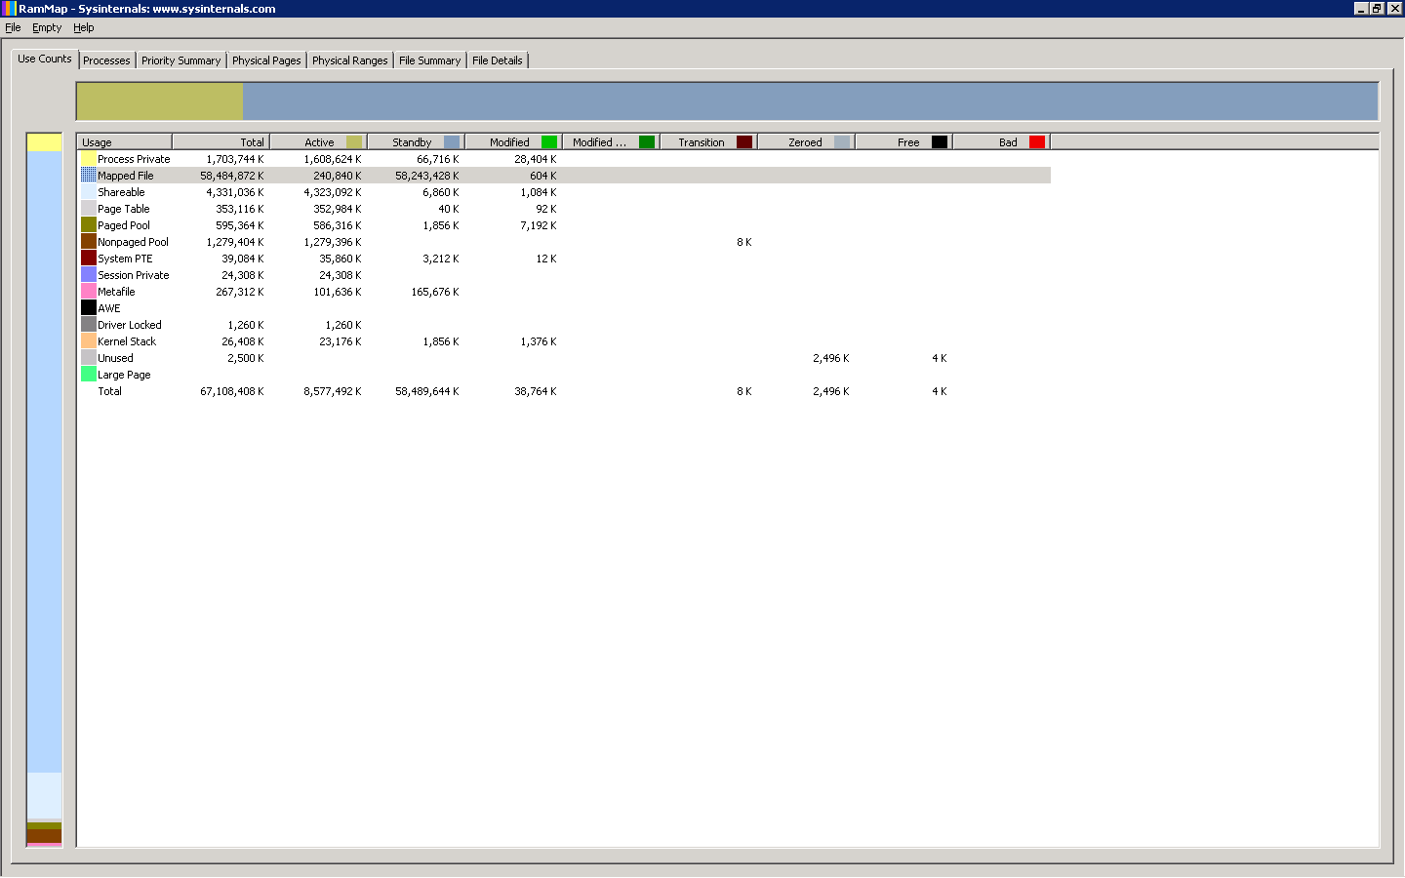

**Network Traffic**

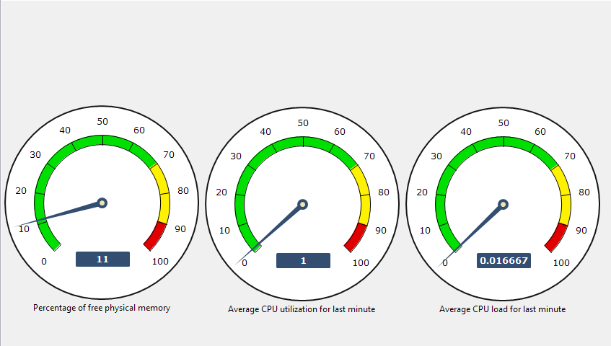

# Conclusion

Based on our 360 Analysis on the DB, Application and the Network, we found few aspects that we can re-look at and fix to improve performance on the DB and the Application

1. Every time after the Schedule online Pro Backup runs, the system seems to be experiencing a slowness and latency on response.
2. There were one instance that application server was pointed to low memory server and may be due to that Application could be late response.
3. We found that there is a compatibility issue with Windows 2008 R2 Server and the Progress 10.2B SP 5.

# Reference

<http://knowledgebase.progress.com/articles/Article/000014375>

<http://knowledgebase.progress.com/articles/Article/P167048?popup=true>

<http://www.microsoft.com/en-us/download/details.aspx?id=9258>

# Workaround

As a resolution for above mention drawbacks, we recommend following steps to be taken to improve the performance on the application.

1. Stop Online Schedule Probackup and Switch to Manual Offline Backup for a period of one month
2. Re-Start the DB Server Every Day Night
3. Re-Start the DB Server Before Month End

Further to improve Application Level and the DB Level Performance we need to get the DB Password and See some of the Key aspect as mention below.

1. DB Reads
2. Profiler etc...

# Contact Us

Mahinda Jayakody

072317666 / 0716825707

[mahinda@modular4.com](mailto:mahinda@modular4.com)

Web Site : [www.modular4.com](http://www.modular4.com/)