

Copyright © 2014 ModularFour SolutionPvt Ltd| Confidential



iCAM Financial System

Implementing the Loan Management

RELEASE_2015-04-02

Table of Contents

1 Introduction 3

1.1 Overview 3

1.2 Scope 3

1.3 Purpose 3

1.4 Definitions, Acronyms and Abbreviations 3

1.5 Pre-Conditions 4

1.6 References 4

2 Assumptions 5

3 Data Model 6

4 Detailed Design 7

4.1 Driver Pop message 7

4.2 Flow Diagram 7

4.3 Program List 7

4.4 Look & Feel 8

4.5 Java Layer – proposed Implementation 10

4.6 Progress Layer - Proposed Implementation 10

4.7 Install & Rollback Scripts 10

# Introduction

## Overview

* Over a past few months Assetline Loan Division has manage their Daya to day Business Transaction by manual system (in Excel Sheets). But when the business start grow by the time past they could not respond the business demand as they wanted. Therefore they need a automated system to record their day to day Business transaction and manage the Loan Contracts towards end.

## Scope

* Pledge Loan
* Revolving Loan
* Invoice Discounting
* Variable Interest

## Purpose



## Definitions, Acronyms and Abbreviations

| **Term** | **Description** |
| --- | --- |
|  |  |
|  |  |

## Pre-Conditions

* All Enhancement Has to be Deployed to Production Prior to the Loan Deployment

## References



# Assumptions

* In Scope
  + Introduce Loan Module to the Existing iCAM Solution
  + Under Loan Management System Following Loan Type will be Introduced
    - Revolving Loan
    - Pledge Loan
    - Invoice Discounting
    - Variable Interest
* Out of Scope
  + Commercial Credit Loan Type
  + Real Business of Factoring
  + Recovery For Dealers
  + Any Mobile Apps

# Data Model

* CORPINFO
* GLINFO
* LEASEINFO

Tables Introduced to GLINFO

CREATE TABLE "GLINFO"."TBLDAILYINTEREST"

(

"DAI_DATEFROM" DATE,

"DAI_CONNO" VARCHAR2(13 BYTE) NOT NULL ENABLE,

"DAI_DATETO" DATE,

"DAI_NOOFDAYS" NUMBER(4,0),

"DAI_DUEAMT" NUMBER(15,2),

"DAI_TOTINT" NUMBER(15,2),

"DAI_DUTTYPE" VARCHAR2(3 BYTE),

"DAI_DUCTYPE" VARCHAR2(3 BYTE),

"DAI_DUEDTE" DATE,

"DAI_LASTUPDATE" DATE,

"DAI_LASTUPTIME" VARCHAR2(10 BYTE),

"DAI_LASTUPUSERID" VARCHAR2(12 BYTE)

)

SEGMENT CREATION DEFERRED PCTFREE 10 PCTUSED 40 INITRANS 1 MAXTRANS 255 NOCOMPRESS LOGGING STORAGE

(

INITIAL 65536 NEXT 1048576 MINEXTENTS 1 FREELISTS 1 FREELIST GROUPS 1 BUFFER_POOL DEFAULT FLASH_CACHE DEFAULT CELL_FLASH_CACHE DEFAULT

)

TABLESPACE "GL" ;

CREATE TABLE "GLINFO"."TBLDAILYINTERESTHISTORY"(

"DIH_CONNO" VARCHAR2(13 BYTE),

"DIH_DATEFROM" DATE,

"DIH_DATETO" DATE,

"DIH_NOOFDAYS" NUMBER(4,0),

"DIH_DUEAMT" NUMBER(15,2),

"DIH_TOTINT" NUMBER(15,2),

"DIH_DUTTYPE" VARCHAR2(3 BYTE),

"DIH_DUCTYPE" VARCHAR2(3 BYTE),

"DIH_DUEDTE" DATE,

"DIH_LASTUPDATE" DATE,

"DIH_LASTUPTIME" VARCHAR2(10 BYTE),

"DIH_LASTUPUSERID" VARCHAR2(12 BYTE)

)

SEGMENT CREATION IMMEDIATE PCTFREE 10 PCTUSED 40 INITRANS 1 MAXTRANS 255 NOCOMPRESS LOGGING STORAGE

(

INITIAL 65536 NEXT 1048576 MINEXTENTS 1 MAXEXTENTS 2147483645 PCTINCREASE 0 FREELISTS 1 FREELIST GROUPS 1 BUFFER_POOL DEFAULT FLASH_CACHE DEFAULT CELL_FLASH_CACHE DEFAULT

)

TABLESPACE "GL" ;

# Detailed Design

## Loan Management

### Reference

Edit List Category Definition

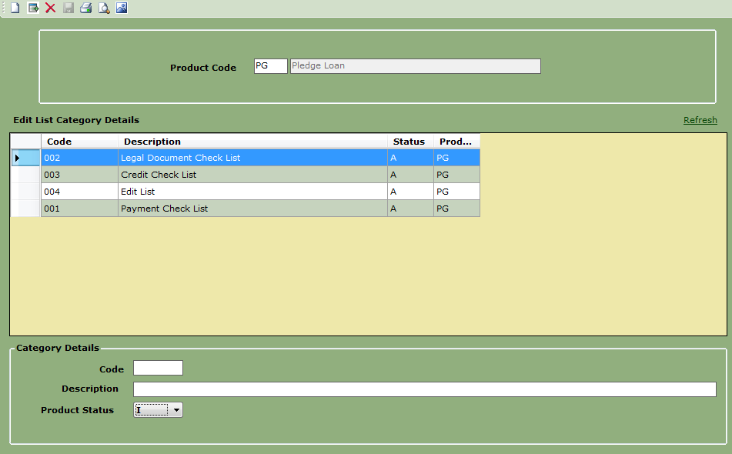

Loan Types

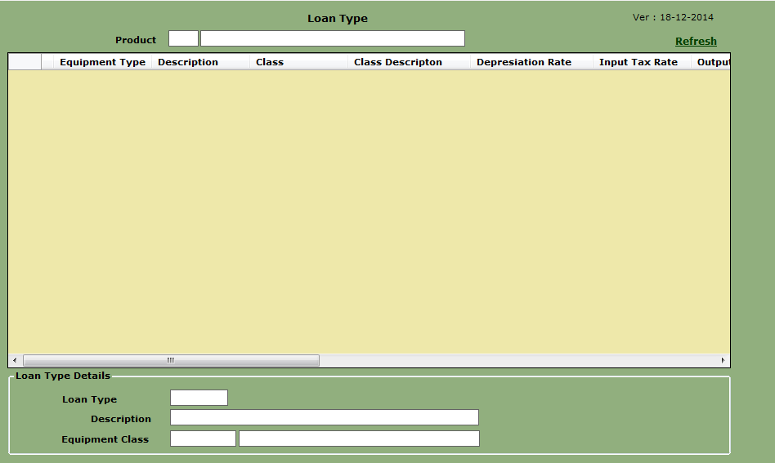

### Application Maintenance

Trail Calculation

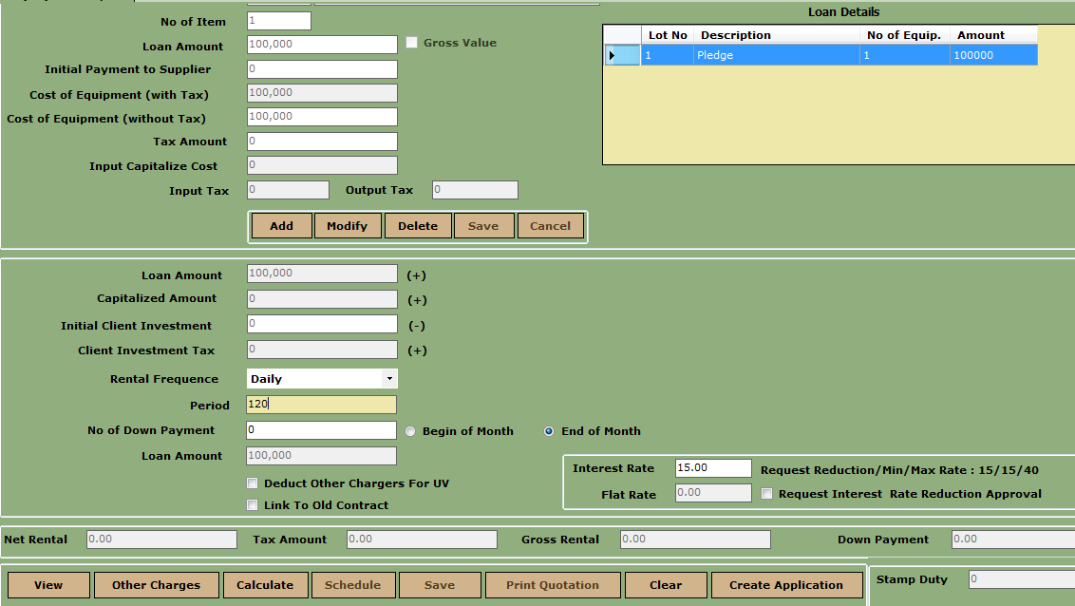

Flexible Trail Calculation

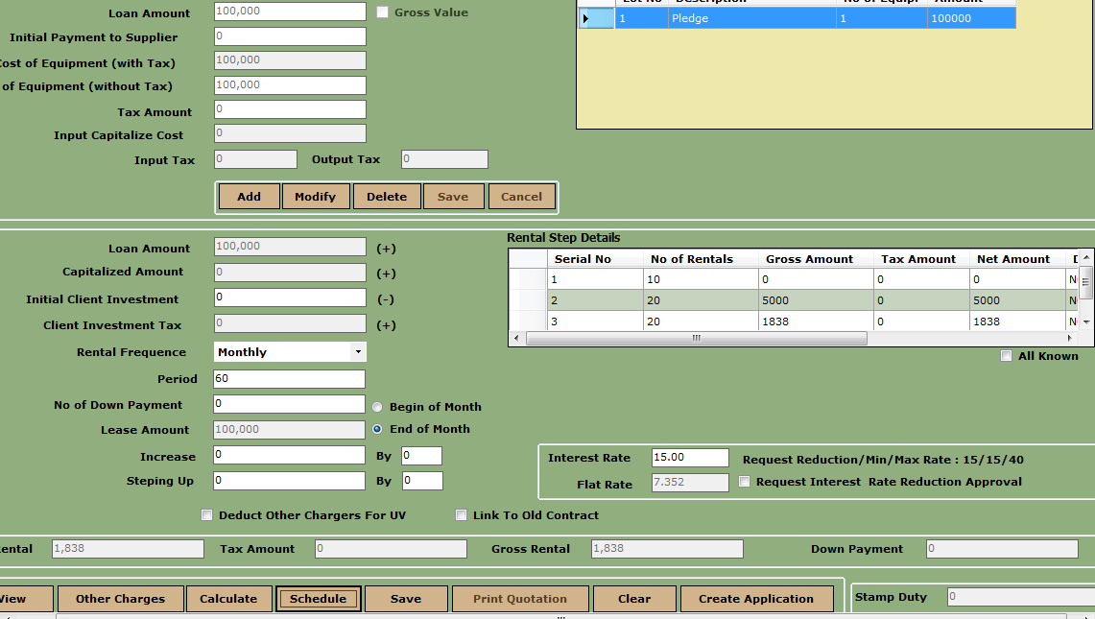

Application Create

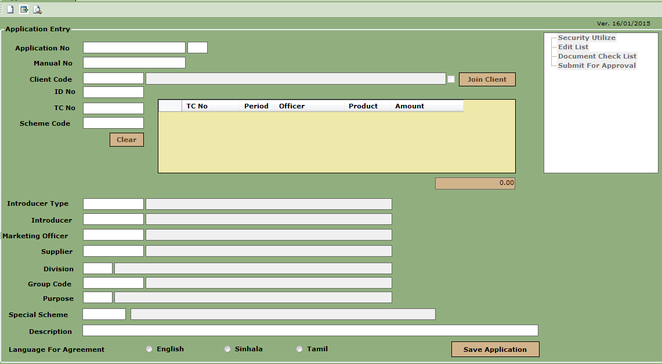

Submit For Approval

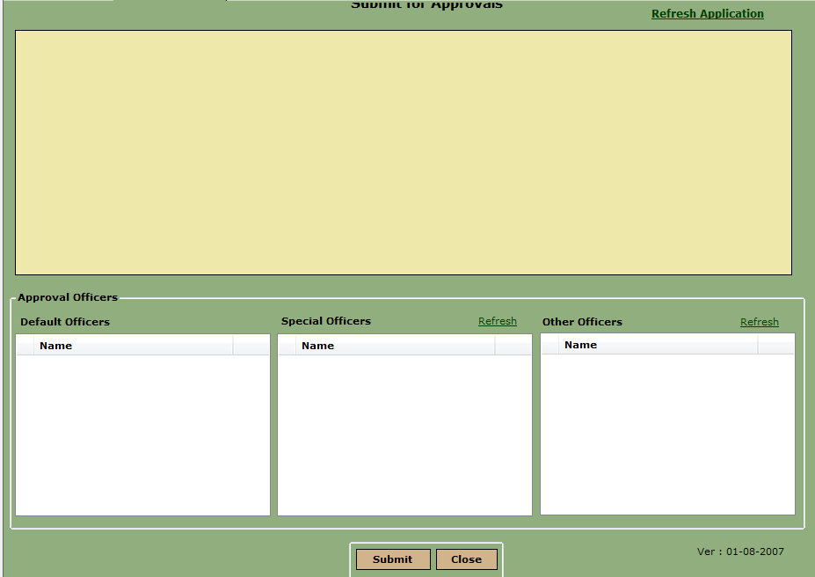

Application Approval

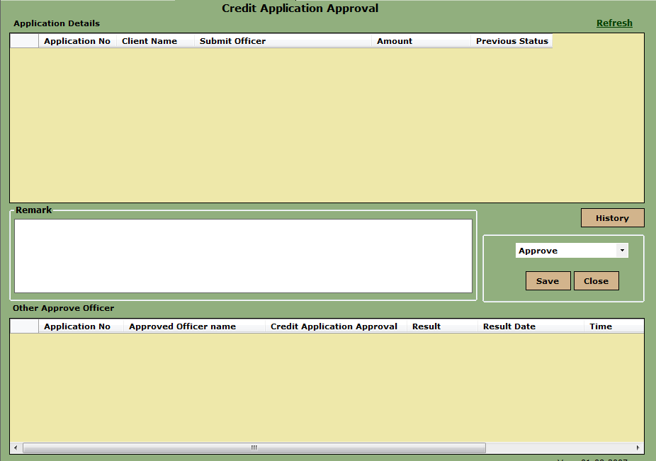

### Information Center

Contract Inquiry

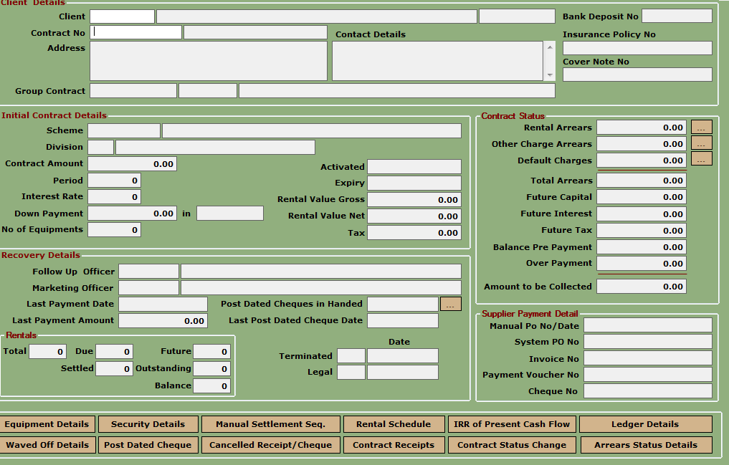

## Flow Diagram

* N/A

## Program List

|  |  |  |  |
| --- | --- | --- | --- |
| **Namespace** | **Program Name** | **New/Existing** | **Description** |
| LoanInfo | LT101220.cs | New | Edit List Category Definition |
|  | LT101221.cs | New | Edit List Category Item Definition |
|  | LT201011.cs | New | Loan Type Definition |
|  | LT202011.cs | New | Standard Proposal |
|  | LT202012.cs | New | Flexible Proposal |
|  | LT202030.cs | New | Application Create |
|  | LT202040.cs | New | Application Cancel |
|  | LT202070.cs | Modify | Edit List |
|  | LT202090.cs | New | Submit For Approval |
|  | LT202102.cs | Modify | Application Approval |
|  | LT204010.cs | Modify | Initiate Contract |
|  | LT204050.cs | Modify | Manual Activation |
|  | LT205010.cs | Modify | Manual NOT |
|  | LT207011.cs | Modify | Standard Closure |
|  | LT207012.cs | Modify | Rechedulement Closure |
|  | LT207013.cs | Modify | Facility Cancellation & Refund |
|  | LT207020.cs | Modify | Closure Remove |
|  | LT207030.cs | Modify | Confirm Closure |
|  | LT212010.cs | Modify | Contract Inquiry |
|  |  |  |  |
|  |  |  |  |
|  |  |  |  |

## Install & Rollback Scripts

Stored Procedures

|  |  |  |  |
| --- | --- | --- | --- |
| **Folder** | **Program Name** | **New/Existing** | **Description** |
| install | install/[CDEV-3654](http://agile.ironmountain.com/jira/browse/CDEV-3654)-Install.p | New |  |