**Modular4 Solutions (Pvt.) Limited.**

#472, Kohalwila Rd, Gonalwala, Kelaniya, Sri Lanka.

E-mail: [mahinda@modular4.com](mailto:mahinda@modular4.com)

Phone: +94 112918458, +94772317666,+94716825707

10th March 2015

Mr. Sajith Jayarathne **Proposal No: M4PO15000004**

Head of IT,

|  |
| --- |
| **Assetline Leasing Company Limited** |
| 120, 120A, Pannipitiya Road, Battaramulla, Sri Lanka . |

Dear Sir,

**QUOTATION for Mobile Application for Multiple Approvals**

First and foremost, thank you very much for your interest in Modular4 Solutions (Pvt) Ltd. With reference to your inquiry on the above software solution, we are pleased to submit herewith our revised p rice quotation for your kind consideration.

**Pricing Summary**

Cost of software Modification without Maintenance Rs. 350,000.00

**Total cost Rs. 350,000.00**

**Proposal Validity**

This proposal is valid for a period of one (01) month.

**Payment Terms & Other Charges**

**Application System Charges for** **each Module**

50% - on confirmation of the quotation

50% - on implementation of the modifications

We hope this pricing proposal would meet your requirements. Should you need any further clarifications, please feel free to contact us.

Thank You,

Yours sincerely,

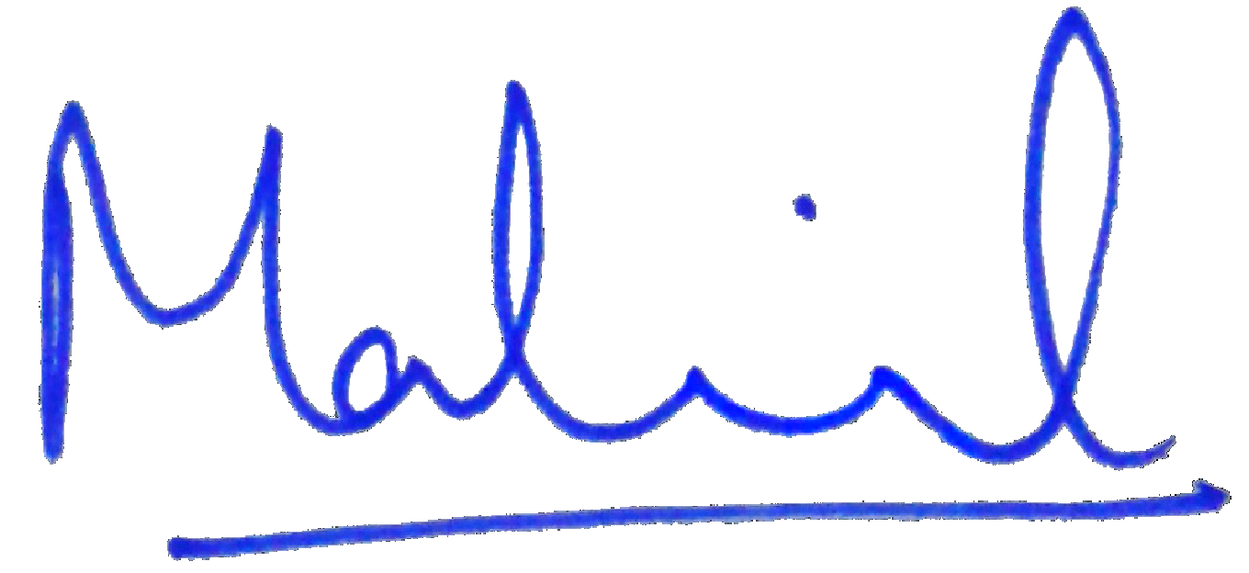

J.M Madhujith Jayakody

Director Project Development