Option I

1. Remove the branch From Initiate Auction Screen

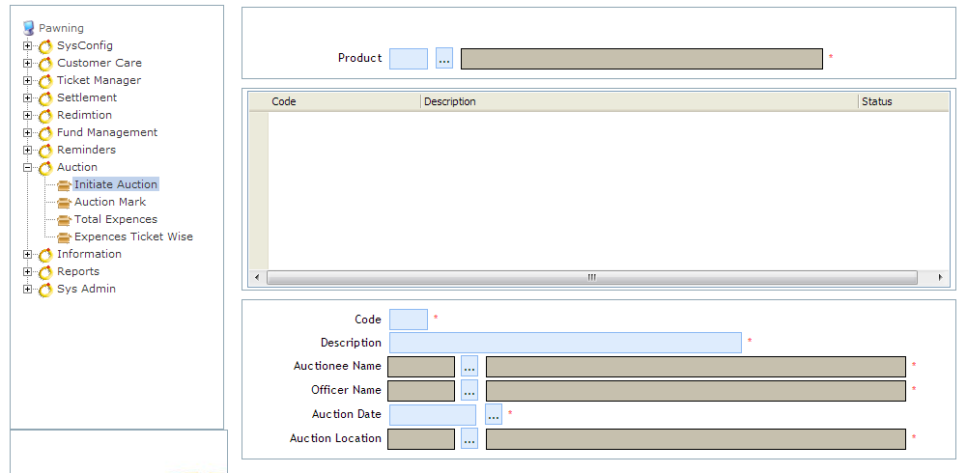

1. Auction Mark Screen

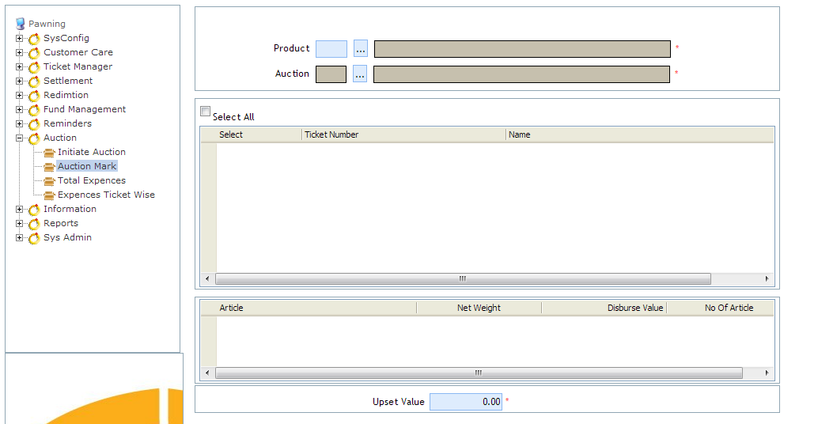

1. Include Auction Selection in Auction Ticket Screen

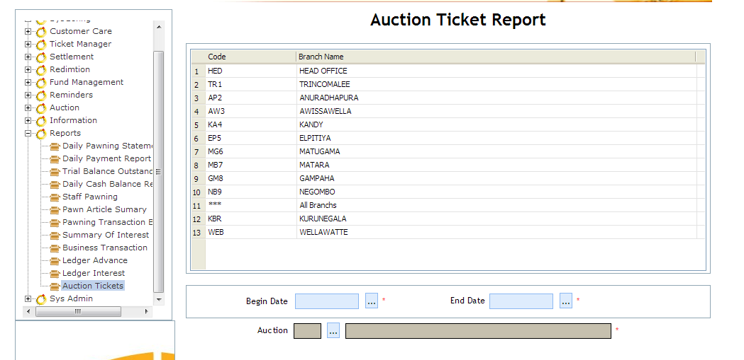

Generate the Report Based on Selected Auction

Option II



Get the Report Based on Selected Auction

Systematically Handel the Branch Selection

Both Option Need Data Corrections