Mr. Indika Kumarasinge
Allianz Insurance

Document Management System
Proposed DMS Suite

Prepared For: Allianz Insurance

Prepared By: Modular4

Proposal Date: 09/12/2015

Description

DMS Solution is a comprehensive, user-friendly package consisting of the following components:
Product Categorization
Document Categorization
Workflow Management
Alert/Reminder Module
Branch Definition
Region Definition etc..
This has been designed for ease-of-use, being menu-driven with consistent structures across all of the application. The database provides shared access to the information while ensuring complete integrity of the data.
DMS Solution provides many convenient reporting features, tailored to the roles of your decision. Also it is an application that optimizes the processes of exchanging documents between enterprises and managing documents within an organization by capturing and reading electronic copies – and eliminating the need for manual data entry.

Proposal Number: M4PO15000011
Table of Contents

Project Purpose and Business Problem 3
Our Solution 3
Implementation Plan 4
Architecture of the DMS Solution 6
Financial Estimates 7

Project Purpose and Business Problem
DMS software should provide users with an online environment within which they can maintain Customer records, Referential documents, with minimum data redundancy & greater security. And improve employee performance and productivity by integrating business processes and data across the organization
Also it should provide the reports, graphs as per the state regulation and market trends.
Finally it should help with MIS reporting for better decision making.

Our Solution

DMS Solution offers the chance to capture of data easily and accurately, facilitate processes, and generate data that is easily accessed and intuitive. It saves time and effort not having to duplicate the posting of transactions. Also enables you to master the data needed to make fast, sound decisions while conducting business.
DMS Solution supports capture of data easily and accurately, facilitates processes, and generates data that is easily accessed and intuitive. The robustness of the product protects the business from internal and external fraudulent activity. DMS Solution simplifies the adherence to regulatory mandates and results in significant savings and provides protection against litigation.

Benefits of using our solution
Enabling Web Base / Mobile App
DMS Solution has been design to access all our stakeholders to access via Internet or any of the Smart phone Device.

Implementation Plan

High Level Project Plan
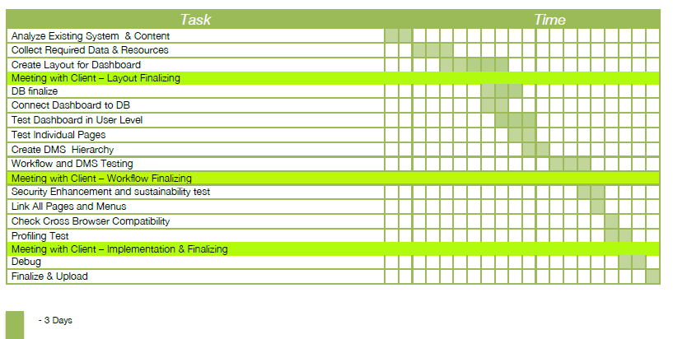
Design & Development 45 Days
Testing & Deployment 15 Days

Software Agreement
The Software Agreement to be signed with “Modular4 Solutions (Pvt) Ltd.”

Software Warranty
This software solution carries a warranty period of Twelve (12) Months from the date of User acceptance test (UAT).

Software Maintenance
Maintenance services shall be provided under a maintenance agreement to be signed after the warranty period expires. The standard annual maintenance charges would be fifteen percent (15%) on the product price plus the subsequent cost of modifications.

Software Maintenance
Upfront 100% maintenance fees for a period of one year at the signing of the maintenance contract.
During such annual maintenance MODULAR4 shall rectify all software related faults, defects and malfunctions free of charge.

Additional Software Modifications
All additional software modification charges will be quoted after a detailed system study. The development of the modifications would begin once a written confirmation is given by the client.

Modification Charges
50% - on confirmation of the quotation
50% - on implementation of the modifications

Updates/New Modules
Customers under maintenance service agreement are entitled to free Application Updates within the same version, database, operating system, and application language (subject to application customizations done at the client’s site) of the modules purchased.
Other additional/new modules/new version upgrades would be available at a very special discounted price to your company.

Purchase Order & the Payments
Purchase Order and the payments to be issued to “Modular4 Solutions (Pvt) Ltd.”

Architecture of the DMS Solution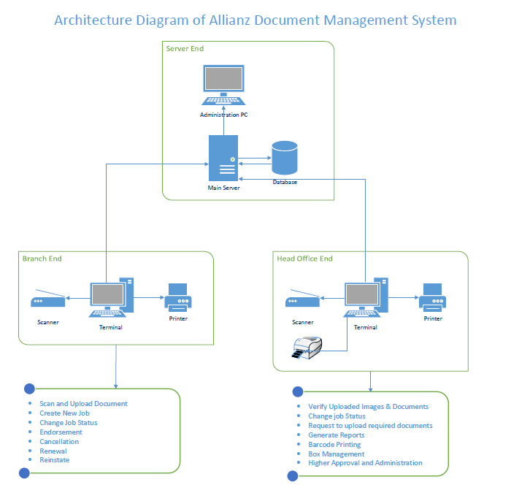

DMS Development Architecture
MySql Data Base
Java 8
Jasper Reporting Framework

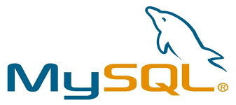



Financial Estimates

Pricing Summary

Cost of the DMS Solution | 1,237,500.00
Total Price | 1,237,500.00

Note:
** MODULAR4 will sell the source code to the client three (3) times of the Software value on unlimited user license, if client needs.
** Unlimited user license will be provided.
** Unlimited Branch Definition

Currency of Offer
All prices are in Sri Lankan Rupees.

Proposal Validity
This proposal is valid for a period of one (01) month.

Payment Terms
50% - on Acceptance of Proposal
50% - on Live Run

Training
User training will be done at site during implementation.
About Modular4

Modular4 has delivered cost effective and high-quality software solutions for a wide range of industries and domains. We work together to deliver the ultimate in customer satisfaction while also helping each business or company achieves their unique needs.
Our competence and experience ensures that we deliver excellent services and products to our customers.
At Modular4 we are proud of our high quality standards. These standards allow us to provide our customers with reliable software applications, regardless of complexity.

Contact Us
Dumindu Wijesekara Mahinda Jayakody
0773435429 072317666 / 0716825707
dumindu@modular4.com mahinda@modular4.com
Web Site : www.modular4.com

Our Clients
Client | User reference | Solution Provided
People’s Merchant Business PLC | Anuranga Indrajith  Manager IT | “Pawn – Brokering” Software Solution
Citizen Development Bank | Mr. Imdaad Nagiub  Senior Manager IT | “Pawn – Brokering” Software Solution
MBSL Savings Bank | Mr. Dushmantha Weerathunga  Manager IT | “Pawn – Brokering” Software Solution
Lake House Printers & Publishers | Mr. Rasika Karandawa | Online Bank Cheque Book Ordering and Cheque Printing (MICR)  Cheque return Notice Printing with Lanka Clearance Process data
City Bank | Mr. Sumeda Karunarathne  Product Manager | Post Dated Cheque management Software
Ideal Property | Mr. Peter Jayalath  Owner | Real Estate management Software
K.G.S Spear Parts | Mr. Sajeewa Ekanayaka  Product Manager | Inventory Solution
Lucky Homes | Mr. Dinesh Kuruwita | Finsoft Total Solution
Global Trust Pvt Ltd | Sheno Jayasekara  Manager IT | “Pawn – Brokering” Software Solution
AssetLine Leasing Company | Sajith Jayarathne  Head of IT | Loan Management, Margin Trading, Fixed Asset Management, Micro Finance

Confidentiality
All material, prices and other information provided in this proposal and other supporting documents, annexure, CD-ROMs, diskettes etc. should not be disclosed to any 3rd party without written consent.

We hope this pricing proposal would meet your requirements. Should you need any further clarifications, please feel free to contact us.

Thank You,
Yours sincerely,


Mahinda Jayakody
Director Projects
Modular4 Solutions

