Assetline Leasing Company Ltd

Cheque Upload

Version 1.0

15-JUN-2015

ModularFour Solution Pvt Ltd.

Revision History

Date | Description | Author | Comments
15-06-2015 | Initial Version | ModularFour

Document Approval

The following Software Requirements Specification has been accepted and approved by the following:
Signature | Printed Name | Title | Date

Table of Contents

Revision History ii
Document Approval ii
1. Introduction 1
1.1 Purpose 1
1.2 Scope 1
1.3 Definitions, Acronyms, and Abbreviations 1
1.4 References 1
1.5 Overview 1
2. General Description 1
2.1 Product Perspective 1
2.2 Product Functions 1
2.3 User Characteristics 1
2.4 General Constraints 1
2.5 Assumptions and Dependencies 1
3. Specific Requirements 1

1. Introduction

1.1 Purpose
Assetline has requested a further development on the Cheque Upload Process to Support their Day to day Routine.

1.2 Scope

Upload the Cheque which given in a Excel Sheet.

1.3 Definitions, Acronyms, and Abbreviations
N/A

1.4 References
N/A

1.5 Overview
Introducing Cheque Upload

2. General Description
N/A

2.1 Product Perspective
All Product

2.2 Product Functions
N/A

2.3 User Characteristics
N/A

2.4 General Constraints
N/A

2.5 Assumptions and Dependencies
N/A

3. Specific Requirements

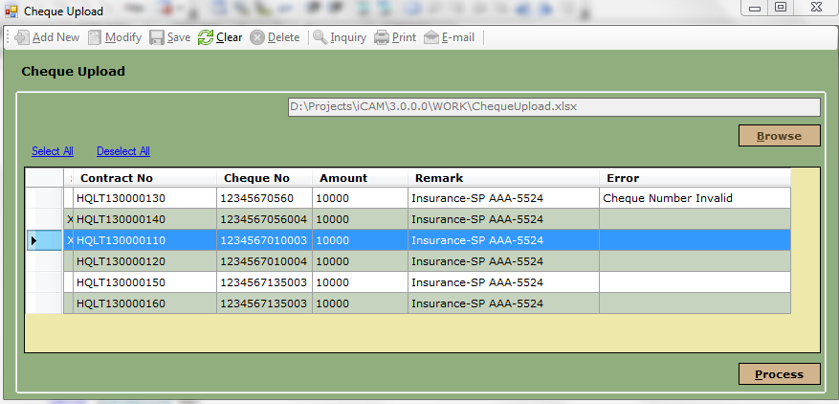

Select the Excel File with the cheque detail to be Uploaded

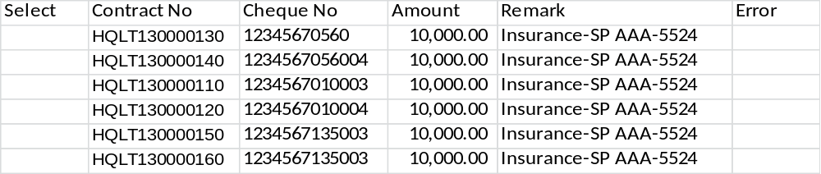
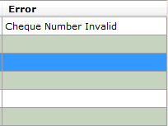
This Column Will have all the Validation Errors


User Can Press on “Sellect All” to Select all the cheques to be posted except for which are having validation errors

User can press “Deselect All” to Deselect all cheques
Once user Press on “Process” button, system will start the Posting cheques process and all the selected item will be post one after the other following will be posted during the process.
- Reciecpts Entry will be cretaed
- Cheque Entry will be created
- Overpayment Entry will be created
- GL Entry will be posted for Overpayment

Stakeholders:
Head of Loan Department (AssetLine), Head Of Accounts Department (AssetLine),
Head of IT (AssetLine), Head of Process (Modular4), Director Projects (Modular4)

