Assetline Leasing Company Ltd

Rectify and Correct Group Receipt

Version 1.0

22-JUN-2015

ModularFour Solution Pvt Ltd.

Revision History

Date | Description | Author | Comments
22-06-2015 | Initial Version | ModularFour

Document Approval

The following Software Requirements Specification has been accepted and approved by the following:
Signature | Printed Name | Title | Date

Table of Contents

Revision History ii
Document Approval ii
1. Introduction 1
1.1 Purpose 1
1.2 Scope 1
1.3 Definitions, Acronyms, and Abbreviations 1
1.4 References 1
1.5 Overview 1
2. General Description 1
2.1 Product Perspective 1
2.2 Product Functions 1
2.3 User Characteristics 1
2.4 General Constraints 1
2.5 Assumptions and Dependencies 1
3. Specific Requirements 1

1. Introduction

1.1 Purpose
Assetline has requested a further development on the Receipting Process to Support their Day to day Routine Group Receipt.

1.2 Scope

Correct GL Entries Should be posted when group receipt entered in to the system

1.3 Definitions, Acronyms, and Abbreviations
N/A

1.4 References
N/A

1.5 Overview
Correct Group Receipt Entries

2. General Description
N/A

2.1 Product Perspective
All Product

2.2 Product Functions
N/A

2.3 User Characteristics
N/A

2.4 General Constraints
N/A

2.5 Assumptions and Dependencies
N/A

3. Specific Requirements

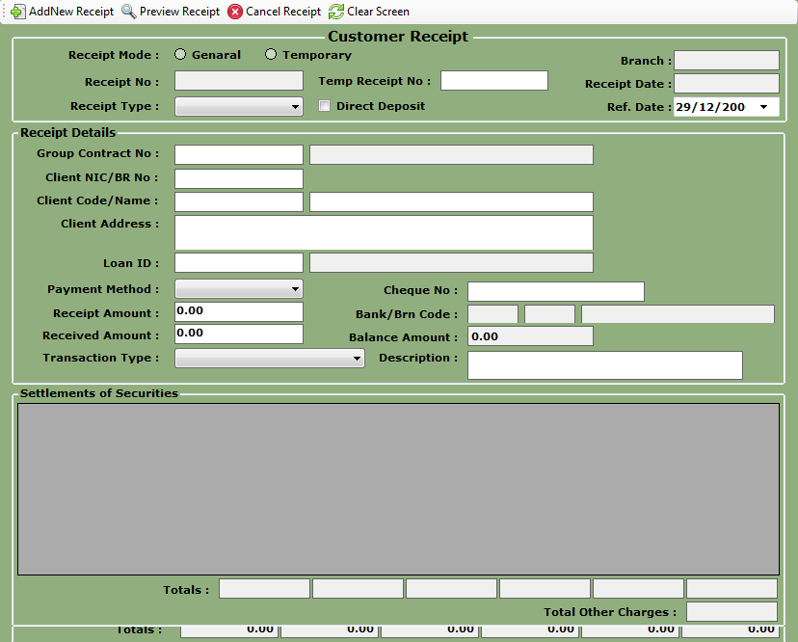

Stakeholders:
Head of Loan Department (AssetLine), Head Of Accounts Department (AssetLine),
Head of IT (AssetLine), Head of Process (Modular4), Director Projects (Modular4)

