Assetline Leasing Company Limited
120, 120A, Pannipitiya Road,
Battaramulla,
Sri Lanka .


ATM Branch Network & ATM Software
Proposed ATM Network

Prepared For: AssetLine Leasing Company Ltd.

Prepared By: Modular4 Solutions (Pvt) Ltd.

Description

ATM Software is a comprehensive, user-friendly package consisting of the following components:
Cash Deposits (OnLine)
Cheque Deposits
Contract Information

This has been designed for ease-of-use, being menu-driven with consistent structures across all of the integrated applications. The database provides shared access to the information while ensuring complete integrity of the data.

Proposal Number: M4PO15000001
Table of Contents

Project Purpose and Business Problem 3
Implementation Plan 4
Architectural Overview 6
Financial Estimates 7
About Modular4 9

Project Purpose and Business Problem
ATM software should provide users with an online environment within which they can View Facility details, Maintain & View Outstanding. And improve efficiency and avoid queues. eLink ATM software offers the chance the customers to pay their outstanding online 24/7.

Feature List
Please Refer Annexure I

Assumption and Constraints
- We assume that the AssetLine has established their own connectivity for each branch with 24/7
- Provided that the database has the 100% accurate data for the customer outstanding, Customer Details etc.
- Provided Devices are well Tested with Accuracy and Efficiency

Implementation Plan

High Level Project Plan
Develop Encrypted HTTPS Transporter 10Days
Application Development 20 Days
Integrating and Test Run in Actual Device 10Days
Parallel and Test Run 5Days

Software Agreement
The Software Agreement to be signed with “Modular4 Solutions (Pvt) Ltd.”

Software Warranty
This software solution carries a warranty period of One (01) Year from the date of User acceptance test (UAT).

Software Maintenance
Maintenance services shall be provided under a maintenance agreement to be signed after the warranty period expires. The standard annual maintenance charges would be eighteen percent (18%) on the product price plus the subsequent cost of modifications.

Software Maintenance
Upfront 100% maintenance fees for a period of one year at the signing of the maintenance contract.
During such annual maintenance MODULAR4 shall rectify all software related faults, defects and malfunctions free of charge.

Additional Software Modifications
All additional software modification charges will be quoted after a detailed system study. The development of the modifications would begin once a written confirmation is given by the client.

Modification Charges
50% - on confirmation of the quotation
50% - on implementation of the modifications

Updates/New Modules
Customers under maintenance service agreement are entitled to free Application Updates within the same version, database, operating system, and application language (subject to application customizations done at the client’s site) of the modules purchased.
Other additional/new modules/new version upgrades would be available at a very special discounted price to your company.

Purchase Order & the Payments
Purchase Order and the payments to be issued to “Modular4 Solutions (Pvt) Ltd.”

Architectural Overview
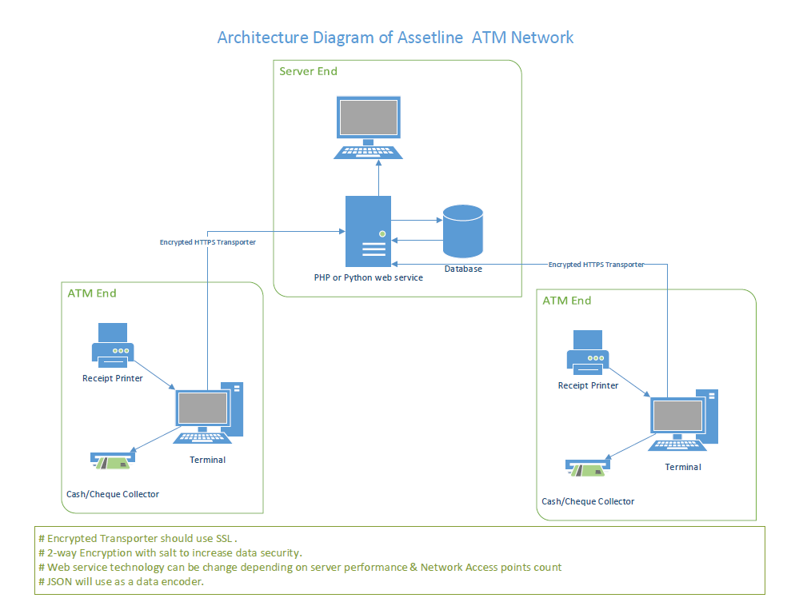

Financial Estimates

Pricing Summary

Total Software Cost Unlimited Branches | 1,270,000.00
Installation Charge for each branch (Except Head Office and One More Branch) | 45,000.00

Note:

** MODULAR4 will provide the source code to the client at the same cost since we are using the Existing Source and the Data Base Structure

Proposal Validity

This proposal is valid for a period of one (01) month.

Payment Terms & Other Charges

Application System Charges:

Option I
50% - on Acceptance of Proposal
30% - on Parallel Run of Software Module (After Successfully implemented Head Office)
30% - on Live Run of Software Module (After Successfully implemented Second Branch)

Training
User training will be done at site during implementation.

About Modular4

Modular4 has delivered cost effective and high-quality software solutions for a wide range of industries and domains. We work together to deliver the ultimate in customer satisfaction while also helping each business or company achieves their unique needs.
Our competence and experience ensures that we deliver excellent services and products to our customers.
At Modular4 we are proud of our high quality standards. These standards allow us to provide our customers with reliable software applications, regardless of complexity.

Contact Us
Dumindu Wijesekara Mahinda Jayakody
0773435429 072317666 / 0716825707
dumindu@modular4.com mahinda@modular4.com
Web Site : www.modular4.com

Our Clients
Client | User reference | Solution Provided
People’s Merchant Business PLC | Anuranga Indrajith  Manager IT | “Pawn – Brokering” Software Solution
Citizen Development Bank | Mr. Imdaad Nagiub  Senior Manager IT | “Pawn – Brokering” Software Solution
MBSL Savings Bank | Mr. Dushmantha Weerathunga  Manager IT | “Pawn – Brokering” Software Solution
Lake House Printers & Publishers | Mr. Rasika Karandawa | Online Bank Cheque Book Ordering and Cheque Printing (MICR)  Cheque return Notice (CRN) Printing with Lanka Clearance Process data
City Bank | Mr. Sumeda Karunarathne  Product Manager | Post Dated Cheque management Software
Ideal Property | Mr. Peter Jayalath  Owner | Real Estate management Software
K.G.S Spear Parts | Mr. Sajeewa Ekanayaka  Product Manager | Inventory Solution
Global Trust | Mr. Susantha Fernando | “Pawn – Brokering” Software Solution
Lucky Homes Pvt Ltd | Mr. M H Wasantha | Real Estate management Software

Confidentiality
All material, prices and other information provided in this proposal and other supporting documents, annexure, CD-ROMs, diskettes etc. should not be disclosed to any 3rd party without written consent.

We hope this pricing proposal would meet your requirements. Should you need any further clarifications, please feel free to contact us.

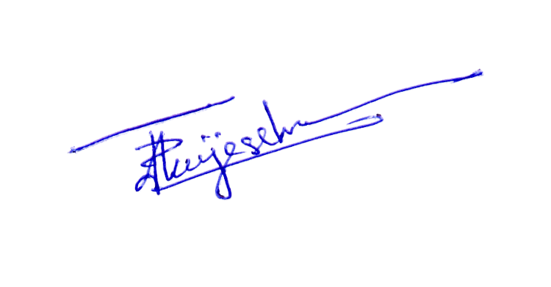
Thank You,
Yours sincerely,

D. Janeendranath Wijesekera
Director Business Development
Modular4 Solutions

Annexure I

System Feature List – eLink ATM System

- Welcome Page
  - User Languages
    - Singhala
    - Tamil
    - English

- Term & Condition

- Contract View
  - Contract Information

- Cash Deposite

- Cheque Deposite

